ASSIGNMENT- 4.3

2303A51254
Nalla Vaishnavi BATCH – 18

Task 1: Zero-Shot Prompting – Leap Year Check
Scenario
Zero-shot prompting involves giving instructions without providing examples. Task Description
Use zero-shot prompting to instruct an AI tool to generate a Python function that:
- Accepts a year as input
- Checks whether the given year is a leap year
- Returns an appropriate result
Note: No input-output examples should be provided in the prompt. Expected Output
- AI-generated leap year checking function
- Correct logical conditions
- Sample input and output
- Screenshot of AI-generated response (if required)
#PROMPT:
#check whether the year is a leap year or not taking input from the user

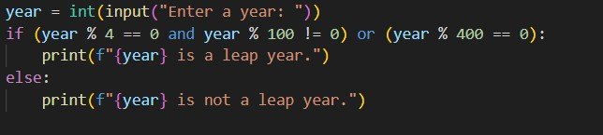
CODE:
OUTPUT:
Analysis:
- AI generated correct code.
- Output was accurate.
- Easy to use in vs.

Task 2: One-Shot Prompting – Centimeters to Inches Conversion
Scenario
One-shot prompting guides AI using a single example. Task Description
Use one-shot prompting by providing one input-output example to generate a Python function that:
  - Converts centimeters to inches
  - Uses the correct mathematical formula
Example provided in prompt:
Input: 10 cm → Output: 3.94 inches
Expected Output
  - Python function with correct conversion logic
  - Accurate calculation
  - Sample test cases and outputs

#prompt:
#convert centimeters to inches output should be in 2 decimal places #Input: 10 cm
# Output: 3.94 inches
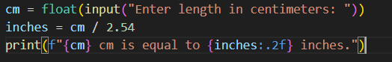
Code:
Output:
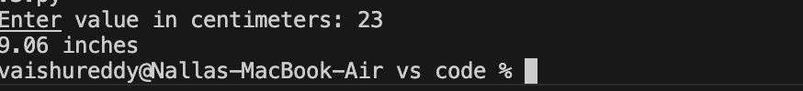
Analysis:

- One example helped the AI generate correct code.

- The task improved understanding of AI pattern learning.

- Clear prompts gave accurate output.

Task 3: Few-Shot Prompting – Name Formatting

Scenario

Few-shot prompting improves accuracy by providing multiple examples. Task Description
Use few-shot prompting with 2–3 examples to generate a Python function that:

  - Accepts a full name as input

  - Formats it as “Last, First”

Example formats:

  - "John Smith" → "Smith, John"

  - "Anita Rao" → "Rao, Anita"

Expected Output

  - Well-structured Python function

  - Output strictly following example patterns

  - Correct handling of names

  - Sample inputs and outputs

#prompt:
#name formatting input first name and last name and output should be in the format Last name, First name
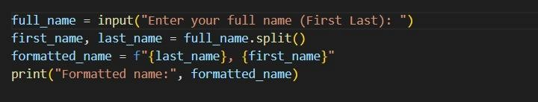
#"John Smith" → "Smith, John" #"Anita Rao" → "Rao, Anita" Code:

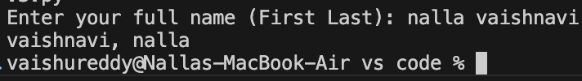
Output:
Analysis:

- examples helped the AI understand name formatting.

- The task improved accuracy in code generation.

- Clear prompts produced correct output.

Task 4: Comparative Analysis – Zero-Shot vs Few-Shot

Scenario

Different prompt strategies may produce different code quality. Task Description
  - Use zero-shot prompting to generate a function that counts vowels in a string

  - Use few-shot prompting for the same problem

  - Compare both outputs based on:

- Accuracy

- Readability

- Logical clarity Expected Output
  - Two vowel-counting functions

  - Comparison table or short reflection paragraph

  - Conclusion on prompt effectiveness

#prompt:
# code to count vowels in a string.
# Compare both functions based on:Accuracy, Readability, and Logical Clarity

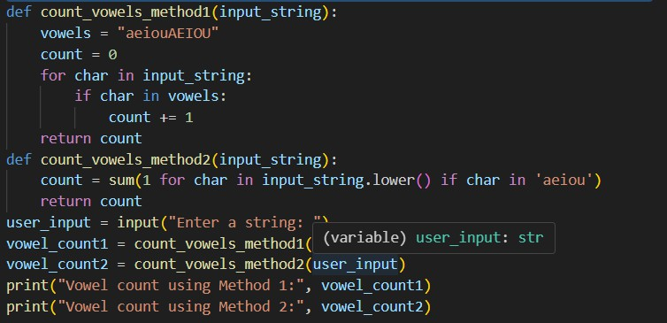
Code:
Output:
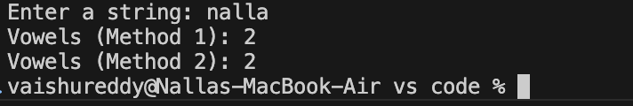
Analysis:
    - ai made task easy and accurate
    - complicated codes can be easily executed
    - various methods can be performed accurately

Task 5: Few-Shot Prompting – File Handling
Scenario
File processing requires clear logical understanding. Task Description
Use few-shot prompting to generate a Python function that:
- Reads a .txt file
- Counts the number of lines in the file
- Returns the line count

Expected Output
- Working Python file-processing function
- Correct line count
- Sample .txt input and output
- AI-assisted logic explanation
#prompt:
#read a .txt file and count number of lines in file and return file count
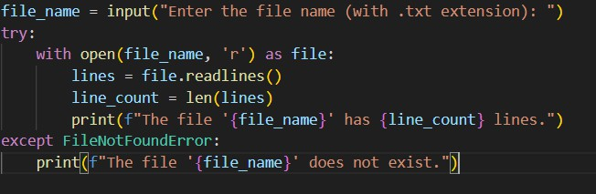
Code:
Output:
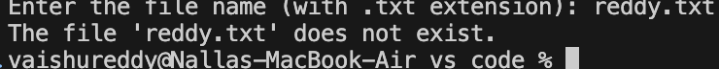
Analysis:
  - vs code made reading file easy
  - the complex codes are executed accurately
  - clear prompts produced with correct outputs

