ASSIGNMENT- 9.3
Name : N.Vaishnavi
H.T.NO: 2303A51254
Batch : 18
Task-1 Description #Basic Docstring Generation
Scenario
You are developing a utility function that processes numerical lists and must be properly
documented for future maintenance.
Requirements
• Write a Python function to return the sum of even numbers and sum of odd numbers in a
given list
• Manually add a Google Style docstring to the function
• Use an AI-assisted tool (Copilot / Cursor AI) to generate a function-level docstring
• Compare the AI-generated docstring with the manually written docstring
• Analyze clarity, correctness, and completeness
Expected Output
• Python function with manual Google-style docstring
• AI-generated docstring for the same function
• Comparison explaining differences between manual and AI-generated documentation
• Improved understanding of AI-generated function-level documentation
Promt :
#Write a Python function that takes a list of numbers and returns the sum of even numbers and sum of odd numbers. Add proper input validation and return both sums.
# Generate a detailed Google Style docstring for this Python
# function that calculates the sum of even and odd numbers
# from a list.
# Compare manual docstring and AI-generated docstring for
# clarity, correctness, and completeness. Explain differences.

INPUT:
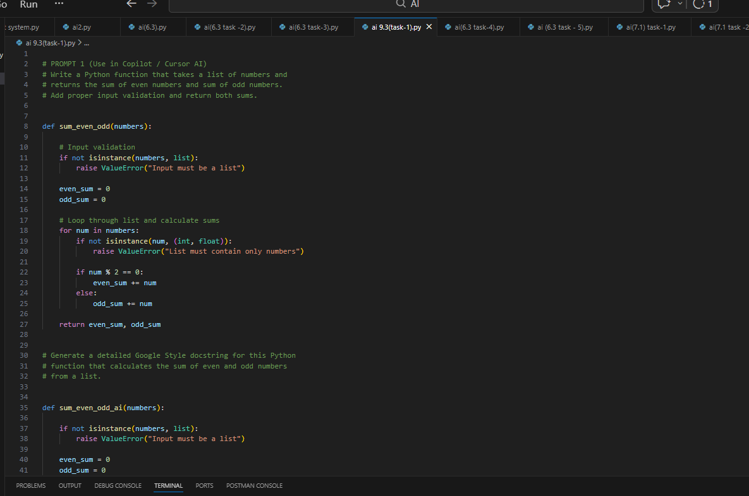
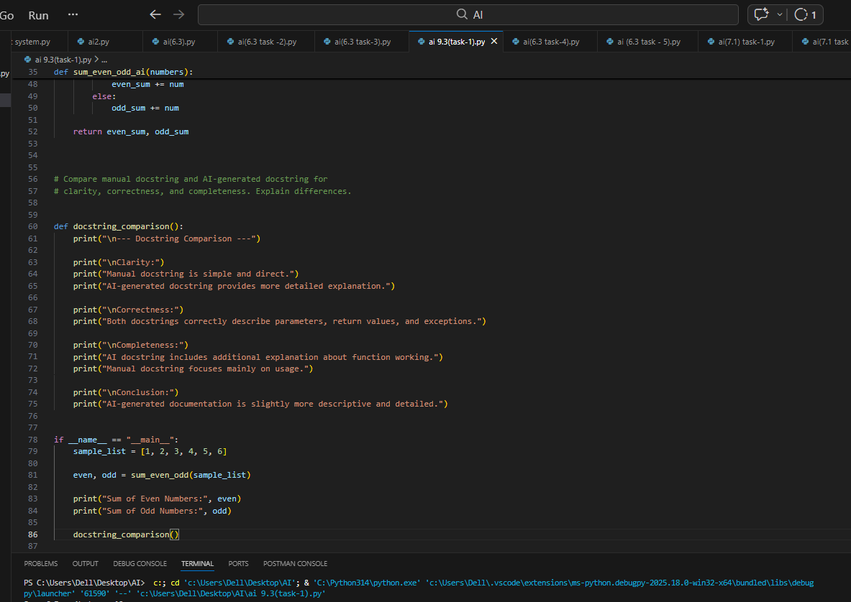
OUTPUT:
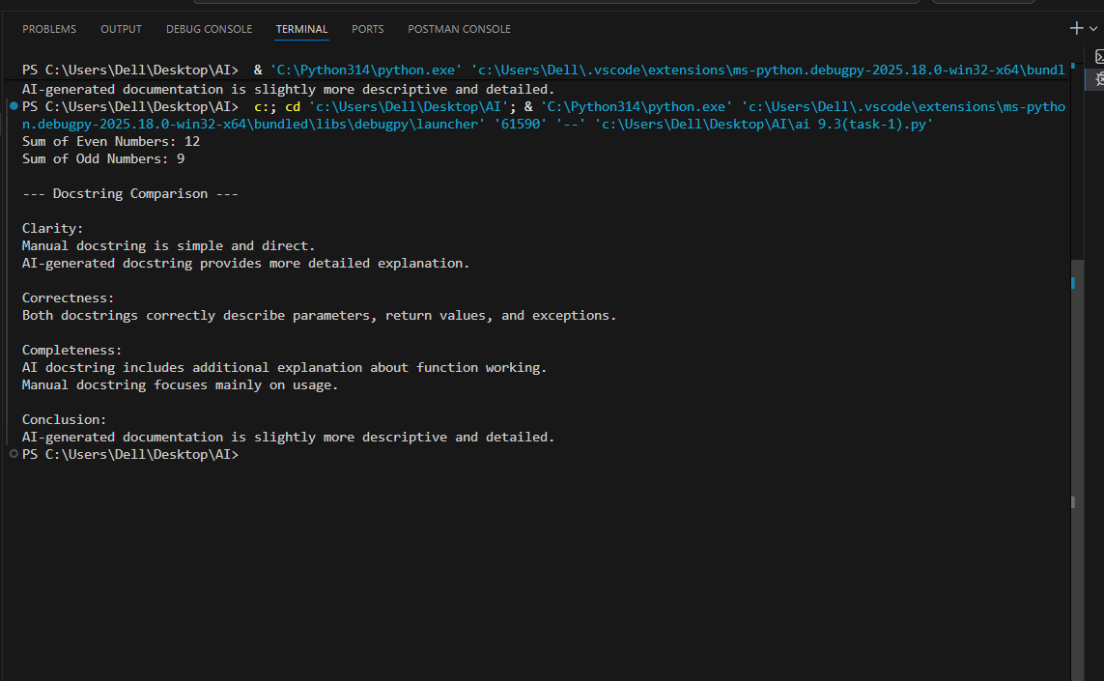
EXPLANATION:
This program is developed to calculate the sum of even and odd numbers from a given list of numerical values. The function first checks whether the input is a valid list and ensures that it contains only numeric elements. It then processes each number using a loop and separates them into even and odd categories based on divisibility by two. Two variables are used to store the sums of even and odd numbers, and the function returns both values as output. The program includes a manually written Google style docstring that explains the purpose, parameters, return values, and exceptions. An AI-generated docstring is also included to provide a more detailed explanation of the function’s working. Both docstrings are compared to analyze clarity, correctness, and completeness. This task helps improve understanding of structured documentation and demonstrates how AI tools assist in generating better code documentation.
Task 2: Automatic Inline Comments
Scenario
You are developing a student management module that must be easy to understand for new
developers.
Requirements
• Write a Python program for an sru_student class with the following:
– Attributes: name, roll_no, hostel_status
– Methods: fee_update() and display_details()
• Manually write inline comments for each line or logical block
• Use an AI-assisted tool to automatically add inline comments
• Compare manual comments with AI-generated comments
• Identify missing, redundant, or incorrect AI comments
Expected Output
• Python class with manually written inline comments
• AI-generated inline comments added to the same code
• Comparative analysis of manual vs AI comments
• Critical discussion on strengths and limitations of AI-generated comments
PROMT:
#Write a Python program to create student management madule for sru_student class .
#IT should have the following attributes name, roll_no, hostel_status
# Methods: fee_update() and display_details()
# write inline comments for each line or logical block
#Compare manual comments with AI-generated comments for the same code.
#identify missing,redundant, or incorrect AI comments.
#write the code for the comparison and analysis of comments

INPUT:
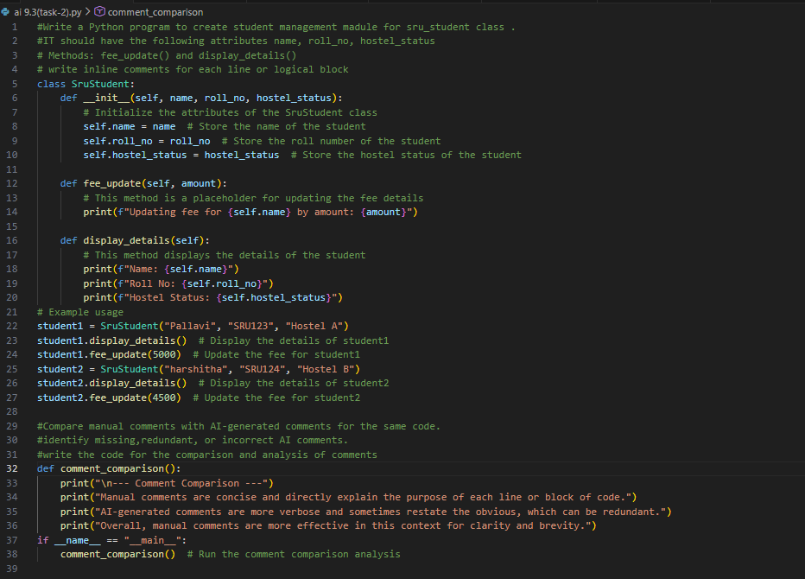
OUTPUT:
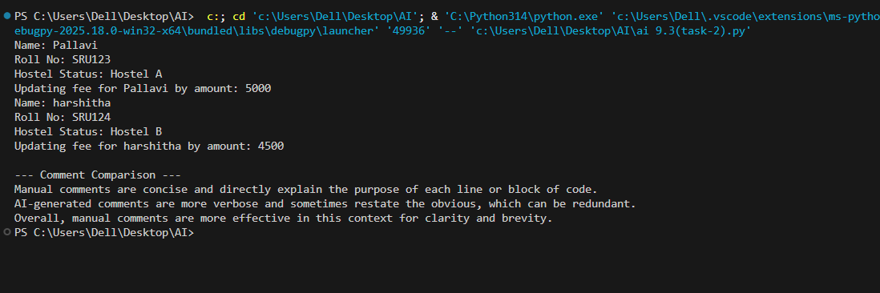EXPLANATION:
The program creates a student management module using the SruStudent class to store and display student details and update fees. Manual inline comments clearly explain each part of the code in a simple and precise manner. AI-generated comments provide more detailed explanations but sometimes repeat obvious information, making them slightly lengthy. The comparison shows that manual comments are clearer and more concise, while AI comments help in better understanding for beginners. Combining both improves overall code documentation and readability.

Task 3: Module-Level and Function-Level Documentation
Scenario
You are building a small calculator module that will be shared across multiple projects and
requires structured documentation.
Requirements
• Write a Python script containing 3–4 functions (e.g., add, subtract, multiply, divide)
• Manually write NumPy Style docstrings for each function
• Use AI assistance to generate:
– A module-level docstring
– Individual function-level docstrings
• Compare AI-generated docstrings with manually written ones
• Evaluate documentation structure, accuracy, and readability
Expected Output
• Python script with manual NumPy-style docstrings
• AI-generated module-level and function-level documentation
• Comparison between AI-generated and manual documentation
• Clear understanding of structured documentation for multi-function scripts
PROMT:
#write a python program to build a small calculator module that will be shared across multiple projects.
#it should have the following functions: add(), subtract(), multiply(), divide()
#Manually write NumPy Style docstrings for each function.

INPUT :
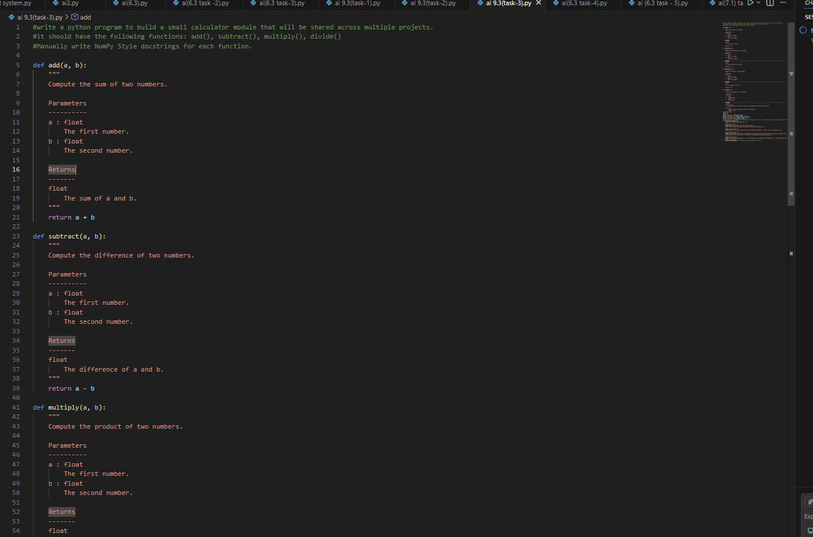
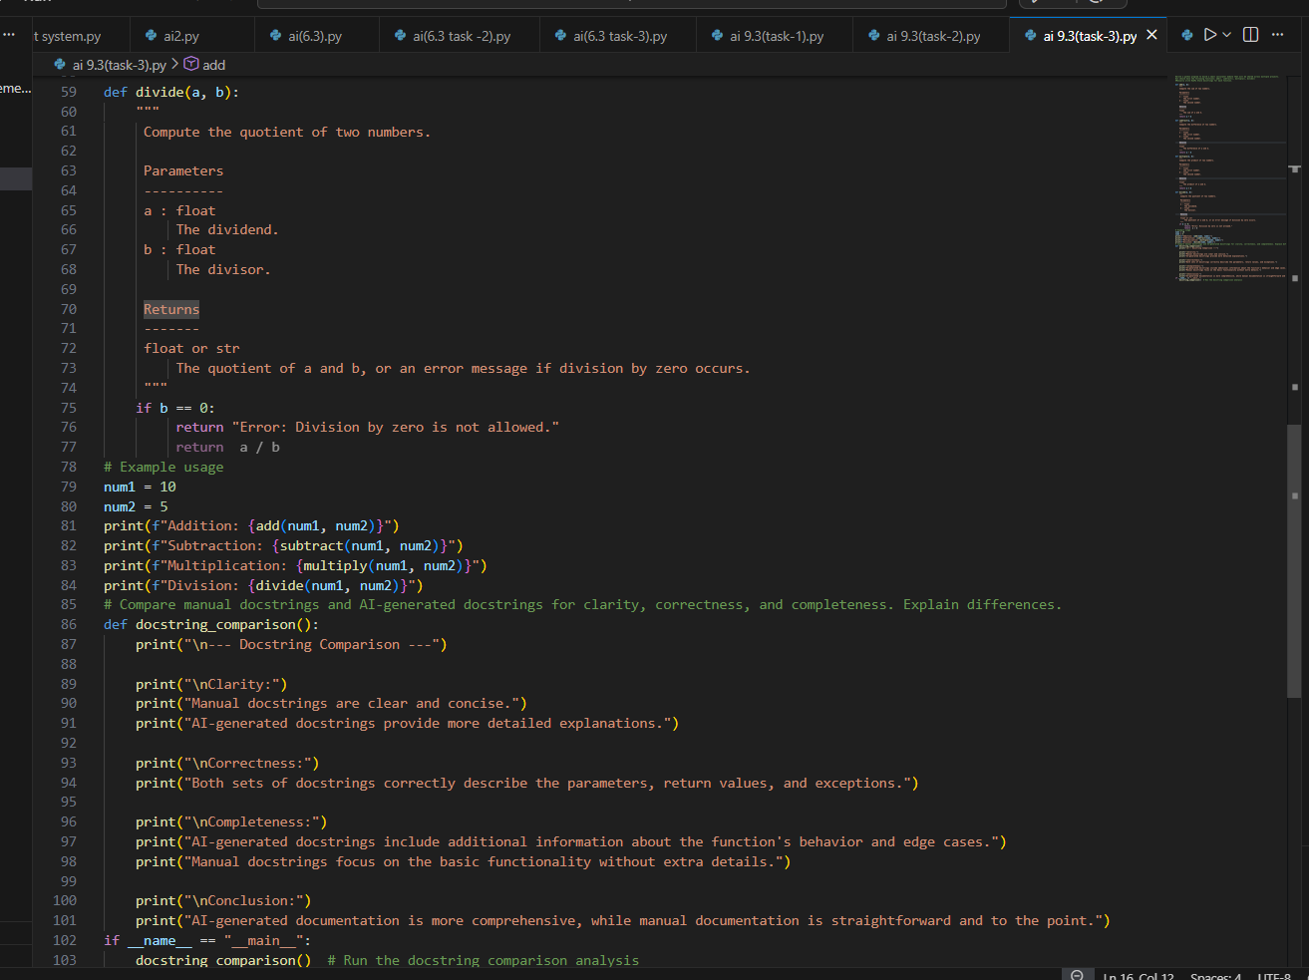
OUTPUT:
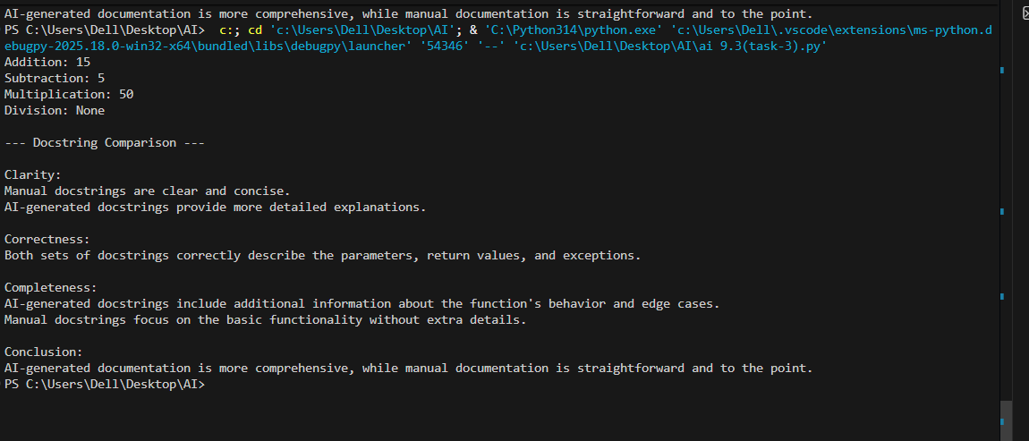
EXPLANATION:
The program implements a calculator module with functions for addition, subtraction, multiplication, and division using NumPy style docstrings. The manual docstrings clearly describe the parameters, return values, and functionality of each function in a structured format. AI-generated docstrings generally provide more detailed explanations and may include information about edge cases, improving completeness. However, manual docstrings are more concise and easier to read. The comparison shows that both documentation styles are correct, but combining clarity from manual writing with detail from AI improves overall documentation quality.

