Lab Assignment 1.5 – AI ASSISTED CODING
Name: Syed Murtaza
H.T No: 2303A51259
Task 1: AI-Generated Logic Without Modularization (String Reversal Without
Functions)
❖ Scenario
You are developing a basic text-processing utility for a messaging
application.
❖ Task Description
Use GitHub Copilot to generate a Python program that:
➢ Reverses a given string
➢ Accepts user input
➢ Implements the logic directly in the main code
➢ Does not use any user-defined functions
Code:
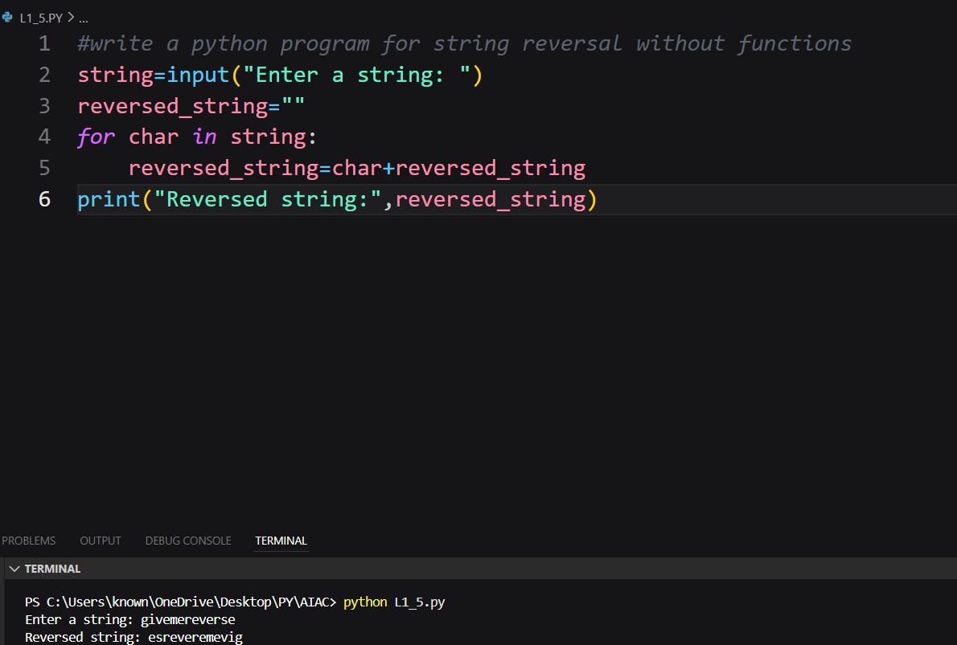
Task 2: Efficiency & Logic Optimization (Readability Improvement)
❖ Scenario
The code will be reviewed by other developers.
❖ Task Description
Examine the Copilot-generated code from Task 1 and improve it by:
➢ Removing unnecessary variables
➢ Simplifying loop or indexing logic
➢ Improving readability
Code:
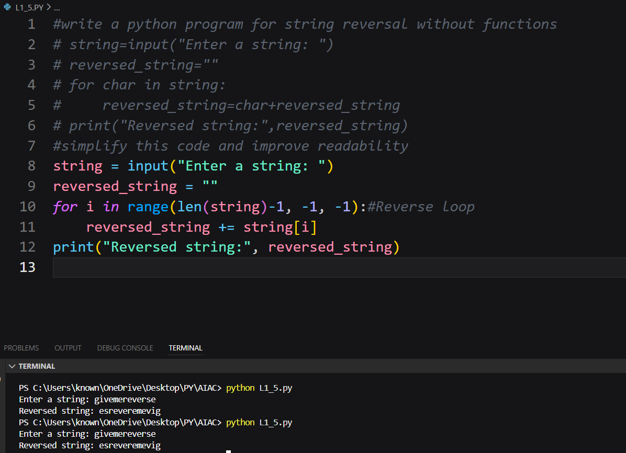
Task 3: Modular Design Using AI Assistance (String Reversal Using Functions)
❖ Scenario
The string reversal logic is needed in multiple parts of an application.
❖ Task Description
Use GitHub Copilot to generate a function-based Python program that:
➢ Uses a user-defined function to reverse a string
➢ Returns the reversed string
➢ Includes meaningful comments (AI-assisted)
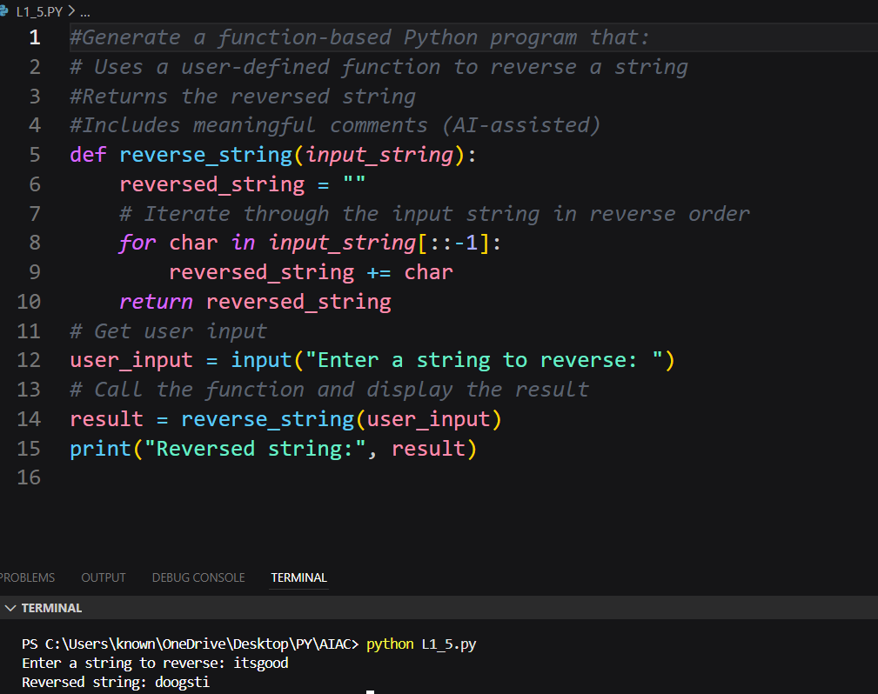
Task 4: Comparative Analysis – Procedural vs Modular Approach (With vs
Without Functions)
❖ Scenario
You are asked to justify design choices during a code review.
❖ Task Description
Compare the Copilot-generated programs:
➢ Without functions (Task 1)
➢ With functions (Task 3)
Analyze them based on:
➢ Code clarity
➢ Reusability
➢ Debugging ease
➢ Suitability for large-scale applications
Comparison Table:
Task 4: Comparative Analysis – Procedural vs Modular Approach
Criteria | Without Functions (Task 1 – Procedural) | With Functions (Task 3 – Modular)
Code Clarity | Code is simple and easy to understand for small programs, but logic and execution are mixed together. | Code is well-structured. Logic is separated into a function, making it cleaner and more readable.
Reusability | Low reusability. The code must be rewritten if string reversal is needed again. | High reusability. The function can be called multiple times with different inputs.
Debugging Ease | Debugging becomes harder as the program grows since all logic is in one block. | Easier to debug because issues can be isolated within the function.
Suitability for Large-Scale Applications | Not suitable for large programs. Code becomes lengthy and difficult to manage. | Highly suitable. Modular design supports scalability and teamwork.
Conclusion
The procedural approach (Task 1) is suitable for small, simple programs, while the modular approach (Task 3) is better for larger, maintainable, and reusable applications. Using functions improves code organization, debugging, and scalability.

Task 5: AI-Generated Iterative vs Recursive Fibonacci Approaches (Different
Algorithmic Approaches to String Reversal)
❖ Scenario
Your mentor wants to evaluate how AI handles alternative logic paths.
❖ Task Description
Prompt GitHub Copilot to generate:
➢ A loop-based string reversal approach
➢ A built-in / slicing-based string reversal approach
Comparison Table:
Task 5: Comparison – Loop-Based vs Slicing-Based String Reversal
Aspect | Loop-Based Approach | Slicing-Based Approach
Execution Flow | Iterates through the string character by character and builds the reversed string step by step. | Uses Python’s built-in slicing mechanism to reverse the string in a single operation.
Time Complexity | O(n) — each character is processed once. | O(n) — slicing traverses the entire string once internally.
Performance for Large Inputs | Slightly slower due to explicit looping and repeated string concatenation. | Faster and more optimized because slicing is implemented in C internally.
Memory Usage | Uses extra memory for constructing the reversed string incrementally. | Creates a new reversed string in one step; generally more memory-efficient.
Readability | More verbose but clearly shows the reversal logic. | Very concise and easy to read.
When Appropriate | Useful for learning, interviews, or when custom logic per character is required. | Best choice for real-world applications where simplicity and performance matter.
Conclusion
Both approaches have the same time complexity, but the slicing-based method is more efficient and concise for large inputs. The loop-based method is valuable for understanding algorithmic flow and applying custom processing during reversal.

