Lab Assignment 2.5 – AI ASSISTED CODING
Name: Syed Murtaza
H.T No: 2303A51259

Task 1: Refactoring Odd/Even Logic (List Version)
❖ Scenario:
You are improving legacy code.
❖ Task:
Write a program to calculate the sum of odd and even numbers in a list,
then refactor it using AI.
Original Code:
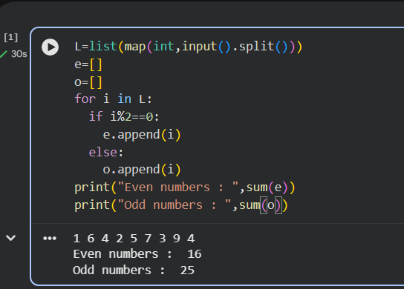
Prompted Code:
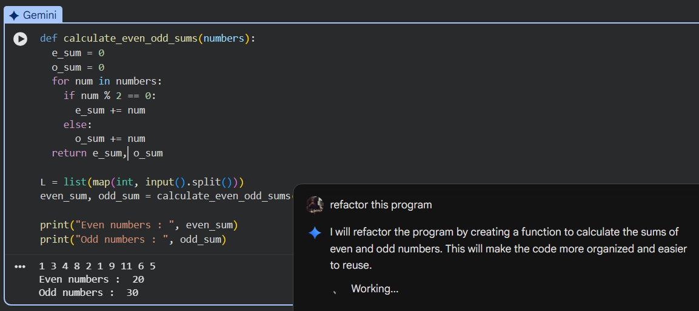
Task 2: Area Calculation Explanation
❖ Scenario:
You are onboarding a junior developer.
❖ Task:
Ask Gemini to explain a function that calculates the area of different
shapes.
Prompted Code:
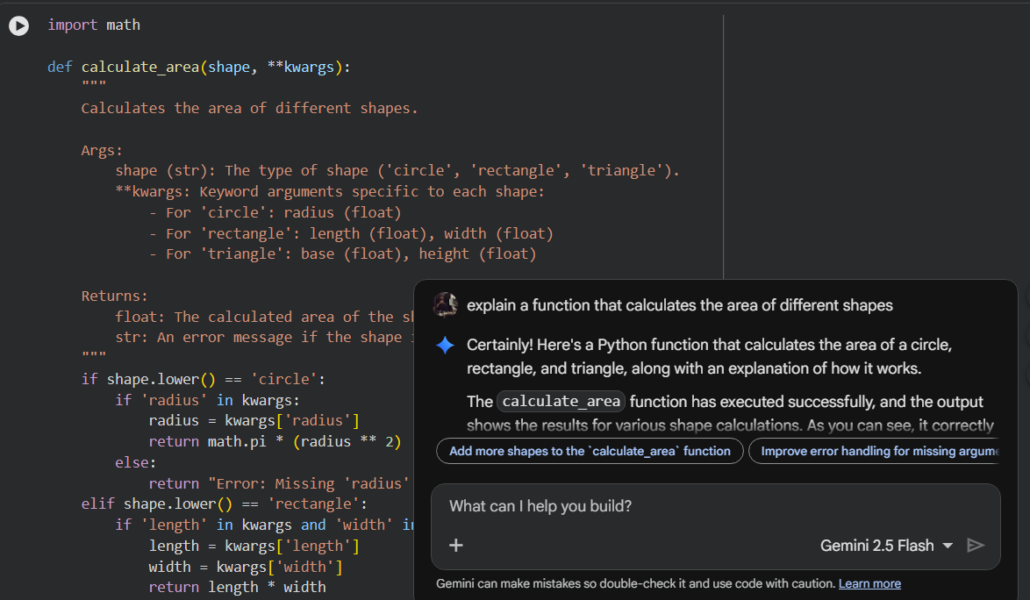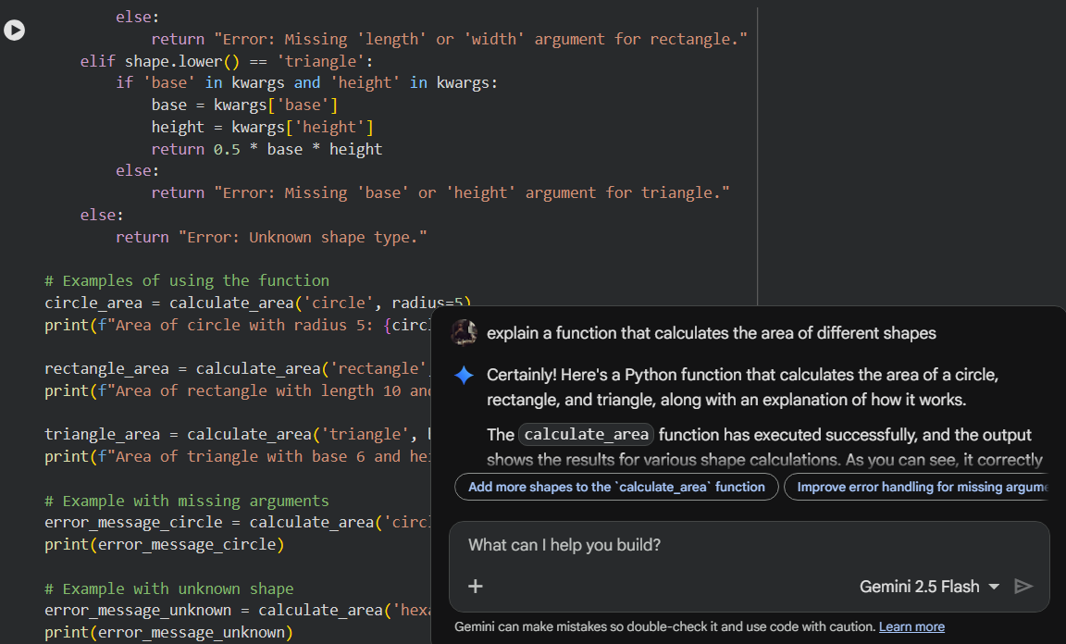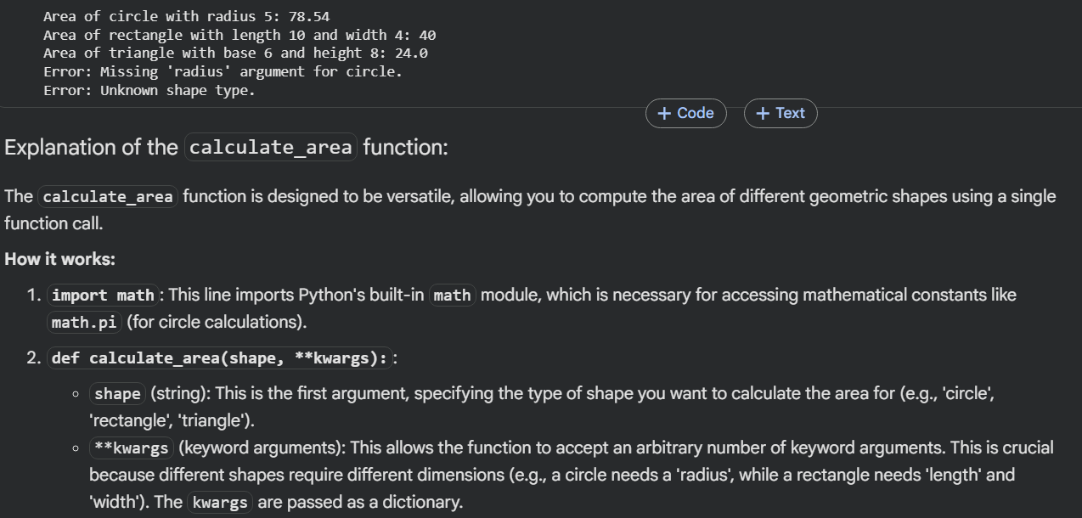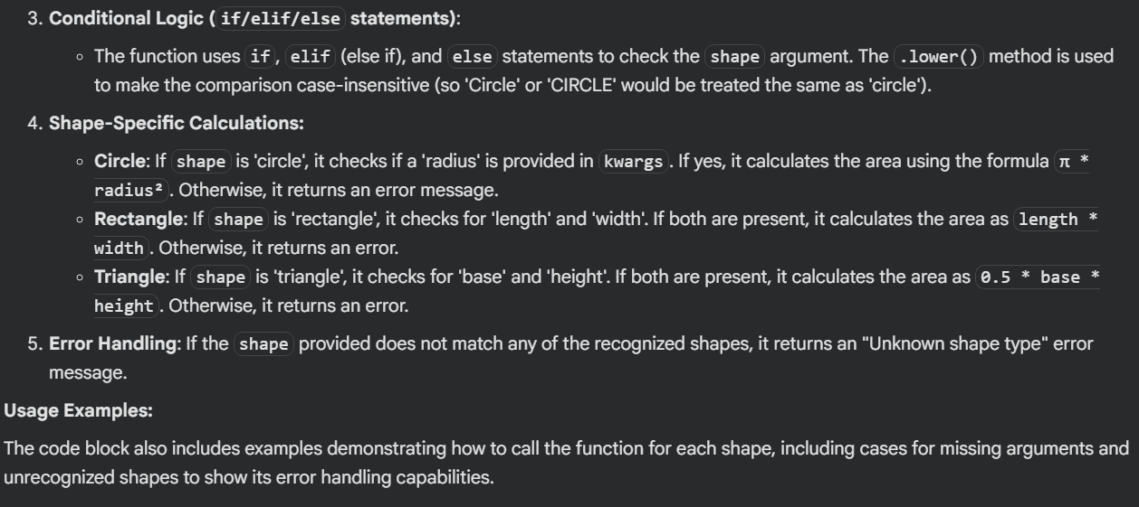
Task 3: Prompt Sensitivity Experiment
❖ Scenario:
You are testing how AI responds to different prompts.
❖ Task:
Use Cursor AI with different prompts for the same problem and observe
code changes.
Prompt And Code:
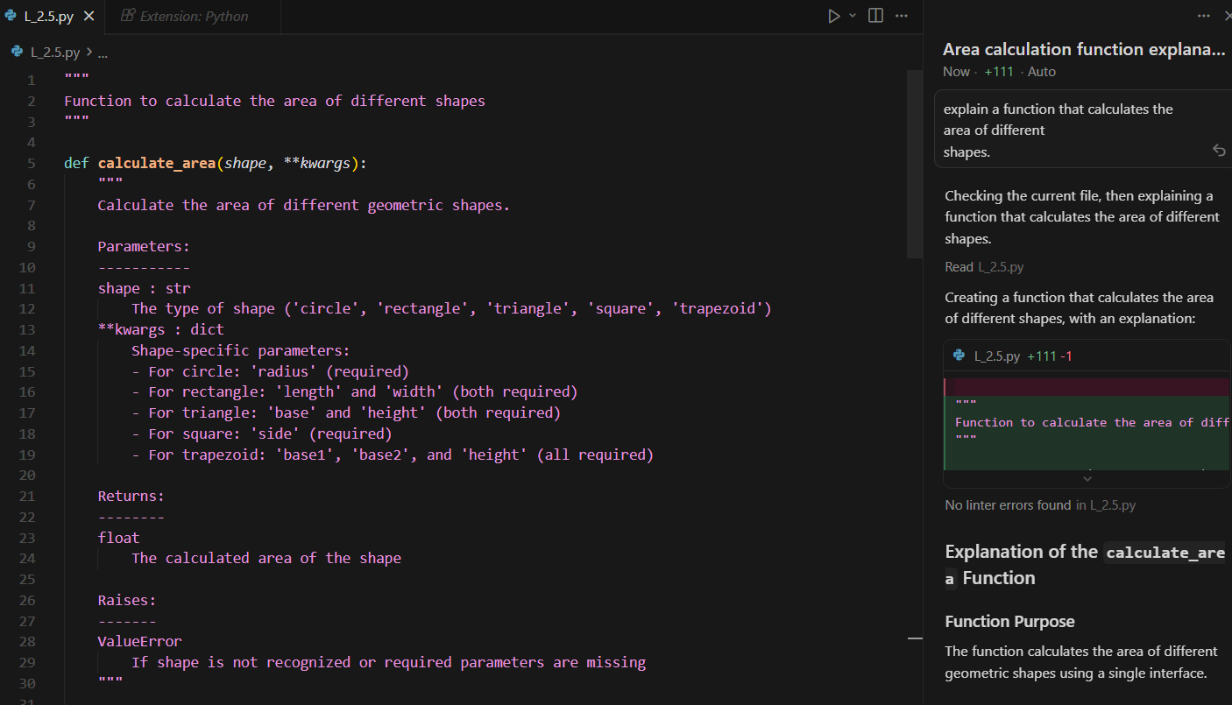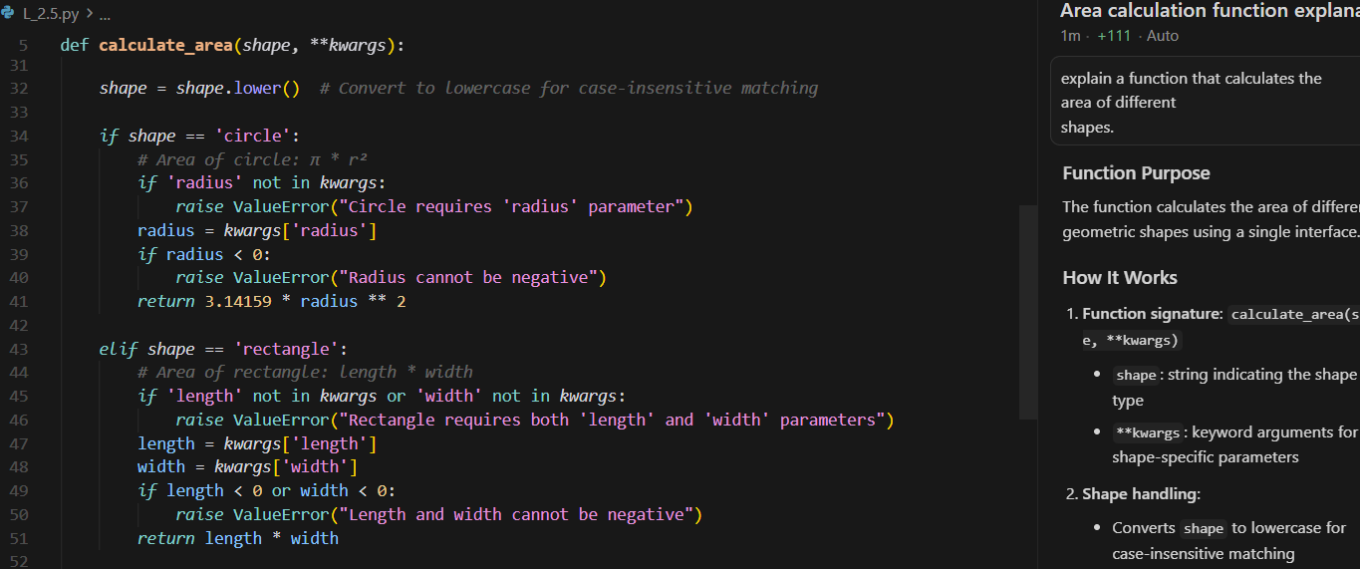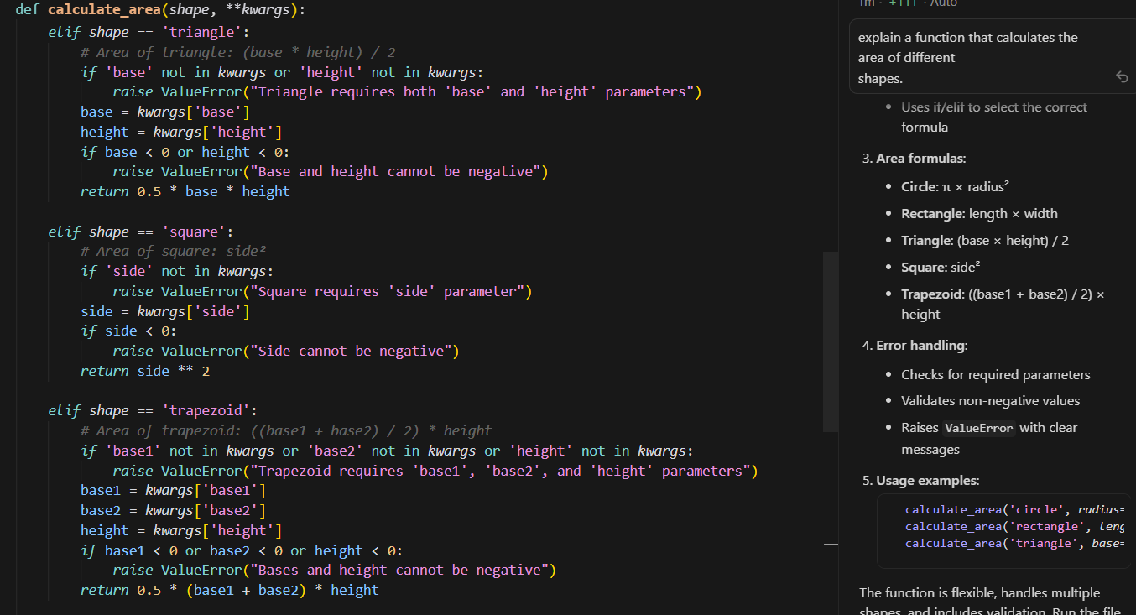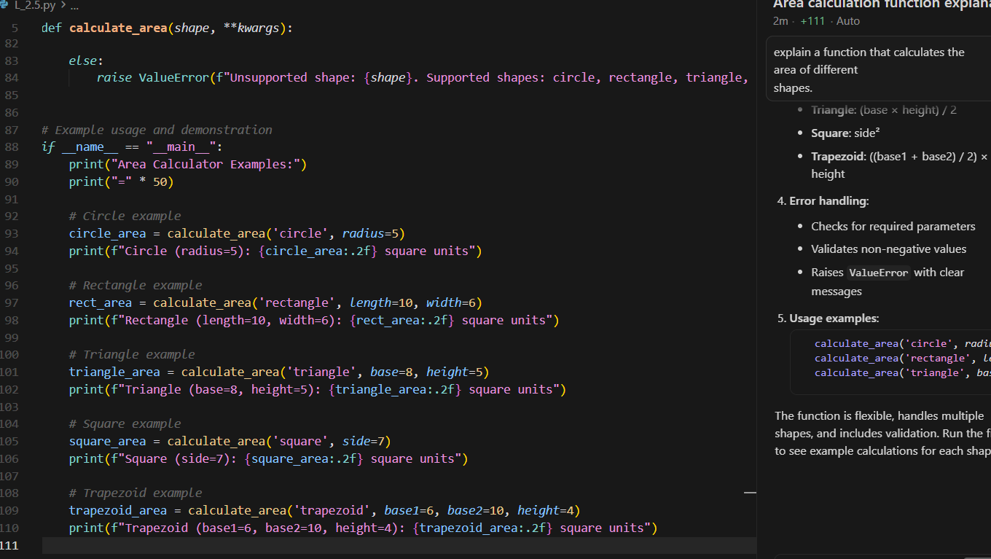Task 4: Tool Comparison Reflection
❖ Scenario:
You must recommend an AI coding tool.
❖ Task:
Based on your work in this topic, compare Gemini, Copilot, and Cursor AI
for usability and code quality.
Tool Comparison Reflection – Gemini vs GitHub Copilot vs Cursor AI
Based on the code generated and explanations provided by Google Gemini, GitHub Copilot, and Cursor AI, clear differences can be observed in usability, robustness, and code quality.
Google Gemini generated clean and readable code with a strong focus on simplicity and beginner-friendly explanations. It used standard libraries (such as math) and returned user-friendly error messages as strings. This approach makes Gemini well-suited for teaching concepts and onboarding junior developers. However, its implementation supports fewer shapes and relies on returning error messages instead of raising exceptions, which limits robustness in large-scale applications.
Cursor AI produced a more comprehensive and production-oriented solution. The generated code supports multiple shapes, includes detailed docstrings, input validation, and proper exception handling using ValueError. Cursor AI also demonstrated better software engineering practices such as defensive programming and clear documentation. This makes Cursor AI highly suitable for refactoring, optimization, and real-world application development.
GitHub Copilot, based on prior observations, excels at rapid inline code generation within the IDE. While it is extremely efficient for writing working code quickly, it provides minimal explanation and documentation by default. This makes it ideal for experienced developers but less effective for learning or code review scenarios.
Conclusion
Gemini is best suited for learning and explanation-focused tasks, Copilot is ideal for fast development, and Cursor AI offers the most balanced solution with high-quality code, strong validation, and clear documentation. Therefore, Cursor AI is the most suitable recommendation for professional and scalable development, while Gemini is preferable for educational use.

