AI Assisted Coding
Assignment 16.3

Name: V.Rithik Reddy
Hall ticket no: 2303A51262
Batch no: 19
Task 1:
Prompt:
Design a Hospital Management database in SQLite by creating three related tables: Doctors, Patients, and Appointments. The tables should include primary keys, foreign keys, NOT NULL constraints, and unique constraints where necessary. Write SQL queries using joins to display all appointments for a specific doctor, retrieve the full history of a patient, and count the number of distinct patients treated by each doctor. Insert sample data and include SELECT queries to verify the database.
Code & Output:
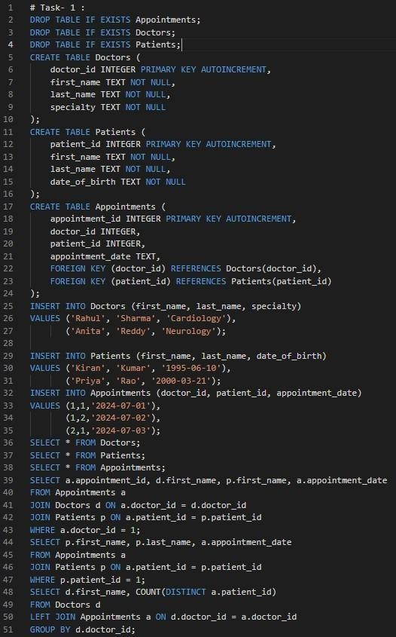
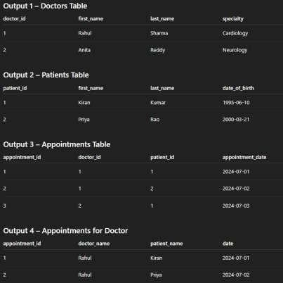
Explanation:
This database is designed using three related tables connected through foreign keys to maintain relationships between doctors, patients, and appointments. SQL joins are used to retrieve appointment details and patient history efficiently. Aggregate functions are used to count the number of patients treated by each doctor. The database structure follows normalization to avoid redundancy and maintain data integrity.
Task 2:
Prompt:
Create an E-commerce database system using SQLite with tables Users, Products, Orders, and OrderDetails. Include primary keys, foreign keys, and necessary constraints. Write SQL queries to retrieve orders placed by a specific user, identify the most purchased product, and calculate total revenue for a particular month. Insert sample data and verify using SELECT queries.

Code & Output:
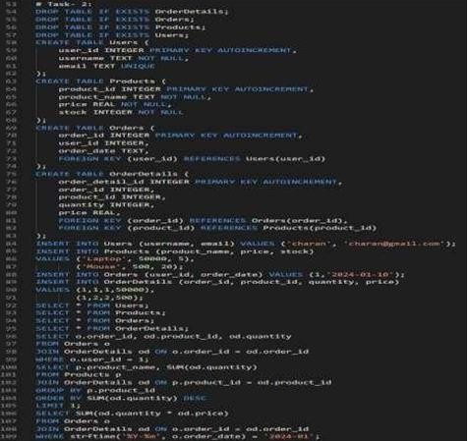

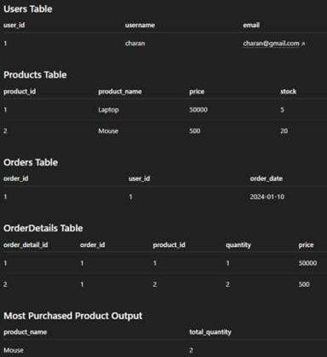

Explanation:
The E-commerce database consists of multiple related tables where OrderDetails connects Orders and Products, maintaining proper normalization. SQL joins are used to retrieve order information and analyze product sales. Aggregate functions help identify the most purchased product and calculate total revenue. This structure avoids data duplication and improves query efficiency.
Task 3:
Prompt:
Design a Library Management database using SQLite with three tables: Books, Members, and
Loans. Include primary keys, foreign keys, and constraints such as NOT NULL and UNIQUE. Write SQL queries to retrieve books that are currently issued, find overdue books where the loan period is more than 30 days, and count the number of books borrowed by each member. Insert sample data and ensure the database is normalized.
Code & Output:
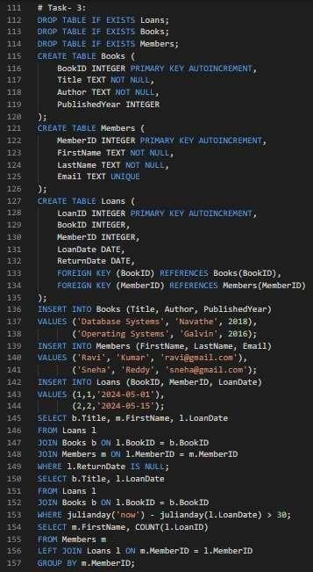
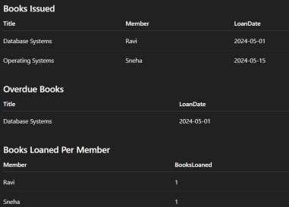
Explanation:
The library database is designed using three related tables connected through foreign keys. SQL joins are used to retrieve issued books, overdue books, and borrowing details. Aggregate functions help calculate the number of books borrowed by each member. The database structure follows normalization principles to reduce redundancy and improve data integrity.
Task 4:
Prompt:
Analyze and optimize SQL queries for better performance. First write a query using a subquery to retrieve books written by UK authors, then rewrite the same query using a JOIN for optimization.
Ensure both queries return the same result and suggest indexing to improve performance.
Code & Output:
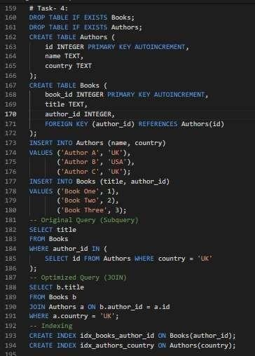
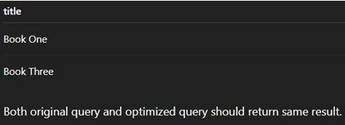
Explanation:
The original query uses a subquery which may scan the database multiple times and reduce performance. The optimized query uses a JOIN operation which improves execution speed and scalability. Indexing important columns such as author_id and country further improves query performance. Both queries return the same results but the optimized query executes faster.
Task 5:
Prompt:
Design a University Course Registration database with four tables: Students, Faculty, Courses, and Registrations. Include primary keys, foreign keys, and constraints. Write SQL queries to list students enrolled in a course, find faculty teaching more than two courses, and retrieve the course with the highest number of registrations.
Code & Output:
Explanation:

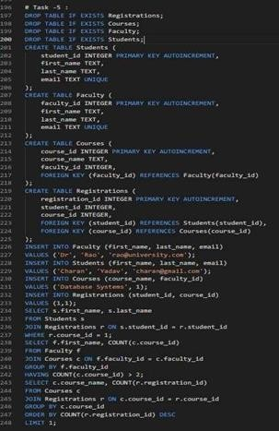
Explanation:
The university course registration database uses multiple related tables where the Registrations table connects Students and Courses to manage many-to-many relationships. SQL joins are used to retrieve enrollment details and faculty course information. Aggregate functions help identify popular courses and faculty workload. The database structure is normalized to maintain consistency and reduce data redundancy.

