RESTFULLOPEREATIONS
Name : V.Rithik Reddy
B-19
H.No:2303A51263
#### simple Restfull operation
const express = require('express');
const app = express();
app.use(express.json());
app.get('/students', (req, res) => {
res.json([{ id: 1, name: "Ravi" }]);
});
app.post('/students', (req, res) => {
const student = req.body;
res.status(201).json({ message: "Student added", data: student });
});
app.listen(3000, () => {
console.log("Server running on port 3000");
});
#### restfull operation with HTML
const express = require('express');
const app = express();
app.use(express.urlencoded({ extended: true }));
app.use(express.json());
let students = [];
app.get('/', (req, res) => {
res.send(`
<h2>Add Student</h2>
<form method="POST" action="/students">
<input type="text" name="name" placeholder="Enter name" />
<button type="submit">Add</button>
</form>
`);
});
app.post('/students', (req, res) => {
const name = req.body.name;
const newStudent = {
id: students.length + 1,
name: name
};
students.push(newStudent);
res.send("Student Added Successfully!");
});
app.get('/students', (req, res) => {
res.json(students);
});
app.listen(3000, () => {
console.log("Server running on port 3000");
});
#### resfull operation with POSTMAN desktop app(https://www.postman.com/downloads/)
const express = require('express');
const app = express();
app.use(express.json());
let students = [
{ id: 1, name: "Ravi" },
{ id: 2, name: "Sita" }
];
// 1 GET - View all students
app.get('/students', (req, res) => {
res.json(students);
});
GET OPERATION:
/ 1 GET - View all students
app.get('/students', (req, res) => {
res.json(students);
});
OUTPUT:
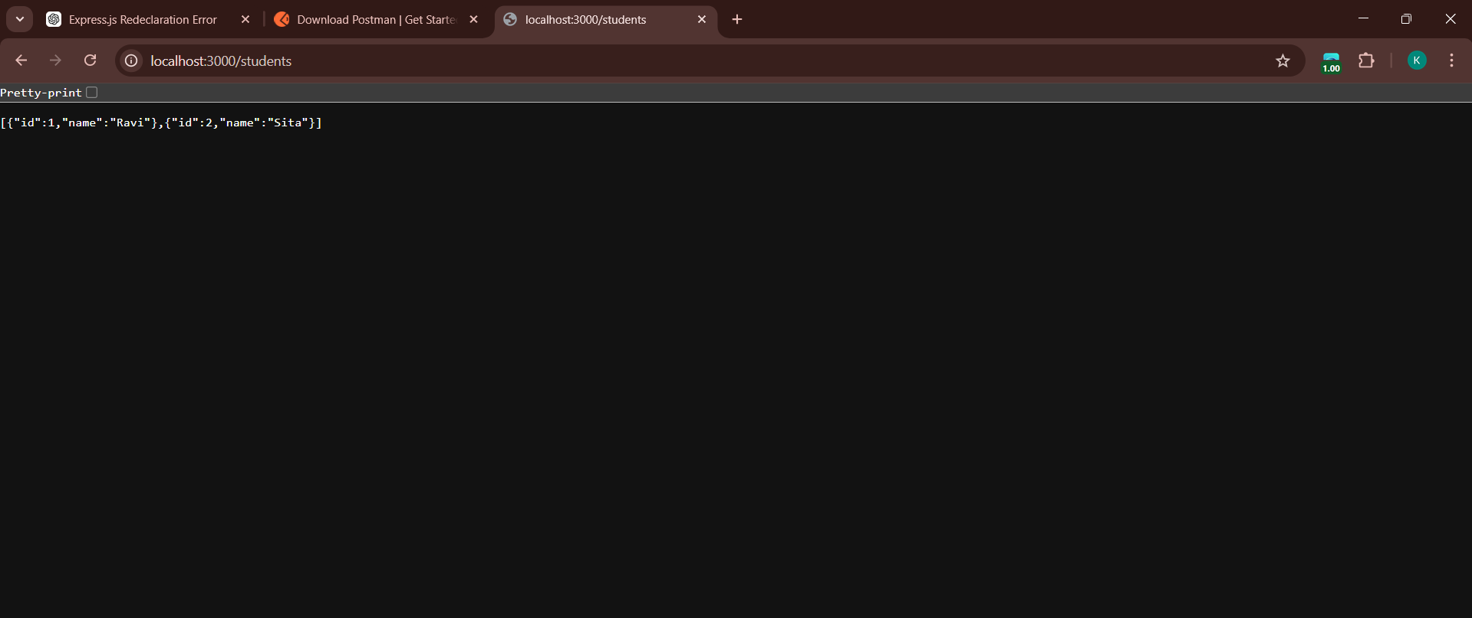
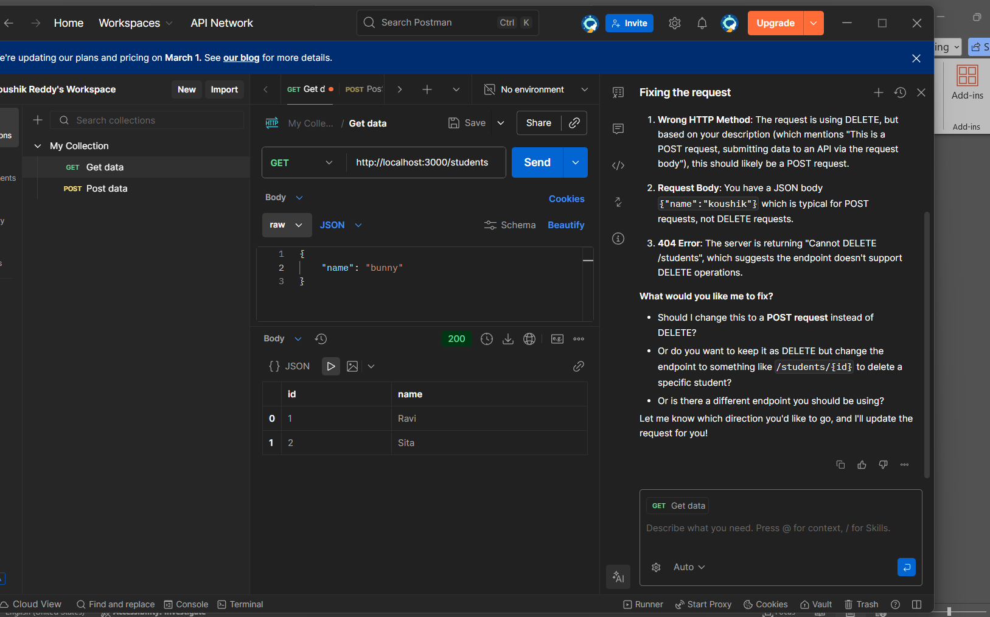

// 2 GET - View single student
app.get('/students/:id', (req, res) => {
const id = parseInt(req.params.id);
const student = students.find(s => s.id === id);
if (!student) {
return res.status(404).json({ message: "Student not found" });
}
res.json(student);
});
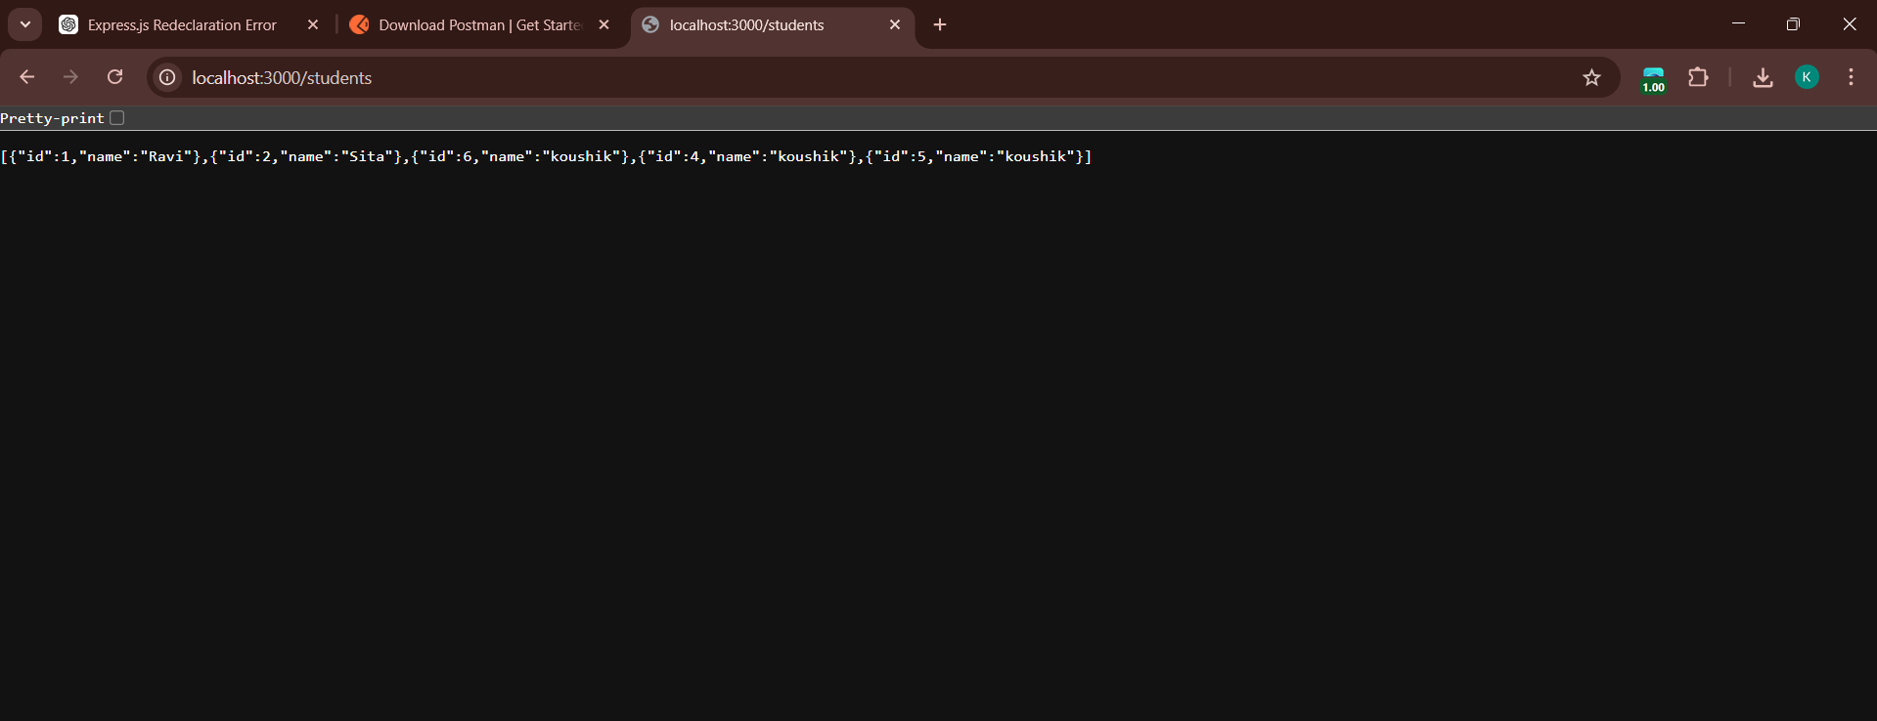
OUTPUT:
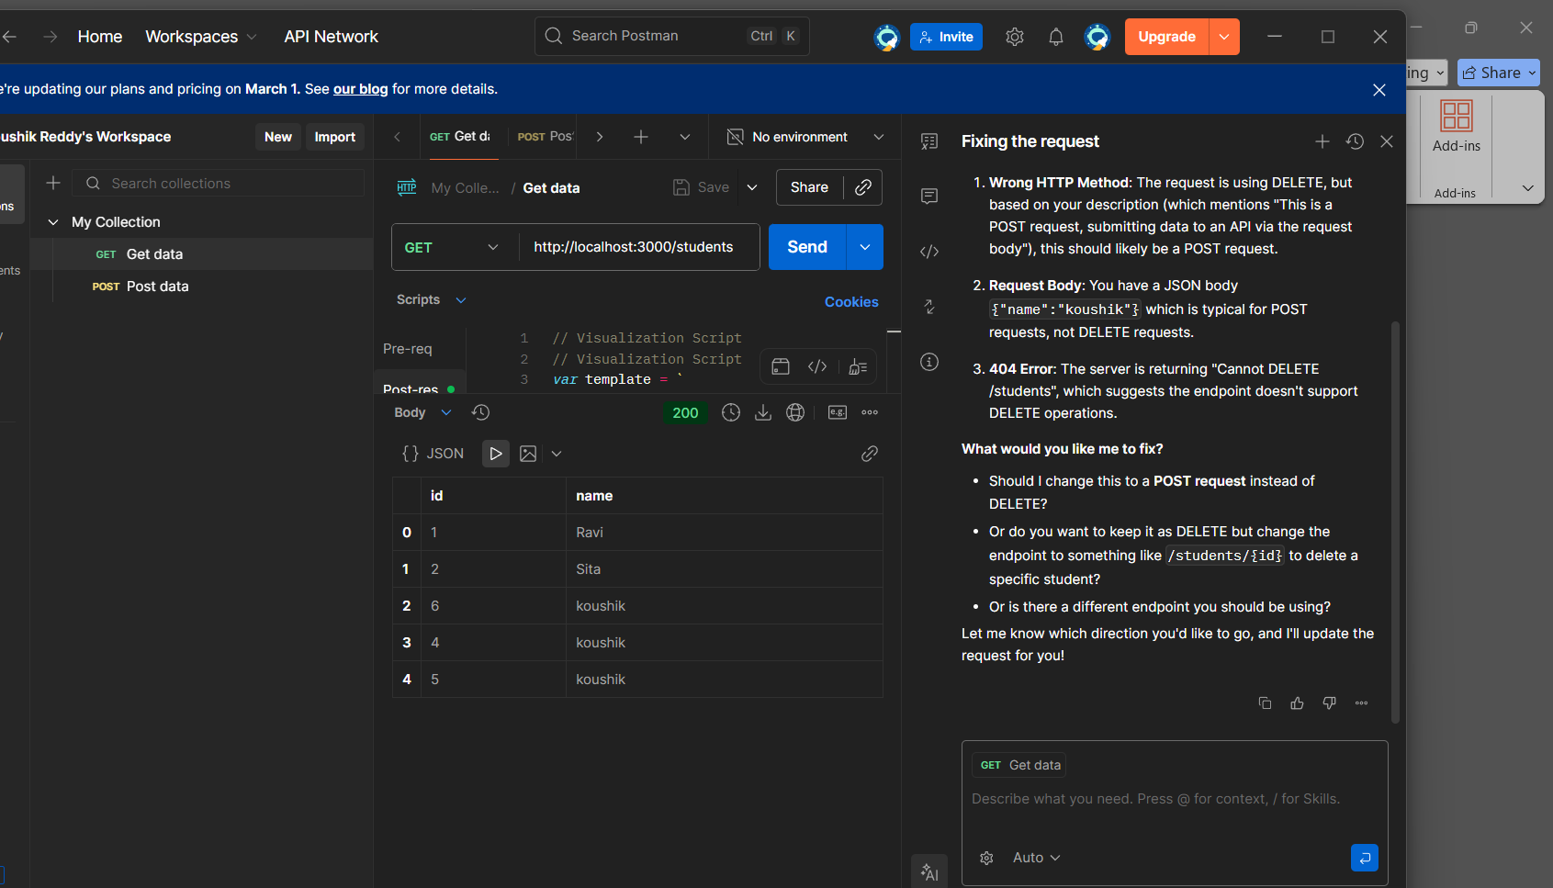
/ 4 PUT - Update student
app.put('/students/:id', (req, res) => {
const id = parseInt(req.params.id);
const { name } = req.body;
const student = students.find(s => s.id === id);
if (!student) {
return res.status(404).json({ message: "Student not found" });
}
student.name = name;
res.json({ message: "Student updated", student });
});
OUTPUT:
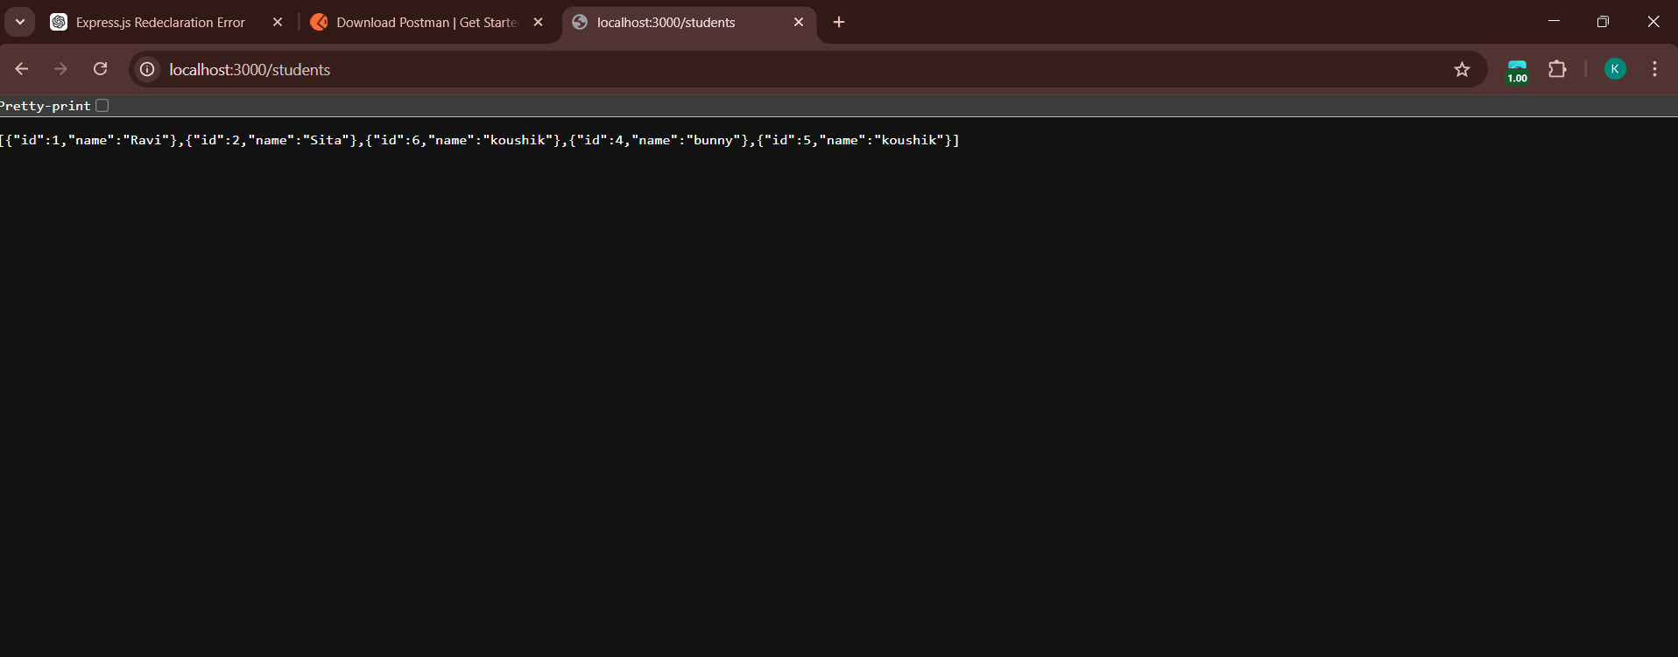
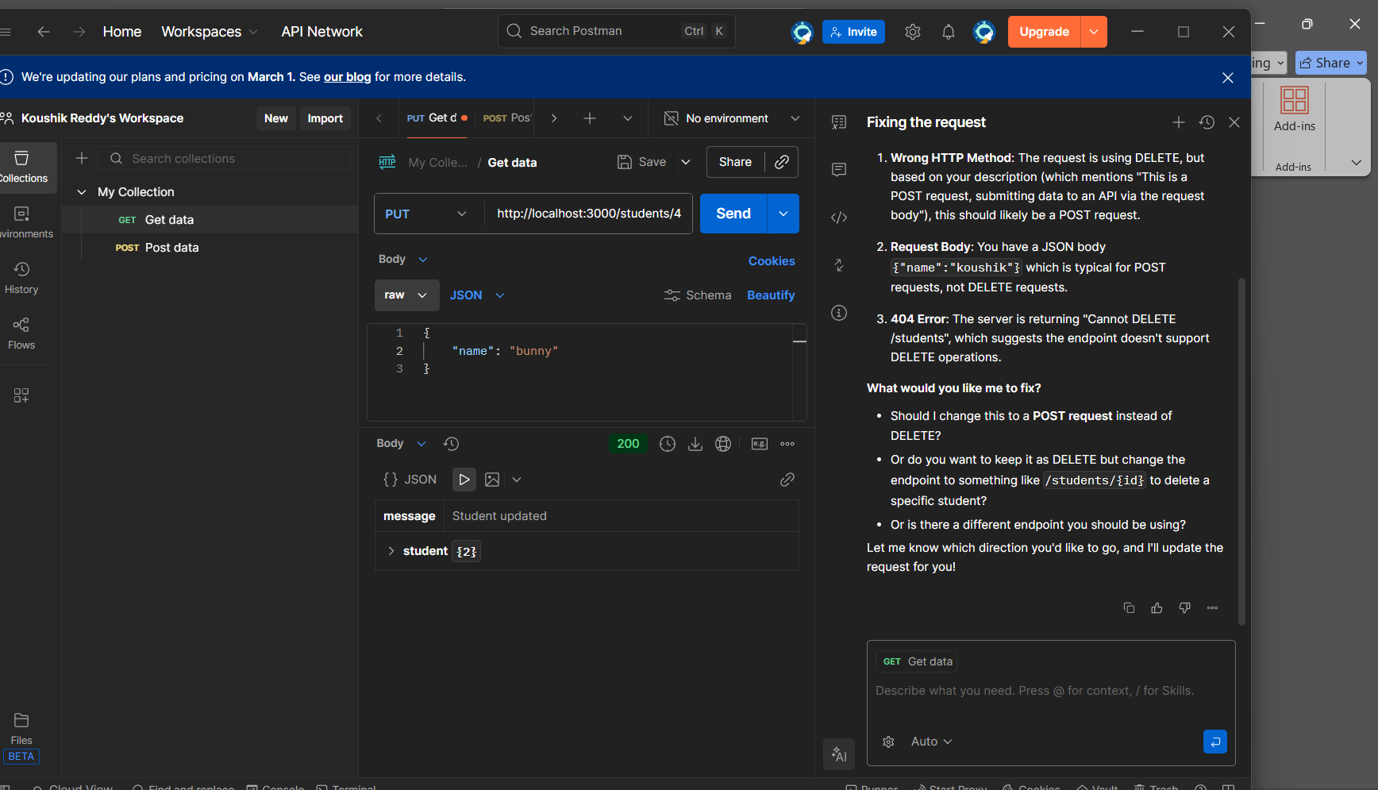
// 5 DELETE - Remove student
app.delete('/students/:id', (req, res) => {
const id = parseInt(req.params.id);
students = students.filter(s => s.id !== id);
res.json({ message: "Student deleted" });
});
app.listen(3000, () => {
console.log("Server running on port 3000");
});
OUTPUT:
