SESSION-2
Name : V Rithik Reddy
H.no : 2303A51263
B-19

SCENARIO-1:
const express = require('express');
const app = express();

app.use(express.json());

let students = [
{ id: 1, name: "Ravi" },
{ id: 2, name: "Sita" },
{ id: 3, name: "John" }
];

// Welcome route
app.get('/', (req, res) => {
res.json({ message: "Welcome to Student Information Server" });
});

// All students
app.get('/students', (req, res) => {
res.json(students);
});

// Student by ID
app.get('/students/:id', (req, res) => {
const id = parseInt(req.params.id);
const student = students.find(s => s.id === id);

if (!student) {
return res.status(404).json({ message: "Student not found" });
}

res.json(student);
});

app.listen(3000, () => {
console.log("Server running on port 3000");
});
IF STUDENT NOT FOUND:
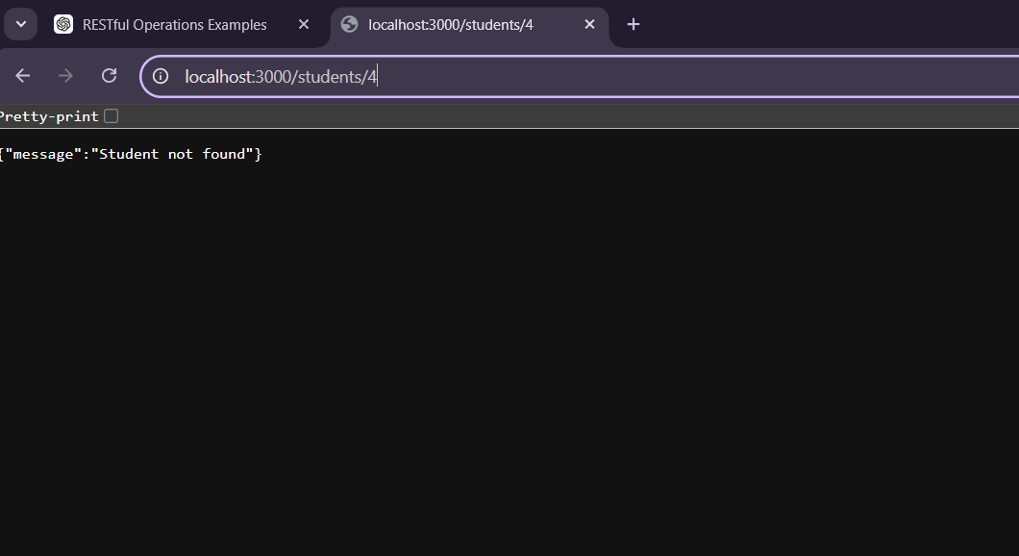
DISPLAY THE DETAILS OF STUDENTS:

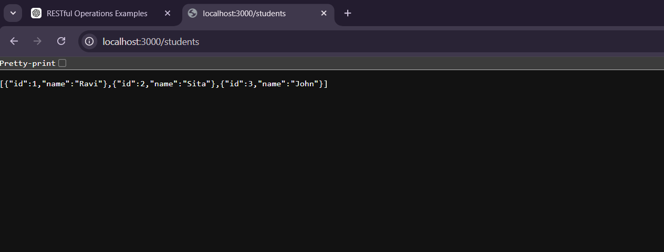
/students/:id → Displays details of a specific student:
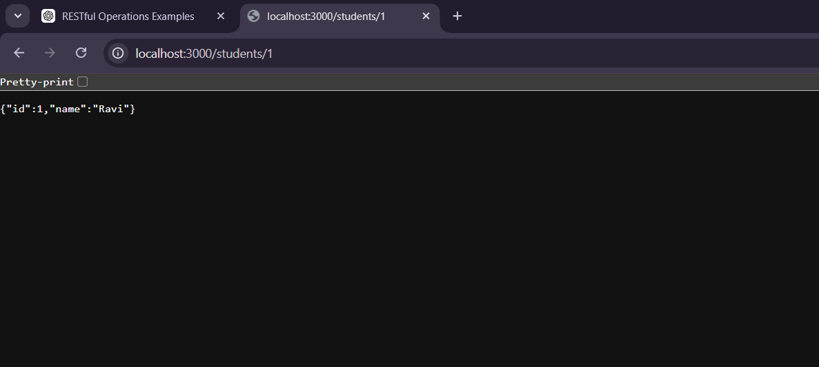
SCENARIO-2:
const express = require('express');
const app = express();

app.use(express.json());

let books = [];

// Welcome route
app.get('/', (req, res) => {
res.json({ message: "Welcome to Online Bookstore API" });
});

// GET all books
app.get('/books', (req, res) => {
res.json(books);
});

// ADD new book
app.post('/books', (req, res) => {
const { id, name } = req.body;

if (!id || !name) {
return res.status(400).json({ message: "ID and Name required" });
}

books.push({ id, name });

res.status(201).json({
message: "Book added successfully",
books: books
});
});

// UPDATE book
app.put('/books/:id', (req, res) => {
const id = parseInt(req.params.id);

const book = books.find(b => b.id === id);

if (!book) {
return res.status(404).json({ message: "Book not found" });
}

book.name = req.body.name;

res.json({
message: "Book updated successfully",
book: book
});
});

// DELETE book
app.delete('/books/:id', (req, res) => {
const id = parseInt(req.params.id);

books = books.filter(b => b.id !== id);

res.json({ message: "Book deleted successfully" });
});

app.listen(3000, () => {
console.log("Server running on port 3000");
});
output:
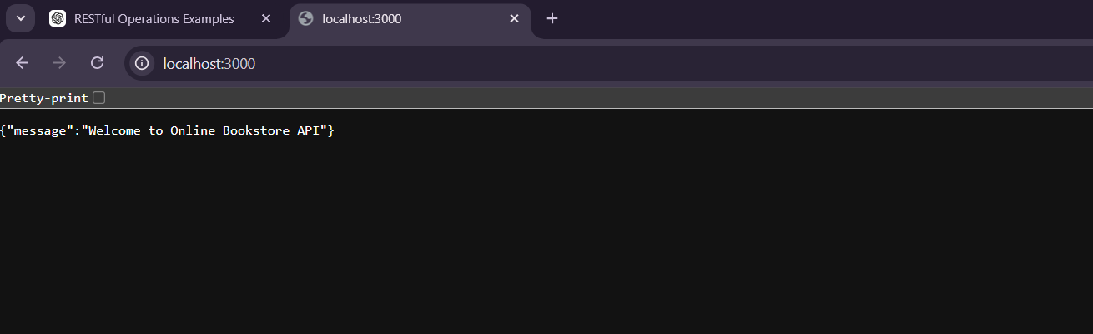
put operations:
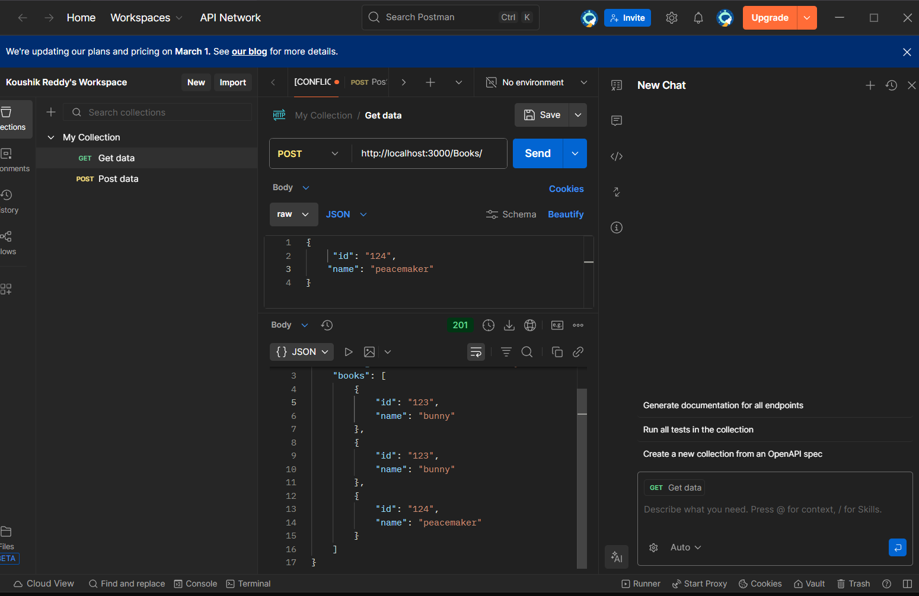
put output:
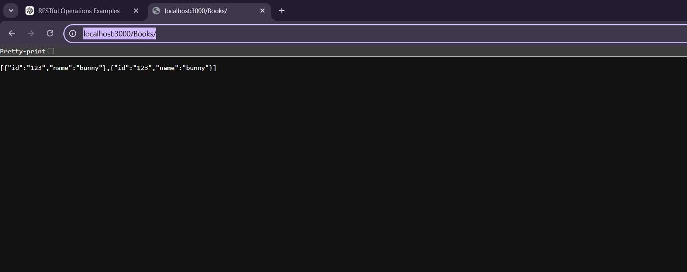
Delete operations:
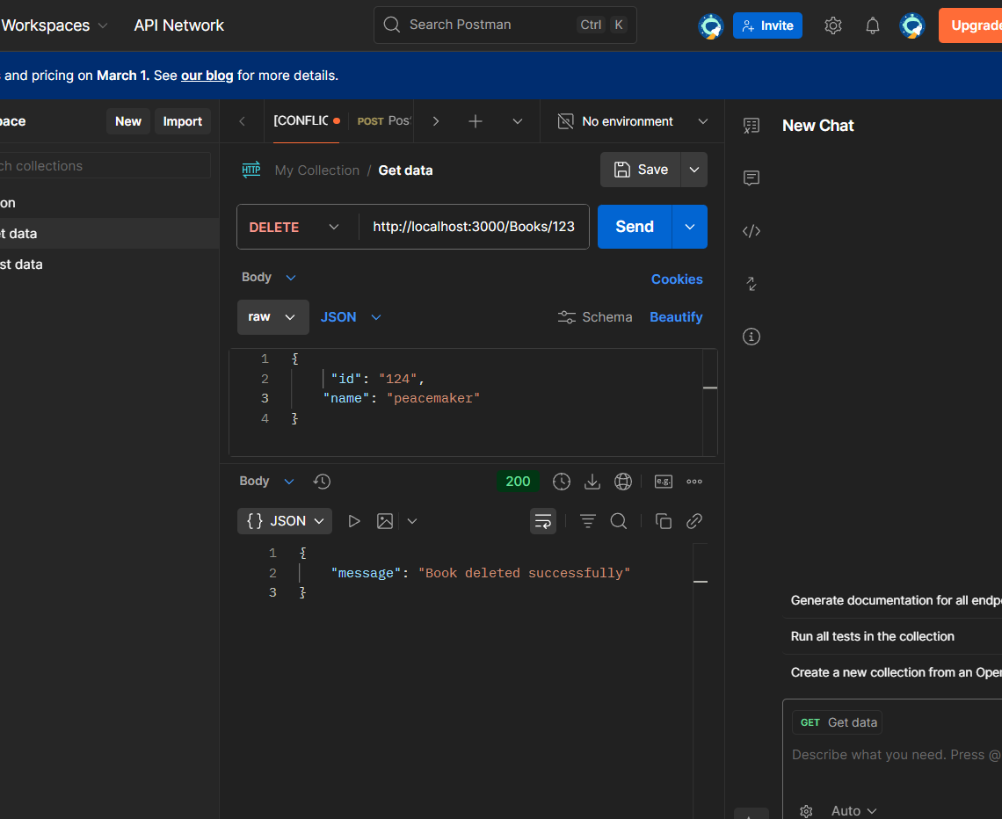
output:
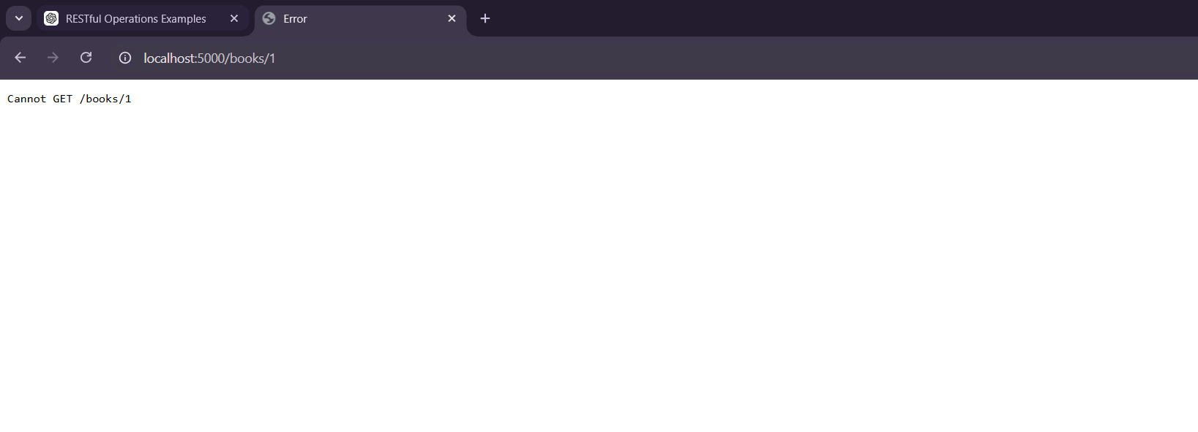
scenario -3:
const express = require('express');
const app = express();

app.use(express.json());

let users = [];

// ===============================
// AUTHENTICATION MIDDLEWARE
// ===============================
function authMiddleware(req, res, next) {
const username = req.headers.username;

if (!username) {
return res.status(401).json({ message: "Access denied! Please login." });
}

next();
}

// ===============================
// REGISTER ROUTE
// ===============================
app.post('/register', (req, res) => {
const { username, password } = req.body;

if (!username || !password) {
return res.status(400).json({ message: "Username & Password required" });
}

users.push({ username, password });

res.json({
message: "User registered successfully",
users: users
});
});

// ===============================
// LOGIN ROUTE
// ===============================
app.post('/login', (req, res) => {
const { username, password } = req.body;

const user = users.find(
u => u.username === username && u.password === password
);

if (!user) {
return res.status(401).json({ message: "Invalid login credentials" });
}

res.json({ message: "Login successful!" });
});

// ===============================
// PROTECTED DASHBOARD ROUTE
// ===============================
app.get('/dashboard', authMiddleware, (req, res) => {
res.json({ message: "Welcome to Dashboard — You are logged in!" });
});

app.listen(3000, () => {
console.log("Server running on port 3000");
});

