ASSIGNMENT_6.3
Name:Ch.Jyothika Ht.no:2303A51280
Batch:05
Task Description #1: Classes (Student Class)
Scenario
You are developing a simple student information management module.
Task
• Use an AI tool (GitHub Copilot / Cursor AI / Gemini) to complete a Student class
PROMPT:
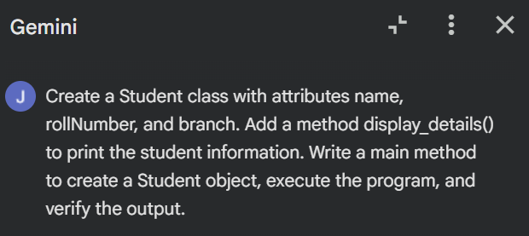

CODE:
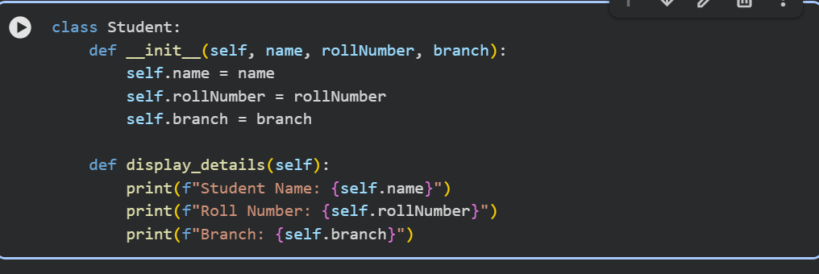

OUTPUT:
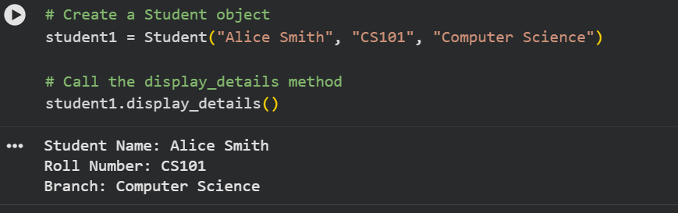
EXPLANATION:
• A class named Student is created to represent student information.
• The __init__() constructor is defined and is called automatically when a Student object is created.
• The constructor initializes the student’s name, roll number, and branch.
• A method display_details() is defined to print the student details.
• A Student object is created by passing values for name, roll number, and branch.
• The display_details() method is called using the object.
• The student information is displayed on the console.

Task 2: Loops (Multiples of a Number)
PROMPT:
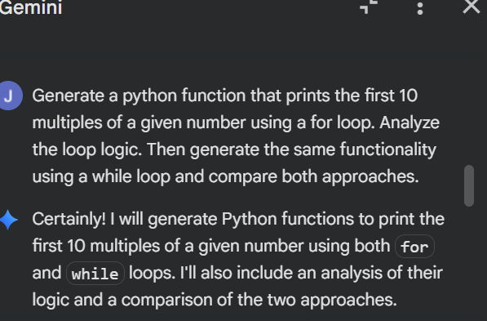
CODE:
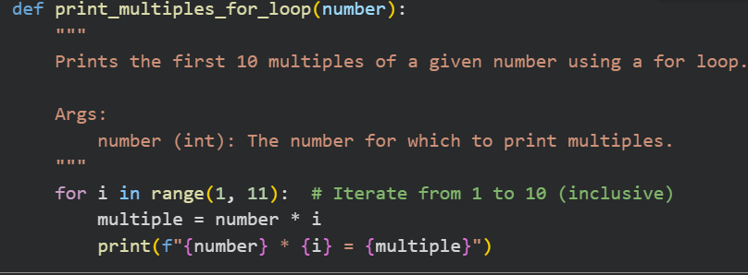
OUTPUT:

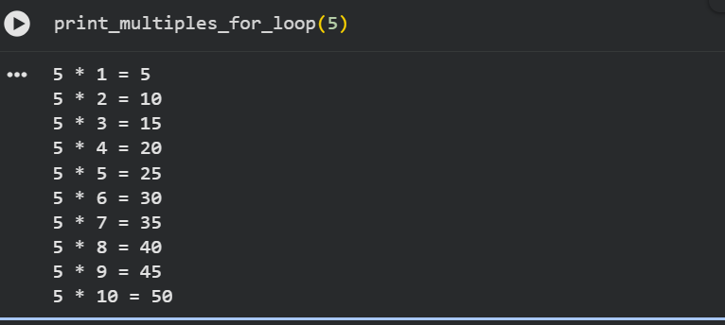

EXPLANATION
• A function is defined that accepts a number as input.
• A loop is used to repeat the process 10 times.
• In each iteration, the input number is multiplied by the loop counter.
• The result of the multiplication gives one multiple of the number.
• Each multiple is printed on the console.
• The loop continues until the first 10 multiples are displayed.
• When the loop ends, the program stops execution.
Task 3: Conditional Statements (Age Classification)
PROMPT:
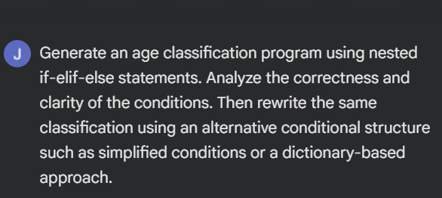
CODE:
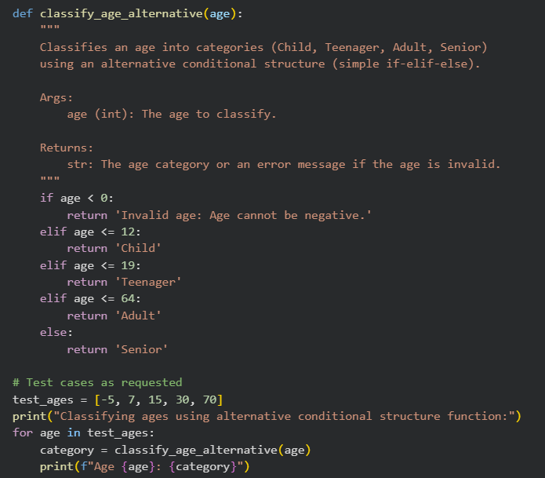
OUTPUT:

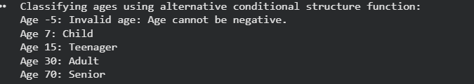
EXPLANATION:
- A function is defined that accepts age as an input value.
- The program checks the age using if-elif-else conditions.
- If the age is less than a certain value, it is classified as a child.
- If the age falls in the next range, it is classified as a teenager.
- If the age is in the adult range, it is classified as an adult.
- If the age is above the adult range, it is classified as a senior.
- Only one condition is executed because once a condition is true, the remaining checks are skipped.
- The function returns or prints the appropriate age group.
Task 4: For and While Loops (Sum of First n Numbers)
PROMPT:
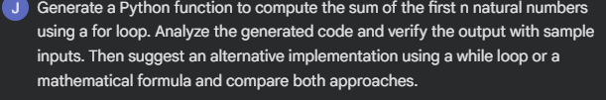

CODE:
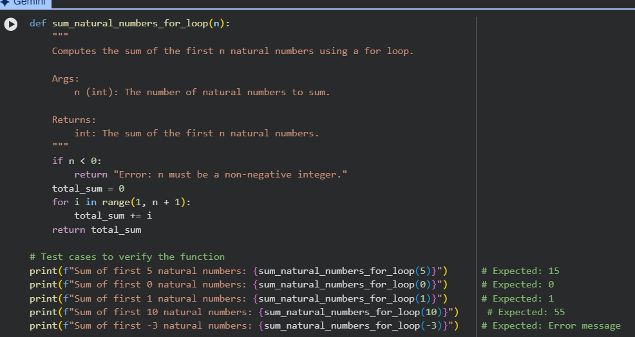

OUTPUT:

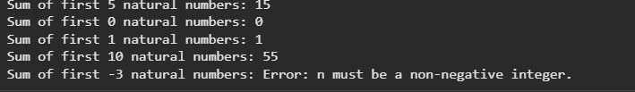
EXPLANATION
• A function named sum_to_n() is defined to calculate the sum of natural numbers.
• The function takes an integer n as input.
• A variable (for example, total) is initialized to 0 to store the sum.
• A for loop runs from 1 to n.
• In each iteration, the current number is added to total.
• After the loop finishes, total contains the sum of the first n natural numbers.
• The function returns or prints the final sum.
• The output is displayed for the given sample input.
Task 5: Classes (Bank Account Class)
PROMPT:

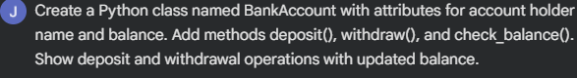

CODE:
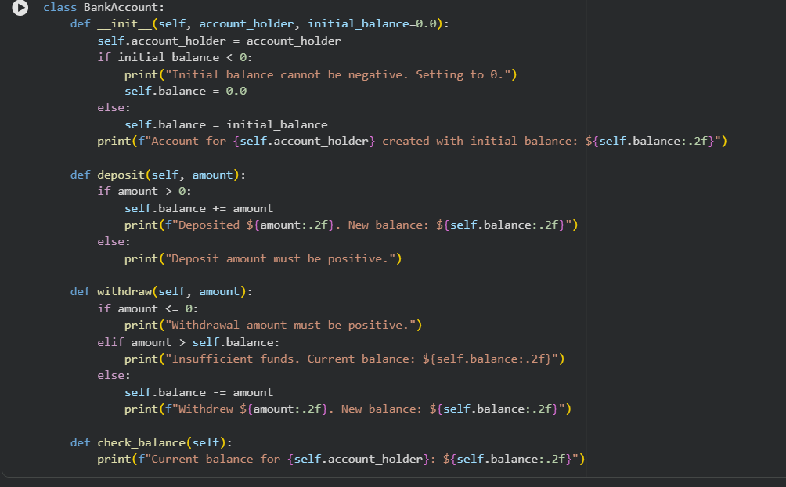

OUTPUT:
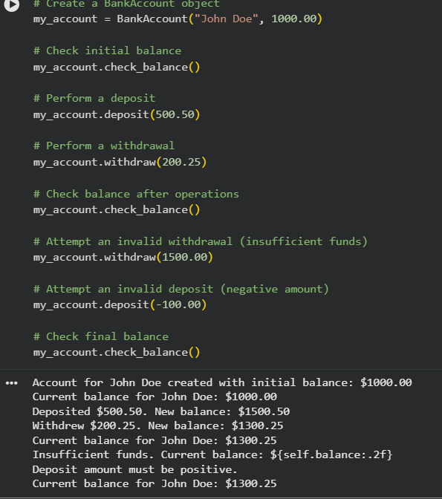
EXPLANATION:
• A class named BankAccount is created to represent a bank account.
• The constructor (__init__) initializes the account holder’s name and the starting balance.
• The deposit() method is used to add a given amount to the current balance.
• The withdraw() method subtracts an amount from the balance after checking if sufficient funds are available.
• If the balance is not enough, the withdrawal is not allowed and a message is shown.
• The check_balance() method displays the current account balance.
• An object of the BankAccount class is created to perform banking operations.
• Deposit and withdrawal methods are called, and the updated balance is shown after each operation

