ASSIGNMENT_3-3
Name:E.Ramya
Ht.no:2303A51282
Batch:05
Task 1: AI-Generated Logic for Reading Consumer Details.
PROMPT:
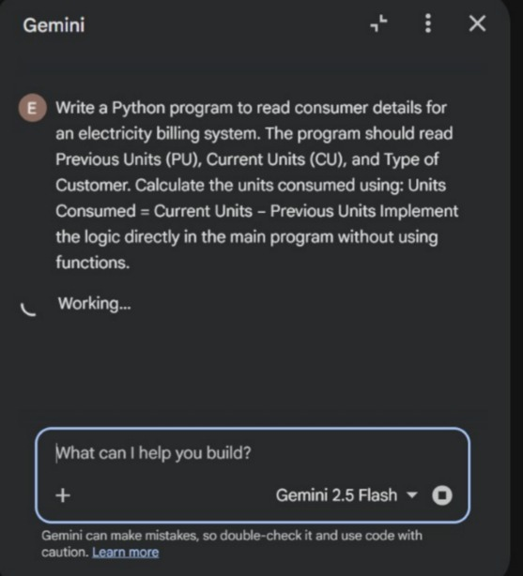

CODE:
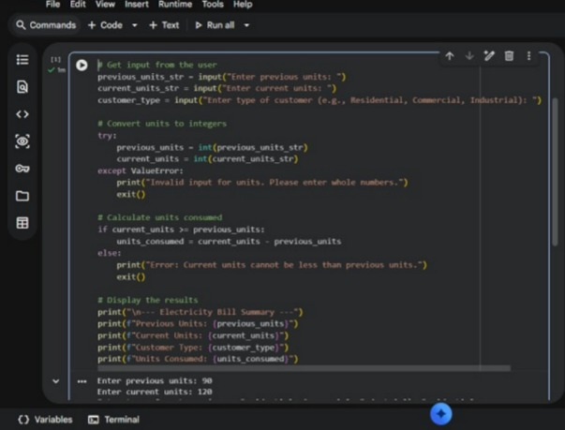
OUTPUT:
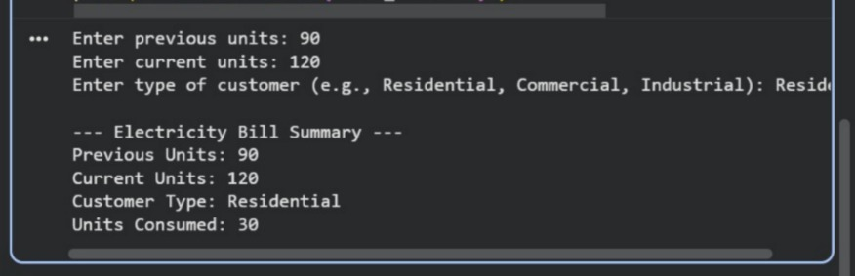
EXPLANATION:
- The program first reads the previous meter reading.
- It then reads the current meter reading.
- The type of customer (Domestic / Commercial / Industrial) is taken as input.
- Units consumed are calculated by subtracting previous units from current units.
- Finally, the program displays the customer type and total units consumed.
Task 2: Energy Charges Calculation Based on Units Consumed.
PROMPT:
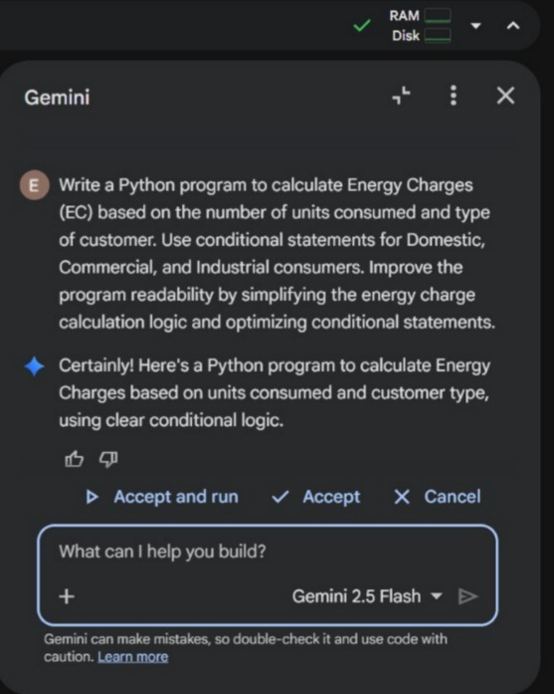
CODE:
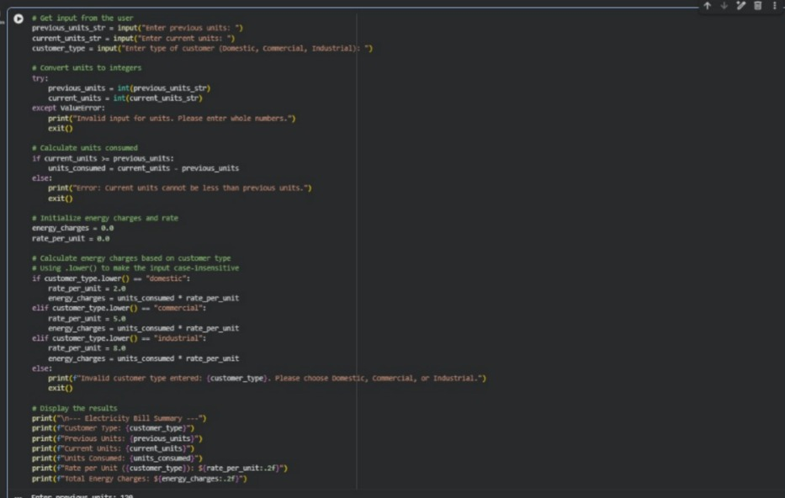
OUTPUT:
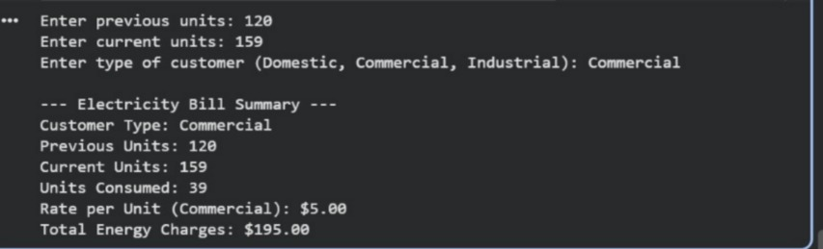
EXPLANATION
- The program takes previous meter reading and current meter reading as input.
- It also takes the type of customer (Domestic, Commercial, or Industrial).
- The program calculates units consumed by subtracting previous units from current units.
- Using if–else conditions, it selects the rate based on customer type.
- Energy charges are calculated by multiplying units consumed × rate.
- Finally, the program displays the customer type, units consumed, and energy charges.
- All logic is written inside the main method without using functions.
- The program is simple and easy to understand for beginners.
Task 3: Modular Design Using AI Assistance (Using Functions).
PROMPT:
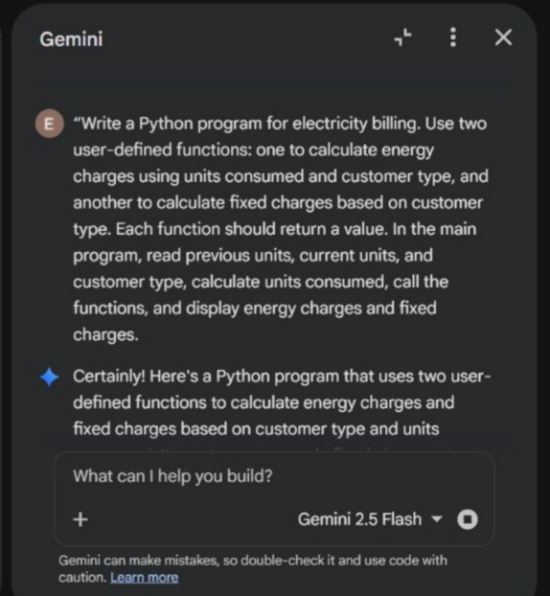
CODE:
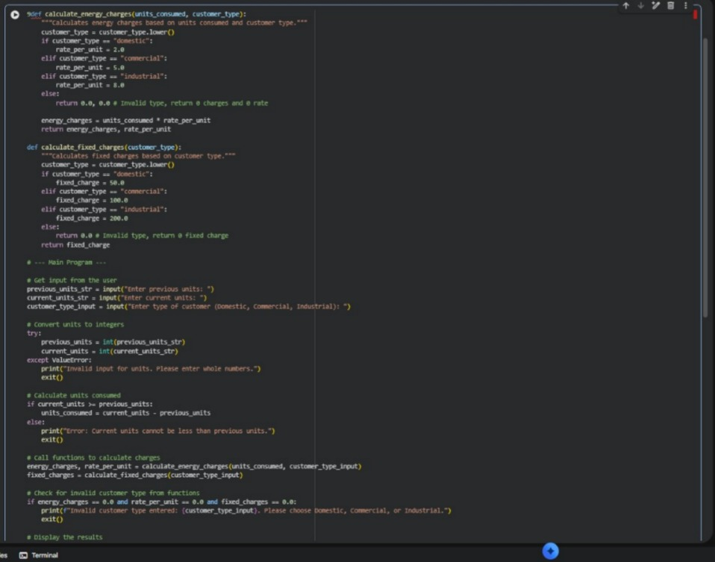
OUTPUT:
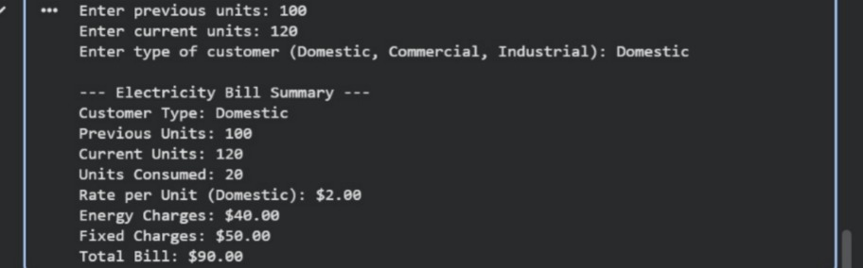
EXPLANATION:
- The program calculates an electricity bill.
- It uses functions so the same logic can be used again.
- One function calculates energy charges.
- Another function calculates fixed charges.
- Functions return the calculated values.
- The main program reads previous units, current units, and customer type.
- It finds units consumed.
- It calls the functions to get charges.
- Finally, it displays energy charges and fixed charges.
Task 4: Calculation of Additional Charges
PROMPT:
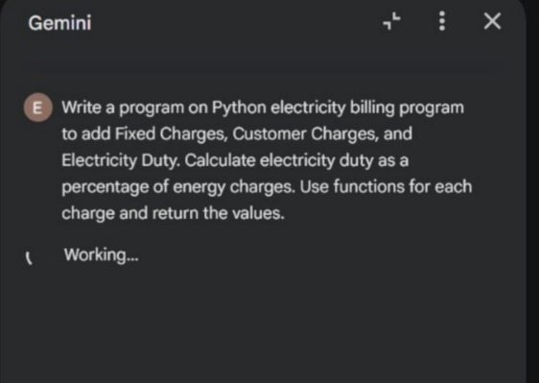

CODE:
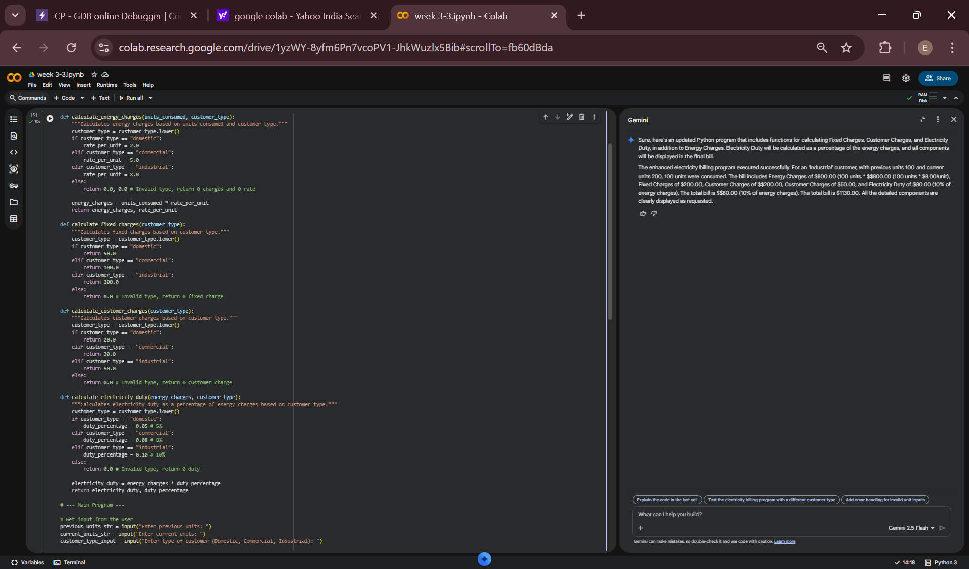
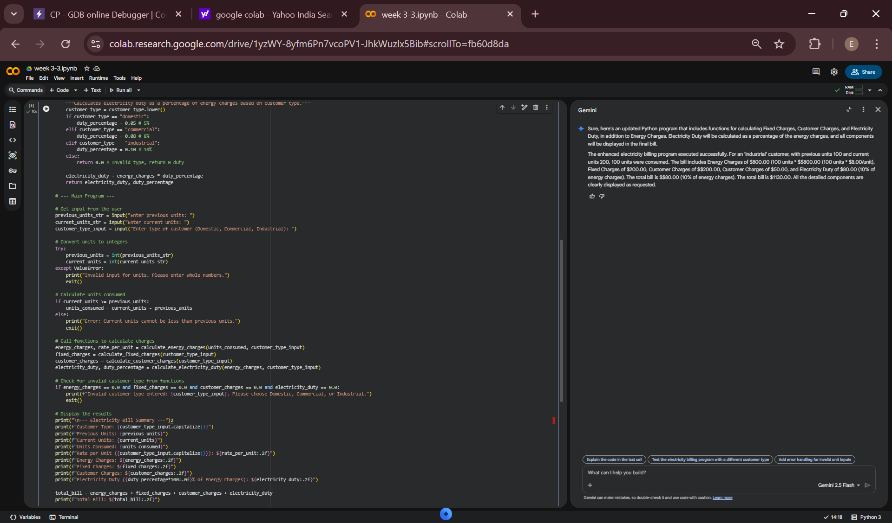
OUTPUT:
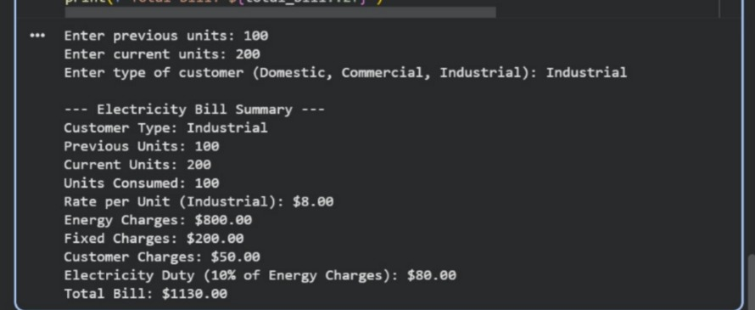
EXPLANATION
- The program calculates an electricity bill.
- It uses functions to calculate different charges so the logic can be reused.
- There is a function for Energy Charges (EC), based on units used and customer type.
- Another function calculates Fixed Charges (FC) and another for Customer Charges (CC).
- Electricity Duty (ED) is calculated as a percentage of Energy Charges.
- The program first reads previous units, current units, and customer type.
- It finds units consumed and calls the functions to get all charges.
- Finally, it prints all charges separately in a clear and readable way.
- The program is simple, reusable, and easy to understand.
Task 5: Final Bill Generation and Output Analysis
PROMPT:
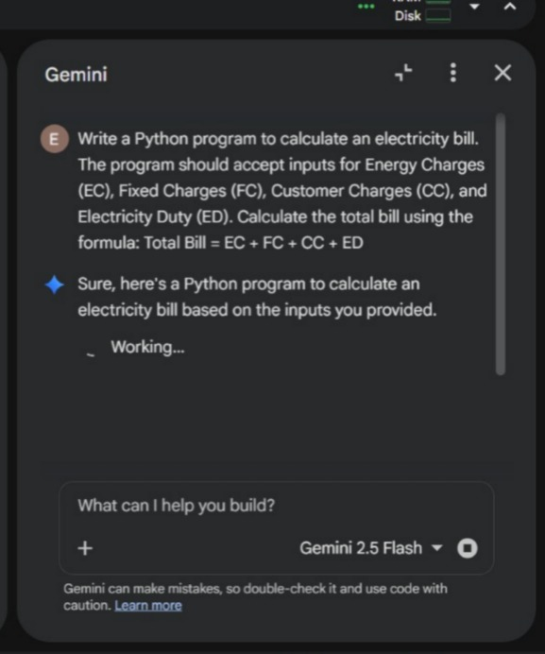
CODE:
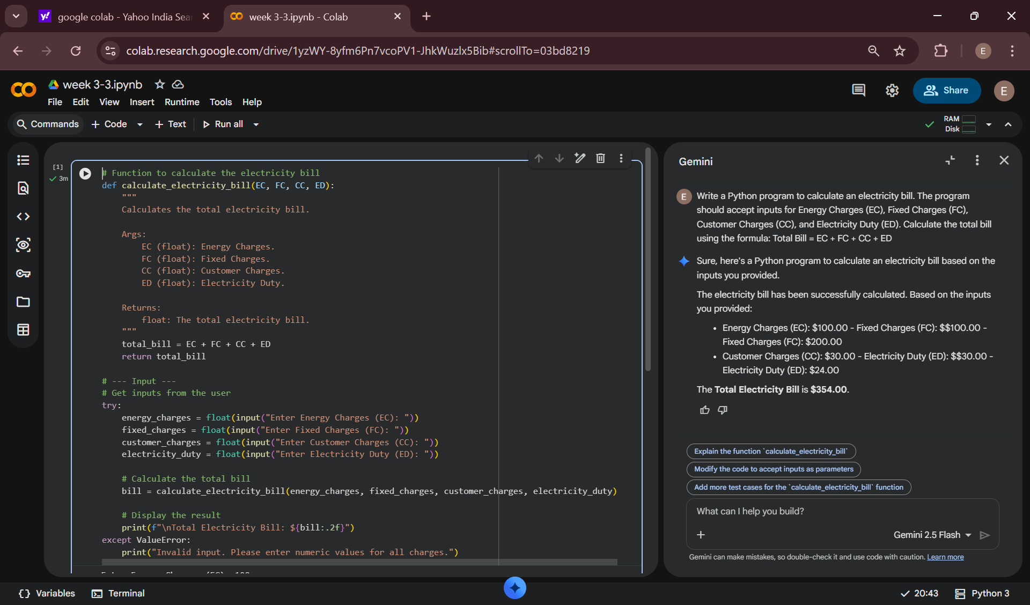
OUTPUT:
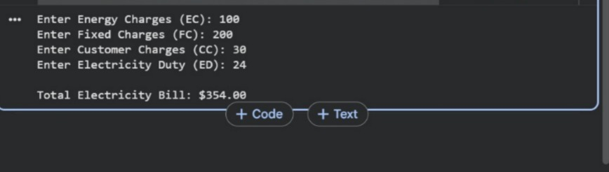
EXPLANATION:
- Takes user input for Energy Charges (EC), Fixed Charges (FC), Customer Charges (CC), and Electricity Duty (ED).
- Stores each value in a separate variable for clarity.
- Calculates the total electricity bill by adding all charges.
- Uses the formula: Total Bill = EC + FC + CC + ED.
- Displays each charge clearly.
- Displays the final total bill amount.
- Uses simple logic and readable variable names.
- Represents a real-world electricity billing process.

