Lab Assignment 4.1

Ai Assisted Coding

N.Rahul
2303A51297
Batch_27

Problem Statement 1: Customer Email Classification Step 1: Prepare Sample Emails

Email ID | Email Text | Category
E1 | I was charged twice for my last bill | Billing
E2 | My app is crashing when I log in | Technical Support
E3 | The service is very good, keep it up | Feedback
E4 | Can you add dark mode feature? | Feedback
E5 | Just saying hello | Others

Step 2: Zero-shot Prompt (NO EXAMPLE)

Classify the following customer email into one of these categories: Billing, Technical Support, Feedback, Others.

Email: "I was charged twice for my last bill"

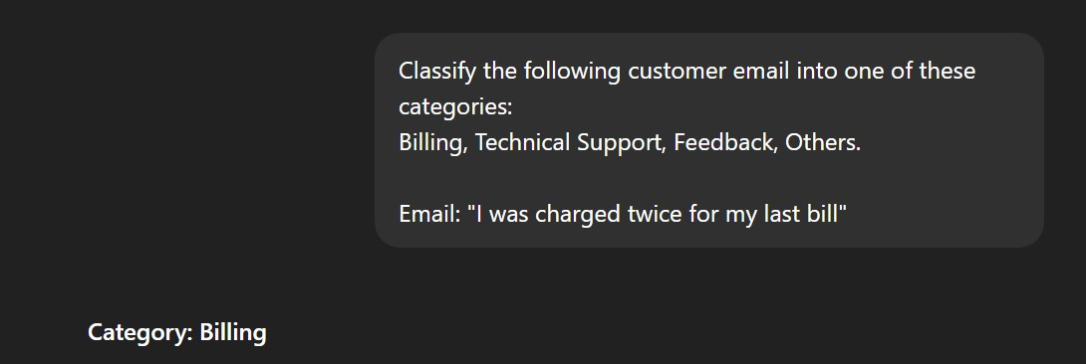

Observation:

The model correctly classified the email without any examples.

Step 3: One-shot Prompt (ONE EXAMPLE):

Example:
Email: "My internet is not working" Category: Technical Support

Now classify the following email into
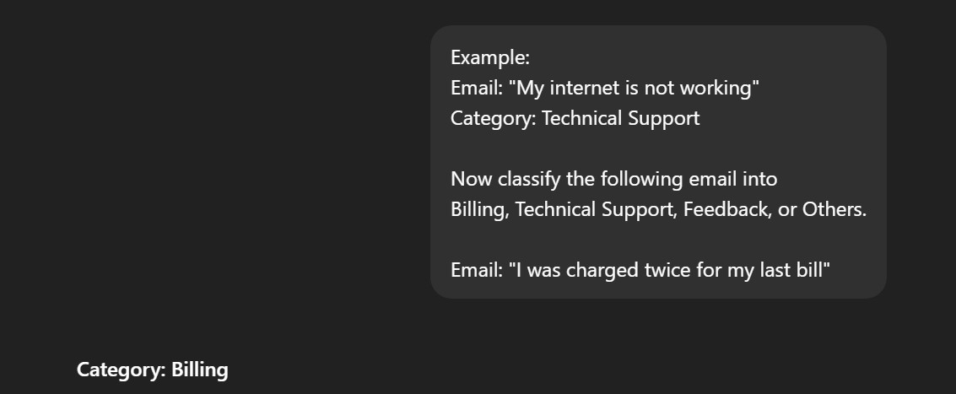
Billing, Technical Support, Feedback, or Others. Email: "I was charged twice for my last bill"

Observation:
Providing one example improved clarity.

Step 4: Few-shot Prompt :

Example 1:
Email: "My internet is not working" Category: Technical Support

Example 2:
Email: "Thank you for great service" Category: Feedback

Example 3:
Email: "I was charged extra this month" Category: Billing

Now classify the following email:
Email: "I was charged twice for my last bill"
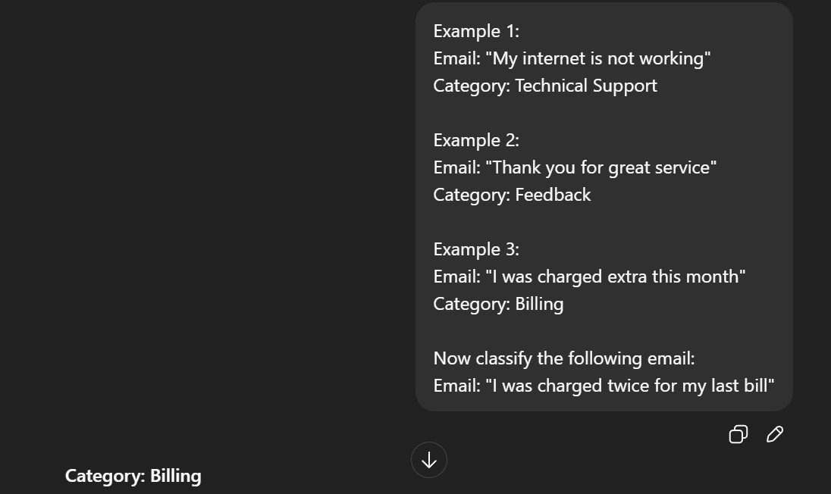

Observation:

Few-shot prompting gave the most confident and accurate output.

Problem Statement 2: Intent Classification for Chatbot Queries

Query ID | User Query | Intent
Q1 | I forgot my account password | Account Issue
Q2 | Where is my order right now? | Order Status
Q3 | Does this laptop support Windows 11? | Product Inquiry
Q4 | How can I contact customer care? | General Question
Q5 | My account is locked | Account Issue
Q6 | When will my product be delivered? | Order Status

Zero-shot Prompting

Prompt:

Classify the following user query into one of these intents: Account Issue, Order Status, Product Inquiry, General Question.

Query: "Where is my order right now?"

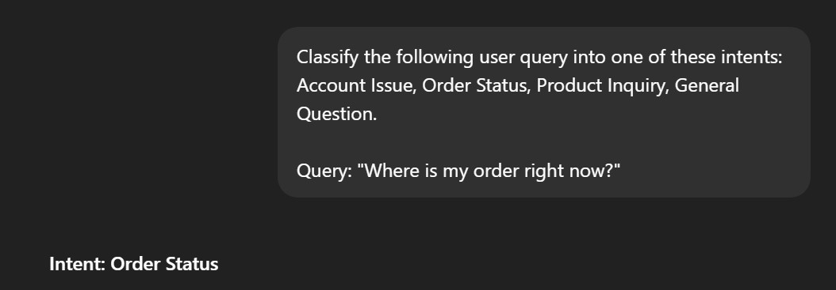

One-shot Prompting

Prompt:

Example:
Query: "I forgot my account password" Intent: Account Issue

Now classify the following query:
Query: "Does this laptop support Windows 11?"
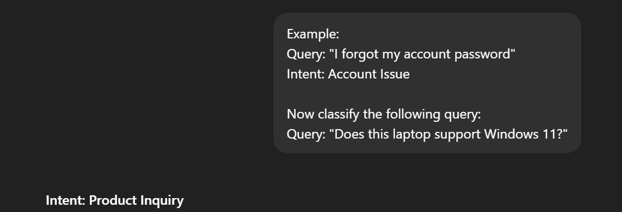

Few-shot Prompting

Prompt:

Example 1:

Query: "My account is locked" Intent: Account Issue

Example 2:
Query: "When will my order arrive?" Intent: Order Status

Example 3:
Query: "Does this phone support 5G?" Intent: Product Inquiry

Example 4:
Query: "How do I contact customer care?" Intent: General Question

Now classify the following query:
Query: "Where is my order right now?"
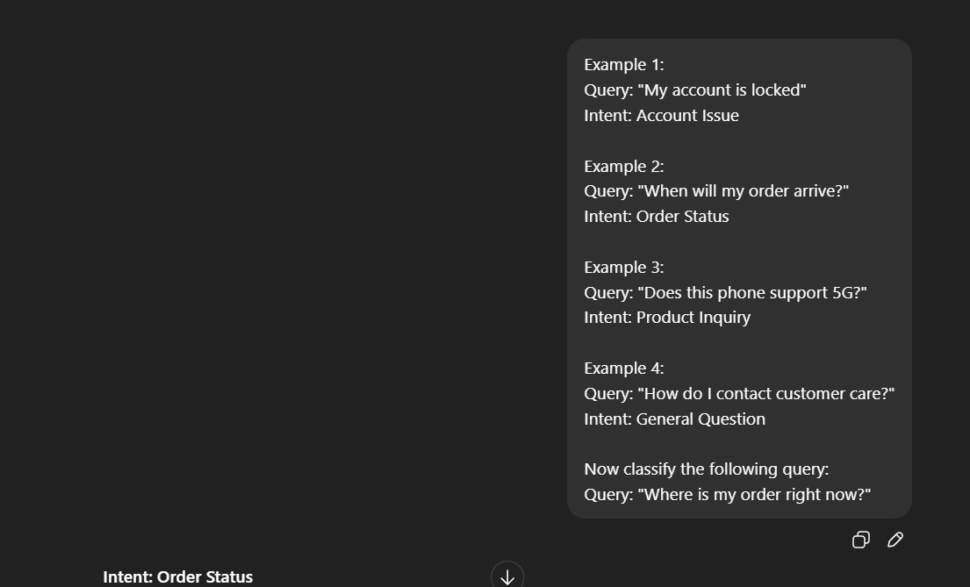

Observation:

Zero-shot works but may be slightly inconsistent.

One-shot improves understanding of intent categories.

Few-shot gives the most accurate and confident results.

Problem Statement 3: Student Feedback Analysis

Zero-shot Prompt
Classify the following student feedback as Positive, Negative, or Neutral. Feedback: "The course content was very helpful and well explained."
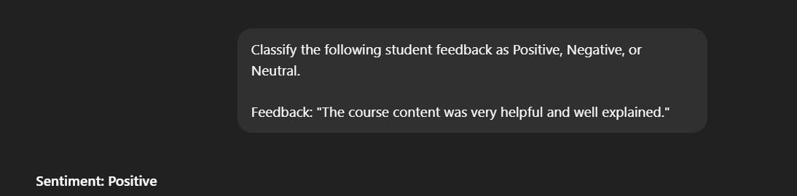

One-shot Prompt

Example:
Feedback: "The lectures were boring and confusing." Sentiment: Negative

Now classify the following feedback:
Feedback: "The instructor explained concepts clearly."

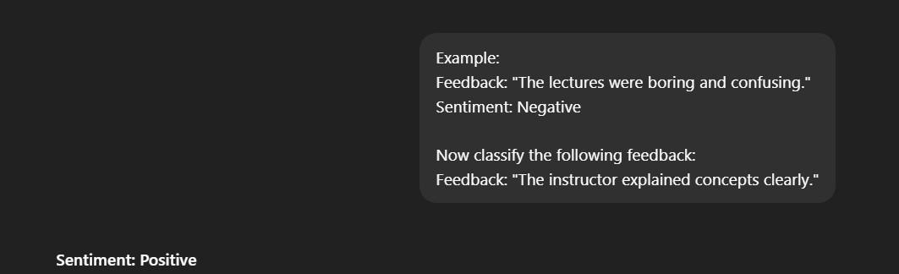

Few-shot Prompt

Example 1:
Feedback: "The classes were engaging and informative." Sentiment: Positive

Example 2:
Feedback: "The syllabus is okay but needs improvement." Sentiment: Neutral

Example 3:
Feedback: "The course pace was too fast." Sentiment: Negative

Now classify the following feedback:
Feedback: "The assignments were manageable and useful."

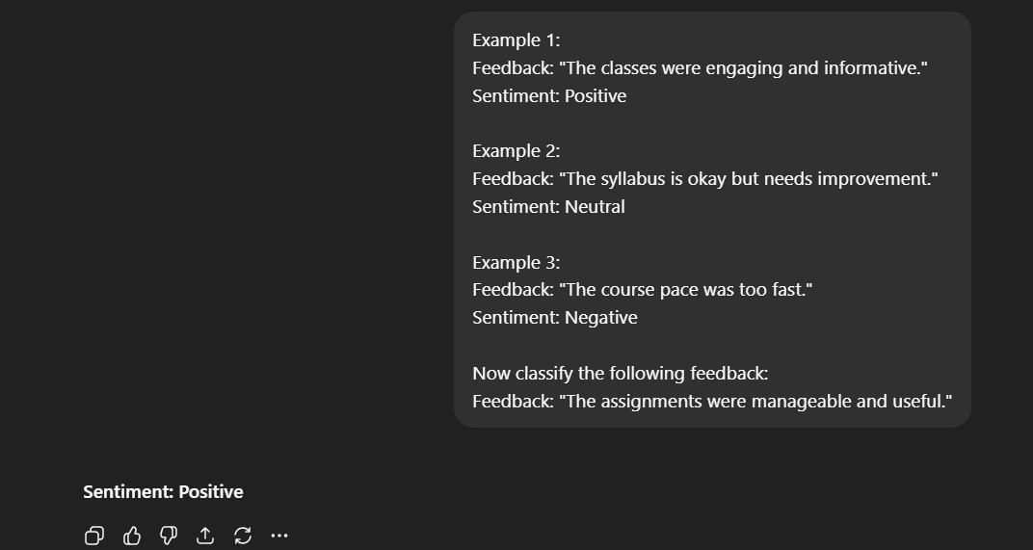

Observation:

Providing examples helps the model better understand tone and context, leading to more accurate sentiment classification.

Problem Statement 4: Course Recommendation System

Zero-shot Prompt

Classify the following learner query as Beginner, Intermediate, or Advanced. Query: "I am new to programming and want to learn Python."

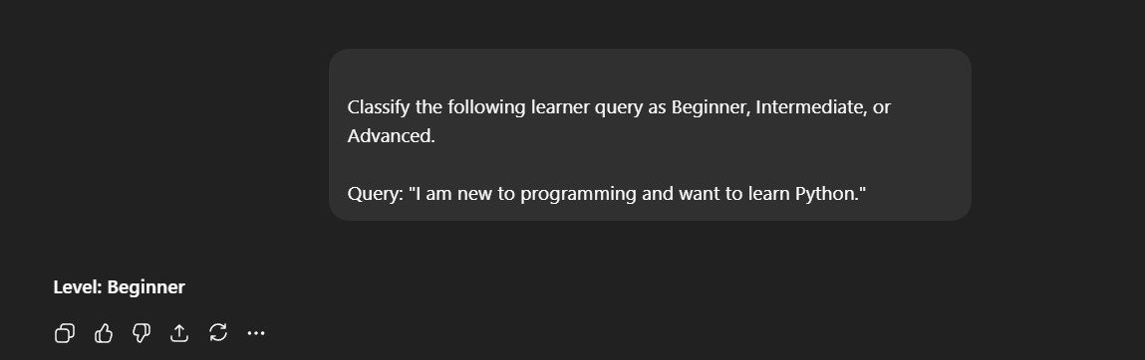

One-shot Prompt

Example:
Query: "I have never coded before" Level: Beginner

Now classify the following query:
Query: "I know basics of Java and want to learn Spring Boot."
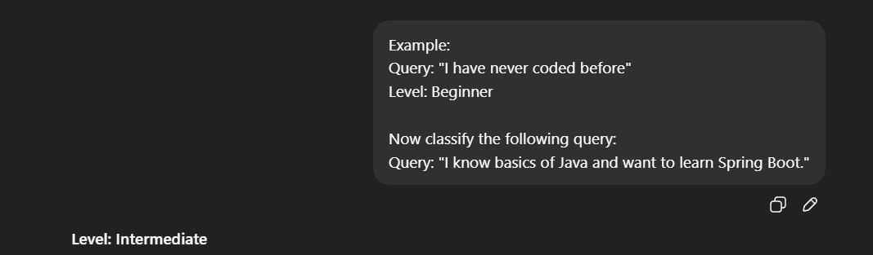

Few-shot Prompt

Example 1:
Query: "I am new to programming" Level: Beginner

Example 2:
Query: "I understand OOP concepts" Level: Intermediate

Example 3:

Query: "I want to master system design and algorithms" Level: Advanced

Now classify the following query:
Query: "I know basics of Java and want to learn Spring Boot."
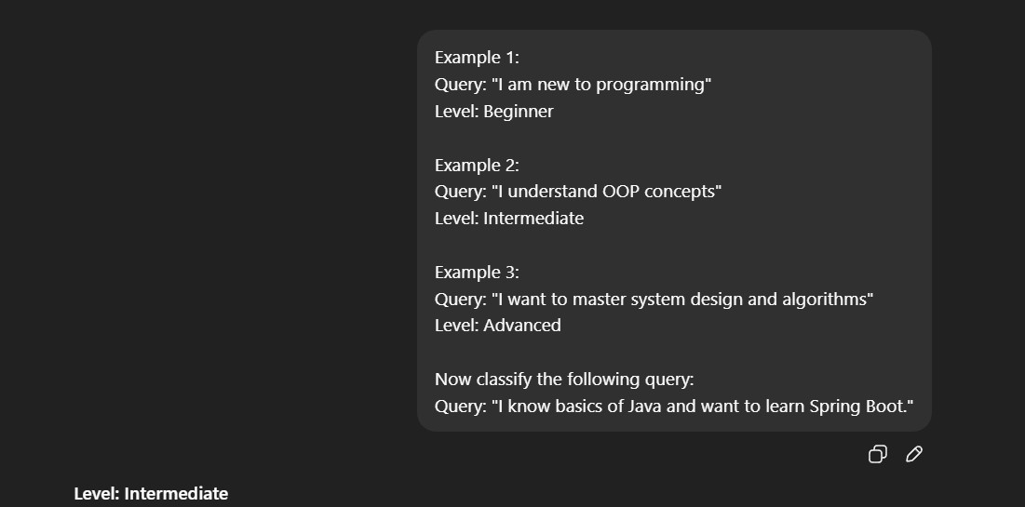

Discussion
Few-shot prompting improves recommendation quality by giving clearer boundaries between skill levels.

Problem Statement 5: Social Media Post Moderation

Zero-shot Prompt

Classify the following social media post as Acceptable, Offensive, or Spam. Post: "Click this link to win free prizes now!"

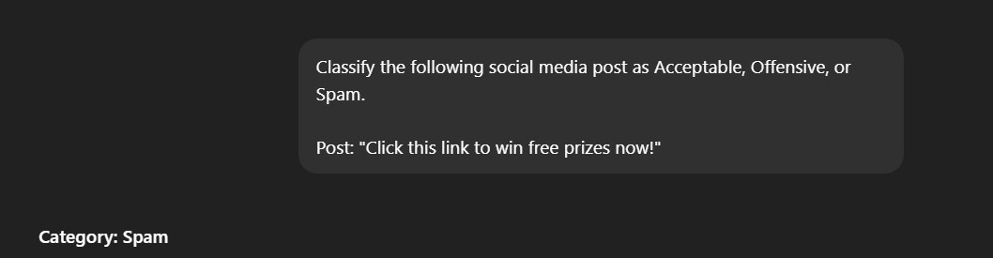

One-shot Prompt
Example:
Post: "Buy followers instantly!" Category: Spam

Now classify the following post:
Post: "Click this link to win free prizes now!"
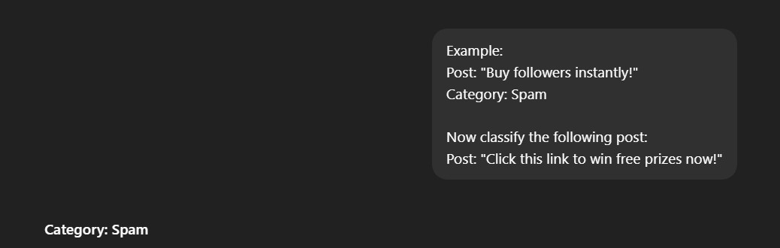

Few-shot Prompt

Example 1:
Post: "This product is amazing!" Category: Acceptable

Example 2:
Post: "You are useless and stupid" Category: Offensive

Example 3:
Post: "Buy followers instantly!"

Category: Spam

Now classify the following post:
Post: "Click this link to win free prizes now!"
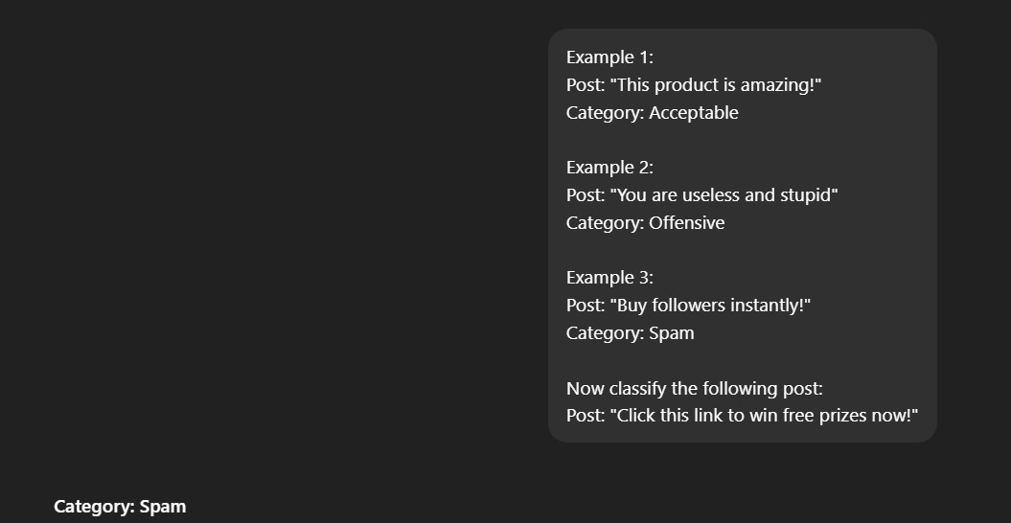

Explanation
Zero-shot prompting can struggle with slang, sarcasm, or hidden spam, whereas examples help the model understand subtle patterns.

