AI Assisted Coding

Assignment - 7.3

N.Rahul
2303A51297
B-27

Task 1: Fixing Syntax Errors

Buggy Code (Before Debugging):
def add(a, b)
return a + b
print(add(3, 5))

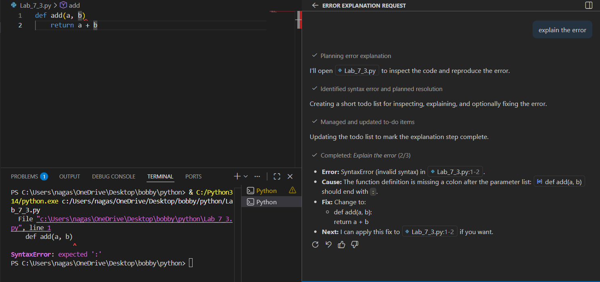

AI-Detected Issue
- Missing colon (:) at the end of the function definition.
- This causes a SyntaxError.

Corrected Code (After Debugging):
def add(a, b):
return a + b
print(add(3, 5))

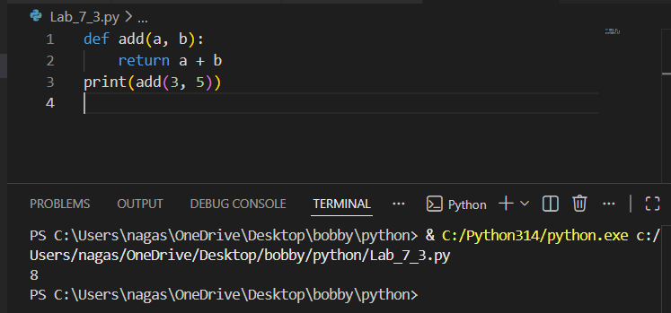

AI Explanation
In Python, every function definition must end with a colon.
The missing colon caused the syntax error. Adding it fixes the issue.

Task 2: Debugging Logic Errors in Loops

Buggy Code (Before Debugging):
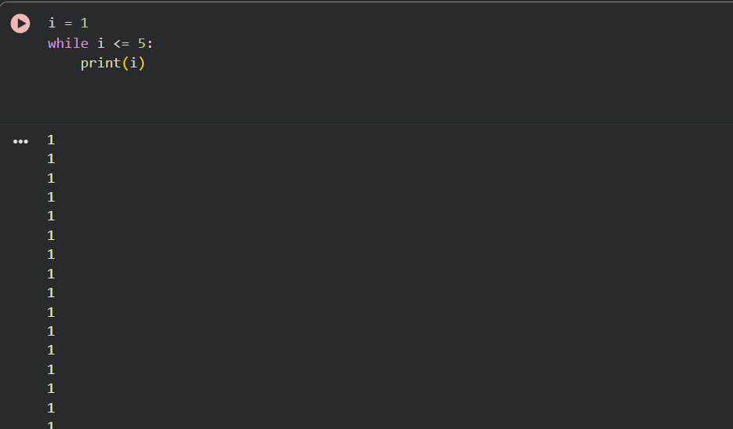
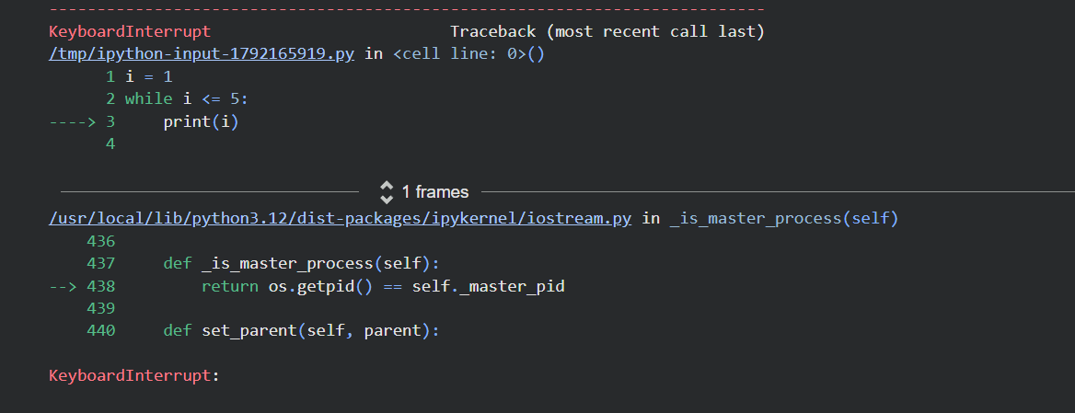
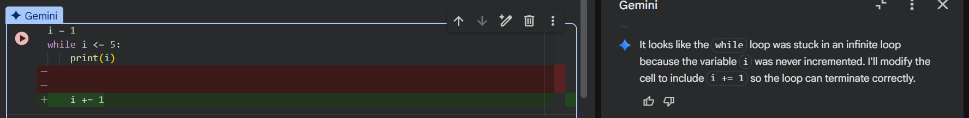

AI-Detected Issue
- The loop variable i is never incremented.
- This causes an infinite loop.

Corrected Code (After Debugging)
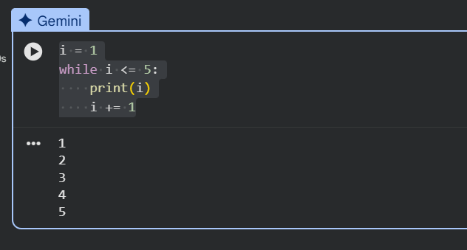

Task 3: Handling Runtime Errors (Division by Zero)

Buggy Code (Before Debugging):
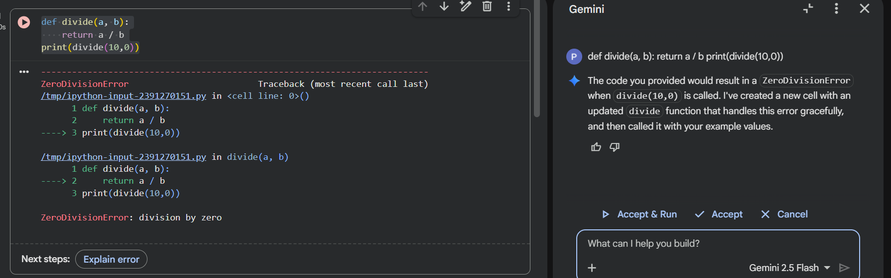

AI-Detected Issue
- If b is zero, the program crashes with ZeroDivisionError.

Corrected Code (After Debugging):
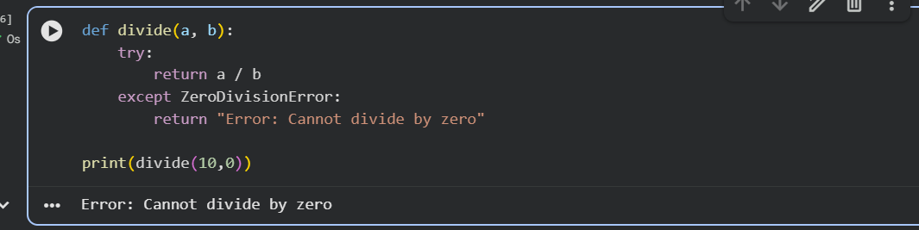

AI Explanation
The AI used a try-except block to handle runtime errors safely.
This prevents the program from crashing.

Task 4: Debugging Class Definition Errors

Buggy Code (Before Debugging):
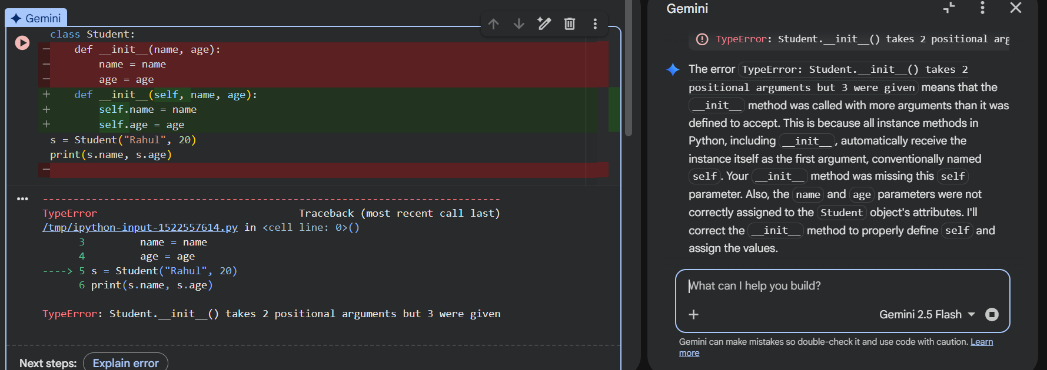

AI-Detected Issue
- Missing self parameter in the constructor.
- Instance variables are not assigned correctly.

Corrected Code (After Debugging):
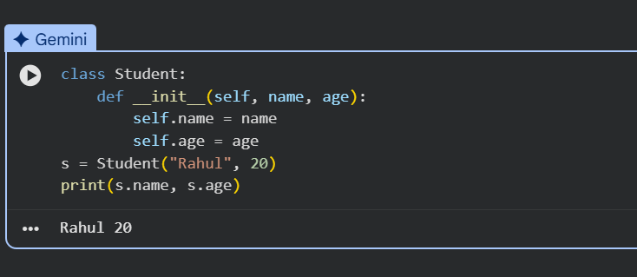

Task 5: Resolving Index Errors in Lists

Buggy Code (Before Debugging):
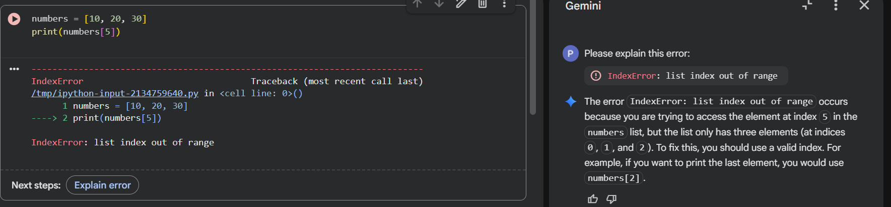

AI-Detected Issue
- Index 5 does not exist in the list.
- Causes an IndexError.

Corrected Code (After Debugging):
