CourseTitle:HIGHPERFORMANCECOMPUTING ASS-9
NAME: P.VARDHINI
HallTicketNo:2303A51301

Lab:OpenMPSynchronizationandLoadImbalanceAnalysis Objective:
ToanalyzesynchronizationoverheadandloadimbalanceinOpenMPprogramsandoptimize performance using proper directives.
Task1:SynchronizationOverhead(CriticalvsReduction) Step 1:
Createafilenamedreduction_bad.c
Implementparallelsummationusing:
#pragmaompcritical inside the loop.
Compile:
gcc-O2-fopenmpreduction_bad.c-oreduction_bad Run with:
exportOMP_NUM_THREADS=1 exportOMP_NUM_THREADS=4 Record execution time.
Step2:
Createreduction_good.c Replace critical with:
#pragmaompparallelforreduction(+:sum) Compile and run with same thread counts.

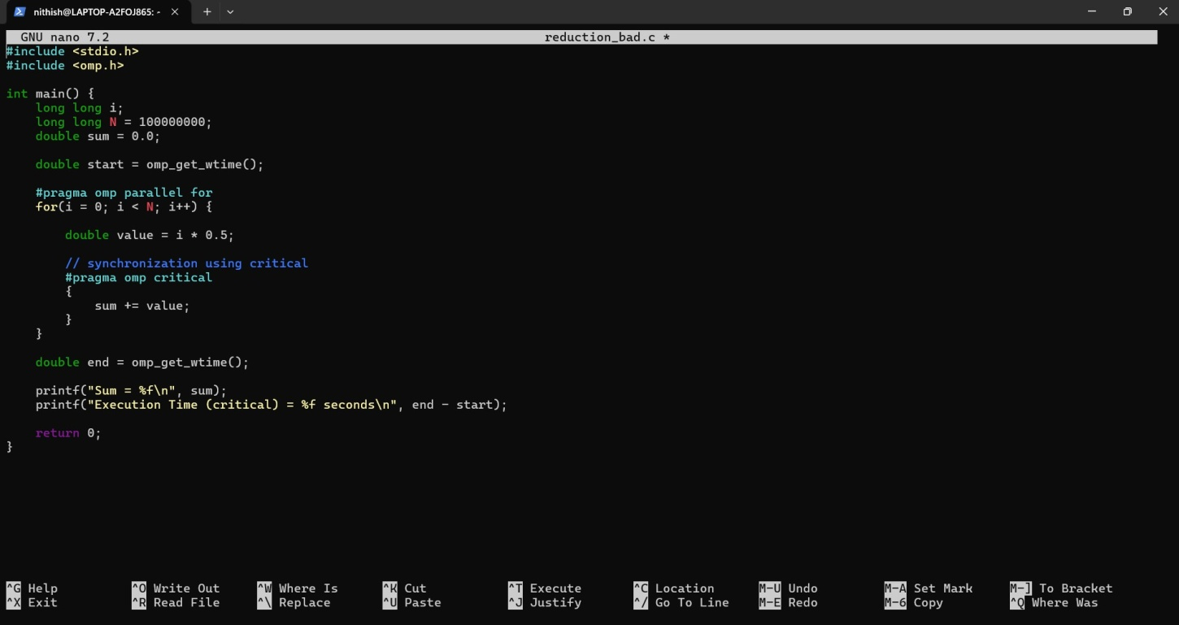
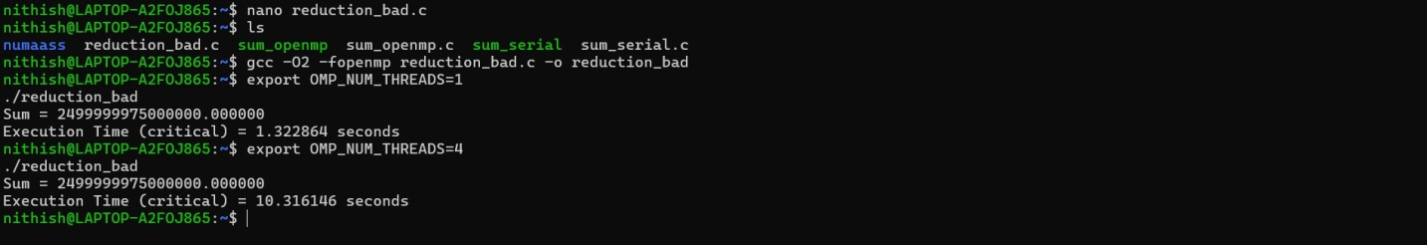

Step2:
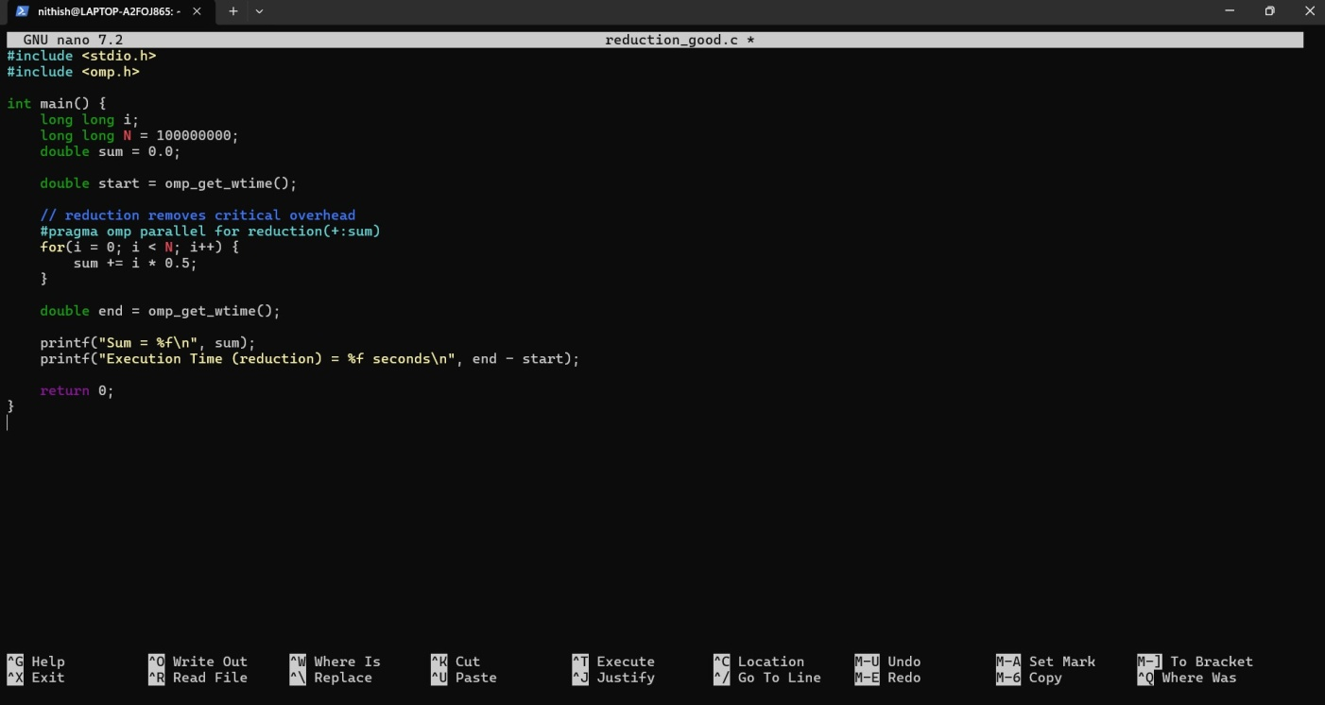

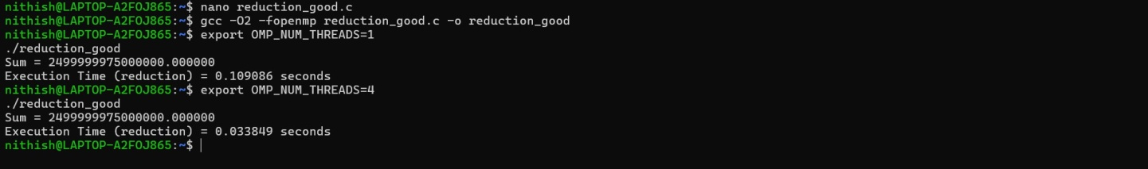

Task2:LoadImbalanceandScheduling

Createafilenamedimbalance.c. Implement a loop where:
One iteration performs heavy computation Otheriterationsperformsmallcomputation Run with default scheduling.
Record execution time.

Now modify to:
#pragmaompparallelforschedule(dynamic) Run again and record time.
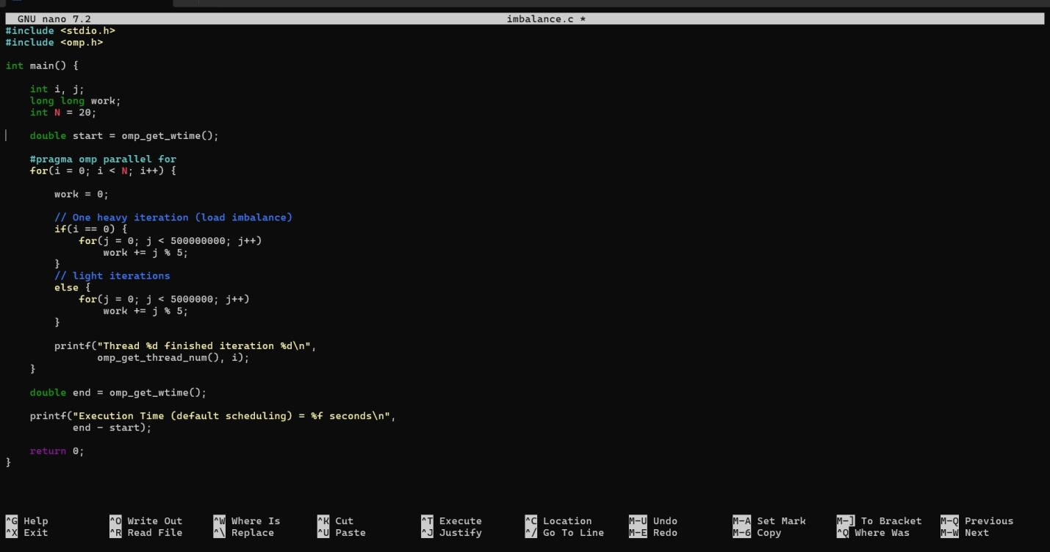

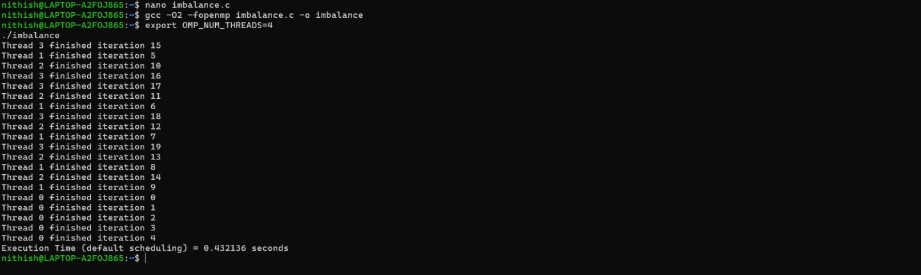
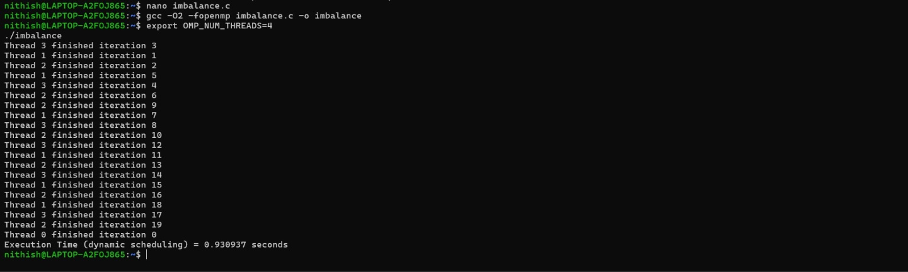

Task3:PerformanceAnalysisQuestions Answer the following:
- Whydoesusingcriticalreducescalability?
When we use a critical section, only one thread is allowed to access that part of the code at a time. So even though multiple threads are created, they end up waiting in a queue to update the sharedvariable.Asthenumberofthreadsincreases,thewaitingtimealsoincreases,whichlimits the benefit of parallel execution.

Howdoesreductionimprove performance?
Withreduction, each thread works on its own temporary copy of the variable instead of sharing one common variable. This means threads can run independently without waiting for each other.
Attheend,OpenMPcombinesallresultsautomatically,whichmakestheprogramfasterand more efficient.

What is load imbalance?
Loadimbalancehappenswhensomethreadsgetmoreworkwhileothersgetless.Thethreads that finish early remain idle while one or two threads are still busy. Because not all CPU
resourcesareusedequally,theoverallperformance decreases.

Whydoesdynamic schedulingimproveperformance inuneven workloads?
Dynamic scheduling distributes work while the program is running instead of assigning everythingatthebeginning.Ifathreadfinishesearly,itimmediatelyreceivesnewwork.This

keepsallthreadsbusyandreducesidletime,whichimprovesoverallperformancewhen workloads are uneven.

Identifythehotspot sectioninyour programand justify.
Thehotspotintheprogramistheheavycomputationloopwhereoneiterationperformsmuch moreworkthantheothers.Thisparttakesthelongesttimetoexecuteanddominatesthetotal runtime, making it the main performance bottleneck.

