CourseTitle:HIGHPERFORMANCECOMPUTING

HallTicketno:2303A51301
Batch no:11
Assignment3:One-to-OneCommunicationPatternusing MPI

Scenario
Inadistributedsimulation,eachprocessmustexchangeboundary data with its neighboring process.

Objective
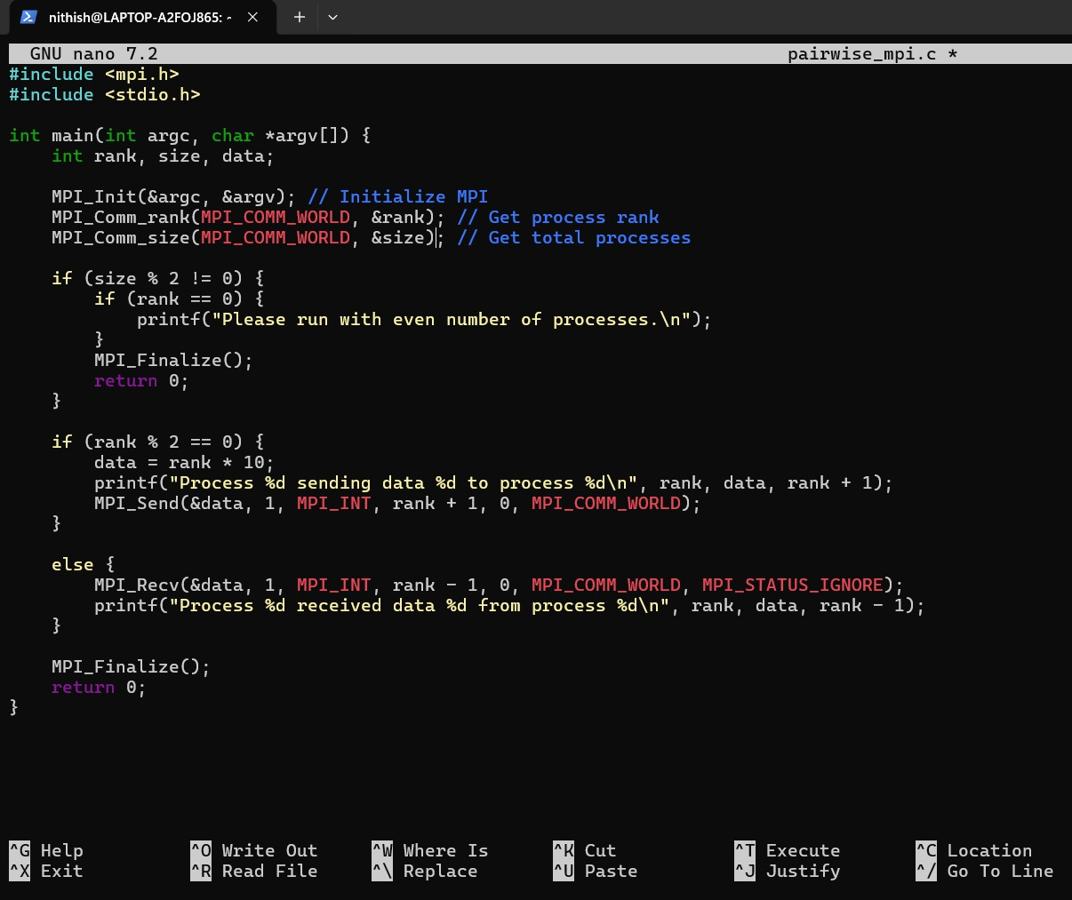
ImplementpairwiseSend/ReceivecommunicationamongMPI Processes.

Tasks
- Runtheprogramwithanevennumberofprocesses.
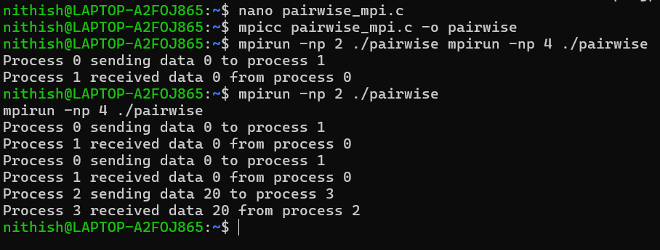
- Eachprocesswithevenranksendsdatatothenextodd- ranked process.

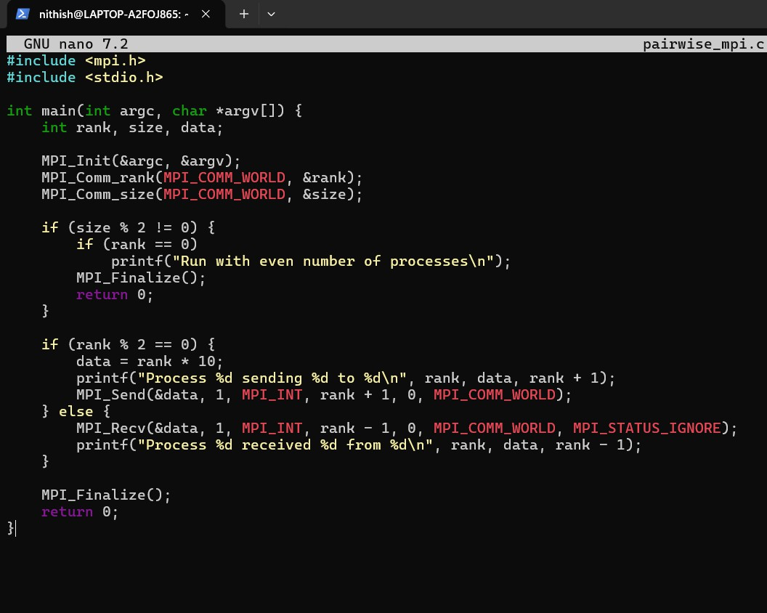
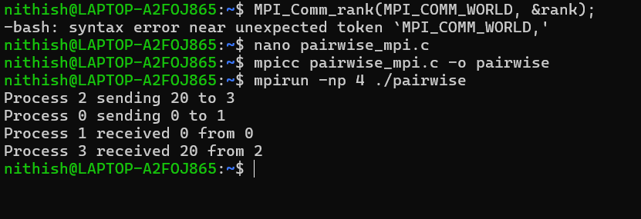
- Odd-rankedprocessesreceiveandprintthedata.

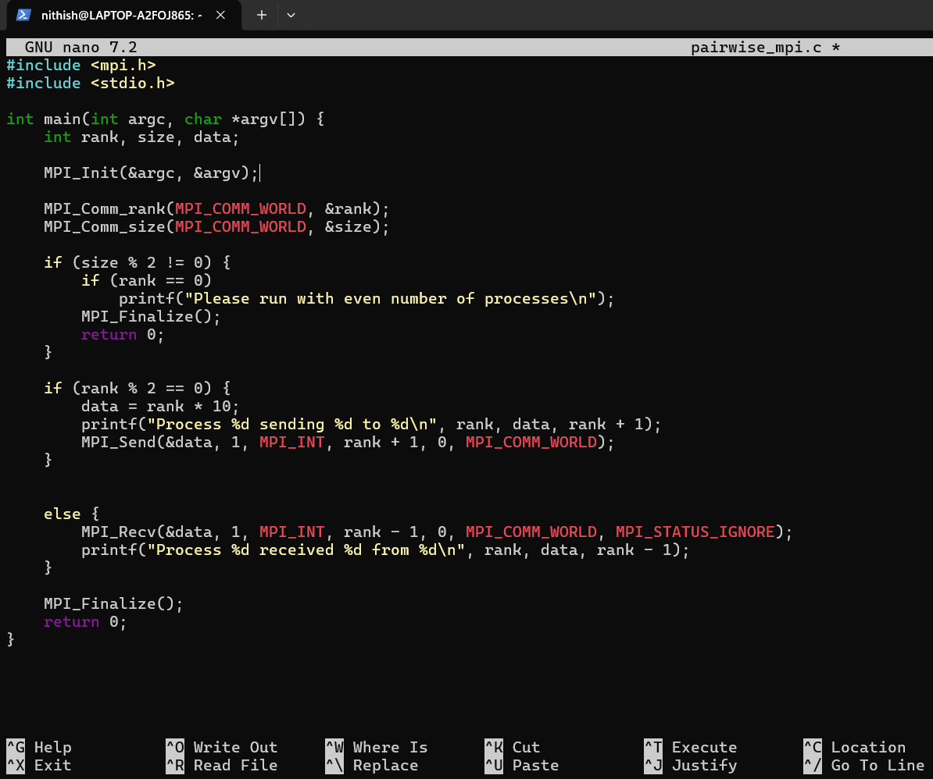

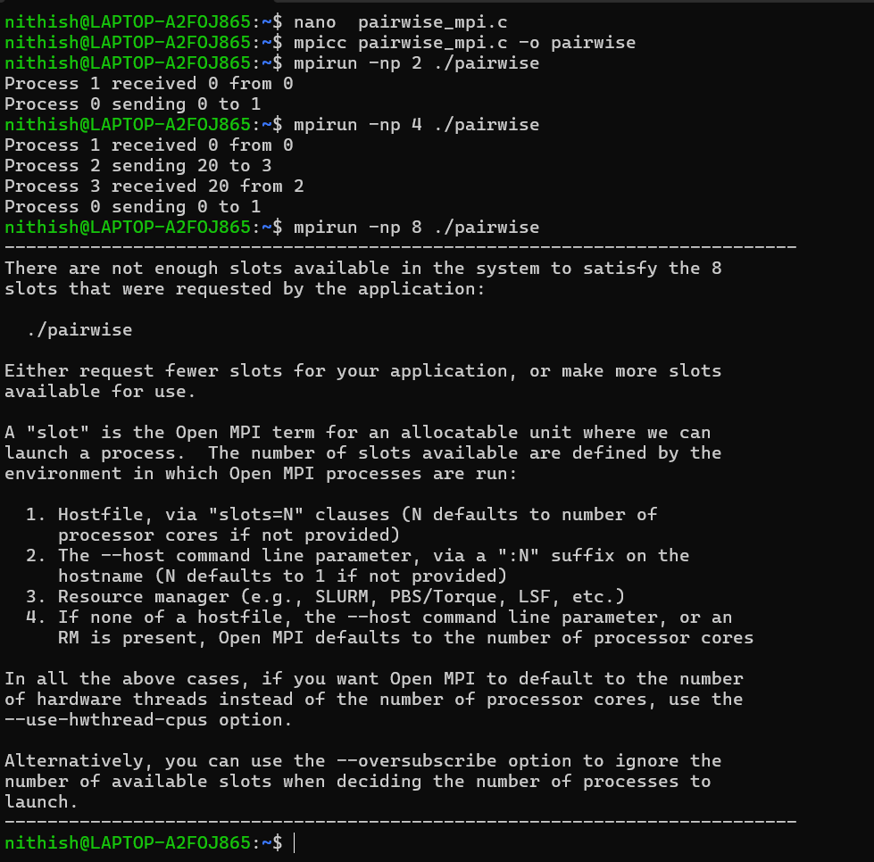
- AnalyzeblockingbehaviorofSend/Receive.
Inthisprogram,bothMPI_Send()andMPI_Recv()areblockingoperations.This meansthattheprocessesdonotcontinueexecutionimmediately—theywaituntil the communication is completed.
When an even-ranked process sends data, it pauses until the data is properly handled.Similarly,theodd-rankedprocesswaitsuntilitreceivesthedatabefore continuing. Because of this, both sending and receiving processes stay synchronized during execution.

Thereisnodeadlockinthisprogrambecausethecommunicationpatternis simple and well-organized. Even-ranked processes only send data, and
odd-rankedprocessesonlyreceiveit.Sincethereisnocircularwaitingbetween processes, the program runs smoothly.
Overall,theblockingnatureofMPIensuresthatdataistransferredcorrectlyand that all processes remain properly coordinated.

LearningOutcomes
- Pairwisecommunicationpatterns
Iunderstoodhowprocessescommunicateinpairs,whereeachprocess exchanges data directly with a specific neighboring process.

Blockingcommunicationbehavior
Ilearnedthatsendandreceiveoperationsareblocking,meaningaprocess waits until the data transfer is completed before continuing execution.

Processsynchronization
Iunderstoodhowprocessesstaycoordinatedwitheachotherduring communication, ensuring correct and orderly data exchange.

