HIGHPERFORMANCECOMPUTING

Assignment-2

NAME:P.VARDHINI
HT.NO:2303A51301
BATCH: 11

Section2:NaïveMatrixMultiplication(O(n3)compute)
Aim
Measure serial performance ofa triple-loopmatrix multiplication implementedinpurePython,andprofilecomputationalhotspots. Requirements
- Python3.8+
- Standardlibrary:time,random,cProfile,pstats,io,tracemalloc.

Code:
importrandom import time importcProfile import pstats import io
importtracemalloc
#
#Generatearandomnxnmatrix #
defgenerate_matrix(n):
return[[random.random()for_inrange(n)]for_inrange(n)]
#

#Naïvematrixmultiplication(O(n^3)) #
defmatmul_naive(A,B):
n= len(A)
C=[[0.0for_inrange(n)]for_inrange(n)] for i in range(n):
forj inrange(n):
forkinrange(n):
C[i][j]+=A[i][k]* B[k][j]
returnC
#
#Measureexecutiontime #
defrun_timing(n):
A = generate_matrix(n)
B= generate_matrix(n)
start=time.perf_counter() matmul_naive(A,B)
end = time.perf_counter()
print("===ExecutionTime===") print(f"Matrix size : {n} x {n}")
print(f"Timetaken:{end-start:.4f}seconds\n")
#
#CPUprofilingusingcProfile
#
defrun_cpu_profile(n):
A = generate_matrix(n)
B= generate_matrix(n)
profiler=cProfile.Profile()
profiler.enable() matmul_naive(A,B)

profiler.disable() s = io.StringIO()
stats = pstats.Stats(profiler, stream=s).sort_stats("cumulative") stats.print_stats(10)
print("===CPUProfiling(Top10)===") print(s.getvalue())

#
#Memoryprofilingusingtracemalloc
#
defrun_memory_profile(n):
A = generate_matrix(n)
B= generate_matrix(n)
tracemalloc.start()
matmul_naive(A,B)
current,peak=tracemalloc.get_traced_memory() tracemalloc.stop()
print("===MemoryProfiling===")
print(f"Currentmemoryusage:{current/10**6:.2f}MB") print(f"Peak memory usage: {peak / 10**6:.2f} MB\n")
#
#Mainfunction #
defmain():
N= 200# Changecarefully:100,200,300(higher=muchslower) print("\nNaïve Matrix Multiplication Performance Analysis\n") run_timing(N)
run_cpu_profile(N)
run_memory_profile(N)
if name =="main": main()

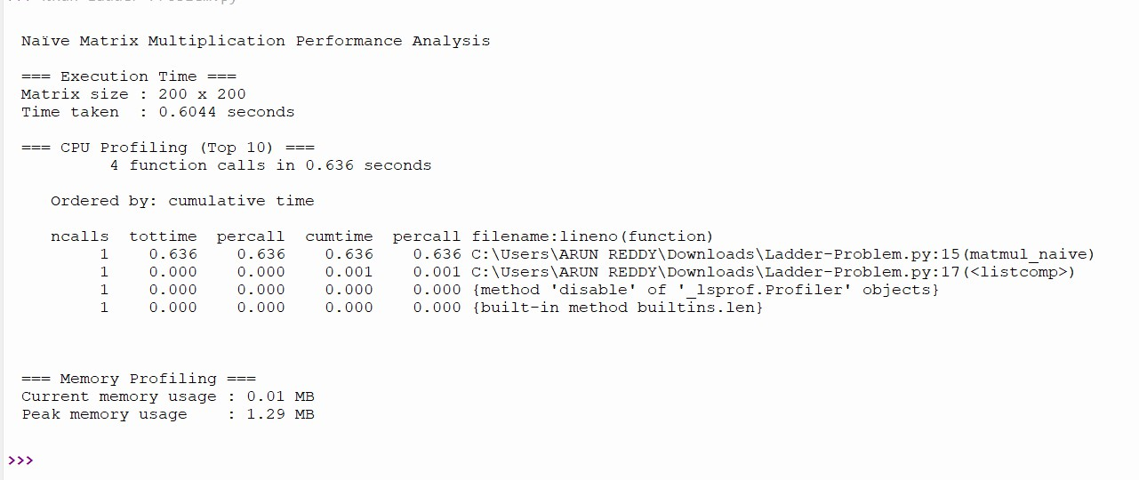
LOCALOUTPUT:

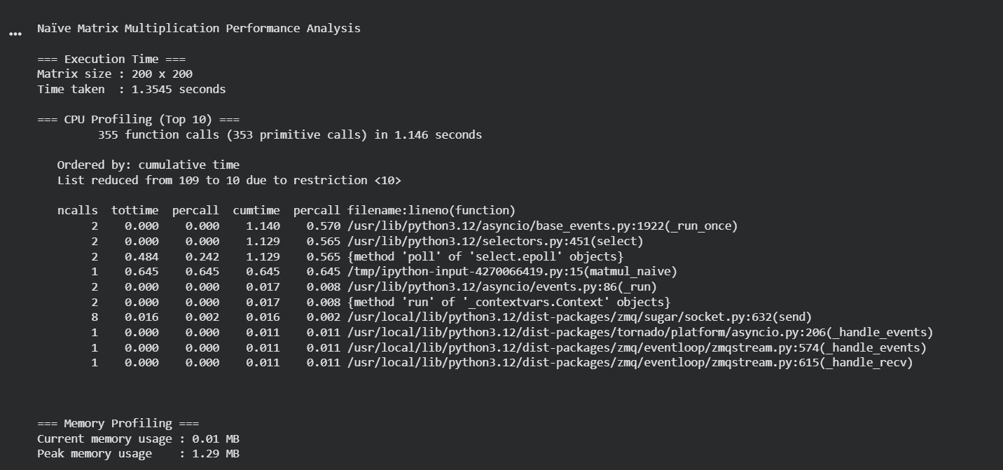
GOOGLECOLAB CPU:

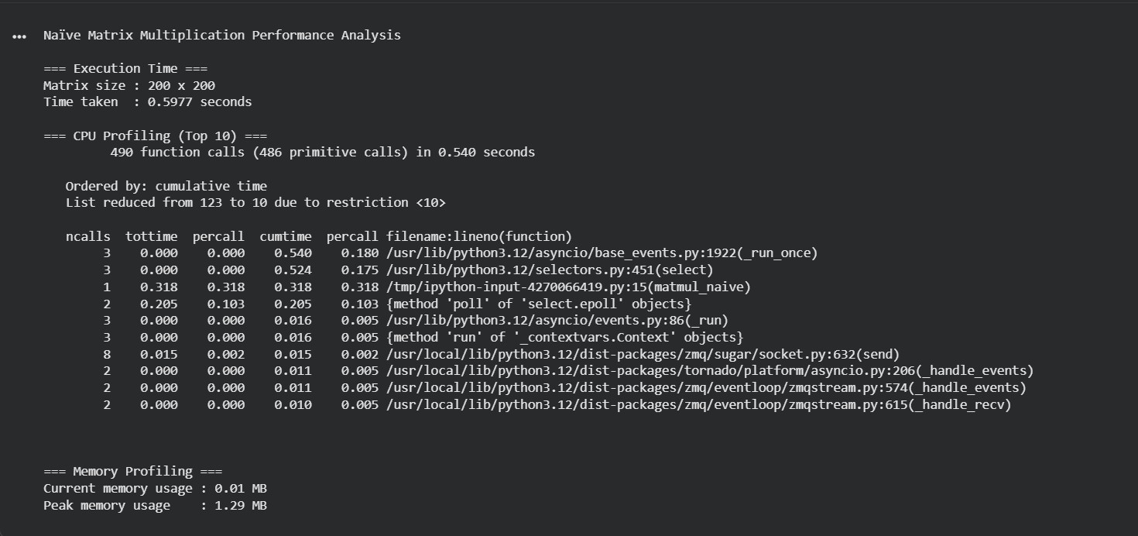
TPU:

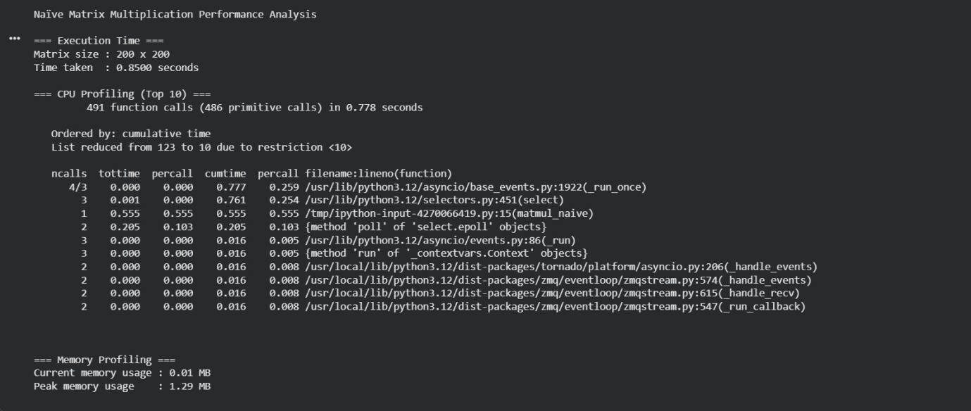
GPU:

