CourseTitle:HIGHPERFORMANCECOMPUTING-ASS_10 HALL TICKET:2303A51301
Task1:MPIHelloWorld
Step1:Createafilenamedhello.cwiththefollowingcode:
#include <mpi.h> #include<stdio.h>
intmain(intargc,char**argv){ MPI_Init(&argc, &argv);
//InitializeMPI int rank, size;
MPI_Comm_rank(MPI_COMM_WORLD,&rank);
// Get process rank MPI_Comm_size(MPI_COMM_WORLD,&size);
//Gettotalnumberofprocesses
printf("Hellofromrank%dof%d\n",rank,size);
MPI_Finalize(); //CleanupMPI return 0;
}

Step1:
Create a file named reduction_bad.c Implementparallelsummationusing: #pragma omp critical
insidetheloop. Compile:
gcc-O2-fopenmpreduction_bad.c-oreduction_bad Run with:
exportOMP_NUM_THREADS=1 exportOMP_NUM_THREADS=4 Record execution time.

Step2:Compiletheprogramusingmpicc:
>mpicc-ohello hello.c
Step3:Runtheprogramwithdifferentnumbersofprocesses(e.g.,2,4)and observe the output:
mpirun-np2./hello

mpirun-np4./hello
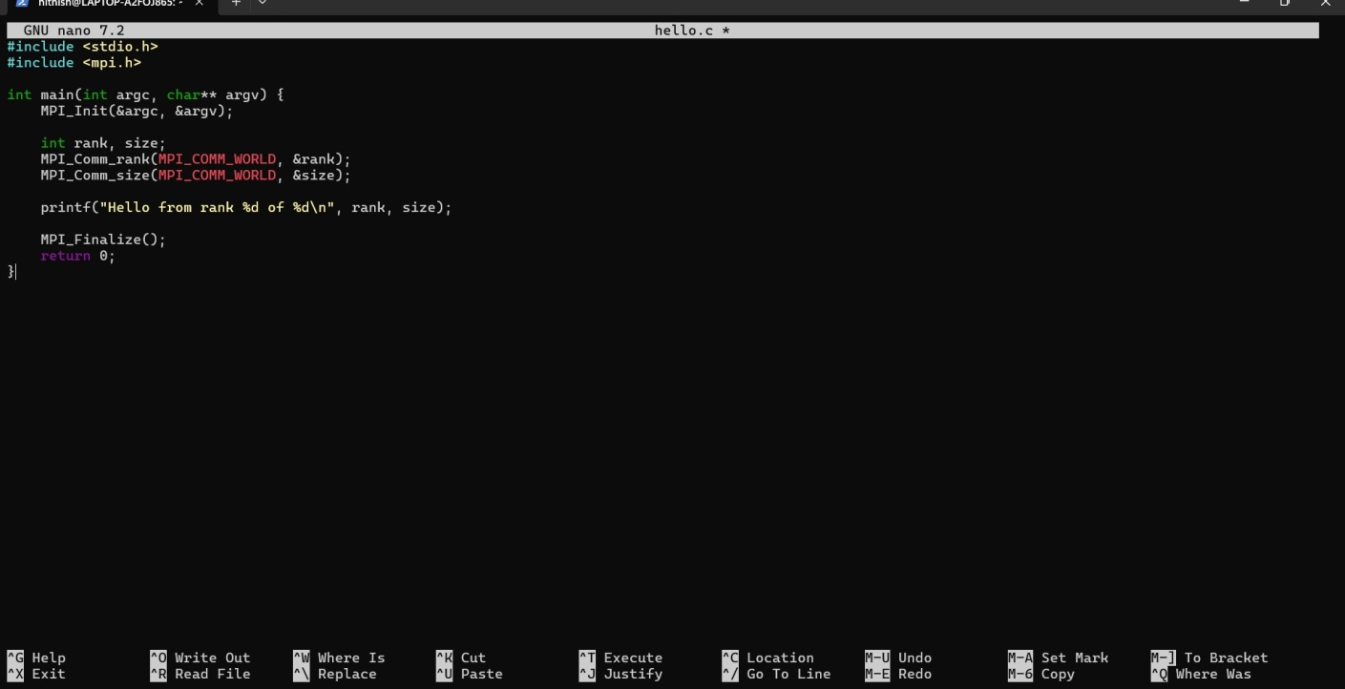



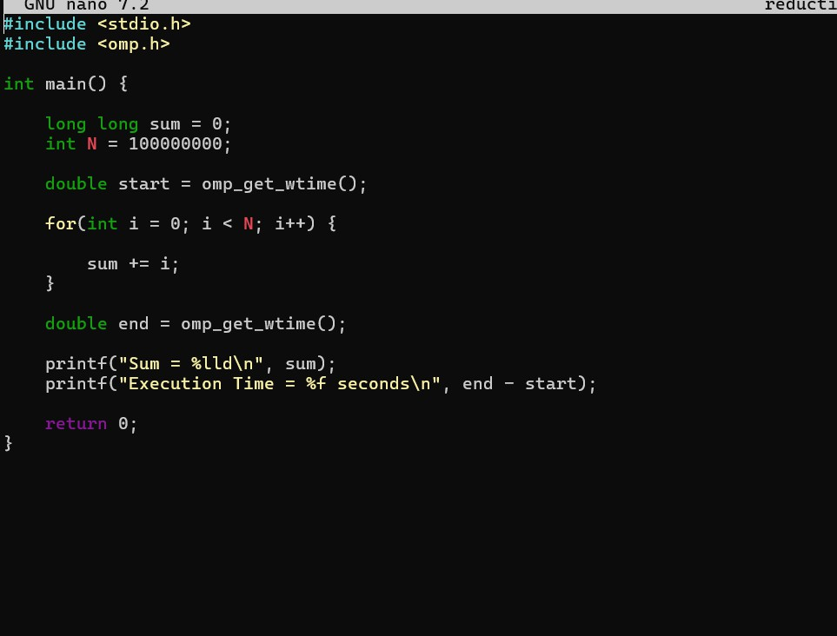

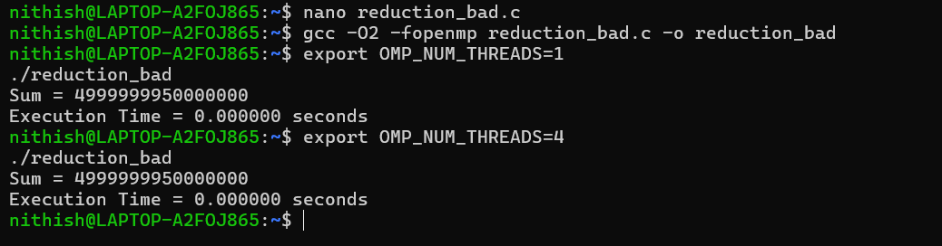
Step4:Answerthefollowingquestions:
- WhatdoMPI_InitandMPI_Finalizedo?
- Whatistherangeofranksforagivennumberofprocesses?
- Whycantheoutputorderbedifferenteachtimeyou run?

- WhatdoMPI_InitandMPI_Finalizedo?

MPI_Init is used to start the MPI (Message Passing Interface) environment.It prepares all the processes so they can communicate with each other during parallelexecution.Insimpleterms,ittellstheprogram:“Nowweareentering parallel mode.”
MPI_FinalizeisusedtosafelyendtheMPIenvironment.
It cleans up resources and stops communication between processes. After this function,noMPIcommandsshouldbeused.Itbasicallymeans:“Parallelworkis finished.”
- Whatistherangeofranksforagivennumberofprocesses?
EachprocessinMPIgetsauniquerank(IDnumber)soitcanbeidentified. If there are N processes, the ranks start from 0 and go up to N − 1.
Example:
Iftotalprocesses=4
Thenrankswillbe:0,1,2,3
So,therangeofranksis:
0to(numberofprocesses−1)
- Whycantheoutputorderbedifferenteachtimeyou run?
InMPIprograms,multipleprocessesrunsimultaneously(inparallel).
Since they execute independently and the operating system schedules them differentlyeachtime,oneprocessmayfinishearlierorlaterindifferentruns.
Because of this, the print statements from different processes may appear in a differentordereverytimeyouexecutetheprogram—eventhoughtheprogram itself is correct.

Task2:SimpleSend/Receive–One-wayCommunication
Step1:Createafilenamedping.cthatsendsanintegerfromrank0torank1. #include <mpi.h>
#include<stdio.h>
intmain(intargc,char**argv){ MPI_Init(&argc, &argv);
int rank; MPI_Comm_rank(MPI_COMM_WORLD,&rank); int data;

if(rank==0){ data = 42;
MPI_Send(&data,1,MPI_INT,1,0,MPI_COMM_WORLD);
printf("Rank0sentvalue%d\n",data);
}elseif(rank==1){
MPI_Recv(&data,1,MPI_INT,0,0,MPI_COMM_WORLD, MPI_STATUS_IGNORE);
printf("Rank1receivedvalue%d\n",data);
}
MPI_Finalize(); return 0;
}

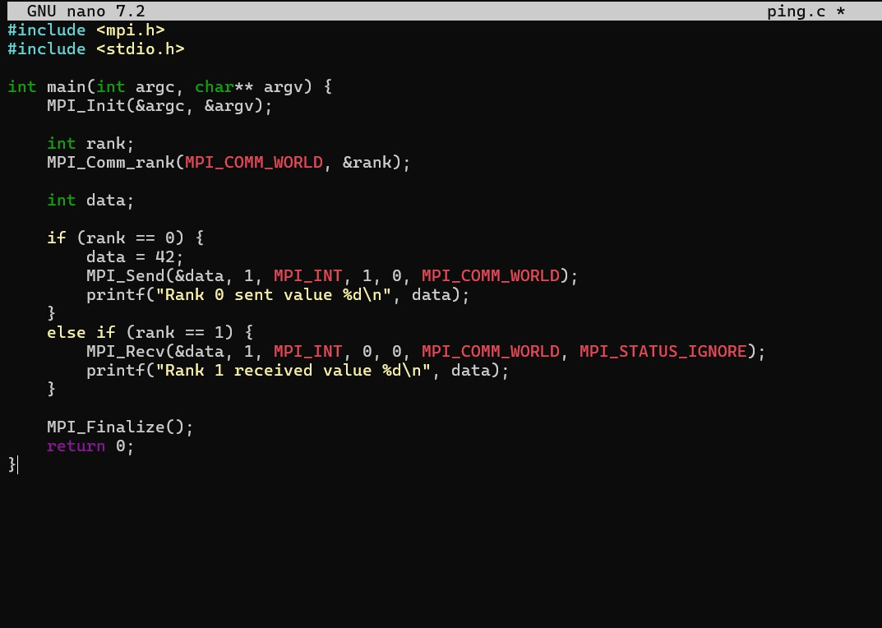

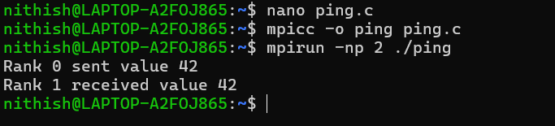

Step2:Compileandrunwithexactly2processes:
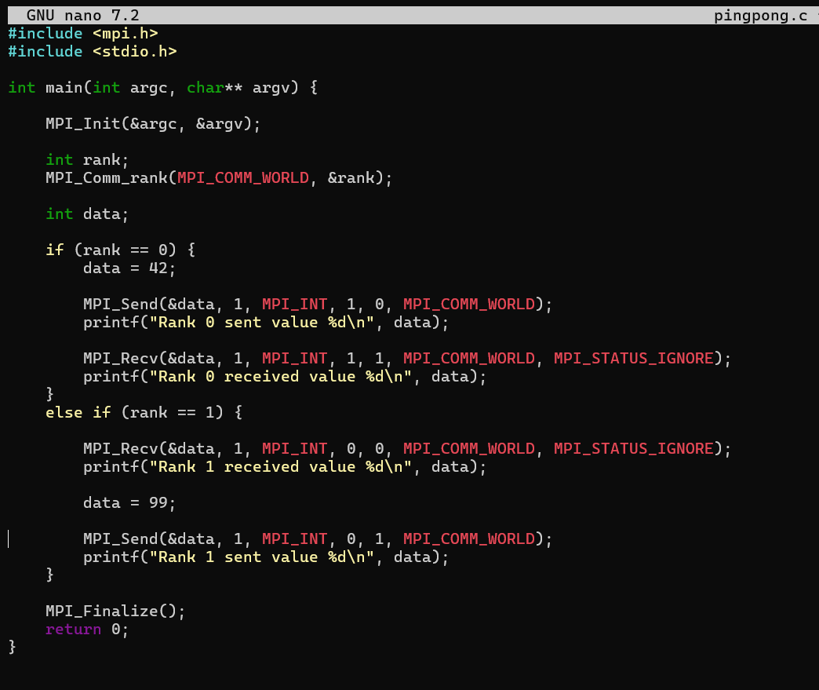
mpicc-opingpong.c mpirun -np 2 ./ping



Step4:Answerthefollowing:
- Whatwouldhappenifyouruntheprogramwithmorethan2processes? Why?
- WhatisthepurposeofthetagparameterinMPI_SendandMPI_Recv?
- WhatdoesMPI_STATUS_IGNOREdo?

- Whatwouldhappenifyouruntheprogramwithmorethan2processes?Why? If the program is run with more than 2 processes, only rank 0 and rank 1 will participate in communication because the code is written only for them.
Other ranks (like 2, 3, etc.) will simply start and finish without doing anything. In somecases,extraprocessesmayremainidleorcauseconfusionifcommunication is expected but not defined for them.

- WhatisthepurposeofthetagparameterinMPI_SendandMPI_Recv? The tag acts like a message label or identifier.
Ithelpsthereceivingprocessknowwhichmessageitisreceiving,especiallywhen multiple messages are being sent between the same processes. This prevents mixing up different messages.

- WhatdoesMPI_STATUS_IGNOREdo?

MPI_STATUS_IGNORE tells MPI that the program does not need detailed informationaboutthereceivedmessage(suchassenderdetailsormessagesize). It simplifies the code when that extra information is not required.

Task3:DeadlockandAvoidance
Step1:Createafilenameddeadlock_bad.cthatattemptsacircularsend/receive:
#include <mpi.h> #include<stdio.h>
intmain(intargc,char**argv){ MPI_Init(&argc, &argv);
int rank; MPI_Comm_rank(MPI_COMM_WORLD,&rank);

intdata=rank; if(rank==0){
MPI_Send(&data,1,MPI_INT, | 1, | 0, | MPI_COMM_WORLD);
MPI_Recv(&data,1,MPI_INT, | 1, | 0, | MPI_COMM_WORLD,

MPI_STATUS_IGNORE);
}elseif(rank==1){
MPI_Send(&data,1,MPI_INT, | 0, | 0, | MPI_COMM_WORLD);
MPI_Recv(&data,1,MPI_INT, | 0, | 0, | MPI_COMM_WORLD,
MPI_STATUS_IGNORE);
}
MPI_Finalize(); return 0;
}

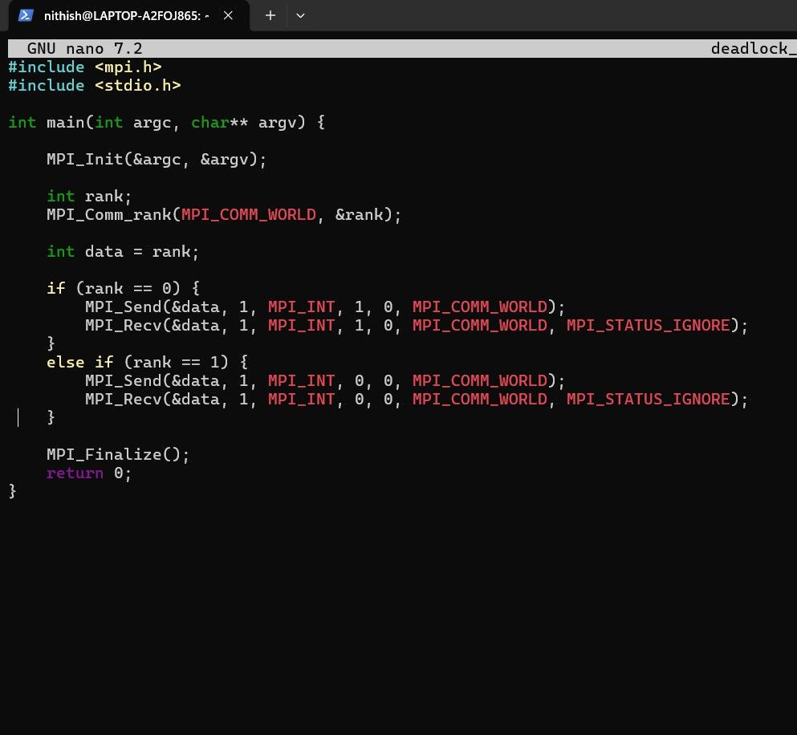

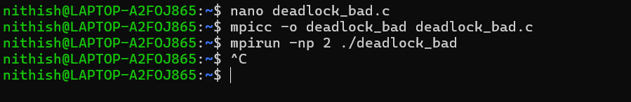
Step2:Compileandrunwith2processes.Observewhathappens(theprogramwill hang – you may need to kill it with Ctrl+C).

Step3:Nowcreateafixedversiondeadlock_fixed.cbyreorderingthecallssothat one process receives first:
#include<mpi.h>

#include<stdio.h>
intmain(intargc,char**argv){ MPI_Init(&argc, &argv);
int rank; MPI_Comm_rank(MPI_COMM_WORLD,&rank); int data = rank;
if(rank==0){
MPI_Send(&data,1,MPI_INT, | 1, | 0, | MPI_COMM_WORLD);
MPI_Recv(&data,1,MPI_INT, | 1, | 0, | MPI_COMM_WORLD,
MPI_STATUS_IGNORE);
}elseif(rank==1){
MPI_Recv(&data,1,MPI_INT,0,0,MPI_COMM_WORLD, MPI_STATUS_IGNORE);
MPI_Send(&data,1,MPI_INT,0,0,MPI_COMM_WORLD);
}
MPI_Finalize(); return 0;
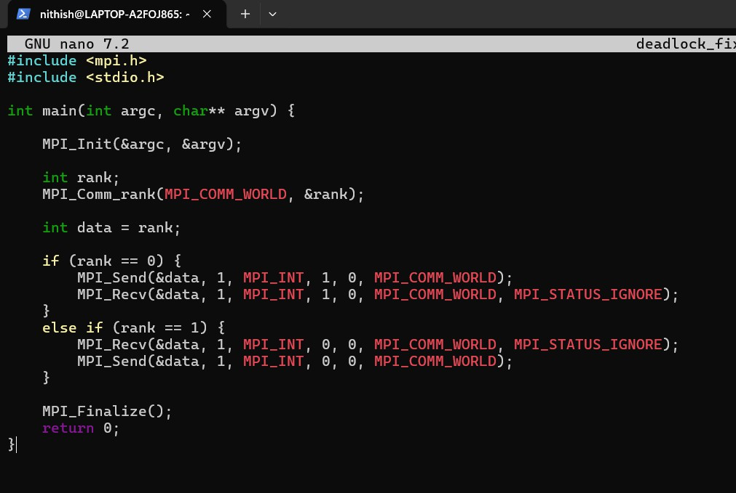
}

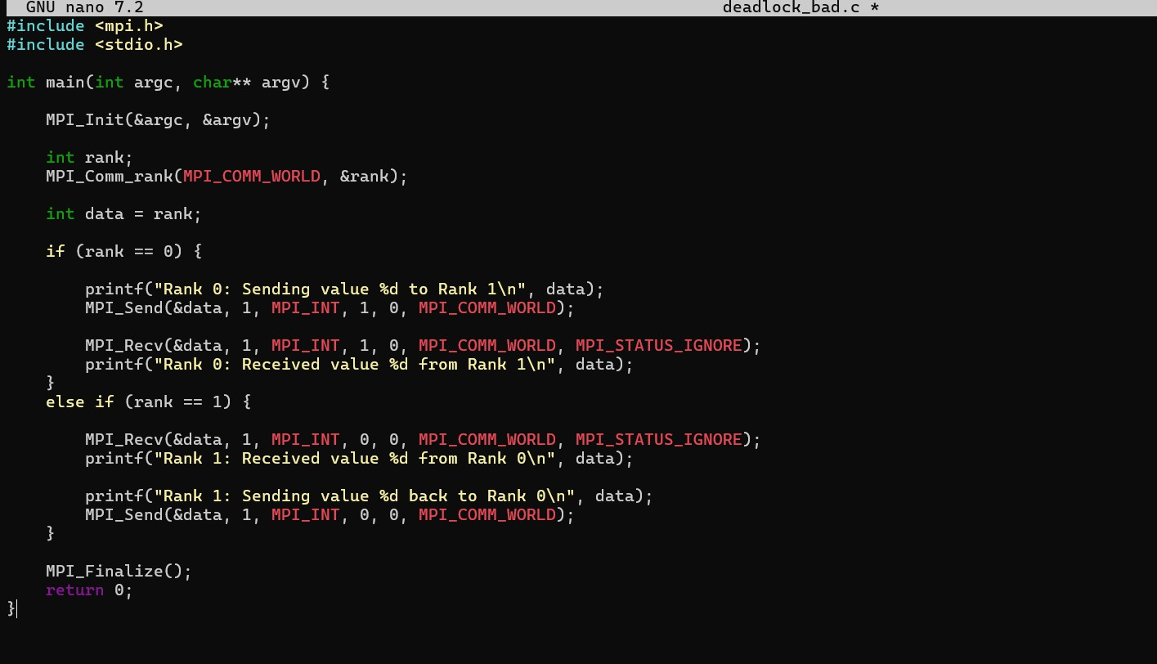
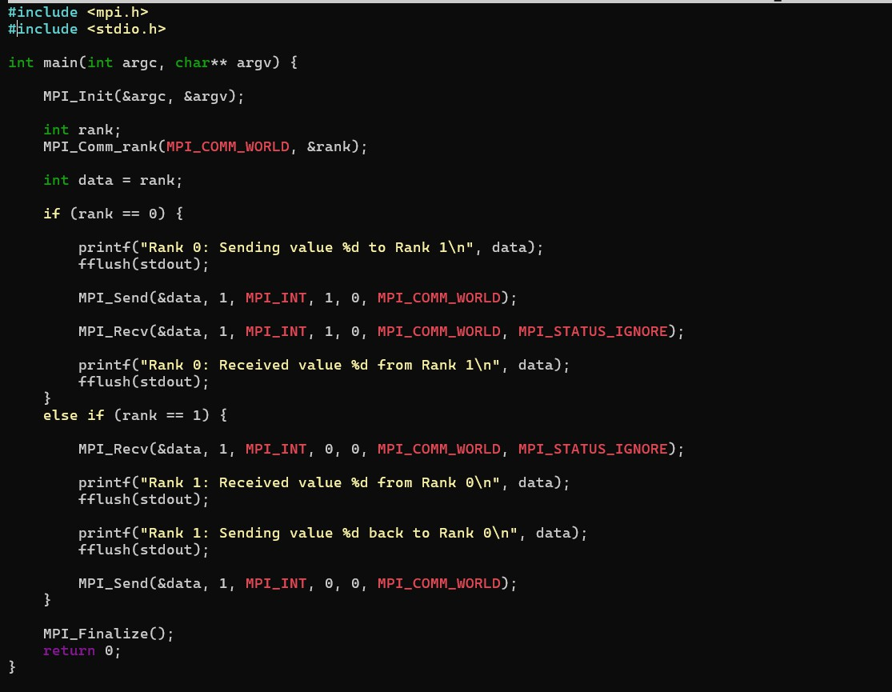

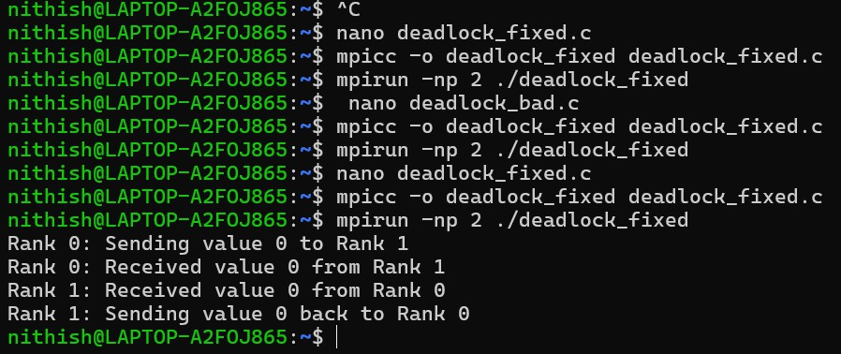
Step4:Compileandrunthefixedversion.Itshouldcompletewithouthanging.

Step5:Answerthefollowingquestions:
- Why does the first version deadlock? Explain in terms of the order of calls. In the first program, both processes (rank 0 and rank 1) try to send data at thesametimebeforereceivinganything.SinceMPI_SENDSwaitsuntilthe other process is ready to receive, each process keeps waiting for the other one. Because neither process moves to the receive step, the program gets stuck forever. This situation is called deadlock.

- Howdoesthefixedversionavoiddeadlock?
Inthefixedprogram,theorderofoperationsischanged.Oneprocesssends firstwhiletheotherprocessreceivesfirst.Sinceareceiverisalreadyready, the send operation completes successfully. After that, the reply message is sent back normally. Because both processes are no longer waiting on each other at the same time, the program runs and finishes correctly.

- Couldbufferingeverpreventthisdeadlock?Whyisitunsafetorelyon buffering?
SometimesMPImaytemporarilystoremessagesinmemory(buffering), which can allow a send operation to finish even if the receiver has not started yet. This might make the program seem like it works.
Butrelyingonbufferingisriskybecausebuffersizeislimitedanddepends on the system. A program that works on one computer may fail or hang on another.So,itisalwaysbettertodesignthecommunicationordercorrectly instead of depending on buffering.

