CourseTitle:HIGHPERFORMANCECOMPUTING Ass-8

Name: P.VARDHINI Batch no : 11
HallTicketNo:2303A51301

Lab:OpenMPPerformanceAnalysisandHotspotDetection Objective:
Toidentifyperformancehotspotsandunderstandbasicprofiling concepts.
Task1:CompilewithTiming
gcc-O2-fopenmpsum_openmp.c-osum_openmp


- Task2:MeasureExecutionTime Use:
omp_get_wtime() Record time for: Serial execution Parallelexecution

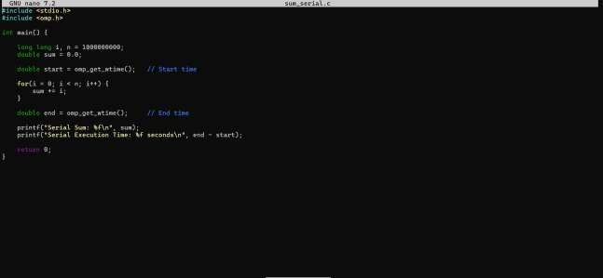


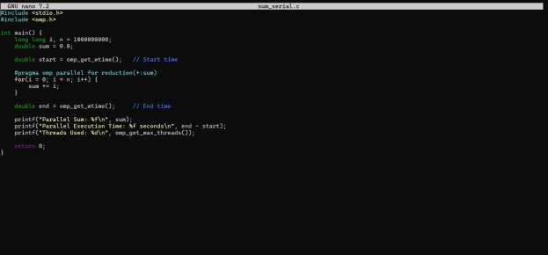


Task3:ObservationQuestions
- Whatisahotspotinperformance analysis?

When we talk about a hotspot in performance analysis, we mean the part of the programwheremostoftheexecutiontimeisspent.Itisthesectionofcodethatdoes the maximum work and consumes the most CPU time.
Inourexperiment(Task1andTask2),wemeasuredexecutiontimeforbothserialand parallel versions of the summation program. After running the program and observing the timing results, it is clear that almost all the execution time is spent inside the for loop that performs the summation.
InTask1,whenweusedthetimecommand,thetotalexecutiontimemainlydepended on how long the loop took to execute.
InTask2,whenweusedomp_get_wtime(),weagainobservedthatthedifference between start and end time mostly reflects the time taken by the loop.

Otherpartsoftheprogram,likevariabledeclarationsandprintingresults,takeverylittle time compared to the loop.
So,inourcase,thesummationloop(serialandparallelloop)isthehotspotbecause
itrunsbillionsofiterationsanddominatestheprogram’stotalexecution time.

Identifyingthishotspotisimportantbecauseimprovingorparallelizingthisloop(using OpenMP) directly improves the overall performance of the program.

Whydoessynchronizationincreaseexecution time?
In our OpenMP experiment, we compared serial and parallel execution times. The parallelversionwasfasterbecausemultiplethreadsworkedatthesametime.However, synchronization can reduce this benefit.
Synchronizationincreasesexecutiontimebecauseitmakesthreadswaitforeachother. Whenseveralthreadstrytoaccessorupdatethesamesharedvariable(like suminour program), the system has to control access to avoid errors. This control mechanism slows things down.
In our summationprogram, if we useda criticalsectioninsteadof the reduction clause,everythreadwouldhavetowaitbeforeupdatingthesumvariable.Eventhough multiple threads are running, only one would be allowed to update the value at a time. This waiting reduces parallel efficiency and increases execution time.
So,eventhoughparallelprogrammingaimstospeedupexecution(asseeninTask1 and Task 2), synchronization adds overhead. The more threads wait for shared resources, the less performance improvement we get.
Insimpleterms,synchronizationincreasesexecutiontimebecauseitreducesthe freedom of threads to run simultaneously.

Whydoesspeedupstopincreasingaftersomethreads?
WhenweincreasedthenumberofthreadsinourOpenMPprogram,wenoticedthat execution time reduced at first. This gave us good speedup. But after some point, adding more threads did not improve performance much. Sometimes, it may even slightly reduce performance.
This happens because not all parts of the program can be parallelized. In our summationprogram,themainloopisparallel,butotherpartslikevariablesetup,thread management, and final result combination still take time. These small serial portions limit the maximum possible speedup.

Another reason is overhead. When we increase threads, the system has to create, manage, and synchronize them. This coordination takes extra time. After a certain numberofthreads,theoverheadbecomescomparabletotheactualcomputationtime.
Also,thenumberofCPUcoresinthesystemmatters.Ifyoursystemhas8coresand you use more than 8 threads, they must share cores. This leads to context switching and resource contention, which reduces performance gains.
So, in our Task 1 and Task 2 experiments, speedup improved when we increased threadsuptoacertainpoint.Afterthat,itstoppedincreasingsignificantlybecauseof:
  - Serialportionsoftheprogram

  - Threadmanagementoverhead

  - Synchronizationcosts

  - Hardwarelimitations(limitedCPU cores)

Insimpleterms,morethreadsdonotalwaysmeanmorespeed.Afteralimit,thesystem cannot efficiently use additional threads

