HIGH PERFORMANCE COMPUTING Lab Ass-4

Name:PVARDHINI Batch-11
Hall Ticket:2303A51301

Lab: OpenMP Parallel Loops (From Serial to Parallel) Task1:OpenMPParallelLoops(FromSerialtoParallel) Objective: Confirm OpenMP-ready system.
Steps:
Lscpu nproc
gcc–version
ExpectedObservation:
MultipleCPUcoresavailable
GCCinstalledwithOpenMPsupport
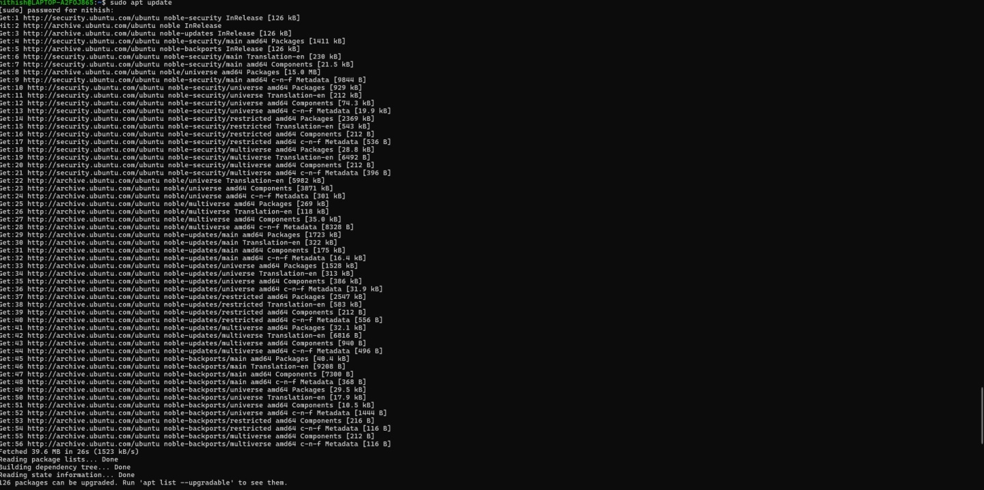
Task2:SerialBaseline–LoopComputation Objective: Establish serial execution time.
File: sum_serial.c #include&lt;stdio.h&gt; #include &lt;time.h&gt;

04-02-2026EOD
#defineN100000000 int main() {
double sum = 0.0; clock_tstart=clock();

for(longi=0;i&lt;N;i++){ sum += i * 0.5;
}

clock_tend=clock();
doubletime_spent=(double)(end-start)/ CLOCKS_PER_SEC;

printf(&quot;Serial Sum: %f\n&quot;, sum); printf(&quot;ExecutionTime:%fseconds\n&quot;,time_spent); return 0;
}
Compile&amp;Run:
&gt;gccsum_serial.c-osum_serial &gt; ./sum_serial
Submission:Screenshotshowingexecutiontime.

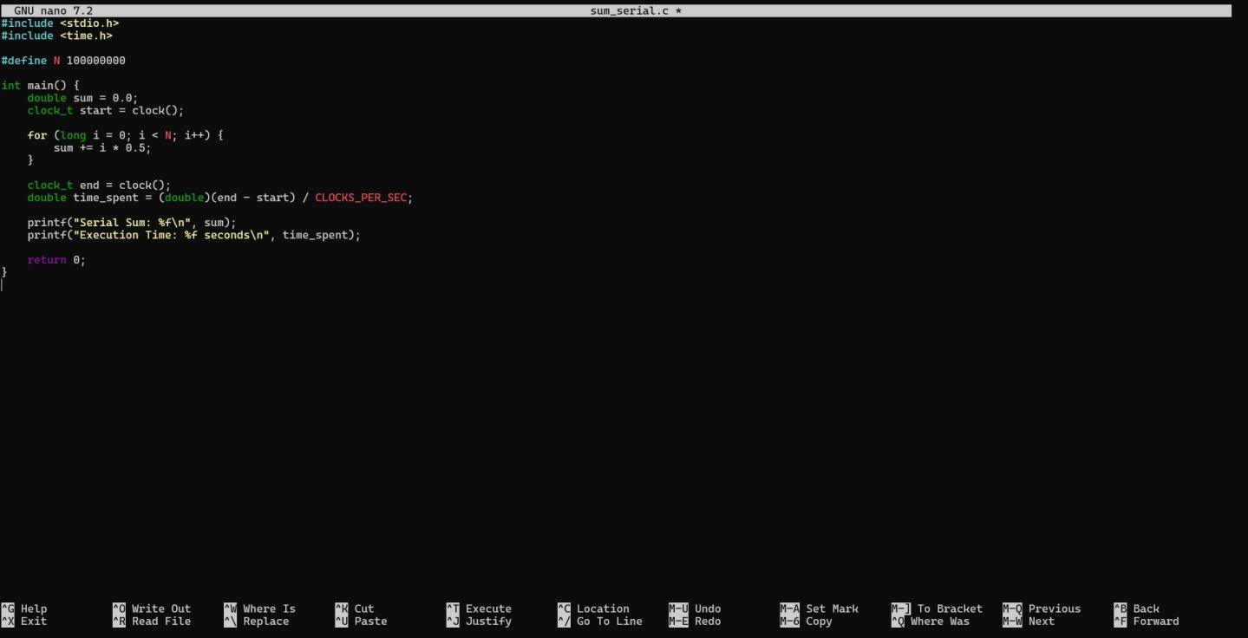
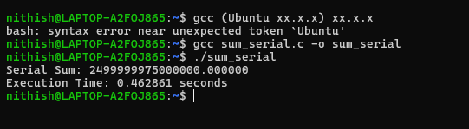

Task3:OpenMPParallelLoop
Objective:ParallelizetheloopusingOpenMP. File: sum_openmp.c

04-02-2026EOD

#include&lt;stdio.h&gt; #include&lt;omp.h&gt;
#defineN100000000 int main() {
doublesum=0.0;
doublestart=omp_get_wtime();

#pragmaompparallelforreduction(+:sum) for (long i = 0; i &lt; N; i++) {
sum+=i*0.5;

}
double end = omp_get_wtime(); printf(&quot;ParallelSum:%f\n&quot;,sum);
printf(&quot;Execution Time: %f seconds\n&quot;, end - start); printf(&quot;ThreadsUsed:%d\n&quot;,omp_get_max_threads());

return0;
}
Compile:

&gt;gcc-fopenmpsum_openmp.c-osum_openmp
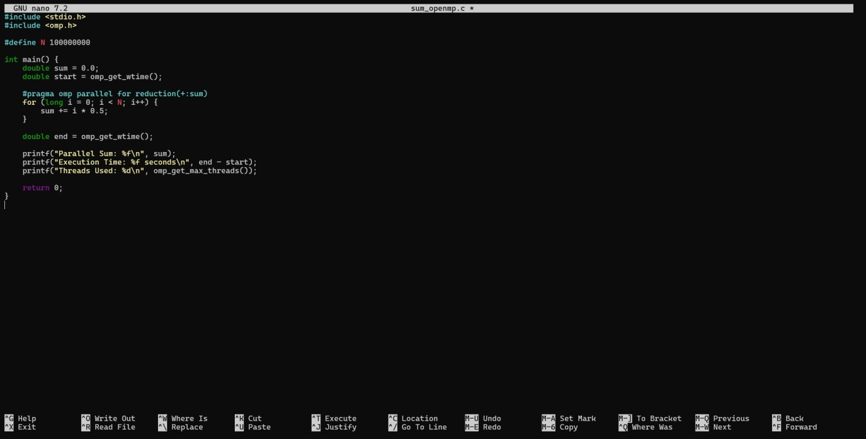
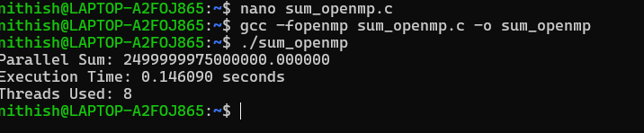

Task4:ThreadScalingExperiment Run with different thread counts: export OMP_NUM_THREADS=1
./sum_openmp

exportOMP_NUM_THREADS=2
./sum_openmp

exportOMP_NUM_THREADS=4
./sum_openmp

exportOMP_NUM_THREADS=8
./sum_openmp

Recordthereadingsinabelowtable:
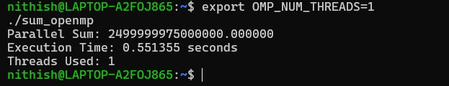
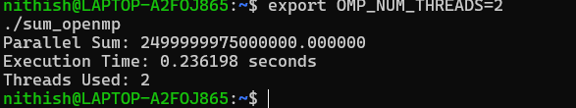
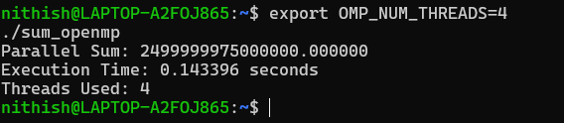
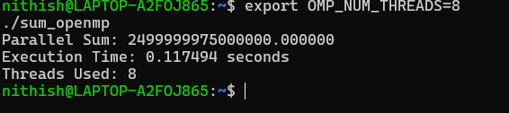

Threads | ExecutionTime(s)
1 | 0.551355seconds
2 | 0.236198seconds

4 | 0.143396seconds
8 | 0.117494seconds

Task5:
Speedup

S(p)=T1/Tp Efficiency E(p)=S(p)/p
Computefor2,4,8threads.
Submission:TablewithSpeedup&amp;Efficiency.

Step1:Identifyexecutiontimes
FromTask4,youalreadyhave:

- T1→executiontimewith1thread

- T2→executiontimewith2threads

- T4→executiontimewith4threads

- T8→executiontimewith8threads

Step2:Useformulas

Speedup:
S(p)=T1TpS(p)=\frac{T_1}{T_p}S(p)=TpT1

Efficiency:

E(p)=S(p)pE(p)=\frac{S(p)}{p}E(p)=pS(p)

Step3:Examplecalculation
Assume(examplevalues):

- T1=1.20s

- T2=0.65s

- T4=0.38s

- T8=0.30s

For2 threads:
- S(2)=1.20/0.65=1.84

- E(2)=1.84/2=0.92

For4 threads:
- S(4)=1.20/0.38=3.15

- E(4)=3.15/4=0.79

For8 threads:
- S(8)=1.20/0.30=4.00

- E(8)=4.00/8=0.50

Threads(p) | TimeTp (s) | Speedup S(p) | EfficiencyE(p)
2 | T2 | T1/T2 | S(2)/2
4 | T4 | T1/T4 | S(4)/4
8 | T8 | T1/T8 | S(8)/8

WhydoesOpenMPworkwellforthisloop?

OpenMP works well here because every loop iteration is independent. Each thread can calculateitspartwithoutwaitingforothers,andattheendOpenMPsafelyaddsallthepartial results together using the reduction clause.

Whathappensifloopiterationsaredependent?
If the iterations depend on each other, running them in parallel can give wrong results. This happensbecausemultiplethreadsmaytrytoreadorupdatethesamedataatthesametime, causing race conditions. Adding synchronization can fix this, but it also slows down the program.

Whydoesspeedupstopimprovingaftersomethreads?
Afteracertainnumberofthreads,performancestopsimprovingbecausethesystemhaslimited CPU cores. Also, managing many threads takes extra time, and they start competing for memory. Some parts of the program still run serially, which limits overall speedup.

IsOpenMPsuitableformulti-nodesystems?Whyorwhynot?
No, OpenMP is mainly meant for systems where all threads share the same memory, like a singlemachine.Inmulti-nodesystems,eachnodehasitsownmemory,socommunicationis needed. For that, MPI is more suitable than OpenMP.

