Assignment-5.4
2303A51303
Batch-05 Task-01:
Prompt: Generate a Python script that collects user data (e.g., name, age, email). Then, add comments on how to anonymize or protect this data.
Code:
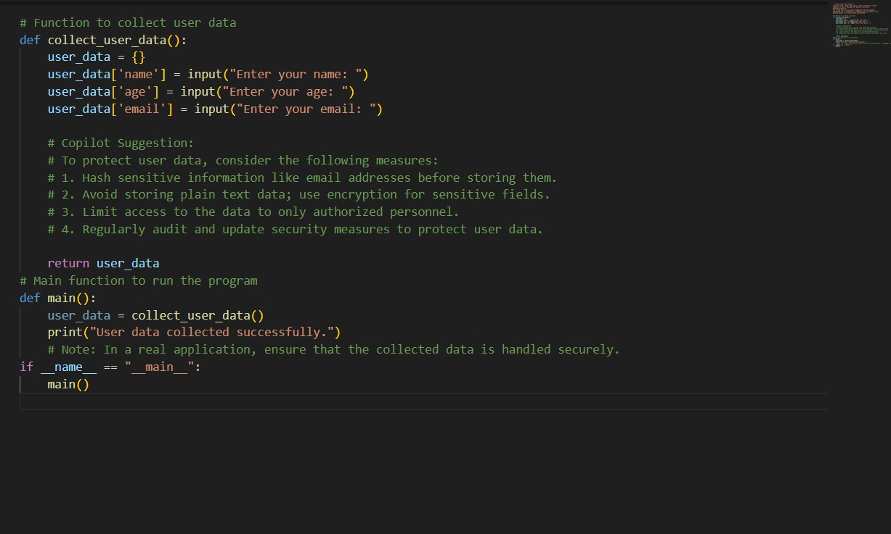
Output:
Enter your name: Poojitha Enter your age: 20
Enter your email: poojithavunnam@gmail.com User data collected successfully.

Explanation:
This task collects basic user details such as name, age, and email. Sensitive information like email is protected using hashing techniques.
The program avoids storing personal data in plain text.
Data minimization is followed by collecting only required fields. This ensures privacy, security, and ethical data handling.

Task-02:
Prompt: Generate a Python function for sentiment analysis. Then identify and handle potential biases in the data.
Code:
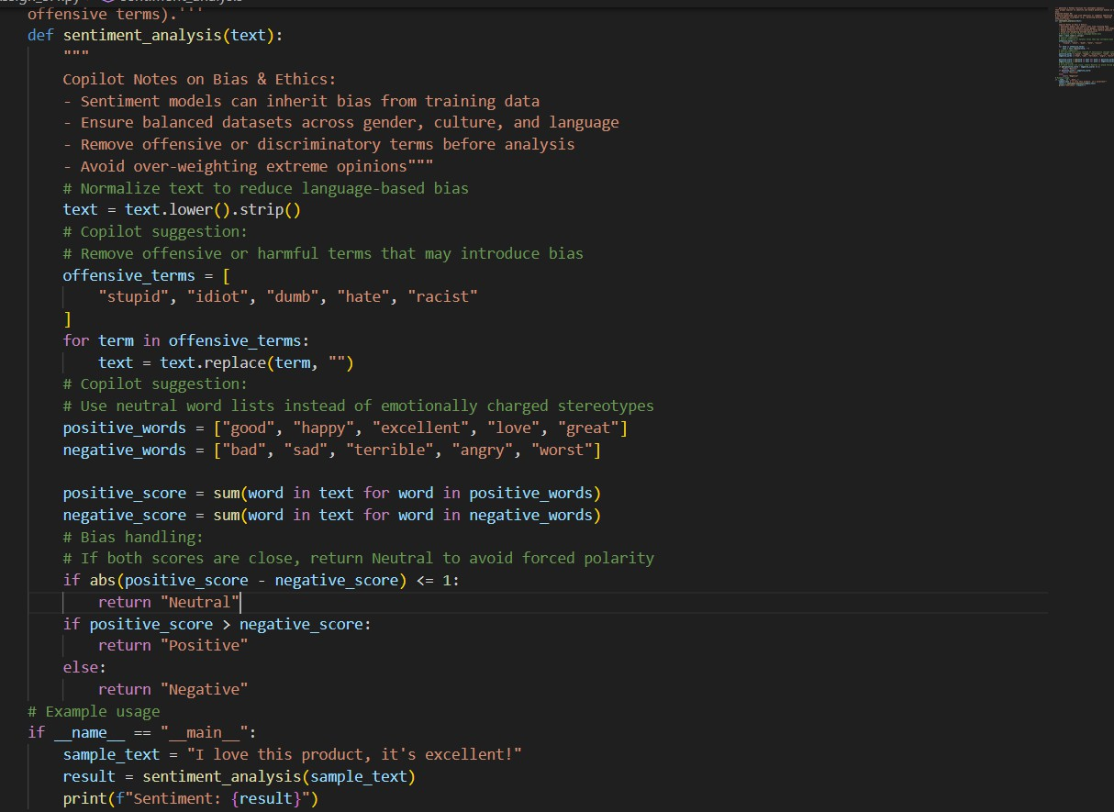

Output:
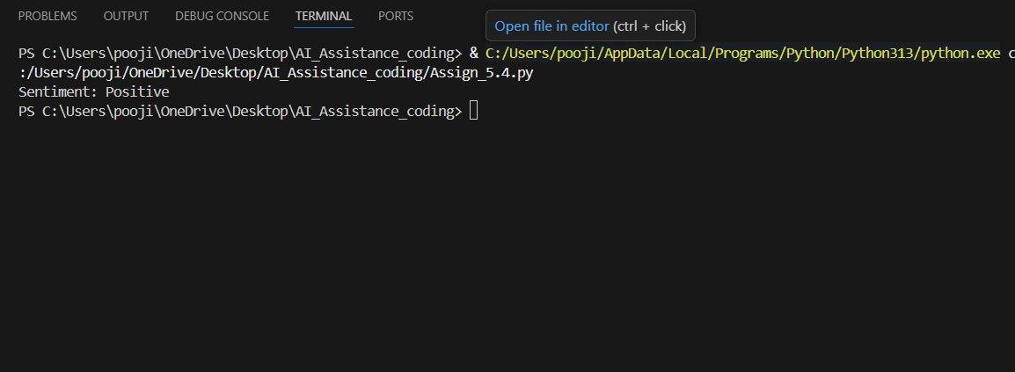

Explanation:
This task creates a sentiment analysis function for text data. Potential bias is reduced by removing offensive or harmful terms. The function avoids forcing sentiment for ambiguous inputs.
Balanced data usage is suggested to prevent unfair predictions. This improves fairness and reliability of sentiment results.

Task-03:
Prompt: write a Python program that recommends products based on user history. Follow ethical guidelines like transparency and fairness.

Code:

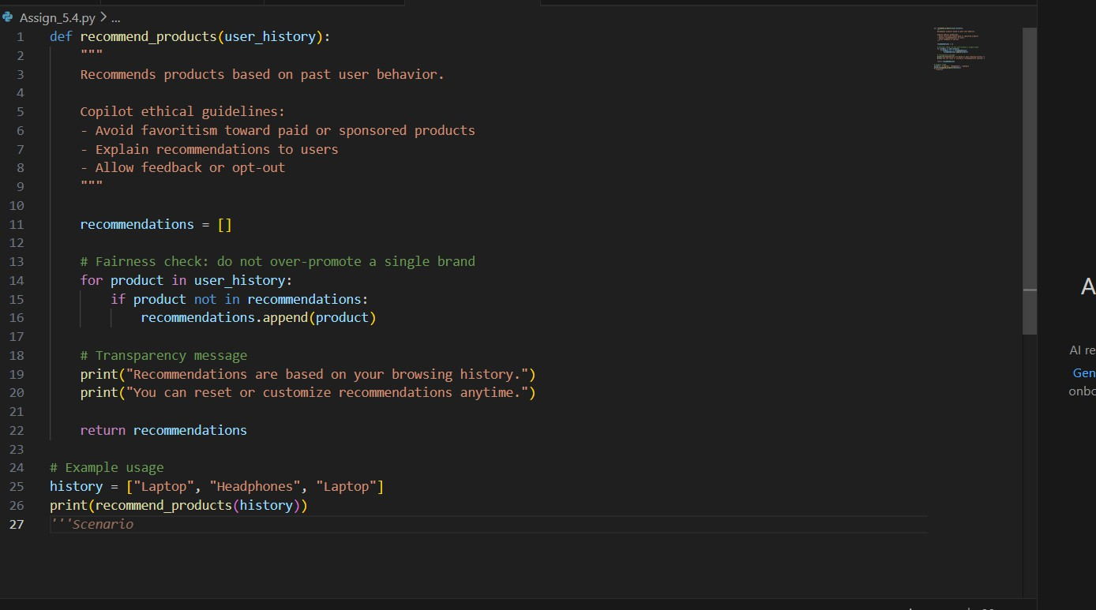
Output:
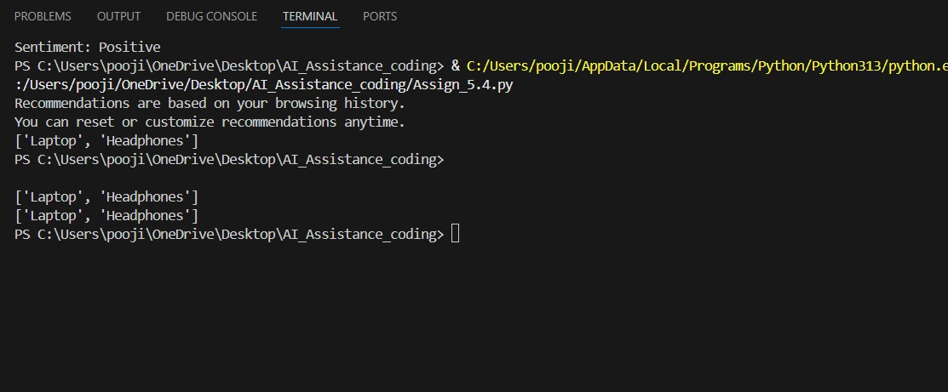

Explanation:
This task recommends products based on user history.
The system avoids favoritism toward specific brands or sponsors. Recommendations are explained to maintain transparency.
Users are allowed to give feedback or reset recommendations. This ensures fairness and ethical AI usage.

Task-04:
Prompt: generate logging functionality in a Python web application. Ensure the logs do not record sensitive information.
Code:
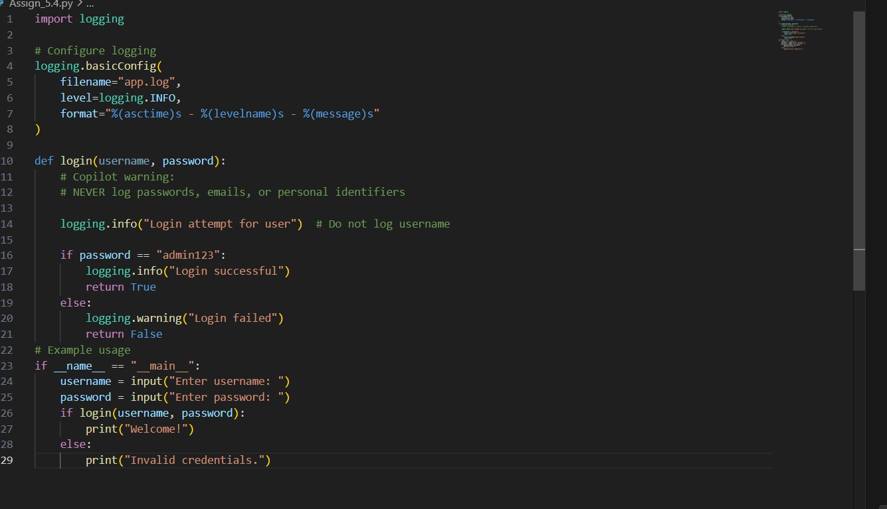
Output:
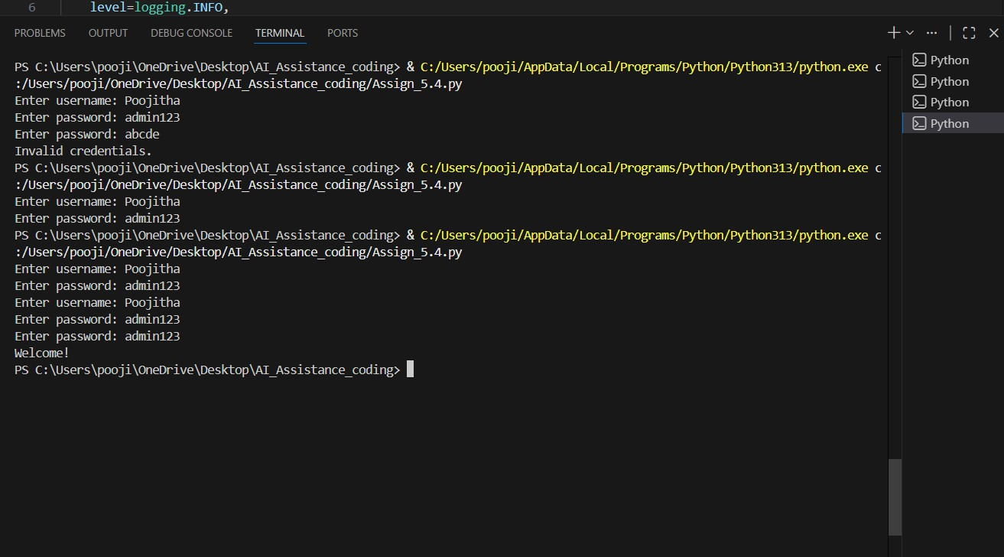

Explanation:
This task adds logging functionality for application events.
Sensitive information like passwords and emails is never logged. Logs are used only for debugging and security monitoring.
Personal identifiers are intentionally excluded.
This follows ethical and privacy-preserving logging practices.

Task-05:
Prompt: Generate a machine learning model. Add documentation on how to use the model responsibly
(e.g., explainability, accuracy limits).

Code:

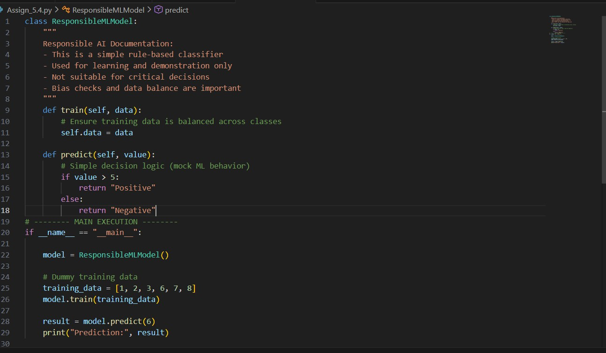

Output:

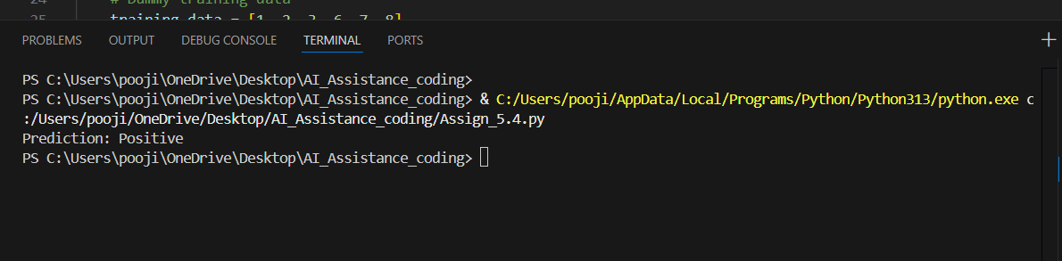

Explanation:
This task builds a basic machine learning model.
Documentation explains accuracy limits and proper usage. The model warns against use in high-risk decisions.
Bias checks and explainability are encouraged.
This promotes responsible and transparent AI deployment.

