Assignment-2.3
2303A51303
Batch-05
Task1:
Prompt: Generate Python code that reads a text file and counts word
Code:

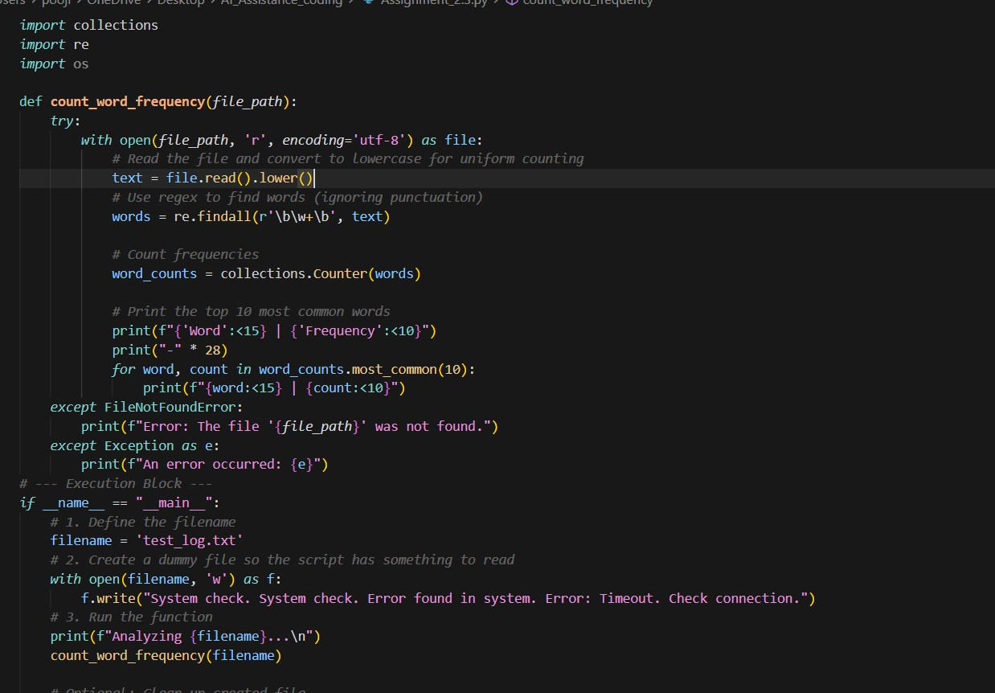
Output:
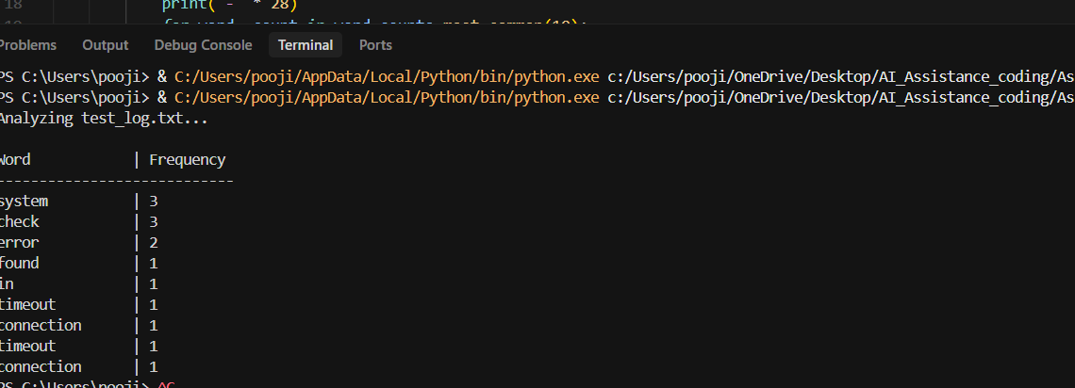

Explanation:
The code reads a text file, converts all text to lowercase, and extracts only words using a regular expression so punctuation is ignored.
It uses collections. Counter to count how many times each word appears in the file.
The program then displays the top 10 most frequent words in a neatly formatted table.
Error handling (try–except) is included to manage cases like missing files or unexpected issues.
In the main block, a sample file is created, analyzed by the function, and optionally removed after execution.

Task2:
Prompt: Write a python code that creates a text file, writes sample text and reads and displays the content
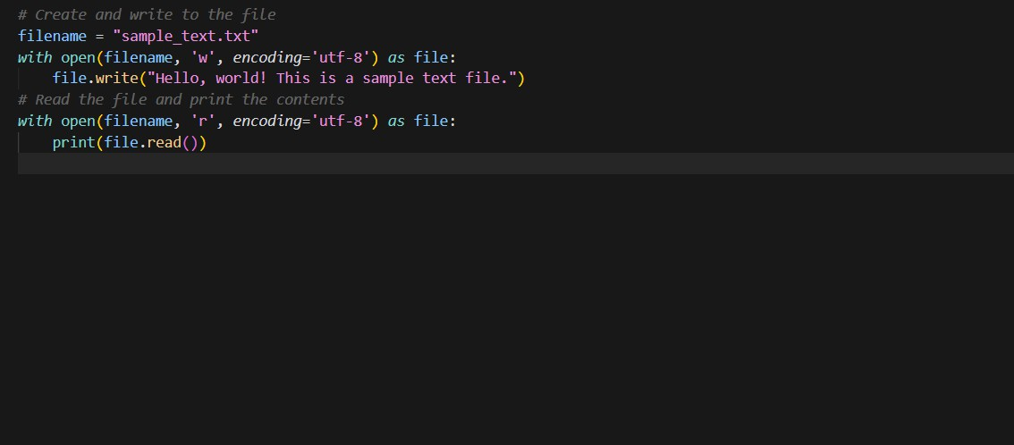
Code:

Output:
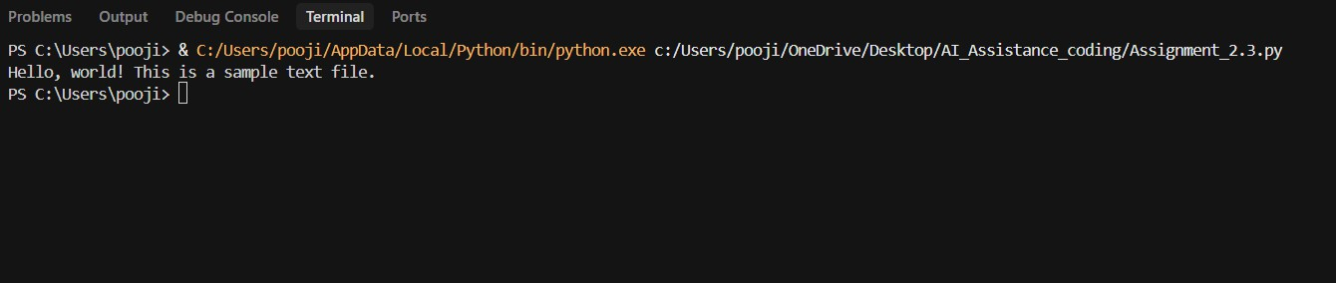

Explanation:
The program creates a text file named sample.txt using write mode. It writes sample text into the file using the write() function.
The file is then opened in read mode to access its contents. The read() function is used to read the entire file content.
Finally, the content of the file is displayed on the screen using print().

Task3:
Prompt: Write a python code read a CSV file and calculate mean, min, and max.
Code:
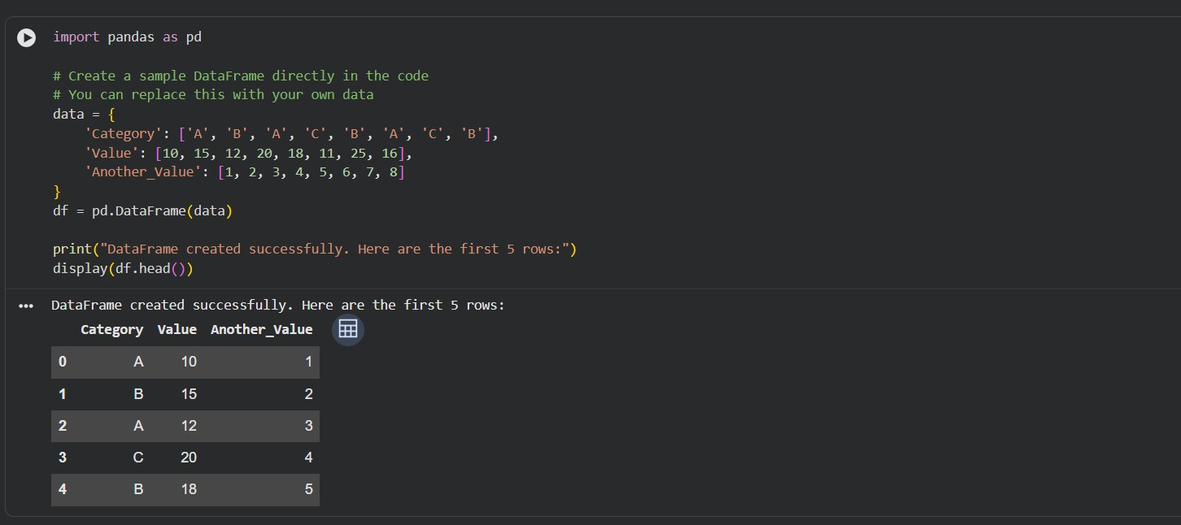
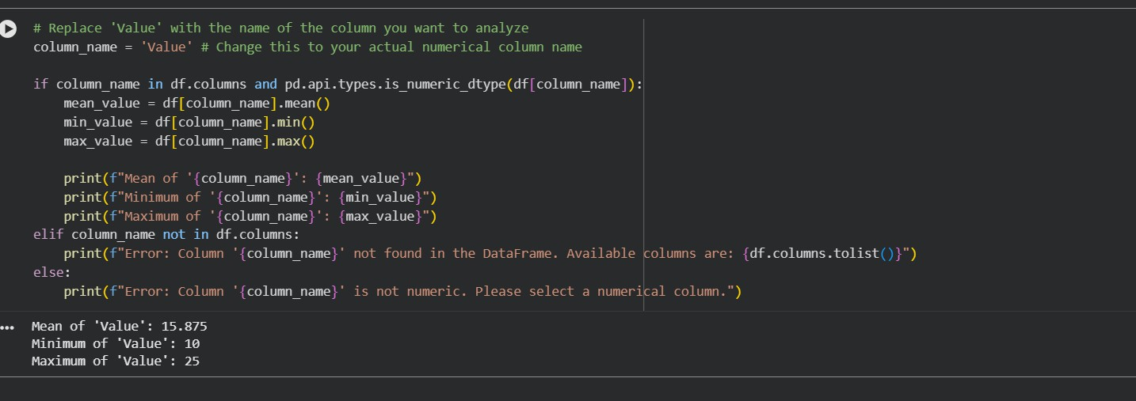

Output:

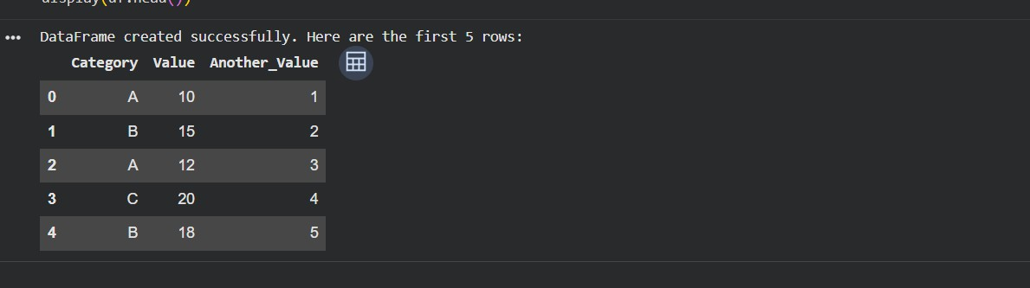

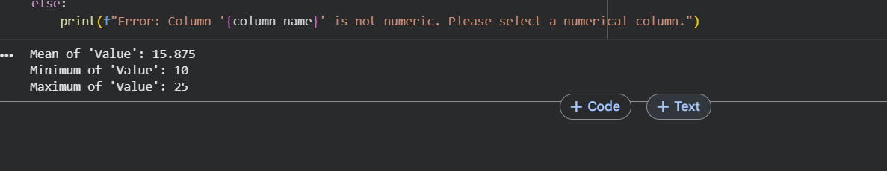
Explanation:
The code creates a Pandas data frame with sample categorical and numerical data. It displays the first five rows to preview the dataset.
The program checks whether the selected column (Value) exists and is numeric.
If valid, it calculates and prints the mean, minimum, and maximum values of that column.

Task4:

Prompt: write a python code for generate: Bubble sort ,Python’s built-in sort()and Compare both implementations.

Code:

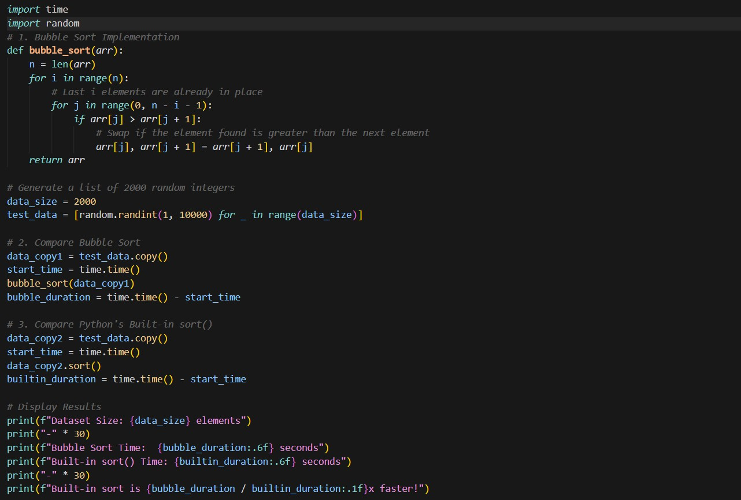
Output:
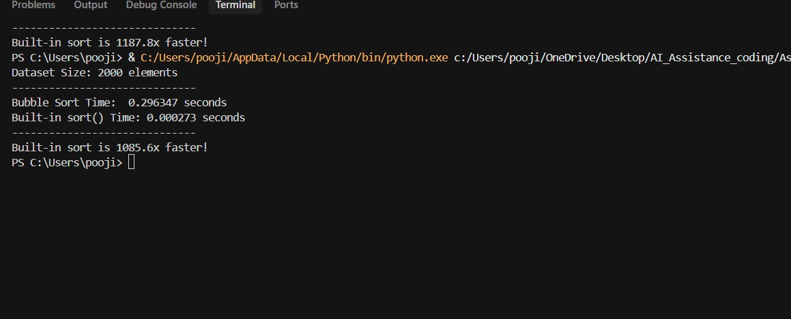
Explanation: The program implements Bubble Sort and measures the time taken to sort 2000 random numbers.
Bubble Sort repeatedly compares adjacent elements and swaps them, making it slow for large datasets.
The same data is sorted using Python’s built-in sort() method, which uses an efficient algorithm.
Execution time for both methods is calculated using the time module. The results show that Python’s built-in sort is many times faster than Bubble Sort

