ASSIGNMENT 7.3
ShaikSabina
2303A51303
Batch – 05
TASK – 01 :
Prompt : Identify and fix the syntax error in a Python function add(a, b) where the function definition is incorrect. Correct the code and briefly explain what the error was and how it was fixed with example usage.
Code :
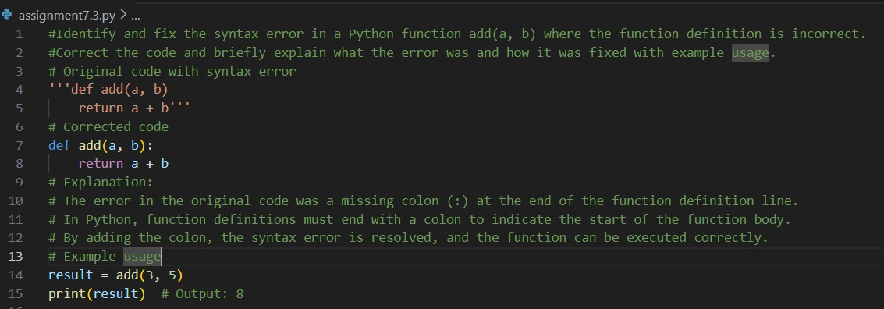
Output :

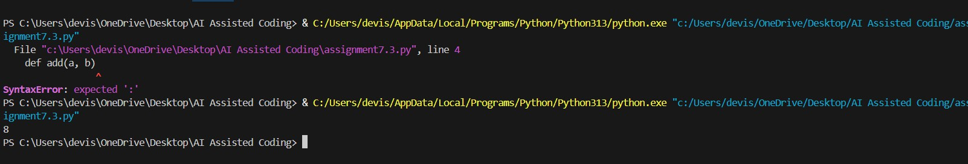
Explanation :
The original function had a syntax error because the colon (:) was missing at the end of the function definition. In Python, the colon is required to start the function body. Adding the
colon fixes the error, allowing the function to run correctly. The example shows the function successfully adding two numbers and printing the result.

TASK – 02:
Prompt : Find and fix a logical error in a Python loop that causes it to run endlessly. Correct the loop and briefly explain why the issue occurred and how it was resolved. Give both the original erroneous code and the corrected code.
Code :

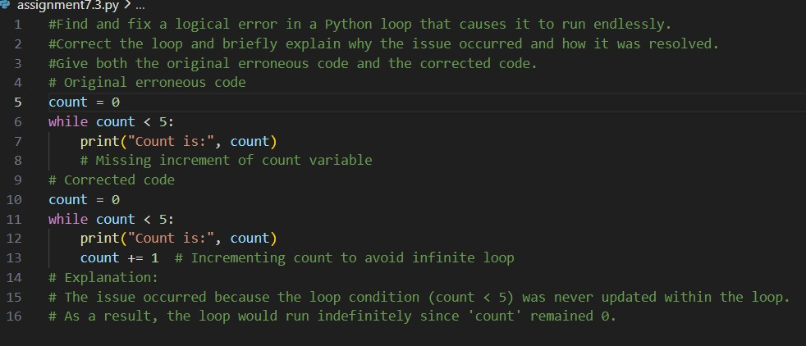
Output :
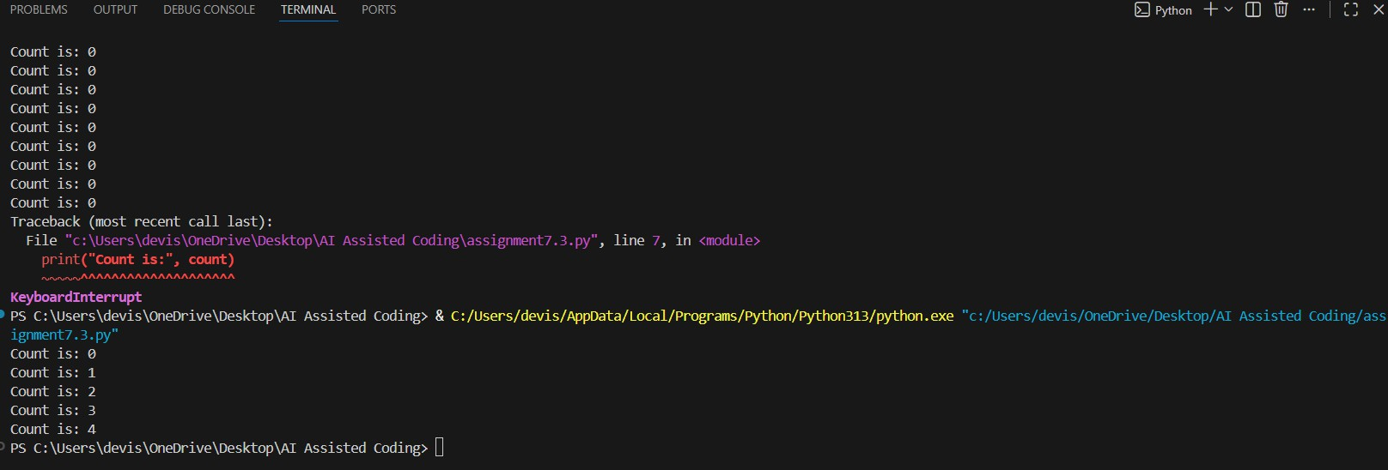
Explanation :
The loop ran endlessly because the count variable was never updated inside the loop. Since the condition count < 5 always remained true, the loop never stopped. Adding an increment to count inside the loop updates the condition and allows the loop to terminate correctly.

TASK 3 :
Prompt : Identify the runtime error in a Python function that performs division. Fix the issue using proper error handling and explain how the solution prevents the program from crashing.

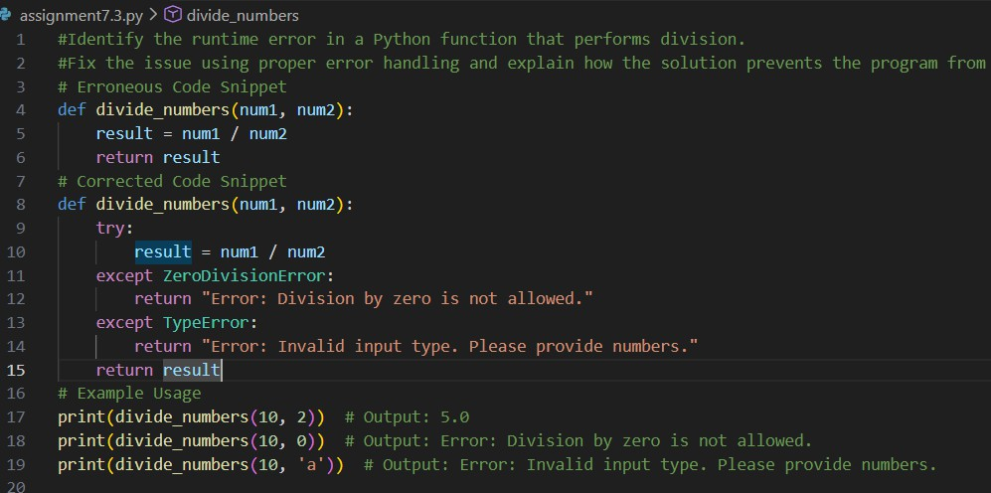
Code
Output :

Explanation :
The erroneous code snippet does not handle the case where the second number (num2) is zero, which would raise a ZeroDivisionError and cause the program to crash. Additionally, if non-numeric types are passed as arguments, a TypeError would occur. The corrected code snippet includes a try-except block to catch these specific exceptions. This prevents the program from crashing by providing user- friendly error messages instead of terminating unexpectedly.

TASK – 04
Prompt : Find and correct the error in a Python class constructor where the required parameter is missing. Fix the class and briefly explain why this parameter is necessary. Give both the incorrect and corrected versions of the code.
Code :
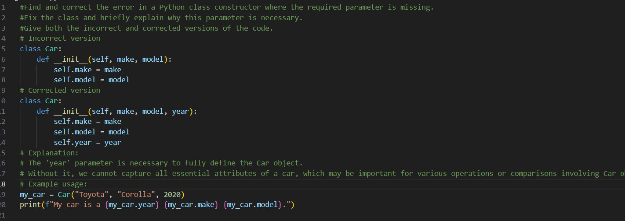
Output :

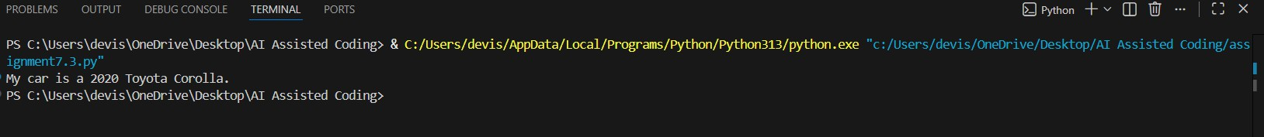
Explanation :
The incorrect version of the class was missing the year parameter, so the Car object did not contain
complete information. The corrected constructor includes the year parameter to properly initialize all essential attributes of a car. This allows each object to store full details and be used correctly in the program.

TASK – 05
Prompt : Detect and fix the error in a Python program caused by accessing an invalid list index. Implement a safe way to access list elements and explain the fix.Give both the erroneous code and the corrected code with an explanation.
Code :
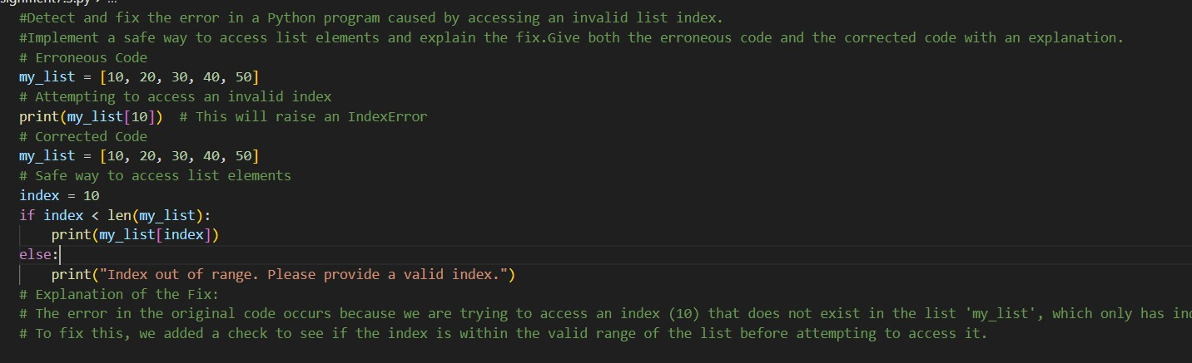
Output :

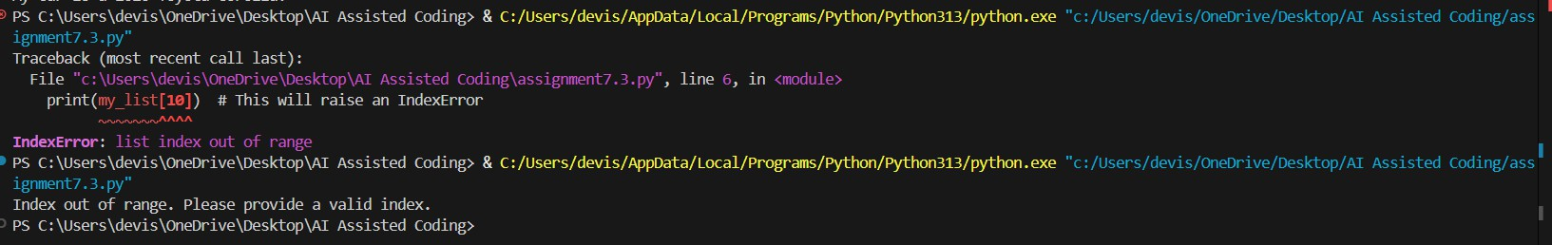
Explanation :
The error occurred because the program tried to access an index that does not exist in the list. In the corrected code, a length check is added before accessing the list element. This ensures the index is within the valid range and prevents the program from crashing due to an IndexError.

