ASSSIGNMENT 9.3
SHAIK SABINA
2303A51303
Batch – 05

TASK – 01 :
Code :
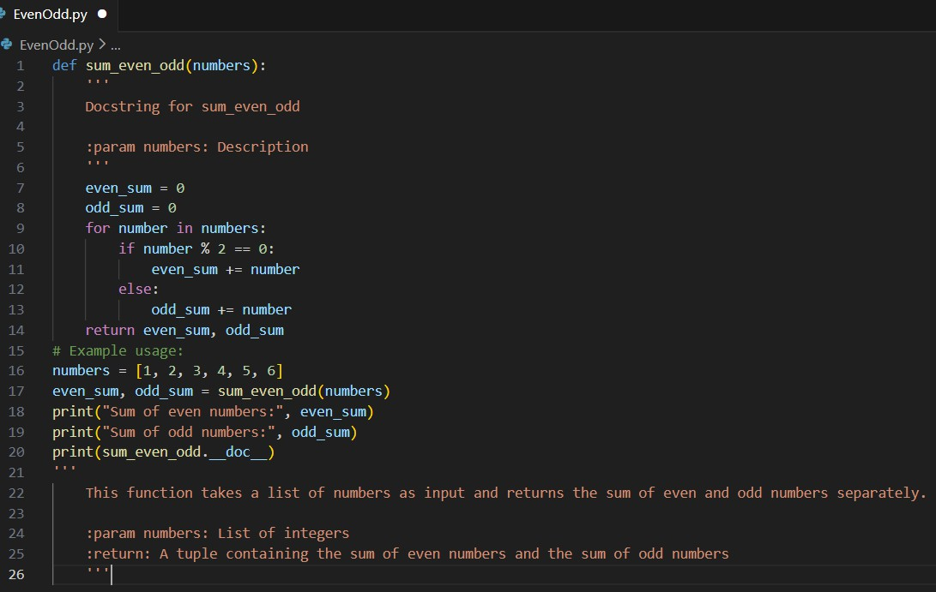
Output :

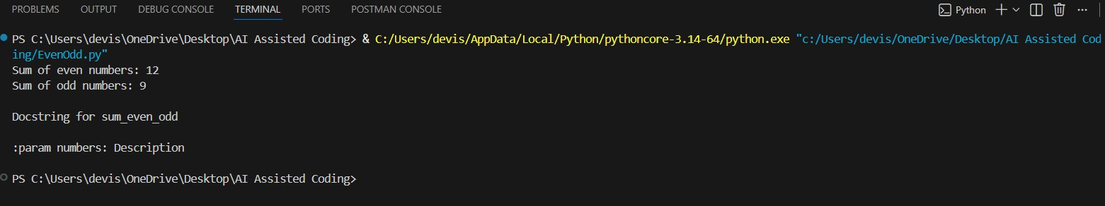
Explanation :
- The manual docstring is too brief and does not clearly explain the function.
- It fails to describe the return values, making it incomplete.
- The AI-generated docstring clearly explains the purpose of the function.

- It properly describes the input parameter and output.
- Overall, the AI-generated docstring is clearer, more correct, and more complete than the manual one.

TASK – 02 :
Code:
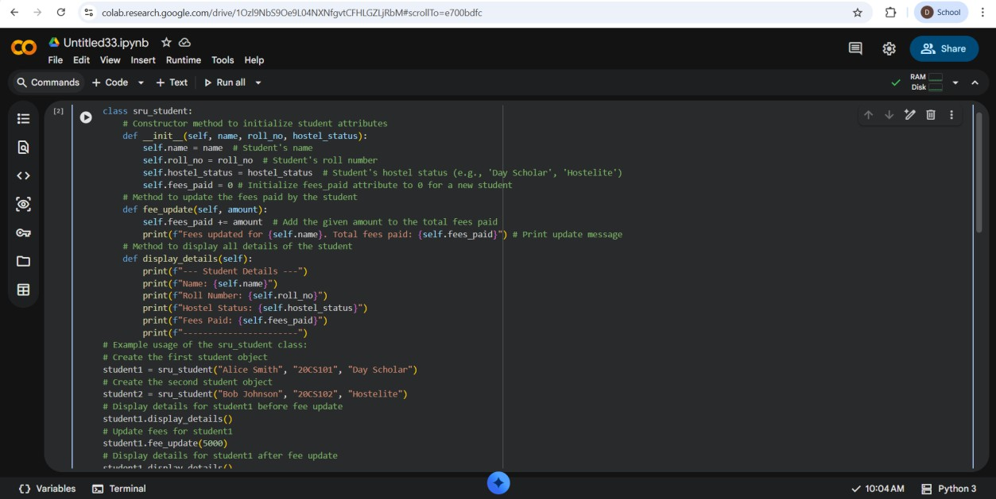
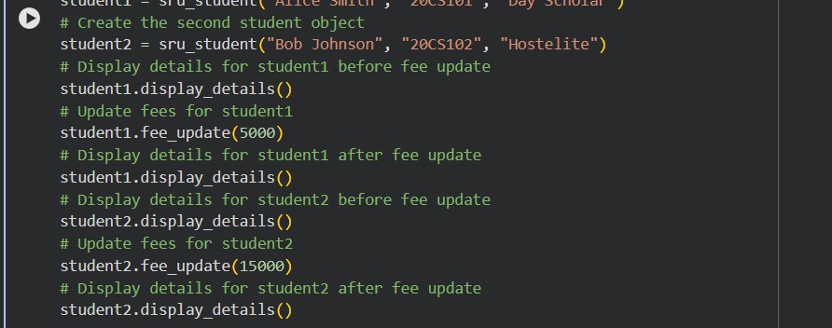

Output :
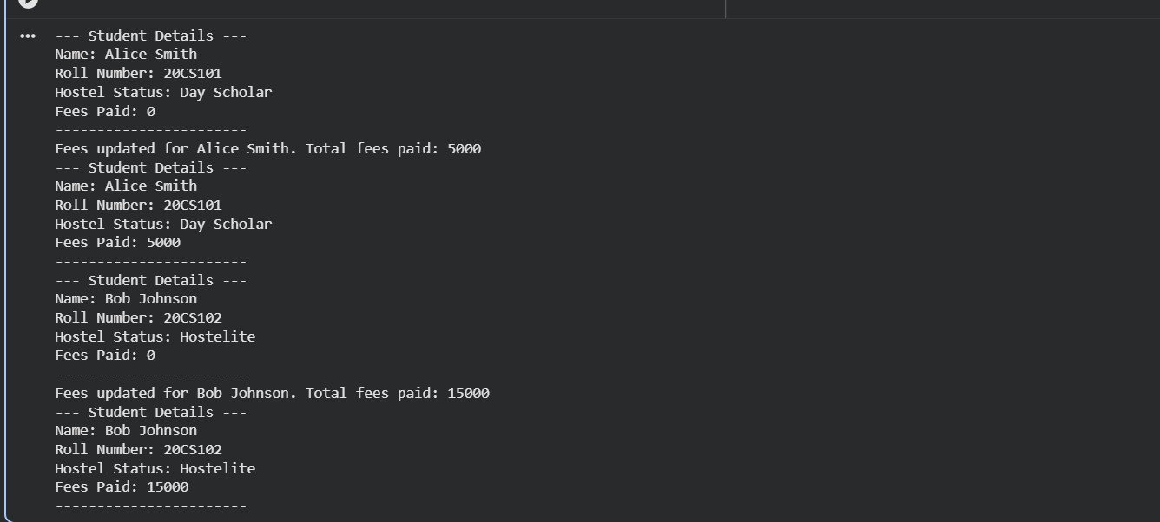
Explanation :
- Manual documentation is written by developers who understand the code deeply and can explain its purpose clearly.
- It gives better explanations, but it takes more time and effort to create.
- AI-generated documentation is created automatically and is quick and consistent.
- However, AI documentation may be too general and may not capture the real intention behind the code.
- Structured documentation explains what each function does, its inputs, and outputs in an organized way.
- This makes the code easier to read, maintain, and work on as a team.

TASK – 03:
Code :
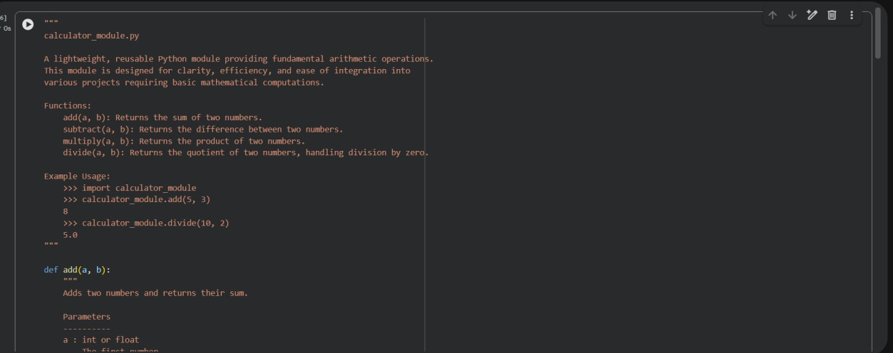

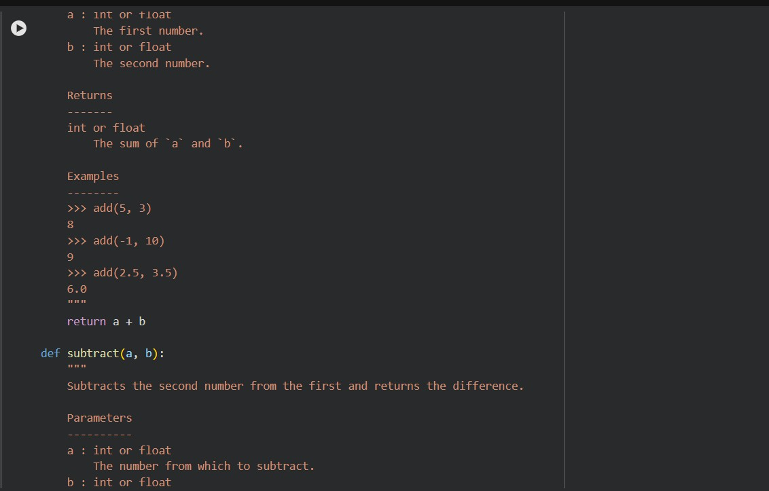
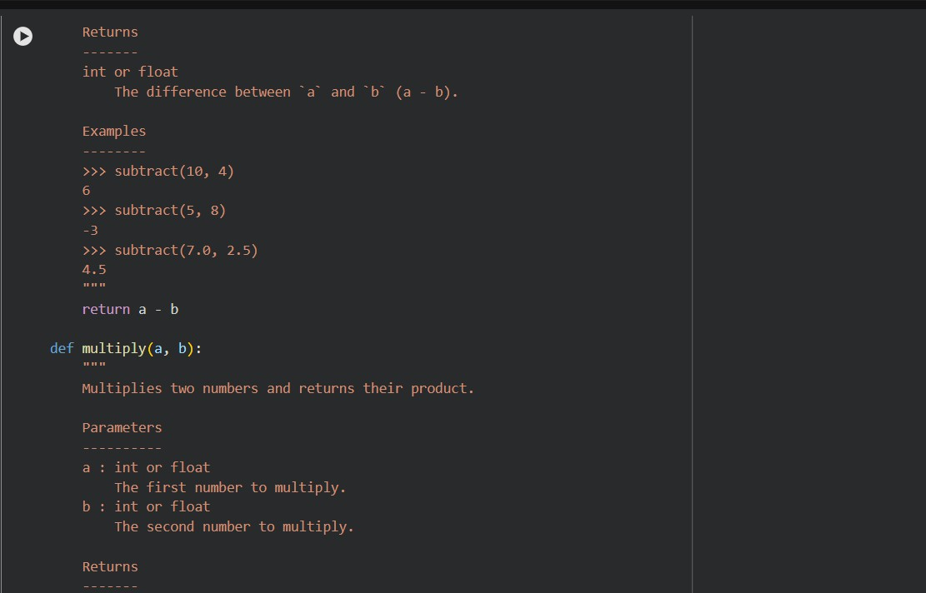

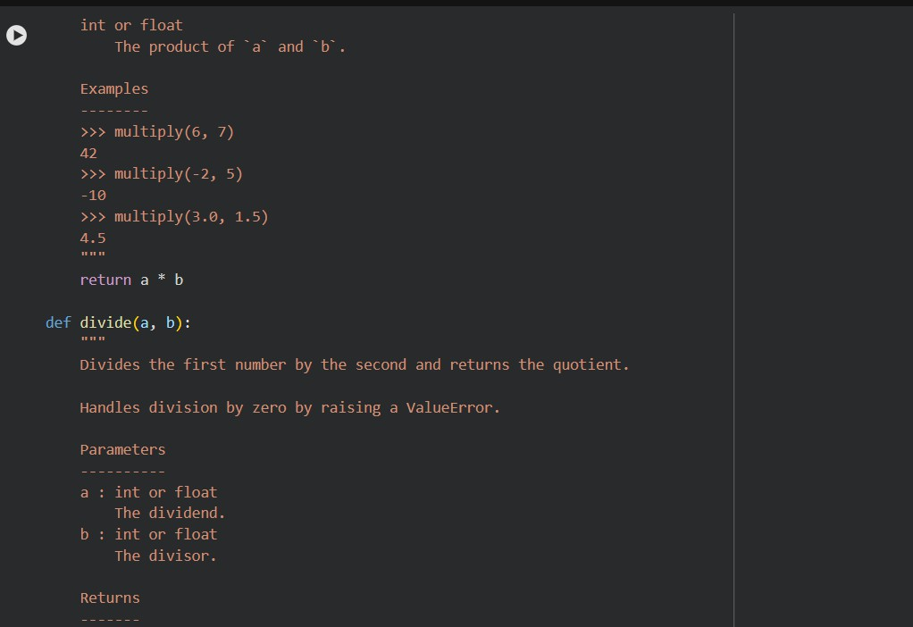
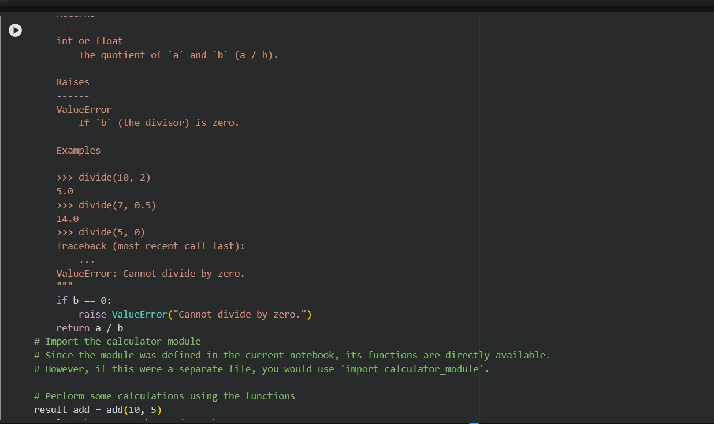

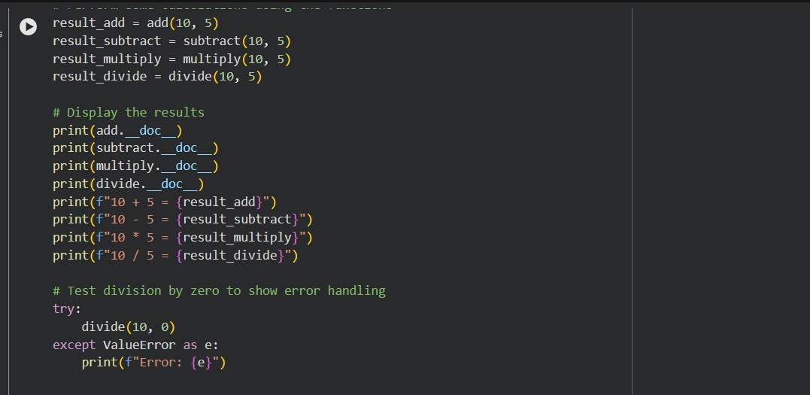
Output :
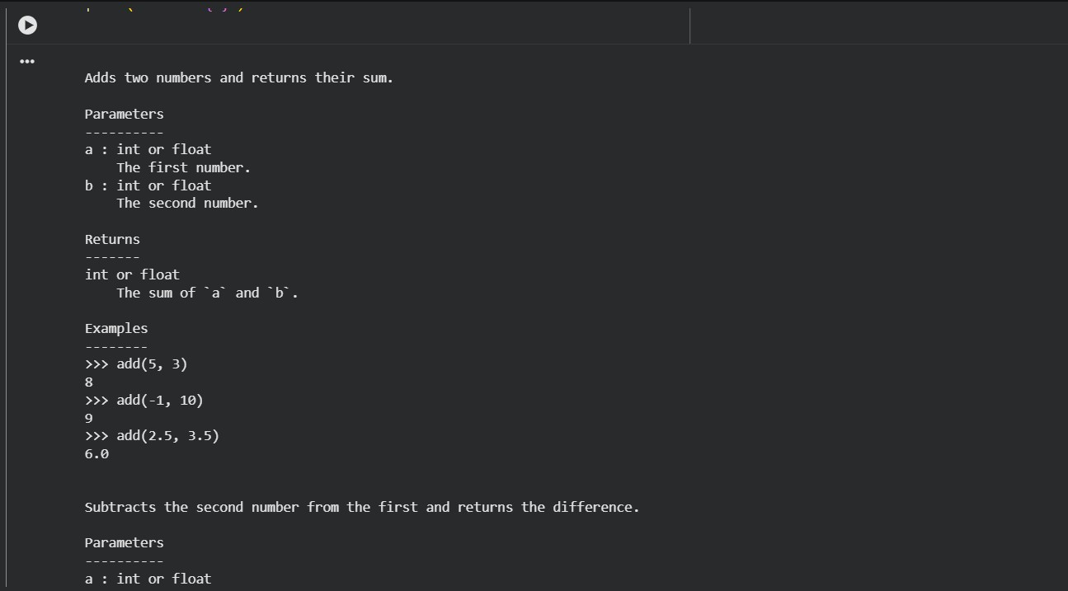

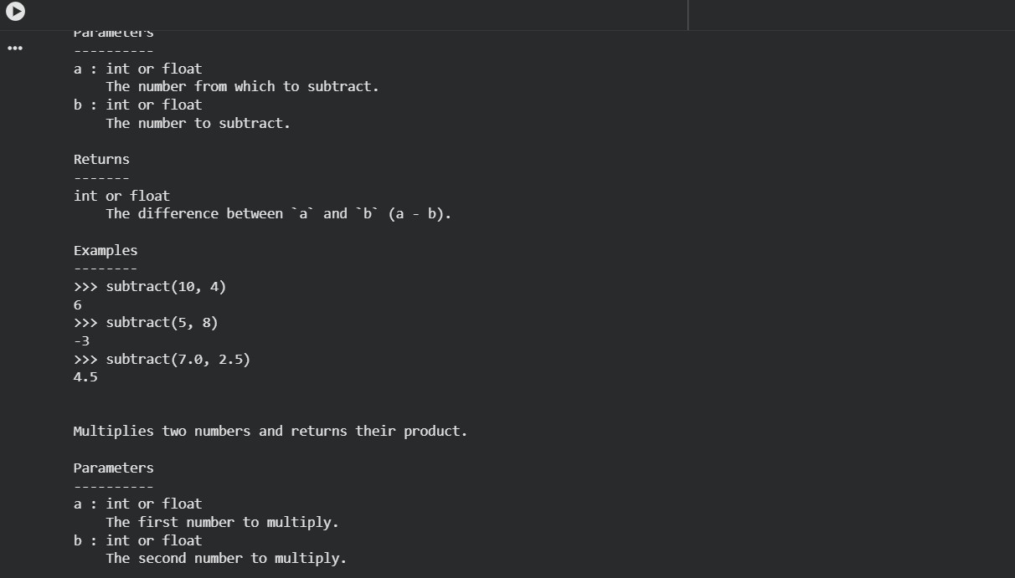
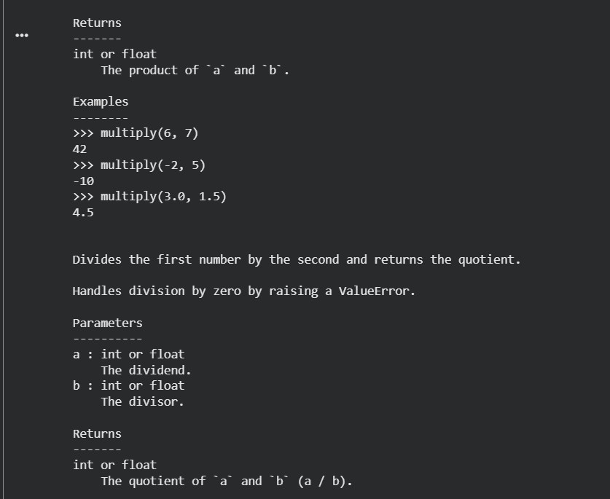

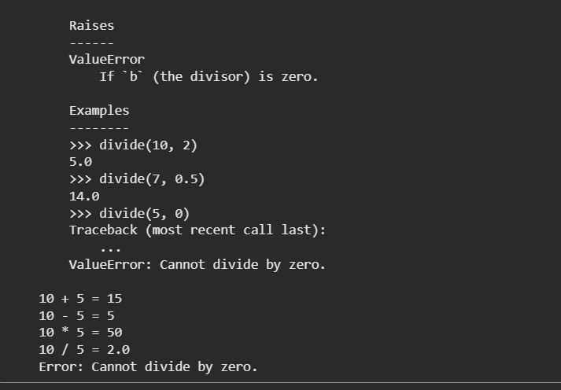
Explanation :
- Manual documentation is written with a full understanding of the code logic and design decisions, while AI-generated documentation is created automatically based on code patterns.
- Manual documentation follows strict documentation standards (such as NumPy style) more accurately, whereas AI documentation may not
always fully follow these formats.
- AI-generated documentation is faster and saves time, but it can miss edge cases or exceptions.
- Manual documentation is usually more precise and reliable, especially for reusable or shared modules.
- AI documentation improves readability for beginners.

