ASSIGNMENT 8.4
SHAIK SABINA
2303A51303 BATCH – 05

TASK – 01
Prompt : Write Python unit tests using unit test for a square(x) function
following TDD. After tests fail, implement square(x) in a separate file so all tests pass.
Code:
Square_test.py
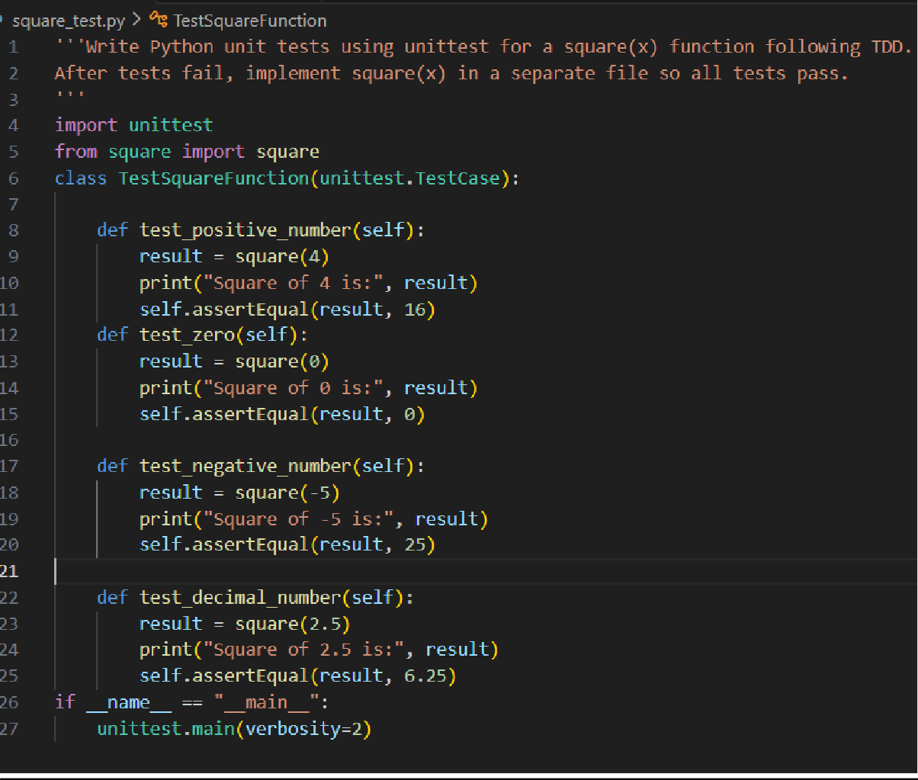

square.py
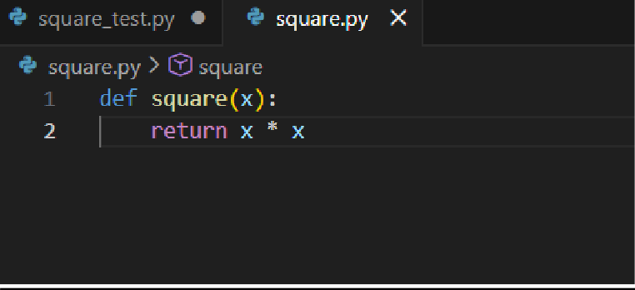
Output :
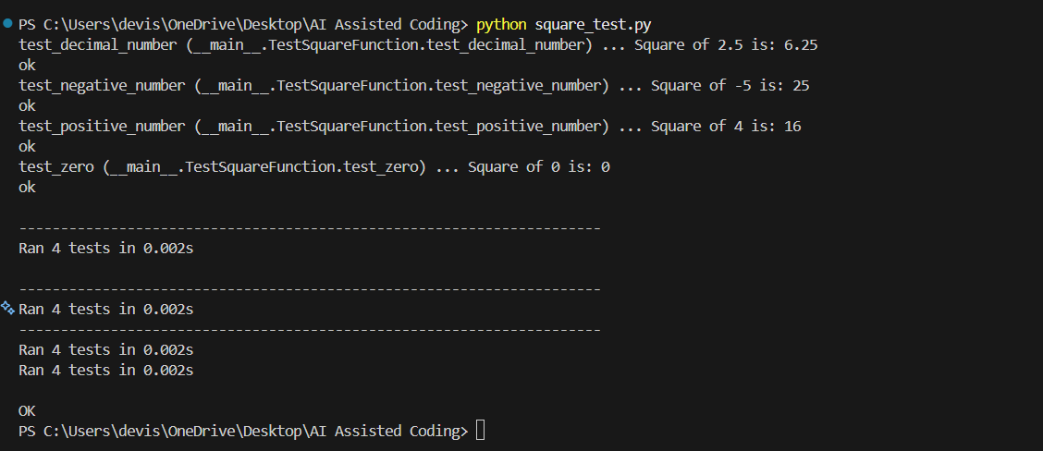
Explanation :
- We follow Test-Driven Development (TDD), where tests are written first.
- The test file (test_square.py) contains unit tests using the unit test module.
- These tests check the square(x) function for:
  - positive numbers
  - zero
  - negative numbers
  - decimal values
- Initially, tests fail because the function is not implemented.
- Then the function square(x) is implemented in a separate file (square.py).
- After implementation, all test cases pass successfully.
- This ensures the function works correctly for different inputs.

TASK – 02
Prompt : #Write unit tests using unittest to validate email addresses for a user registration system. The tests should cover valid and invalid email formats such as missing @, missing domain, missing username, and incorrect structure.
Then, implement the validate_email() function in a separate file so that all test cases pass. The implementation must strictly follow the behavior defined by the test cases.
Code :
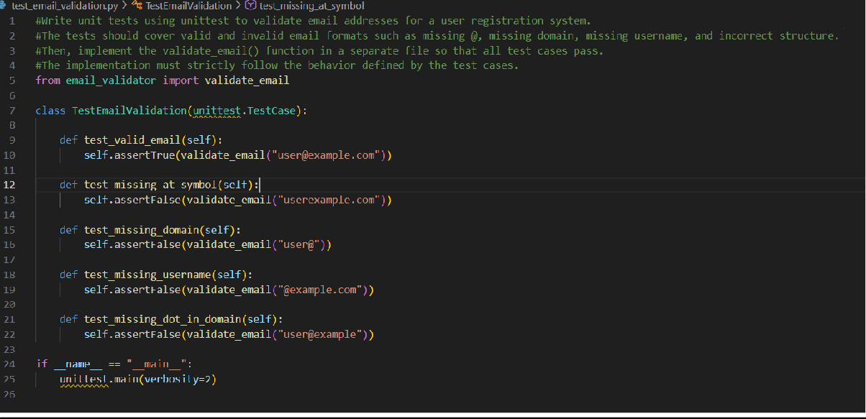
test_email_validator.py
email_validator.py
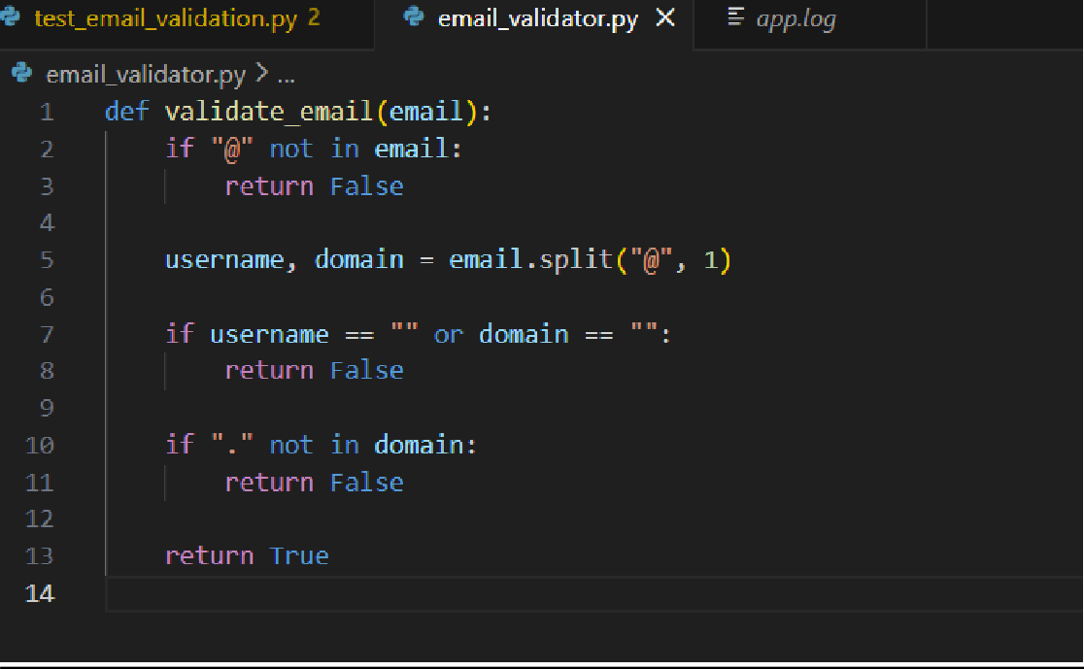

Output :

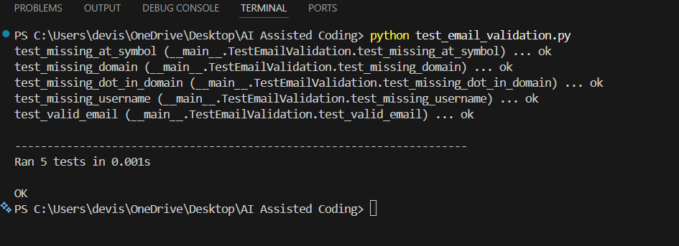
Explanation :
- Unit tests are written first to define valid and invalid email formats.
- Tests check cases like missing @, missing domain, and incorrect structure.
- The validate_email() function is implemented in a separate file.
- The function logic is written only to satisfy test expectations.
- This follows the Test-Driven Development (TDD) approach.

TASK – 03
Prompt : Write unit tests using unittest to determine the correct maximum value among three inputs. Test normal cases, equal values, negative numbers, and mixed values. After the tests are written, implement the find_max(a, b, c) function in a separate file so that all tests pass. The function logic must be
derived strictly from the test cases.
Code :

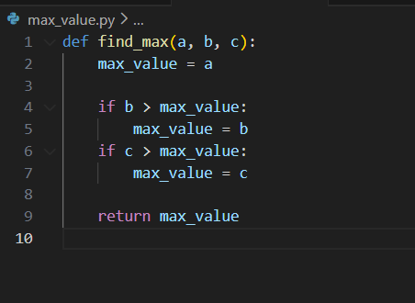
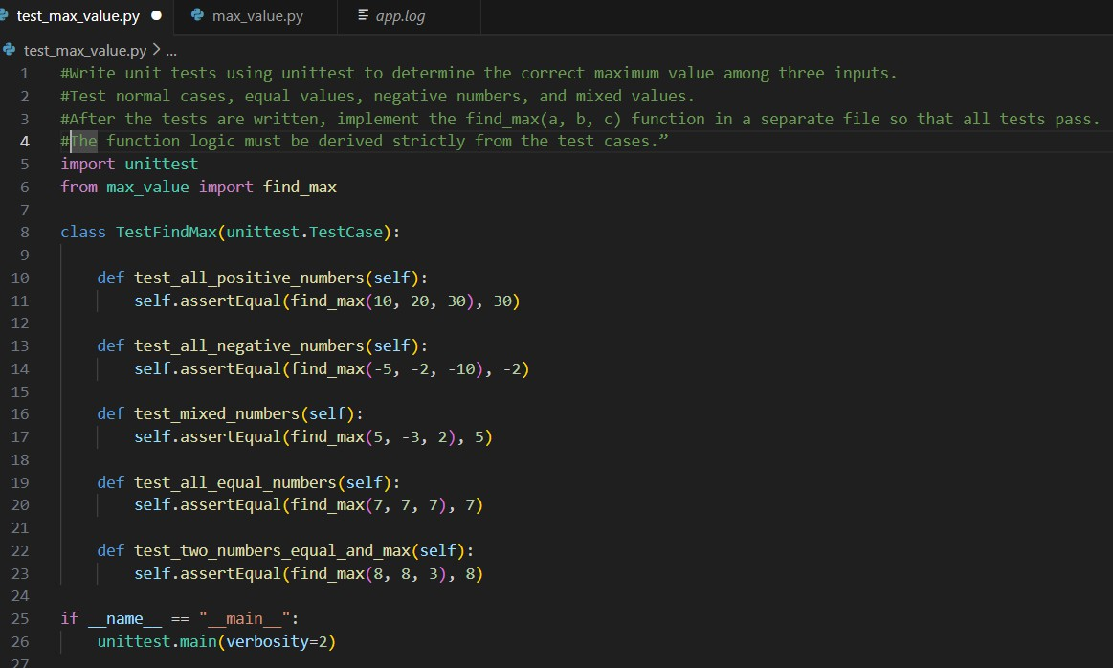
test_max_value.py

Output :
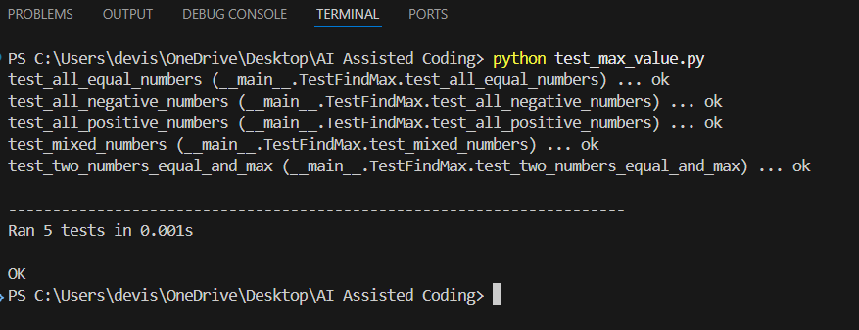
Explanation :
- Test cases are written first to define expected behavior.
- Tests cover positive numbers, negative numbers, equal values, and mixed cases.
- The function find_max() is implemented only after tests are completed.
- The logic is derived strictly from test expectations.
- This demonstrates the Test-Driven Development (TDD) approach.

TASK – 04
Prompt : Write unit tests using unittest for a ShoppingCart class.
The tests should verify adding items, removing items, and calculating total price. After all tests are written, implement the ShoppingCart class in a
separate file so that all tests pass. The implementation must strictly follow the behavior defined in the test cases.
Code :
test_shopping_cart.py

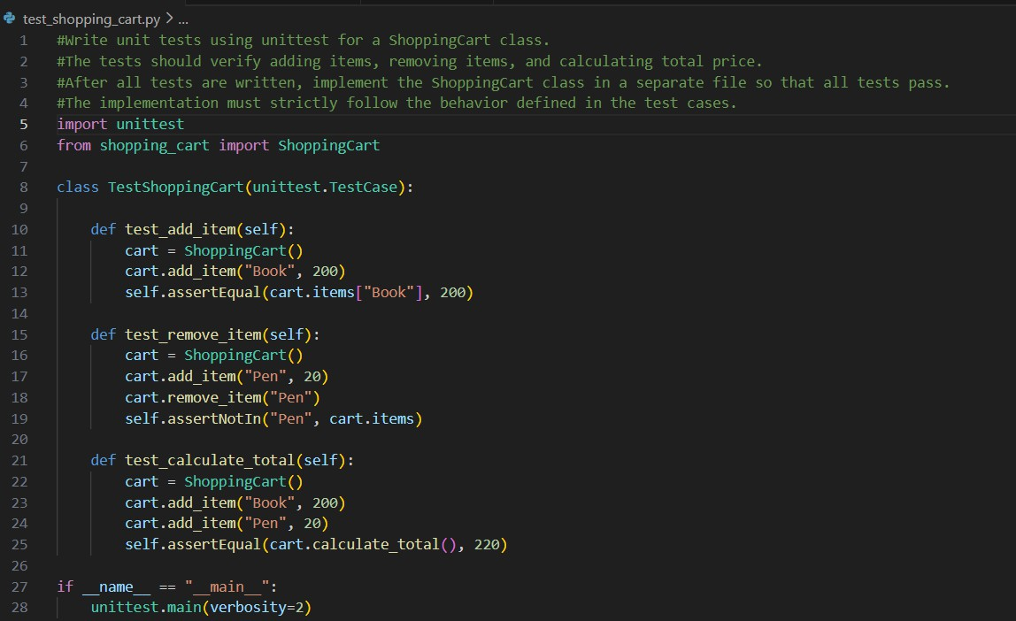
Shopping_cart.py
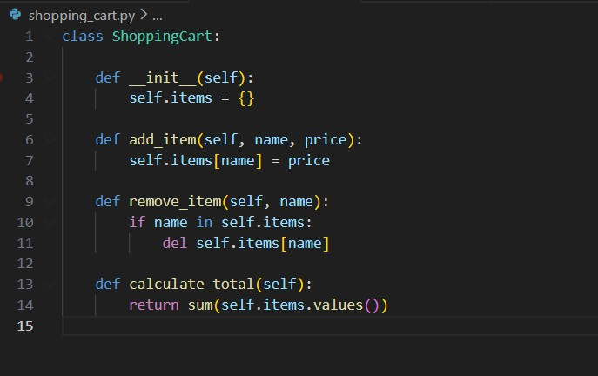
Output :

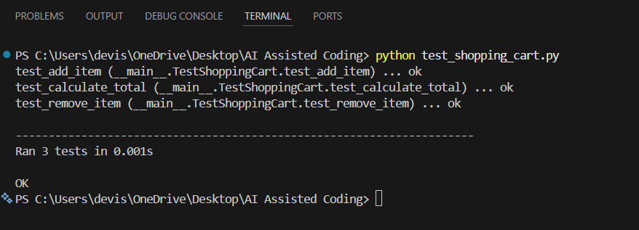
Explanation :
- Unit tests define expected cart behavior.
- Tests cover adding, removing items, and total calculation.
- ShoppingCart class is implemented after tests.
- All logic is derived from test expectations.
- This demonstrates TDD in a class-based design.

TASK – 05
Prompt : Write unit tests using unittest to check whether a string is a
palindrome. Tests should cover simple palindromes, non-palindromes, and case variations. After writing tests, implement the is_palindrome() function in a separate file so that all tests pass.
Code :

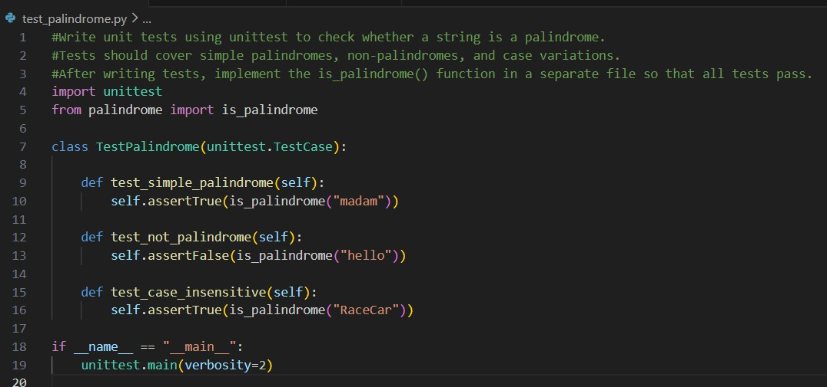
test_palindrome.py
palindrome.py
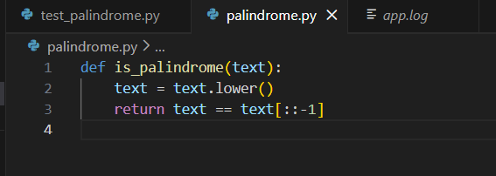

Output :
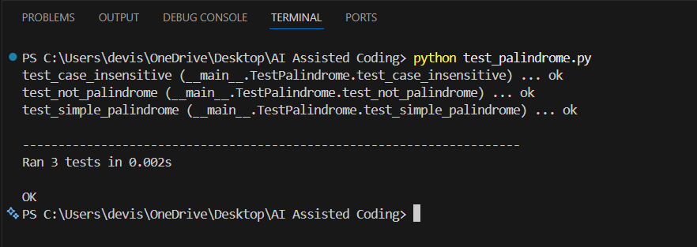
Explanation :
- Tests are written first to define palindrome behavior.
- Cases include valid, invalid, and case-insensitive strings.

- The function is implemented only after tests.
- All tests pass, proving correct TDD usage.

