Assignment-3.3

2303A51303

Batch-05

Task01:
Prompt:
Generate a Python program that:
- Reads: Previous Units (PU),Current Units (CU),Type of Customer, Calculates units consumed, Implements logic directly in the main program (no functions)
Code:

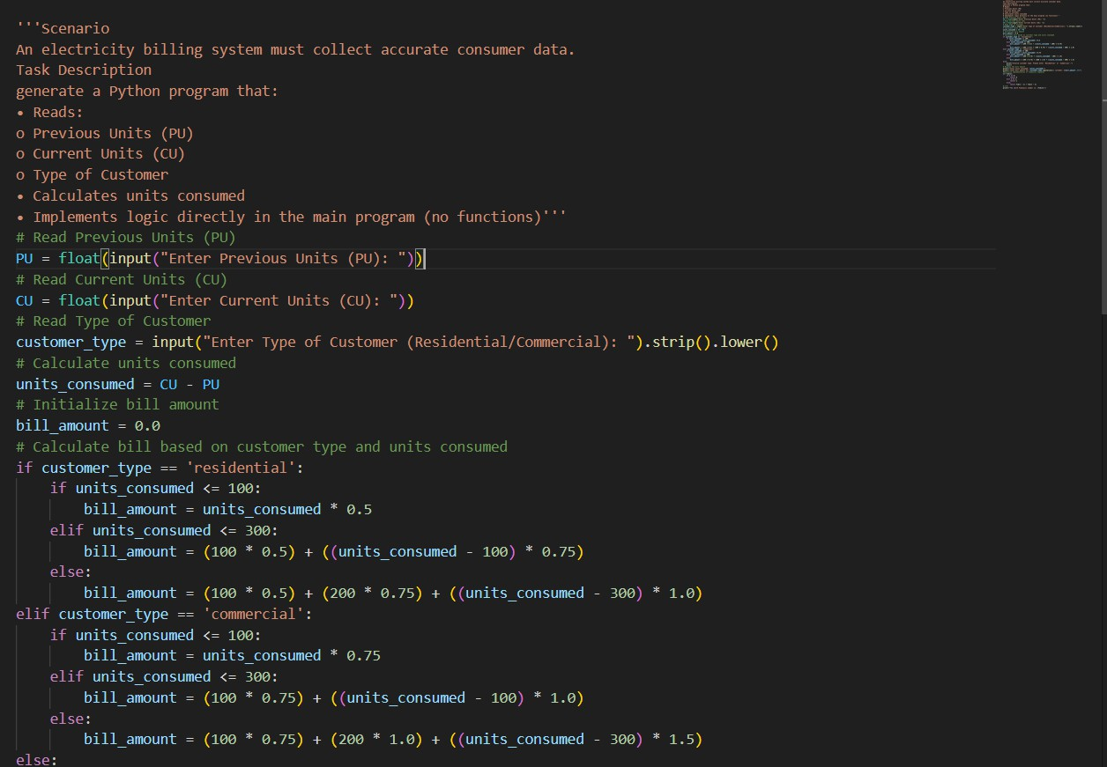

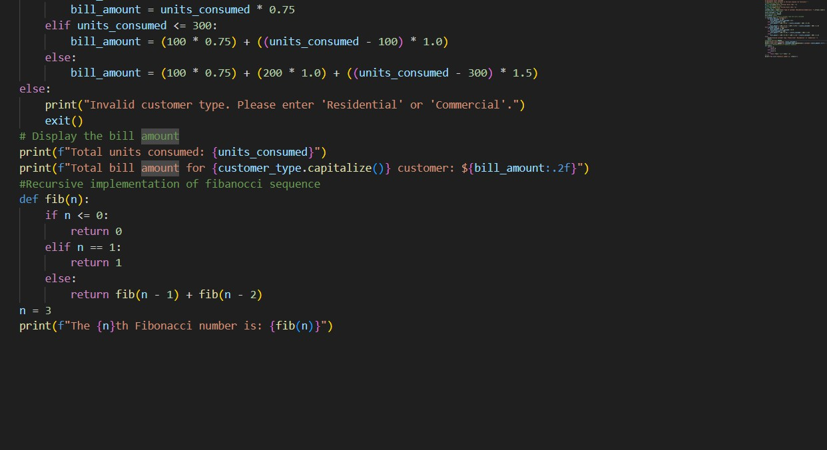
Output:
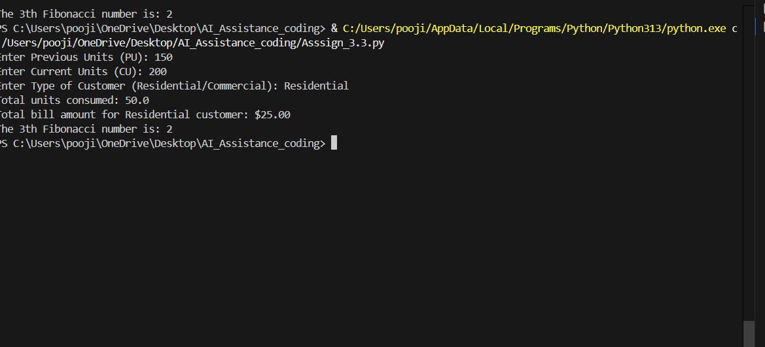
Explanation:
The program reads previous units, current units, and customer type to collect electricity consumption data. It calculates units consumed by subtracting previous units from current units.
Based on customer type (residential or commercial), different slab-wise billing rates are applied.
The total bill amount is computed and displayed along with units consumed.
A recursive Fibonacci function is included to demonstrate recursion by calculating the 3rd Fibonacci number.

Task02:
Prompt: Write a python code
Calculate Energy Charges (EC) and Use conditional statements based on: Domestic, Commercial, Industrial consumers
Improve readability using AI prompts such as: Simplify energy charge calculation logic, Optimize conditional statements

Code:

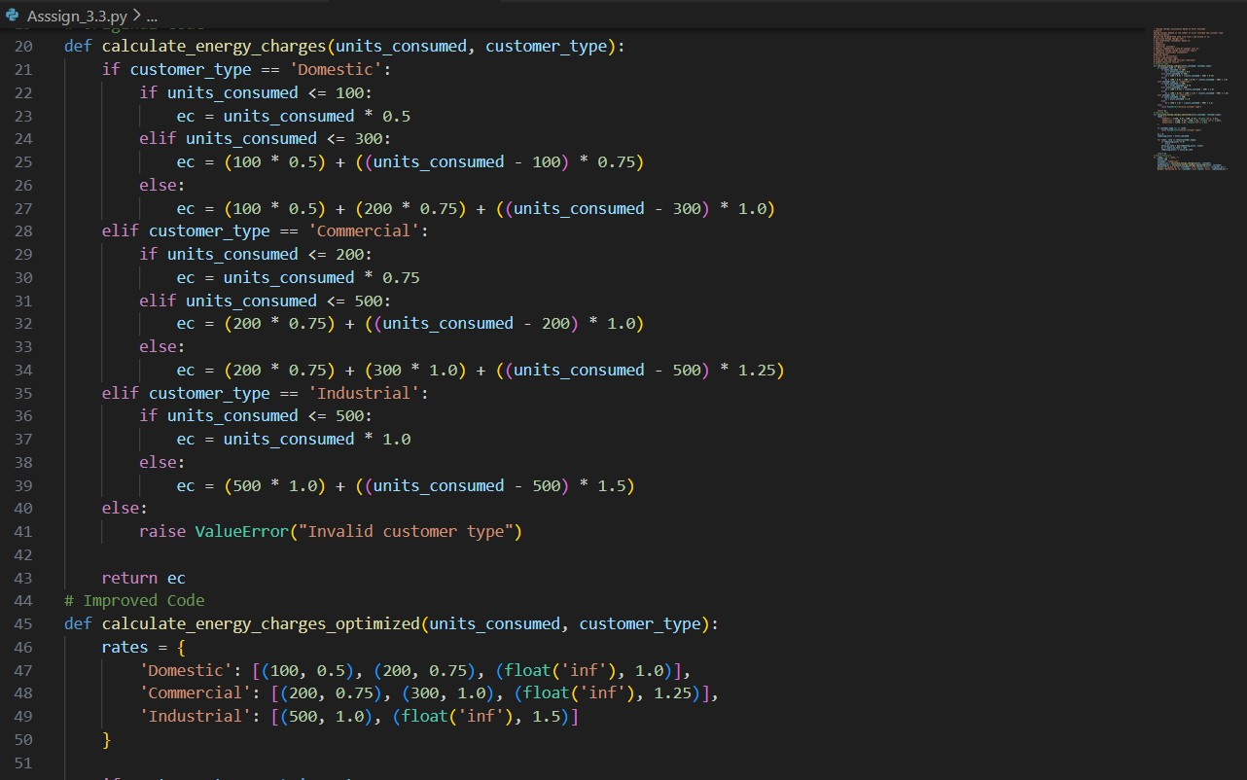

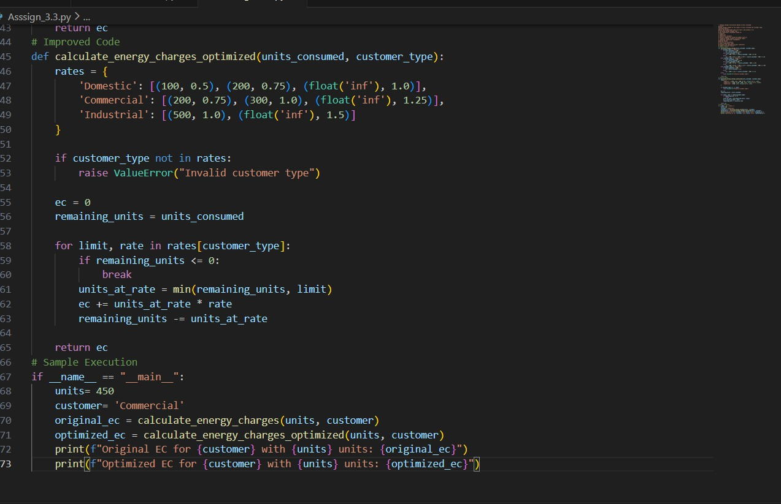
Output:
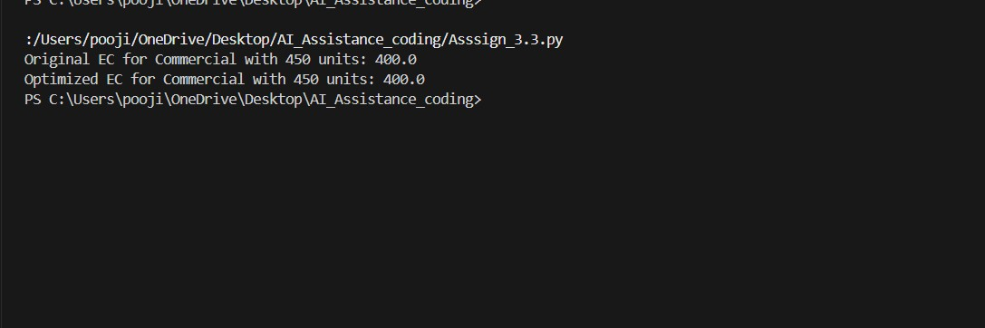
Explanation:
The original code uses nested if–elif conditions, making it longer and harder to maintain.
The optimized code stores slab limits and rates in a dictionary, improving readability and structure.
Adding or modifying tariff slabs is easier in the optimized version without changing logic flow. The optimized approach reduces code repetition by using a loop for
calculations. Both versions produce the same correct energy charge, but the optimized code is cleaner and scalable.

Task03:
Prompt: Python program that:
Uses user-defined functions to Calculate Energy Charges, Calculate Fixed Charges, Returns calculated values
Code:
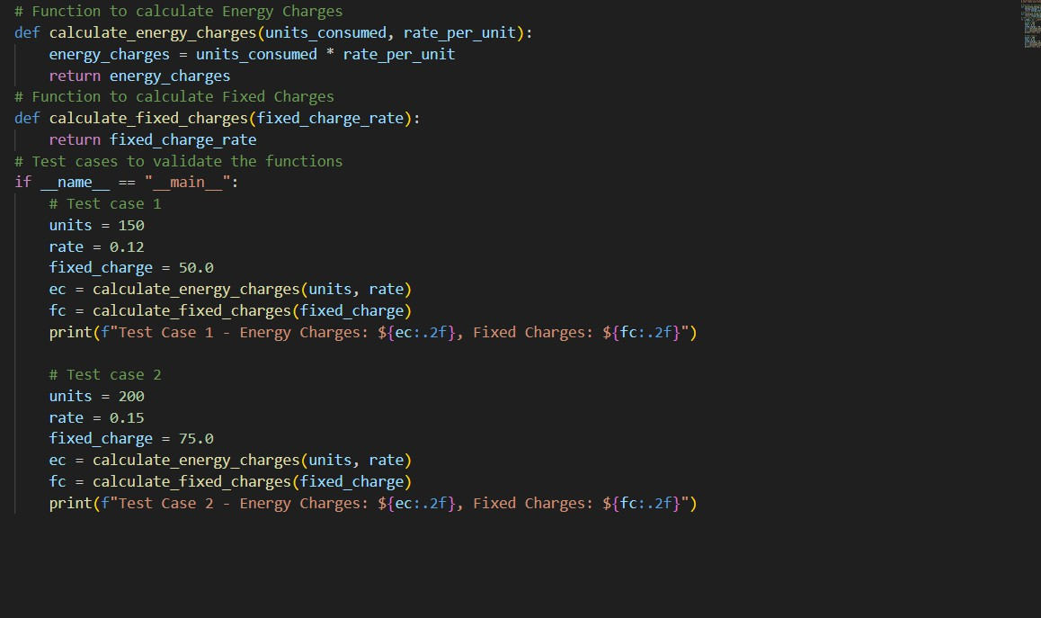
Output:
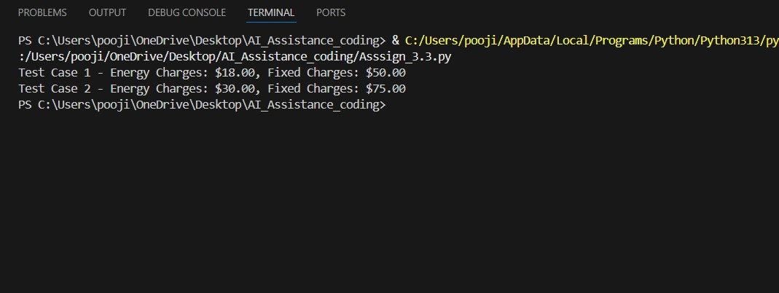
Explanation:
This program demonstrates reusable billing logic using user-defined functions.
The calculate_energy_charges() function computes energy cost by multiplying units consumed with the rate per unit and returns the value.
The calculate_fixed_charges() function returns a fixed charge amount applicable to the

consumer.In the main block, multiple test cases are executed to validate the functions with different inputs.This approach improves code reusability, clarity, and makes billing calculations easy to maintain.

Task04:
Prompt: Write a python code to calculate the FC ,CC,ED, add electricity duty calculation
Code:

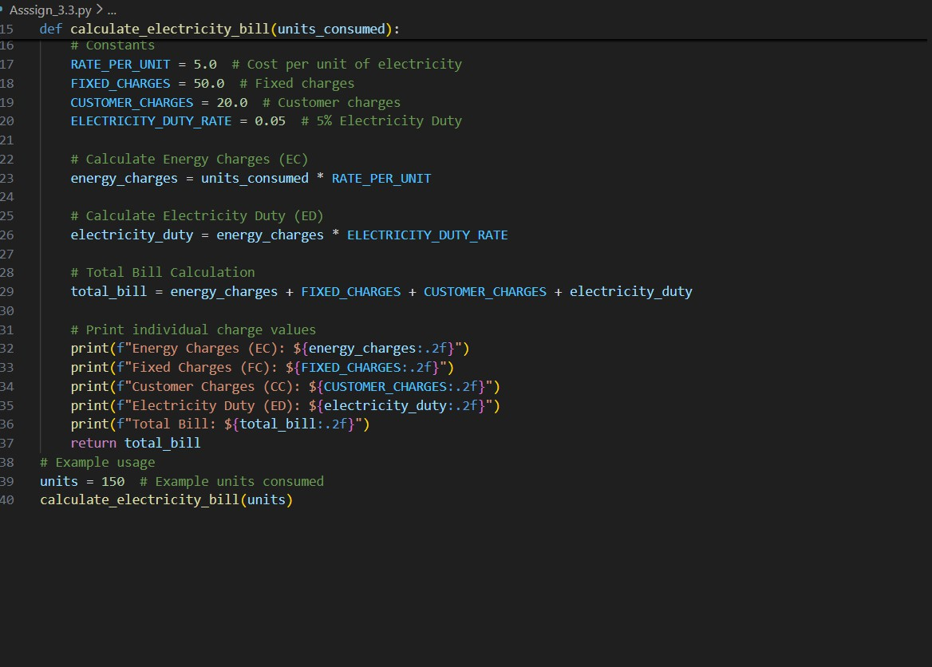
Output:
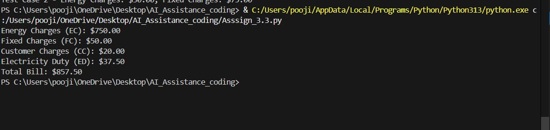

Explanation: This program calculates a complete electricity bill by including multiple charges. It first computes Energy Charges (EC) based on units consumed and a fixed per-unit rate.
Then it calculates Electricity Duty (ED) as a percentage of the energy charges. Fixed Charges (FC) and Customer Charges (CC) are added as constant values. Finally, all charges are summed and displayed clearly to produce the total bill.

Task05:
Prompt: Develop the final Python application to:
Calculate total bill: Total Bill = EC + FC + CC + ED
Display Energy Charges (EC), Fixed Charges (FC),Customer Charges (CC),Electricity Duty (ED),Total Bill Amount
Code:

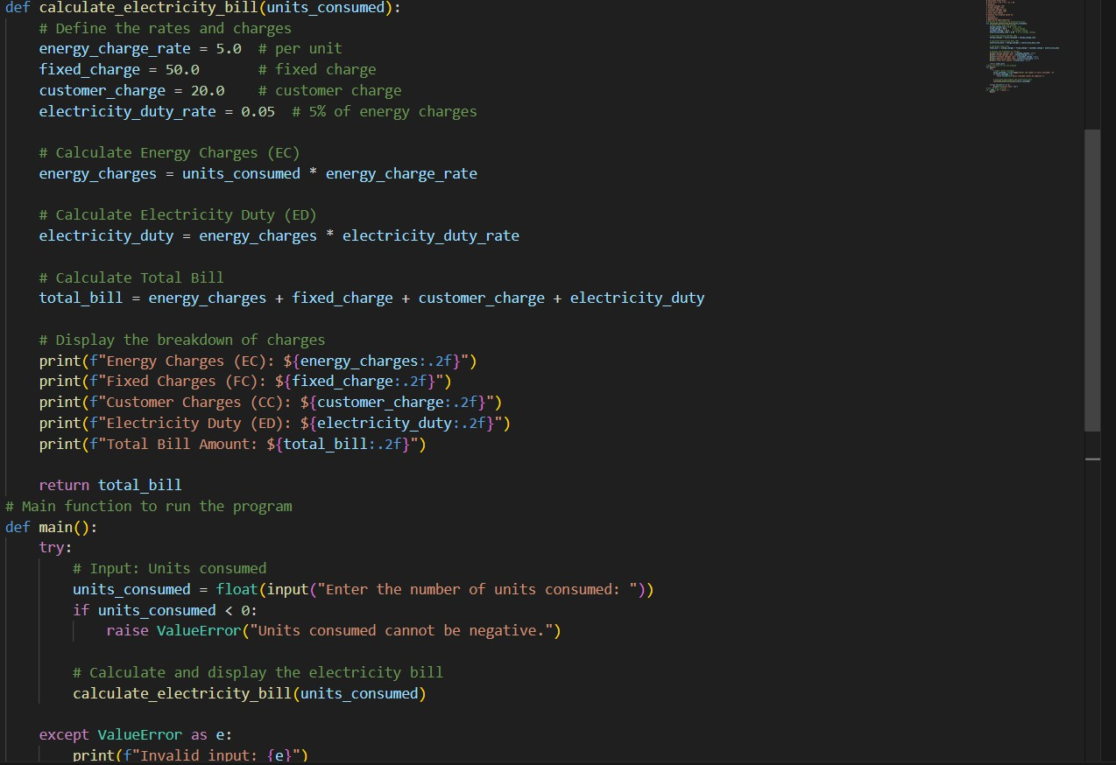

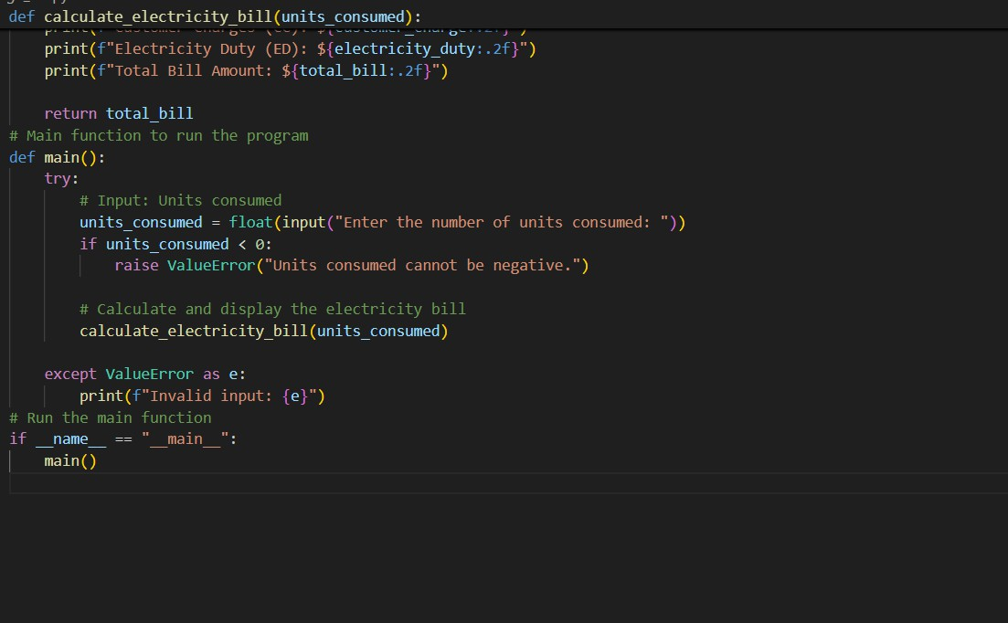
Output:

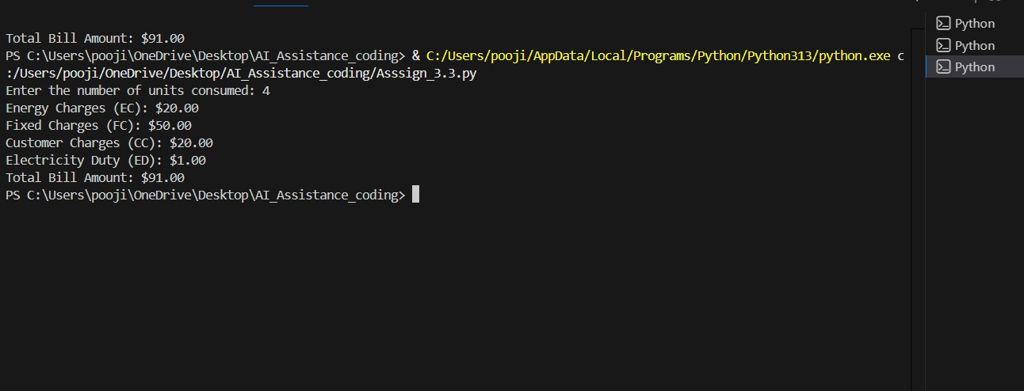
Explanation:
This program accurately calculates the total electricity bill by summing Energy Charges, Fixed Charges, Customer Charges, and Electricity Duty.
Clear variable names and step-by-step calculations make the code easy to read and understand.
Input validation ensures realistic values by preventing negative unit entries.
The detailed output displays each charge separately, improving transparency for users.

