AI-CODING
ASSIGNMENT-7.3
Name: S.Rajkumar
2303a52478
Bt-42
Task 1: Fixing Syntax Errors
AI Detection:
AI detects a SyntaxError because the colon (:) is missing after the function definition.
Corrected Code (AI Fix)
def add(a, b):
return a + b
Explanation
In Python, a colon is mandatory after function definitions.
The missing colon caused a syntax error, which was fixed by adding :.

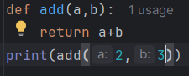

Output:
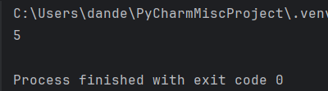
Task 2: Debugging Logic Errors in Loops
AI Detection:
AI identifies an infinite loop because the variable i is never incremented.
Corrected Code (AI Fix)
i = 1
while i<= 5:
print(i)
i += 1
Explanation
Without updating the loop variable, the condition remains true forever.
AI fixed the logic by adding i += 1.
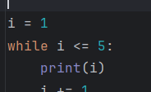

Output:
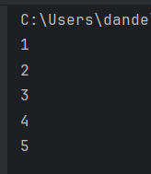
Task 3: Handling Runtime Errors (Division by Zero)
AI Detection
AI detects a ZeroDivisionError during runtime.
Explanation
Division by zero causes a runtime crash.
AI handled the error safely using try-except blocks.

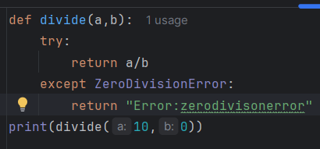
Output:
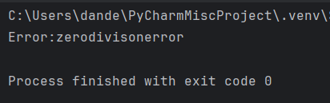
Task 4: Debugging Class Definition Errors
AI Detection
AI detects a TypeError because self is missing in the constructor.
Explanation
self refers to the current object.
Without self, instance variables cannot be accessed or stored properly.
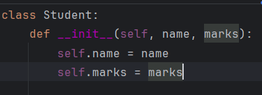
Task 5: Resolving Index Errors in Lists
AI Detection
AI identifies an IndexError because index 5 is outside the list range.

Explanation
AI prevents the crash by checking the list length before accessing the index.
Code fix:
