AI Assisted Coding Lab 11.4
Name:S.Rajkumar
2303A52478
Batch:42
Task 1: Stack Implementation for Undo Operations (LIFO)
Scenario:
You are building a text editor where users can undo their recent actions (typing, deleting, formatting). Each action must be reversed in Last-In-First-Out (LIFO) order
Prompt:Stack Implementation for Undo Operations (LIFO)
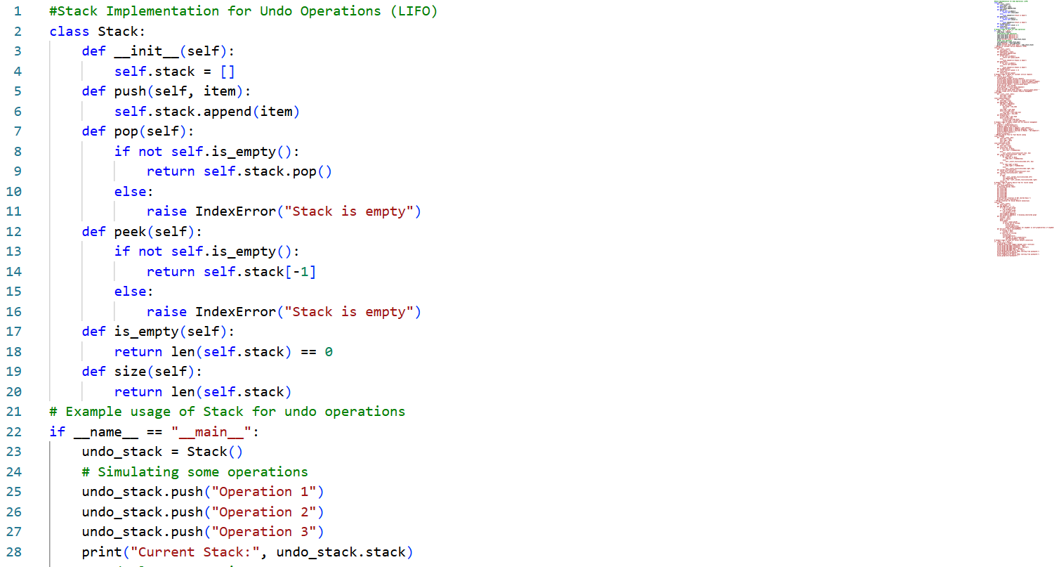
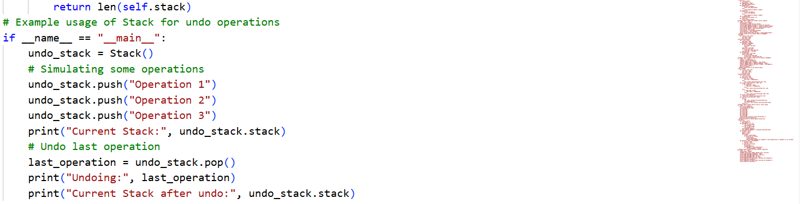
OUTPUT:
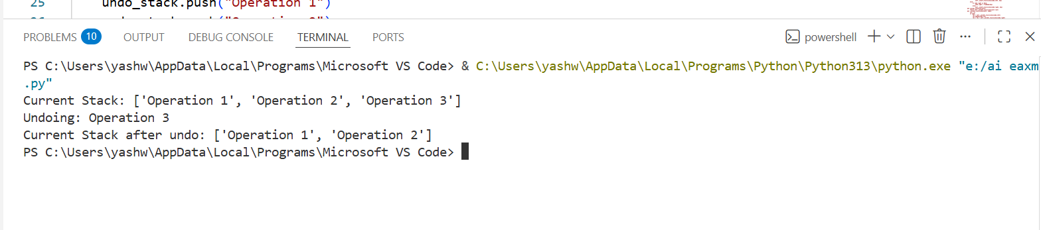
Task 2: Queue for Customer Service Requests (FIFO)
Scenario:
You are developing a customer support system where service requests mustbe handled in the order they arrive.
Prompt:Queue for Customer Service Requests (FIFO)
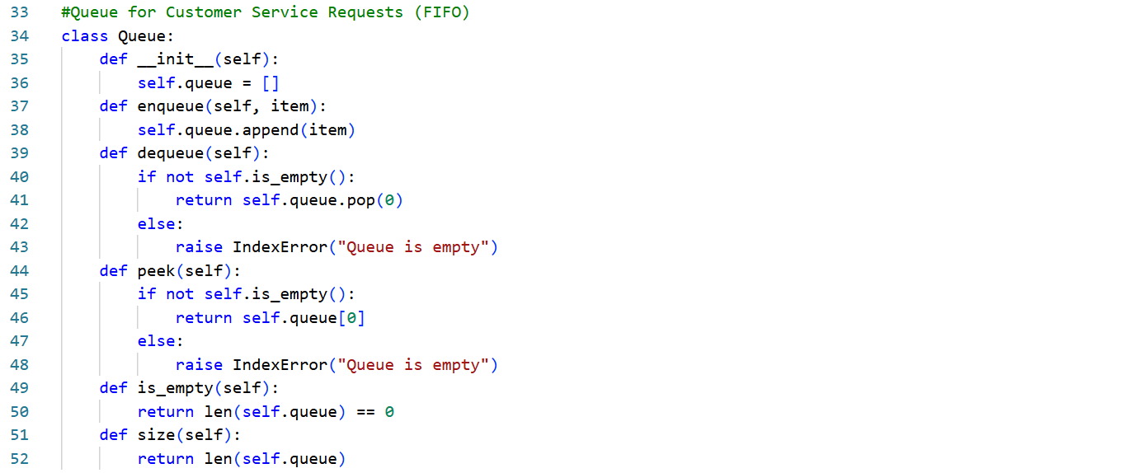
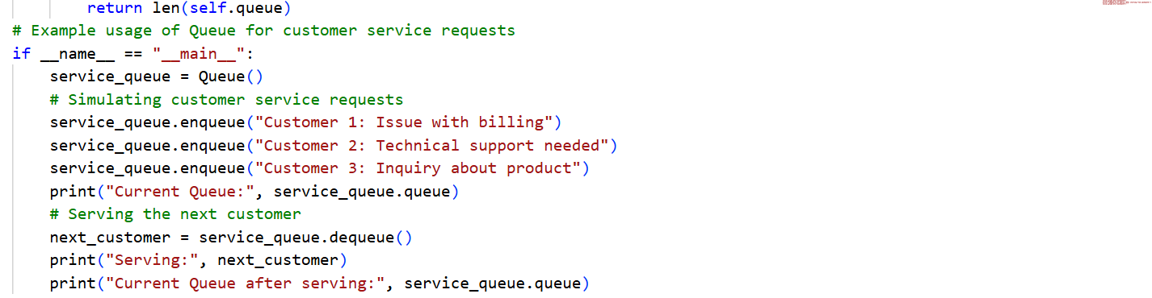
OUTPUT:
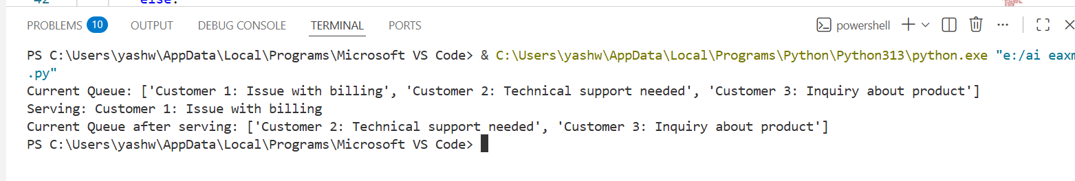
Task 3: Singly Linked List for Dynamic Playlist Management
Scenario
You are designing a music playlist feature where songs can be added or
removed dynamically while maintaining order.
Prompt:Singly Linked List for Dynamic Playlist Management
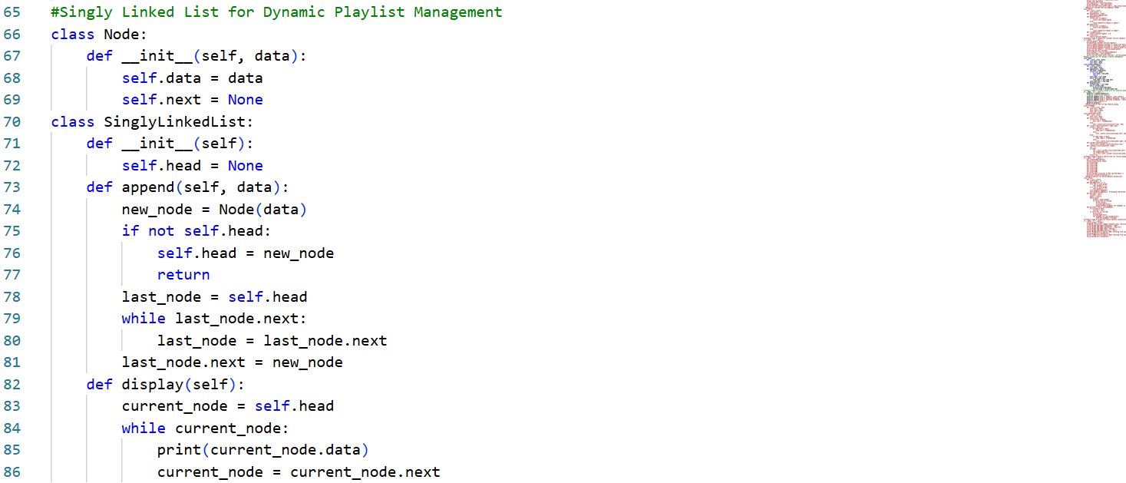

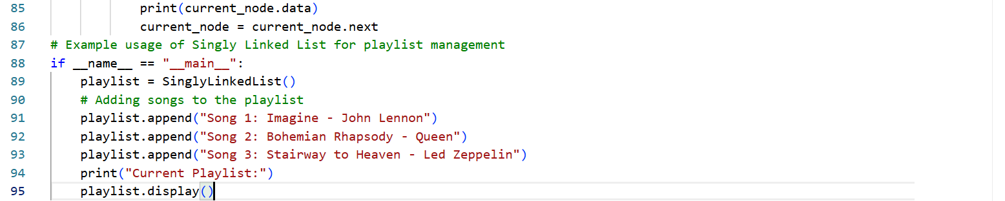
OUTPUT:
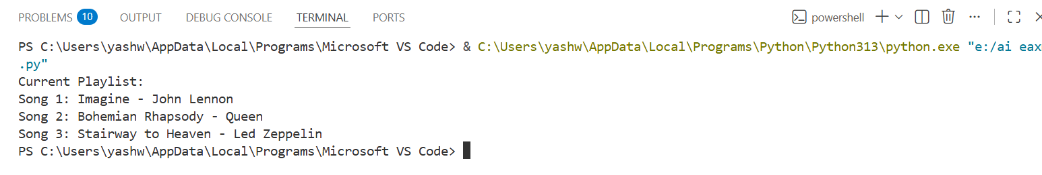

Task 4: Binary Search Tree for Fast Record Lookup
Scenario:
You are building a student record system where quick searching by roll
number is required.
Prompt:Binary Search Tree for Fast Record Lookup
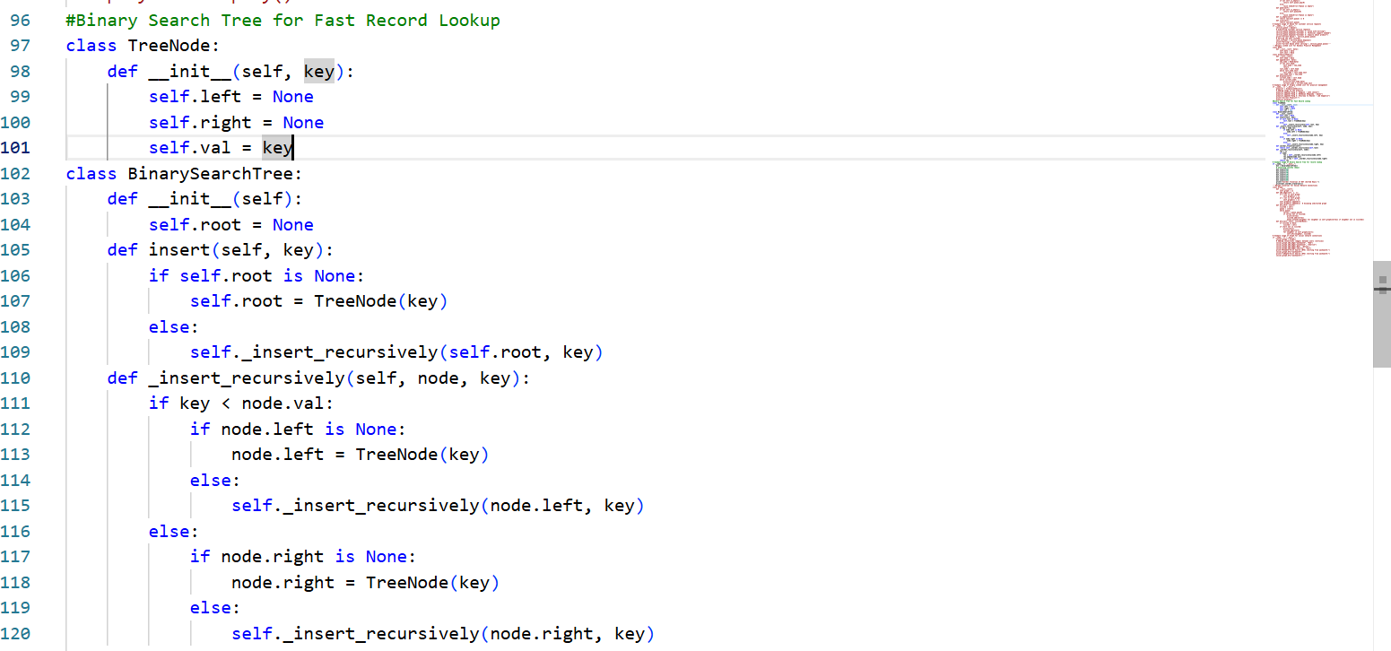
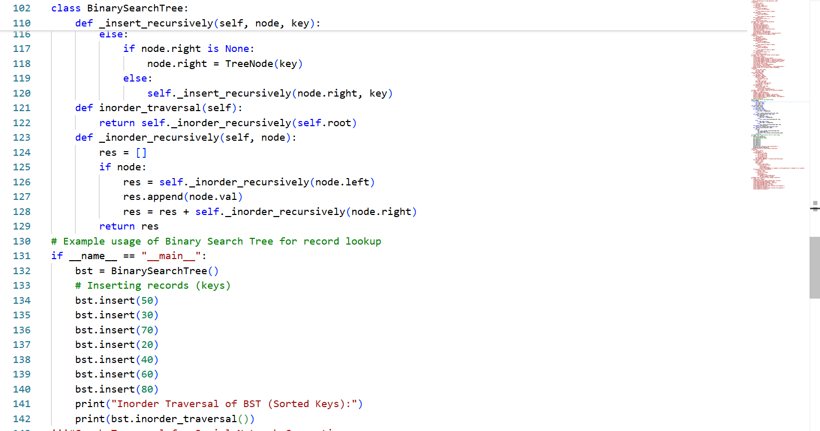
OUTPUT:
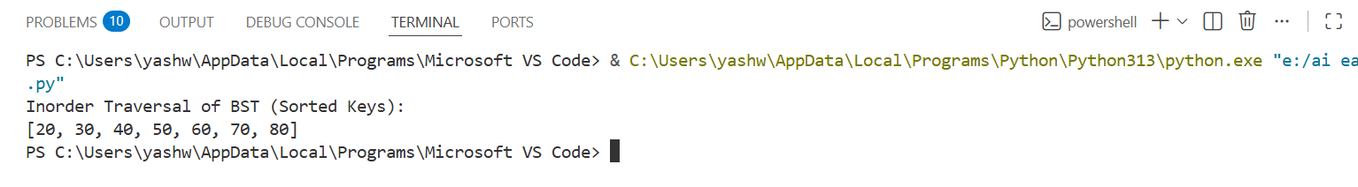
Task 5: Graph Traversal for Social Network Connections
Scenario:
You are modeling a social network, where users are connected to friends, andyou want to explore connections.
Prompt:Graph Traversal for Social Network Connections
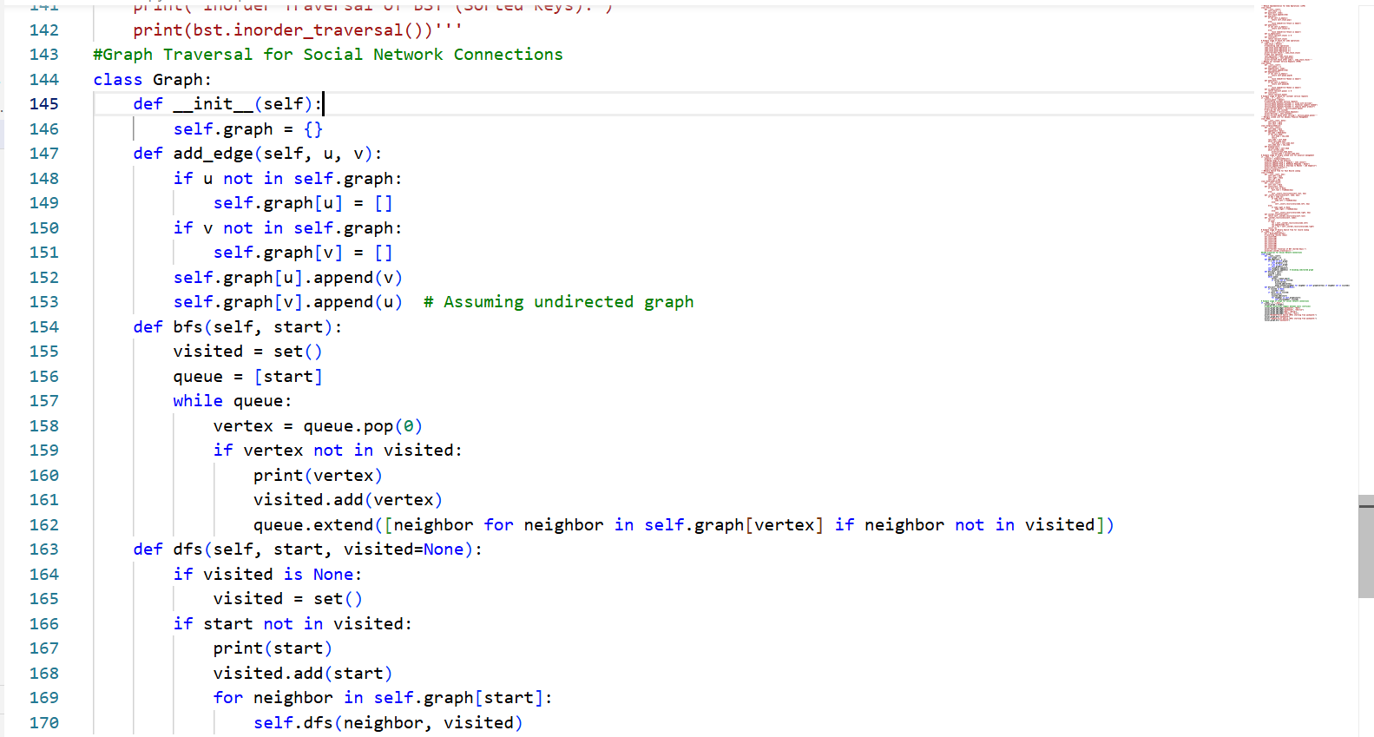
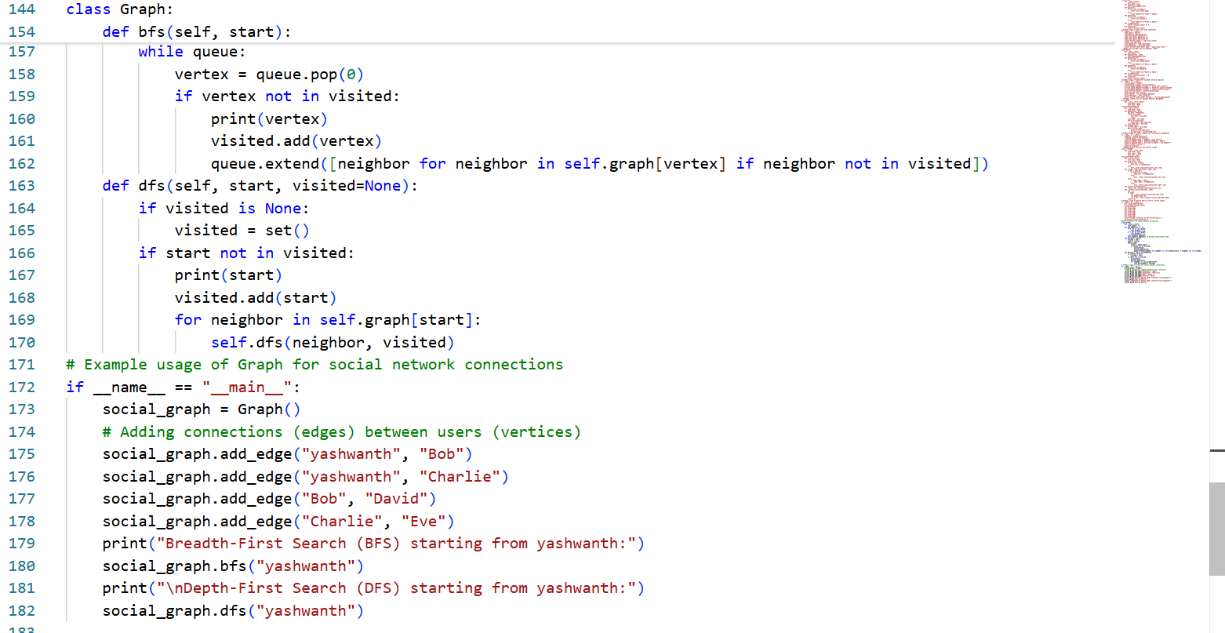
OUTPUT:
