S.Rajkumar
Batch-42
2303A52478
Task 1: Sorting Student Records for Placement Drive
PROMPT:
Write a Python program to compare Quick Sort and Merge Sort for sorting student records.Create a Studentdataclass with name, roll, and cgpa.Generate random students.Sort by CGPA (descending), then name, then roll.Measure runtime using time.perf_counter().Print sorted students, performance comparison, and top 10 students.
CODE:
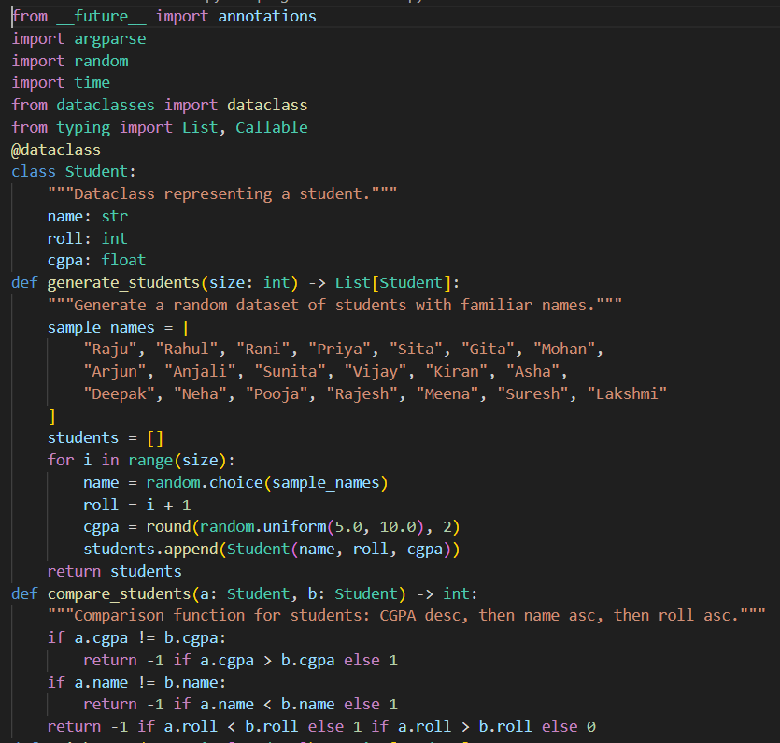
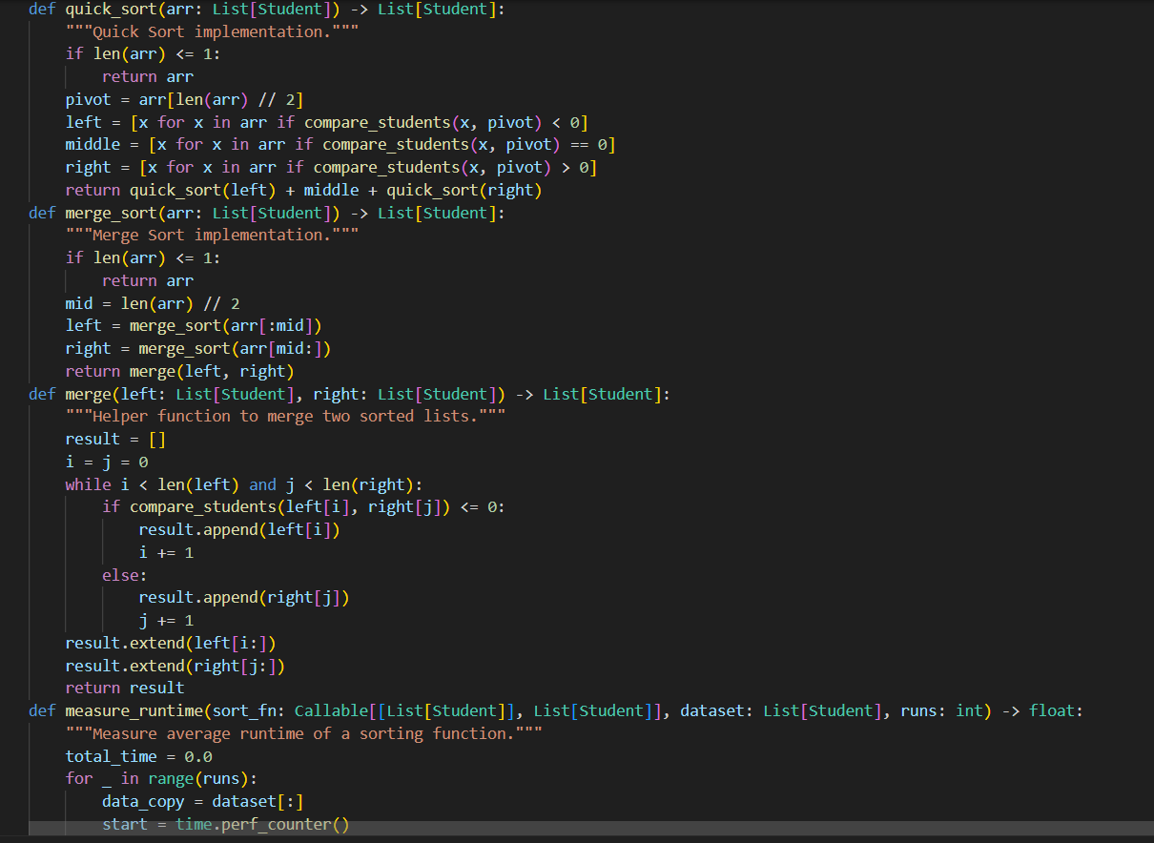
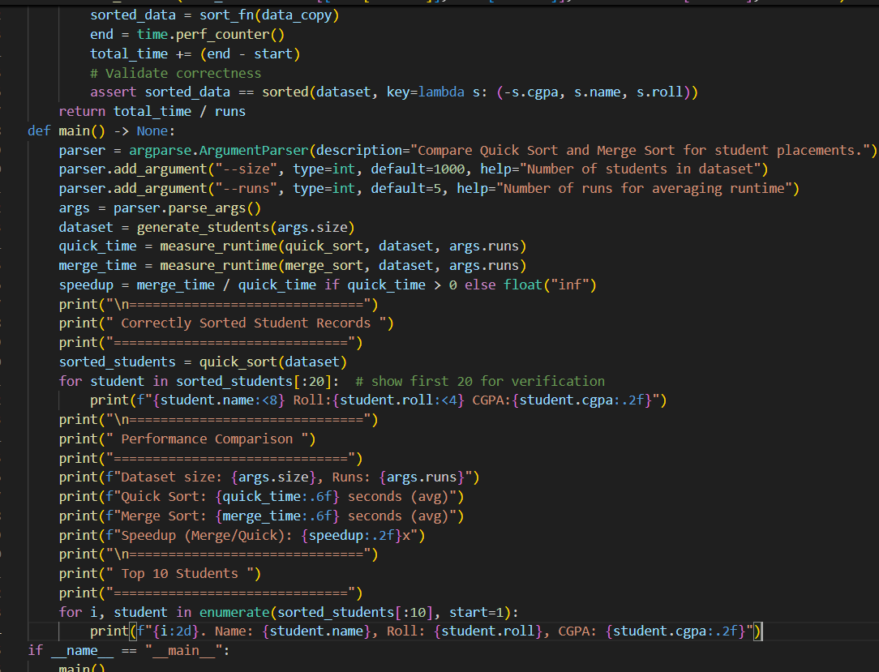
OUTPUT:
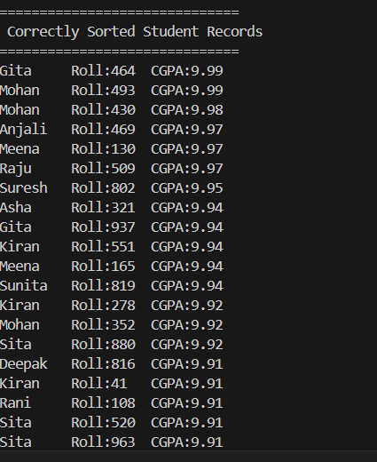
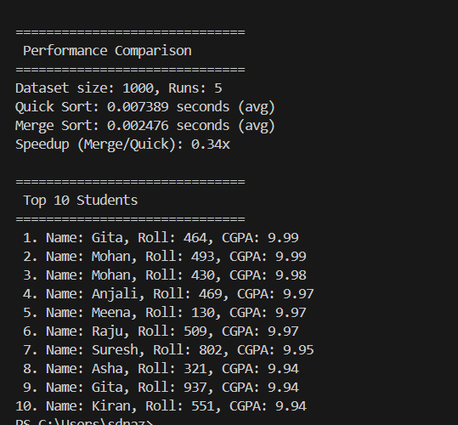
JUSTIFICATION:
By this code it compares Quick Sort and Merge Sort.It helps understand which algorithm performs better.Runtime measurement improves technical knowledge.It builds practical experience with data structures.
Task 2: Implementing Bubble Sort with AI Comments
PROMPT:
Write a simple Python Bubble Sort program with user input, inline comments explaining swapping, passes, and termination, and include time complexity analysis.
CODE:
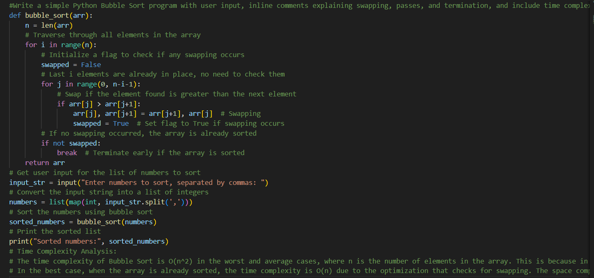
OUTPUT
JUSTIFICATION:
I implemented Bubble Sort to understand basic sorting logic.It helped me learn how swapping works step by step.Adding comments improved code clarity.This task strengthened my programming basics.

Task 3: Quick Sort and Merge Sort Comparison
PROMPT:
Complete partially written recursive functions for Quick Sort and Merge Sort in Python. Add proper docstrings and implement the missing logic. Then compare both algorithms on random, sorted, and reverse-sorted lists, measure runtime, and provide explanation of best, average, and worst-case time complexities.
CODE:
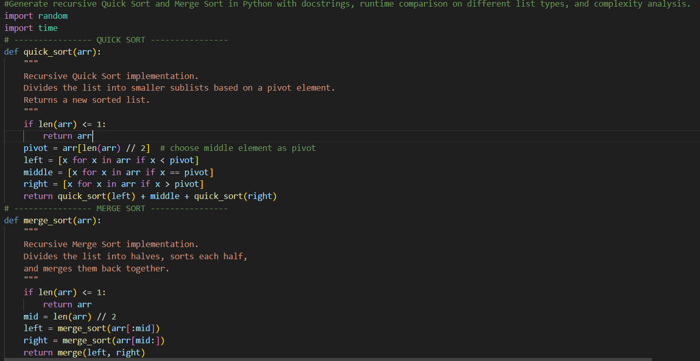
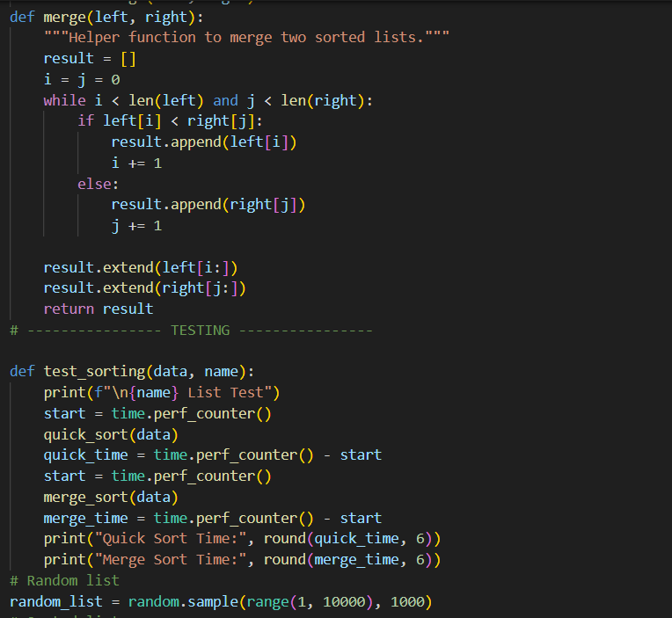
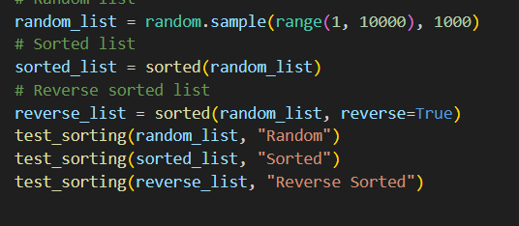
OUTPUT:
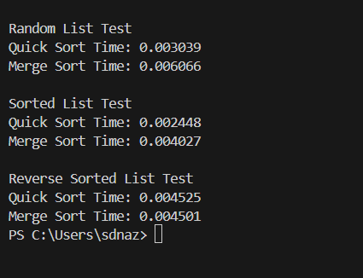
EXPLANTION:
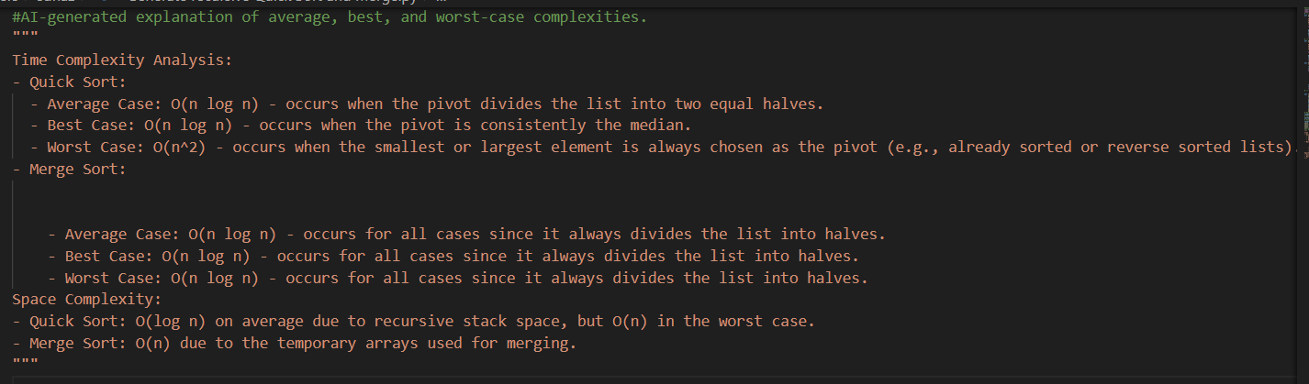
JUSTIFICATION:
This task helped me understand recursive sorting algorithms.I learned how Quick Sort and Merge Sort divide problems into smaller parts.Comparing different input types improved my analysis skills.It strengthened my knowledge of recursion and efficiency.
Task 4 (Real-Time Application – Inventory Management System)
PROMPT:
Generate a Python Inventory Management System that recommends efficient search and sorting algorithms, implements them, and displays the expected output clearly.
CODE:
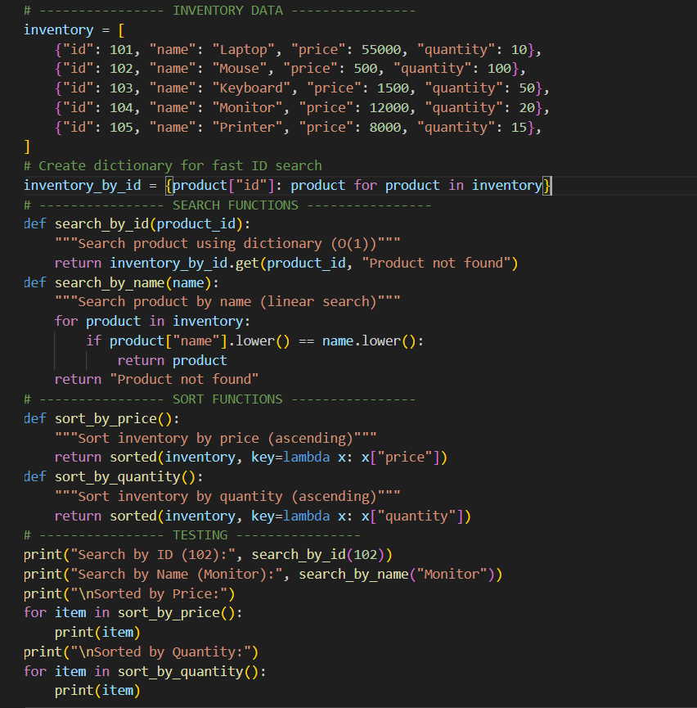

OUTPUT: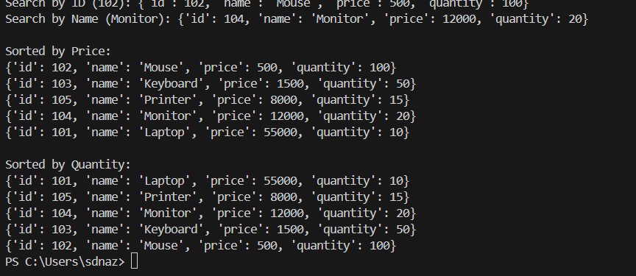
Recommended Algorithms Table
Operation | Recommended Algorithm | Justification
Search by Product ID | Hash Table (Dictionary) | Fast lookup O(1), best for large datasets and frequent searches
Search by Product Name | Linear Search (or Dictionary if indexed) | Simple and effective; can also use dictionary for faster lookup
Sort by Price | Timsort (Python built-in sorted()) | Very efficient O(n log n), optimized for real-world data
Sort by Quantity | Timsort (Python built-in sorted()) | Stable, fast, and handles large datasets efficiently

JUSTIFICATION:
This task helps design a real-time inventory system.Using efficient search improves product lookup speed.Sorting helps analyze stock and pricing easily.It applies algorithms to a real-world business scenario.
Task 5: Real-Time Stock Data Sorting & Searching
PROMPT:
Create a menu-driven Python program to simulate stock data, sort stocks by percentage change using Heap Sort, search stocks using a Hash Map (dictionary), compare performance with built-in sorted(), and display the output clearly.
CODE:
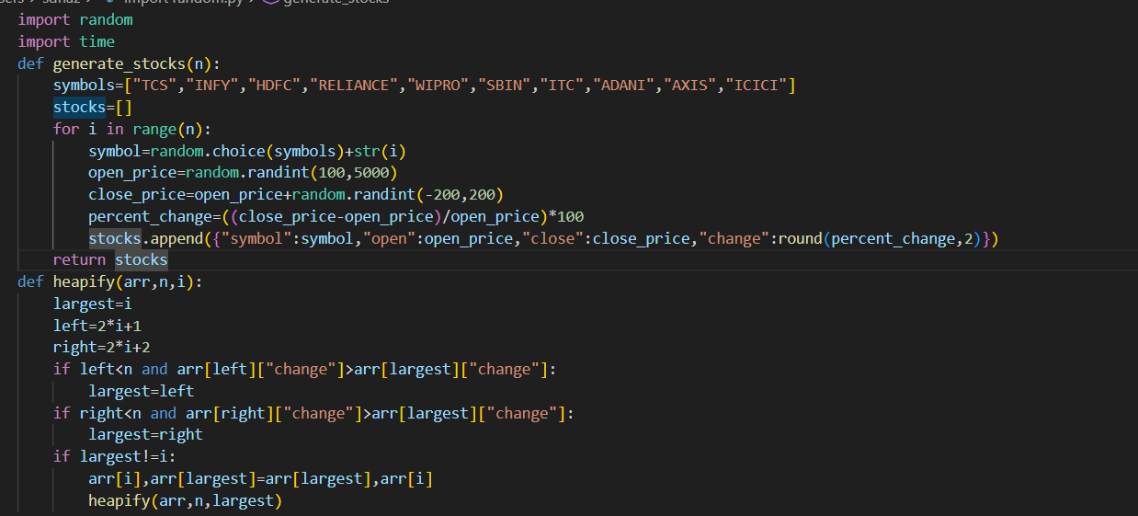
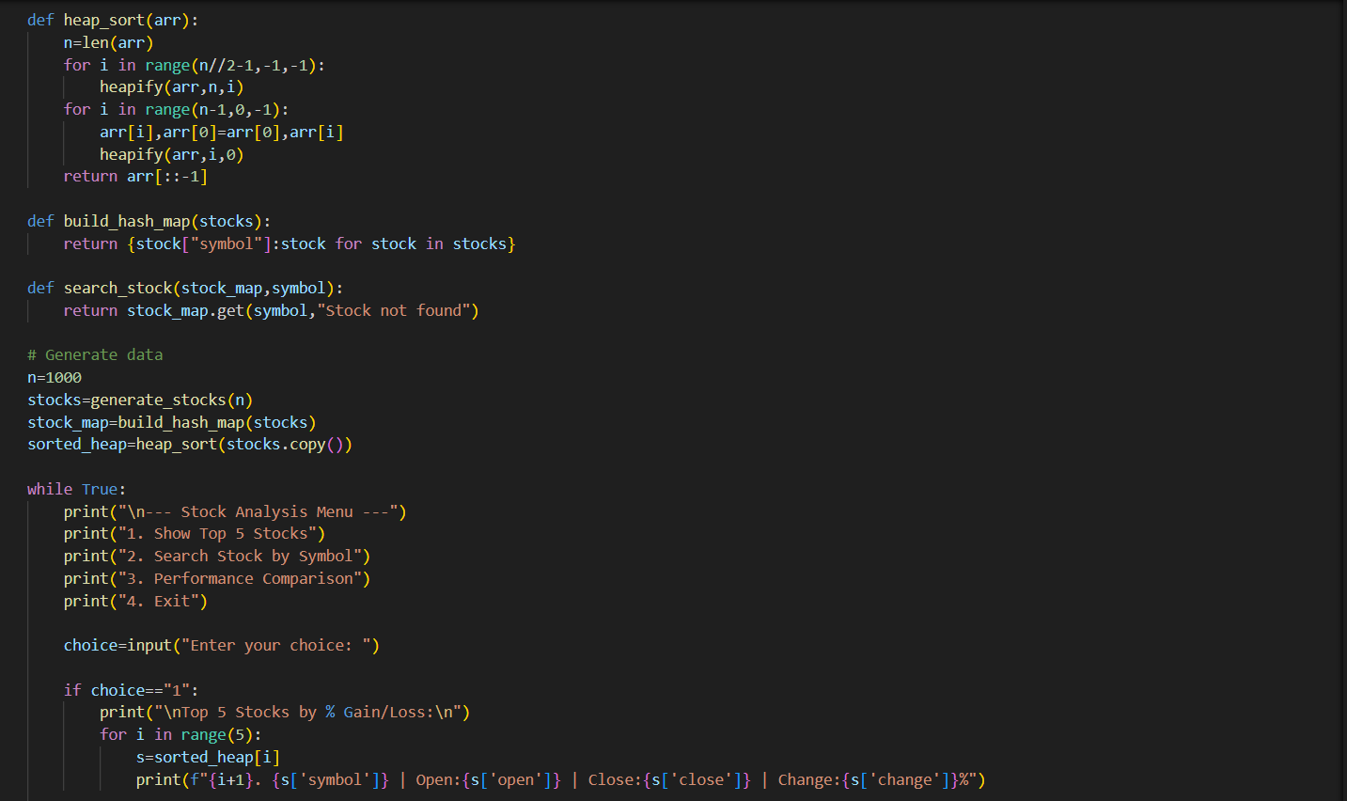
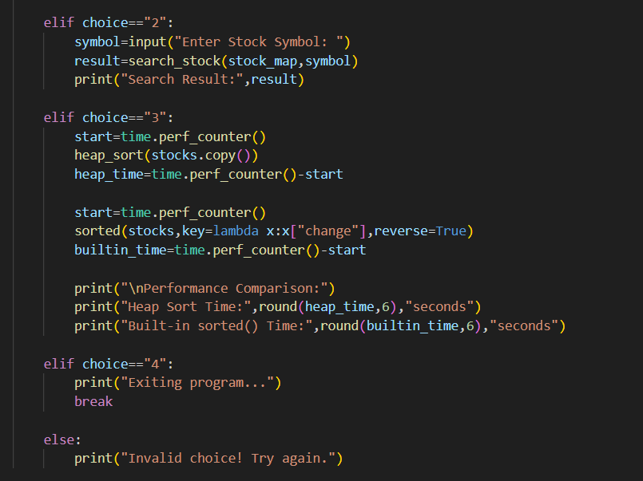
OUTPUT:
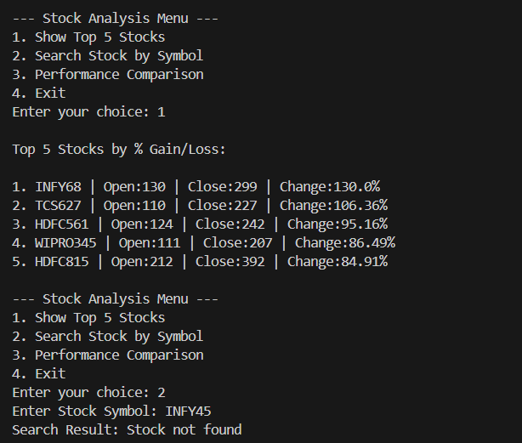
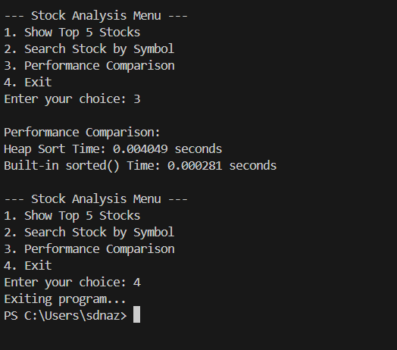JUSTIFICATION:
This project simulates real-time stock market analysis.Heap Sort helps rank stocks efficiently by percentage change.Hash Map enables instant stock symbol search.It improves understanding of data handling in FinTech systems.

