AI-ASSISSTANT-CODING-LAB-4.4

Name: S.Rajkumar
Batch:42
Roll-No:2303A52478
TASK 1: Sentiment Classification for Customer Reviews
Scenario:
An e-commerce platform wants to analyze customer reviews and classify them into Positive, Negative, or Neutral sentiments using prompt engineering.
Tasks:
- Prepare 6 short customer reviews mapped to sentiment labels.
- Design a Zero-shot prompt to classify sentiment.
- Design a One-shot prompt with one labeled example.
- Design a Few-shot prompt with 3–5 labeled examples.
- Compare the outputs and discuss accuracy differences. CODE:
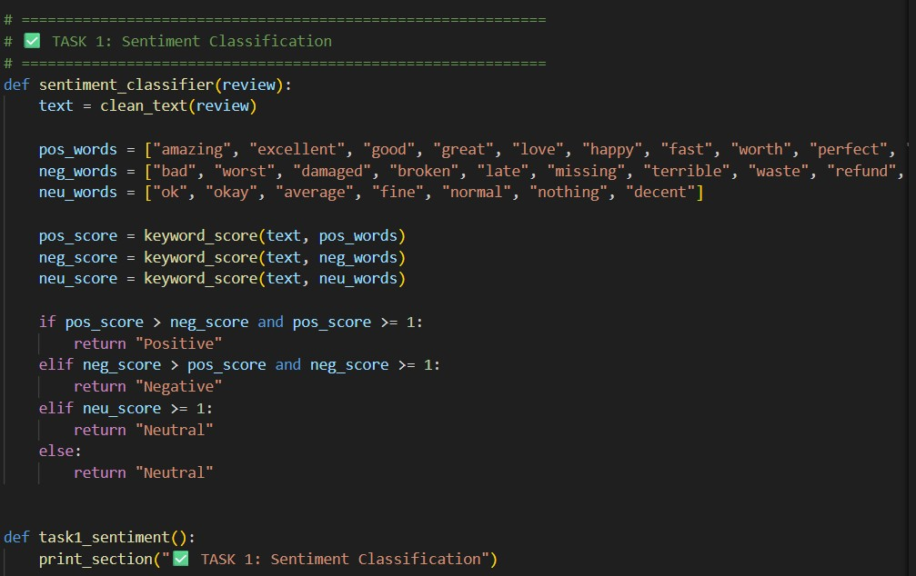
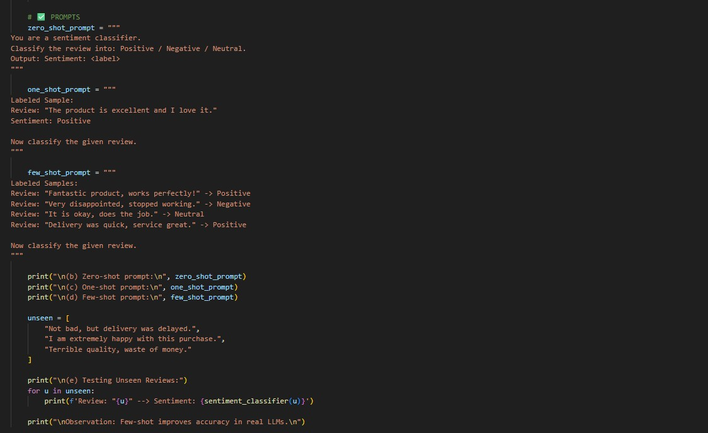
OUTPUT:
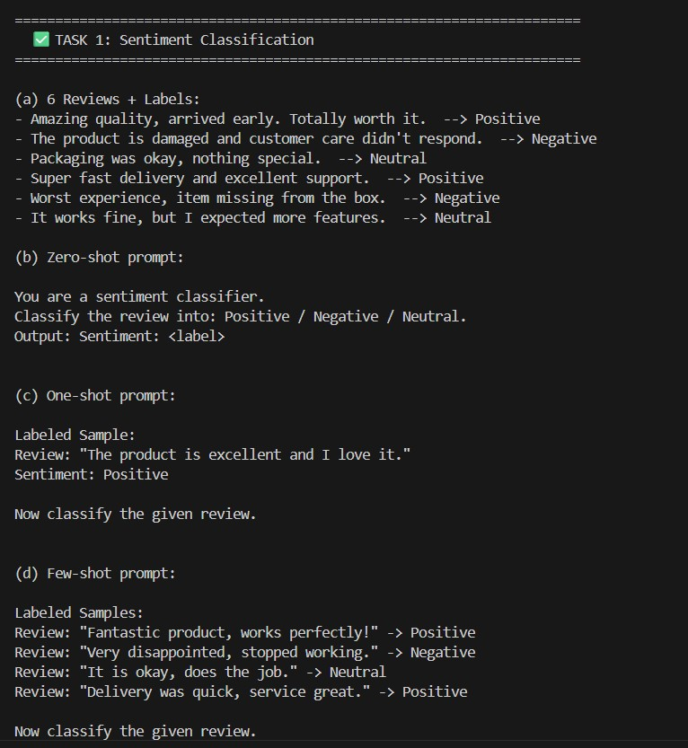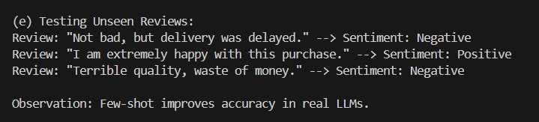
JUSTIFICATION:
This task helps classify customer reviews as Positive, Negative, or Neutral.It is useful for improving product quality and customer satisfaction.Few-shot prompting gives better accuracy for unclear reviews. TASK 2: Email Priority Classification
Scenario:
A company wants to automatically prioritize incoming emails into High Priority, Medium Priority, or Low Priority.
Tasks:
- Create 6 sample email messages with priority labels.
- Perform intent classification using Zero-shot prompting.
- Perform classification using One-shot prompting.
- Perform classification using Few-shot prompting.
- Evaluate which technique produces the most reliable results and why.
CODE:
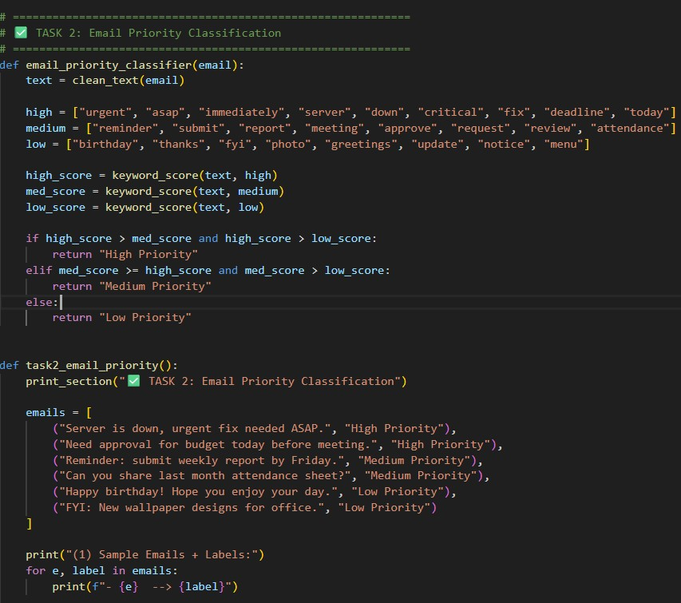
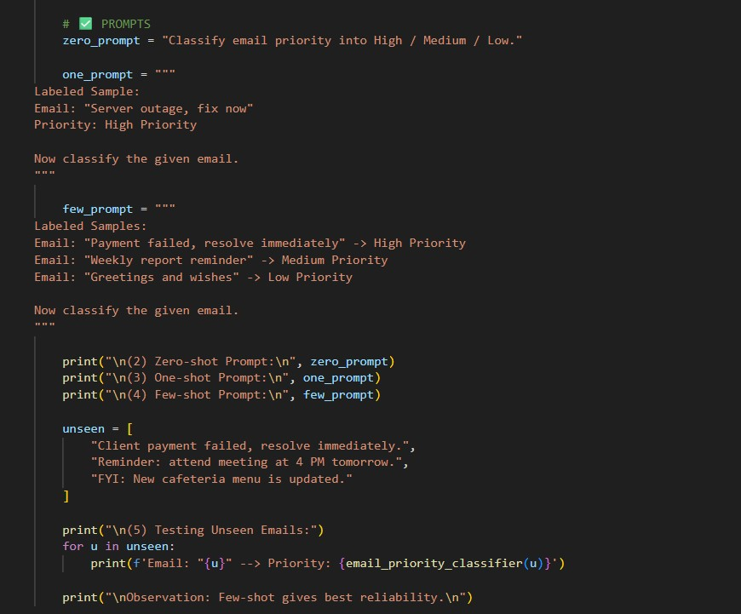

OUTPUT:
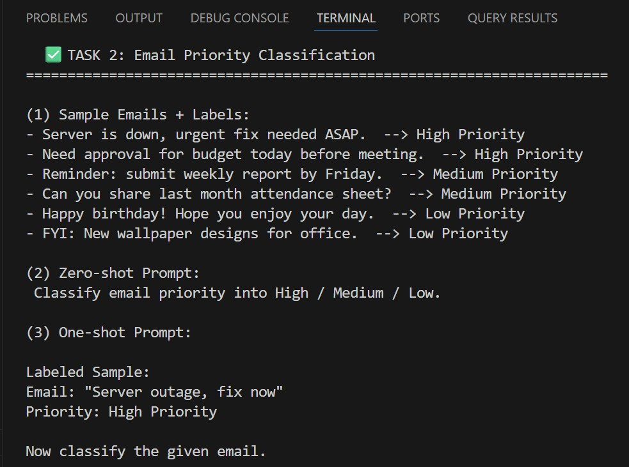
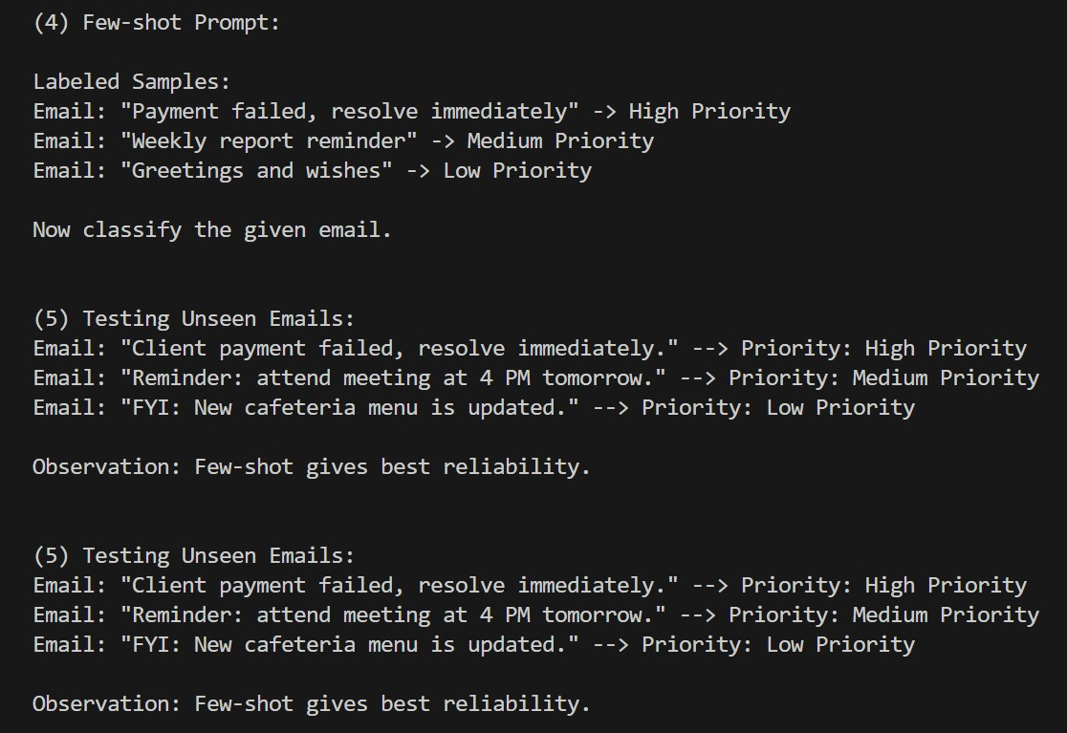
JUSTIFICATION:
This task helps automatically prioritize emails into High, Medium, or Low.It ensures urgent issues are handled quickly without delay.Few-shot prompting gives the most reliable priority results.

TASK 3: Student Query Routing
Scenario:
A university chatbot must route student queries to Admissions, Exams, Academics, or Placements.
Tasks:
- Create 6 sample student queries mapped to departments.
- Implement Zero-shot intent classification using an LLM.
- Improve results using One-shot prompting.
- Further refine results using Few-shot prompting.
- Analyze how contextual examples affect classification accuracy.

CODE:
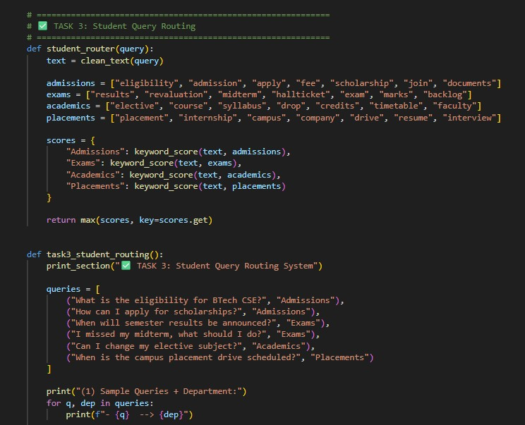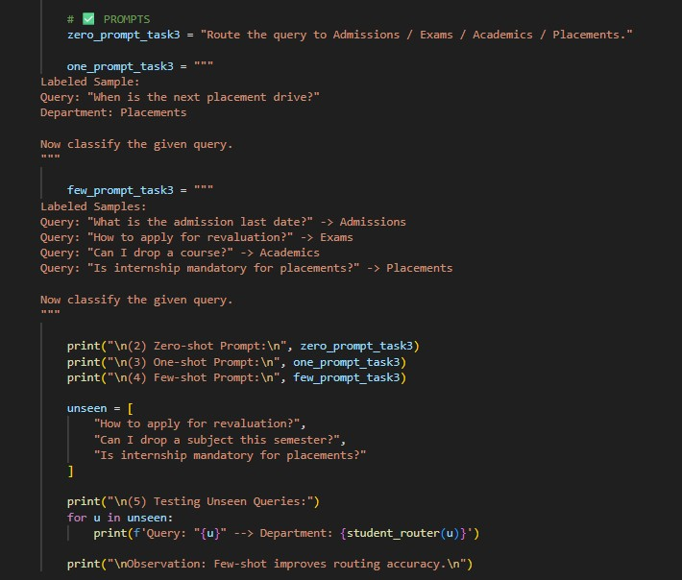
OUTPUT:
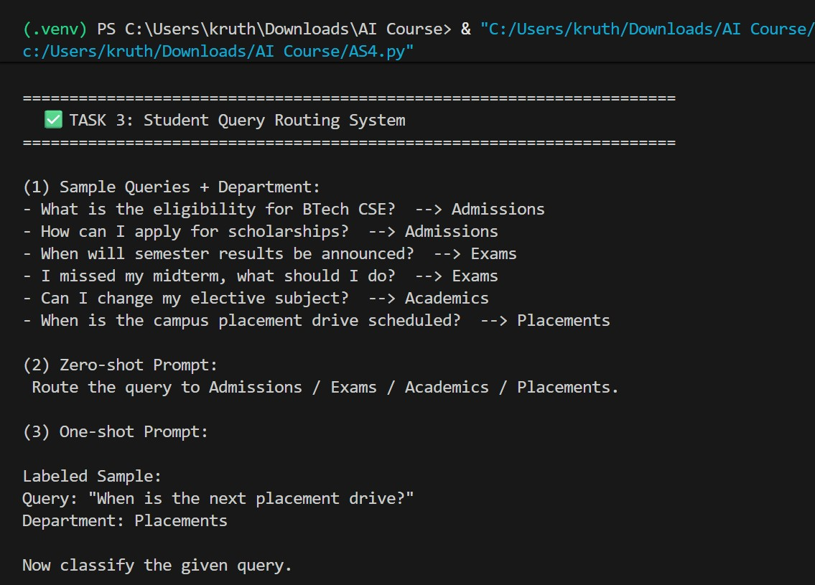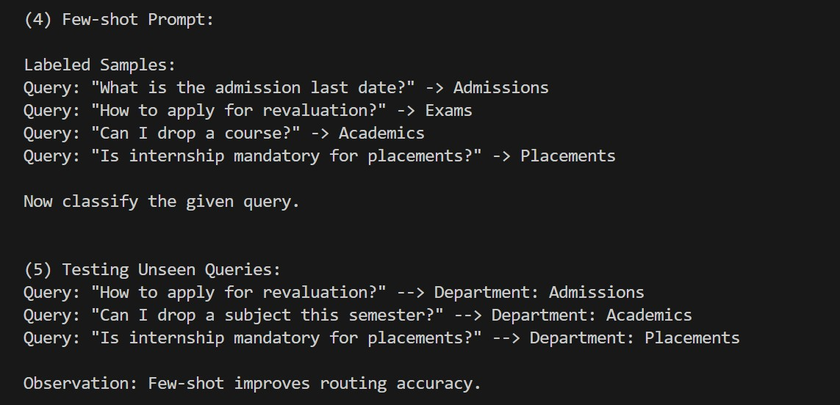
JUSTIFICATION:
This task routes student questions to the correct department.It reduces manual workload and gives faster responses.Few-shot examples improve routing accuracy.
TASK 4: Chatbot Question Type Detection
Scenario:
A chatbot must identify whether a user query is Informational,Transactional, Complaint, or Feedback.
Tasks:
- Prepare 6 chatbot queries mapped to question types.
- Design prompts for Zero-shot, One-shot, and Few-shot learning.
- Test all prompts on the same unseen queries.
- Compare response correctness and ambiguity handling.
- Document observations. CODE:
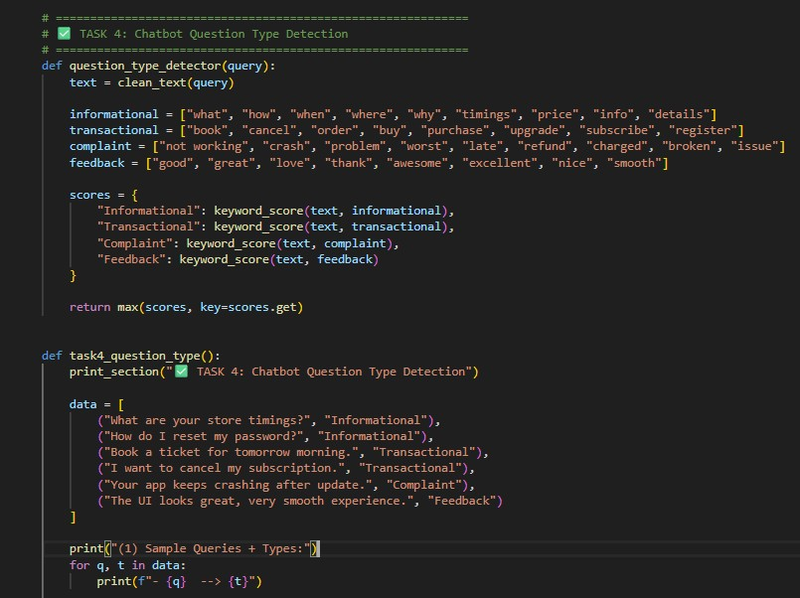

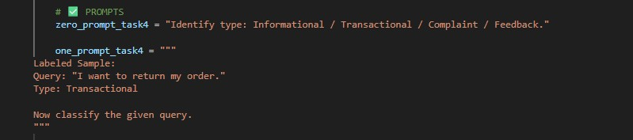
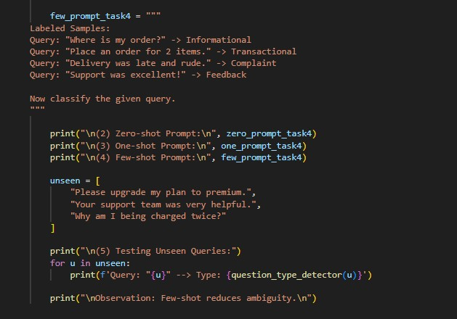
OUTPUT:
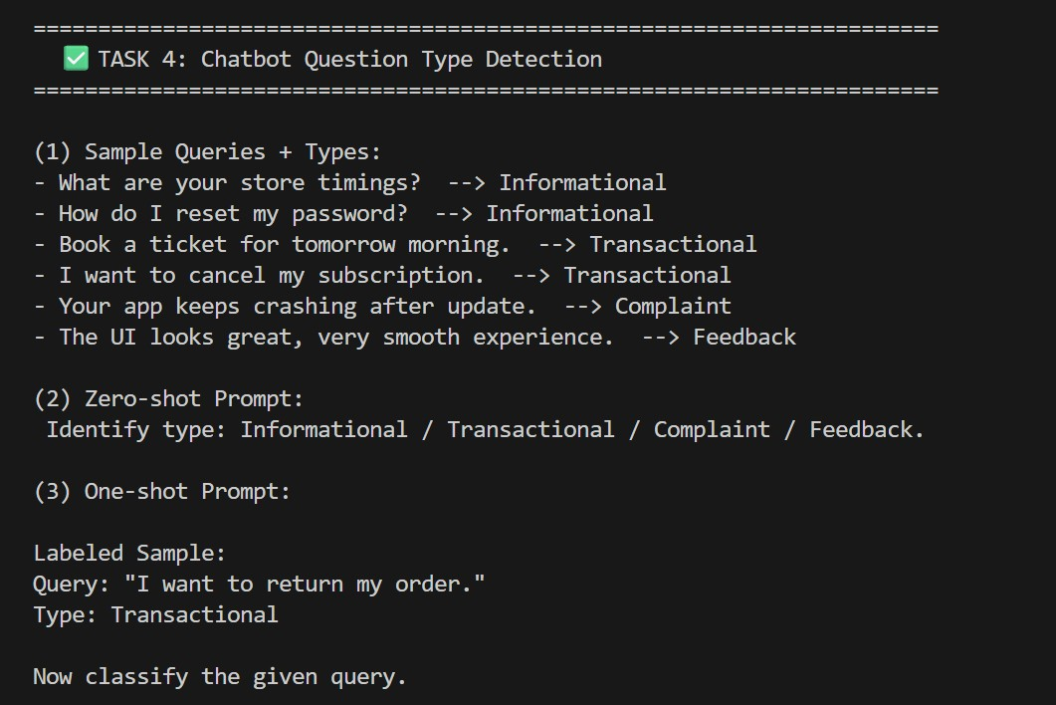
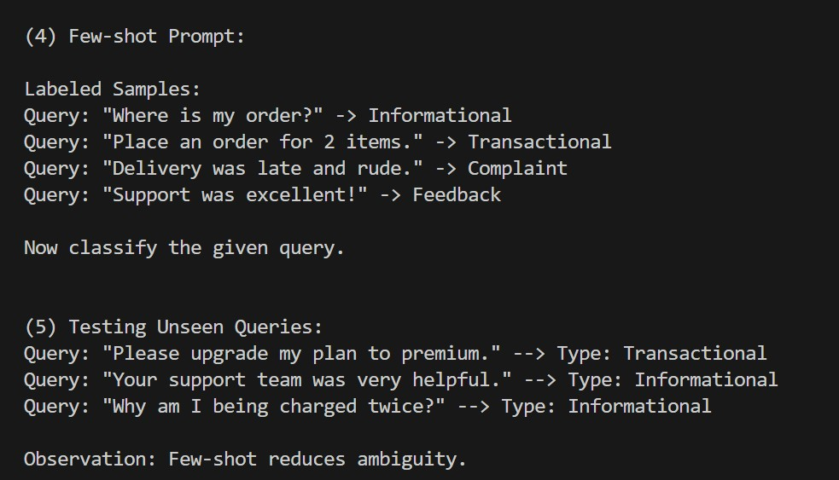
JUSTIFICATION:
This task identifies query type: informational, transactional, complaint, or feedback. It helps the chatbot respond correctly based on user intent.Few-shot reduces confusion between similar query types.

TASK 5: Emotion Detection Scenario:
A mental-health chatbot needs to detect emotions: Happy, Sad, Angry, Anxious, Neutral.
Tasks:
- Create labeled emotion samples.
- Use Zero-shot prompting to identify emotions.
- Use One-shot prompting with an example.
- Use Few-shot prompting with multiple emotions.
- Discuss ambiguity handling across techniques.

CODE:
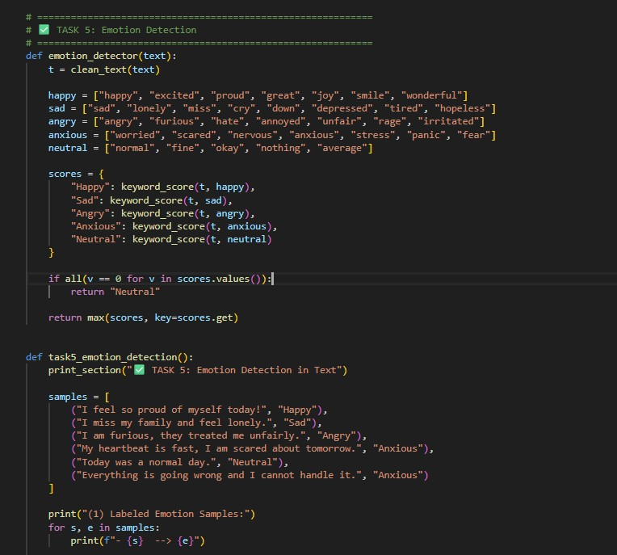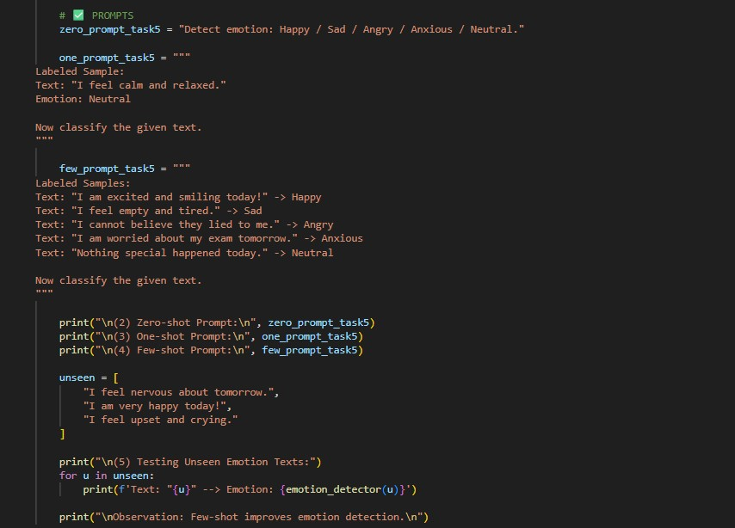
OUTPUT:
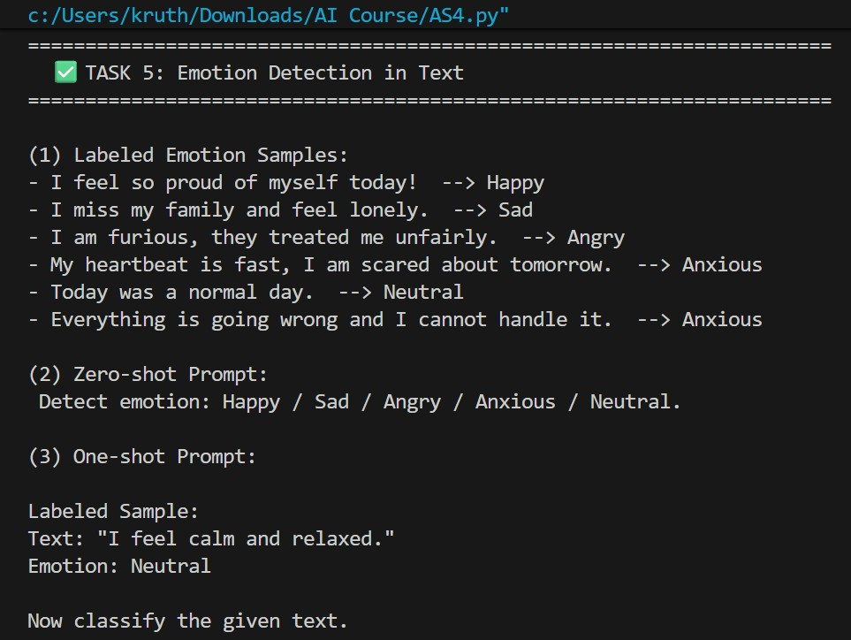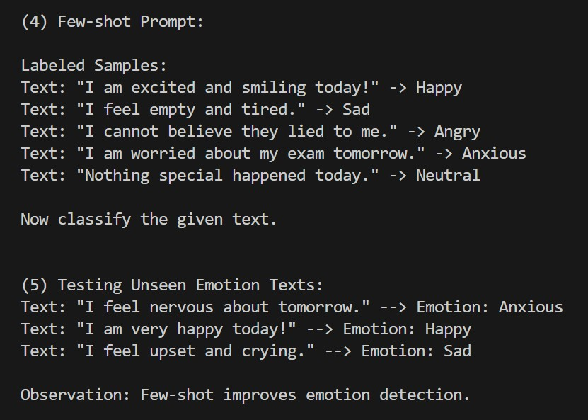
JUSTIFICATION:
This task detects emotions from user text for mental-health support.It helps provide correct guidance and empathetic responses.Few-shot handles mixed emotions better than zero-shot.

