AI ASSISTANT LAB-16
Name :S.Rajkumar
Rollno:2303A52478
Batch:42
Task 1 – Hospital Management Database Scenario :
Create schema and queries for a Hospital Management System Prompt:
Create normalized schema for Hospital Management System
Tables: Doctors, Patients, Appointments
Include primary keys, foreign keys, constraints, valid date checks

CONSTRAINTchk_doctors_experience_non_negative
CHECK (years_experience>= 0)
);

CREATETABLEpatients( patient_idBIGSERIALPRIMARYKEY,
Code :
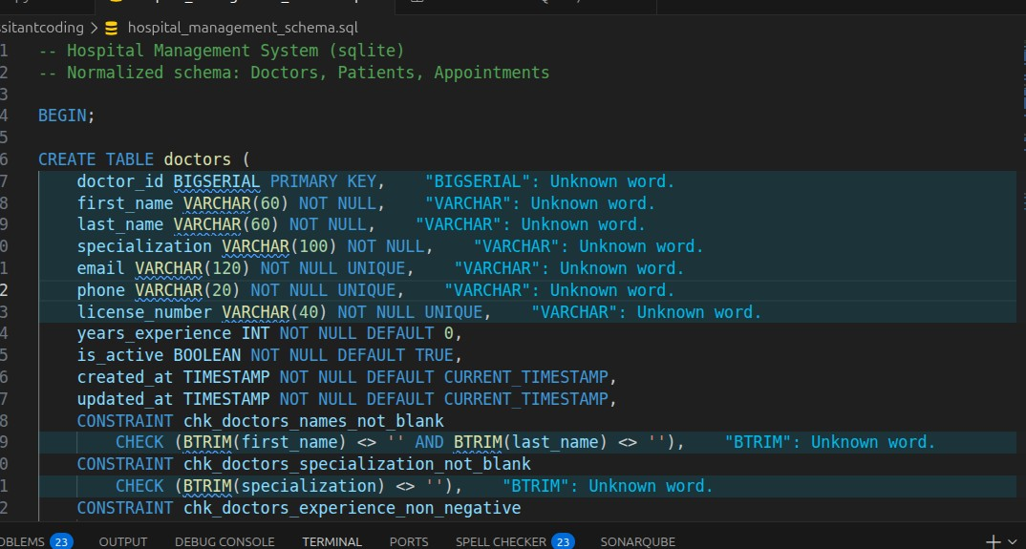
Queries and output:
Query 1:
first_nameVARCHAR(60) NOTNULL, last_nameVARCHAR(60) NOTNULL, date_of_birthDATENOTNULL, genderVARCHAR(20) NOTNULL, emailVARCHAR(120) UNIQUE, phoneVARCHAR(20) NOTNULLUNIQUE, blood_groupVARCHAR(5), emergency_contact_nameVARCHAR(120), emergency_contact_phoneVARCHAR(20), created_atTIMESTAMPNOTNULLDEFAULTCURRENT_TIMESTAMP, updated_atTIMESTAMPNOTNULLDEFAULTCURRENT_TIMESTAMP,
CONSTRAINTchk_patients_names_not_blank
CHECK (BTRIM(first_name) <>''ANDBTRIM(last_name) <>''),
CONSTRAINTchk_patients_valid_dob
CHECK (date_of_birth<= CURRENT_DATE),
CONSTRAINTchk_patients_gender
CHECK (genderIN ('Male', 'Female', 'Other')),
CONSTRAINTchk_patients_blood_groupCHECK (
blood_groupISNULL
ORblood_groupIN ('A+', 'A-', 'B+', 'B-', 'AB+', 'AB-', 'O+', 'O-')
)
);
SELECT * FROM Appointments WHERE doctor_id = 1; Output:
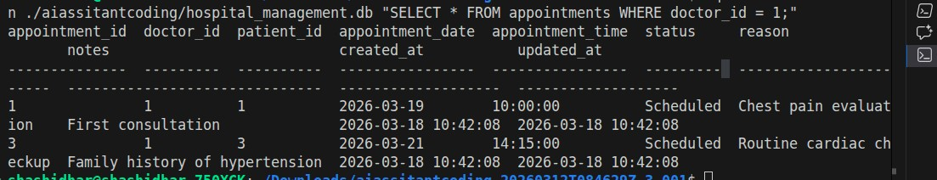
Query 2
SELECT * FROM Appointments WHERE patient_id = 1; Output:
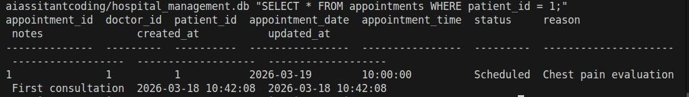
Query 3:
SELECT doctor_id, COUNT(DISTINCT patient_id)
FROM Appointments GROUP BY doctor_id; Output:
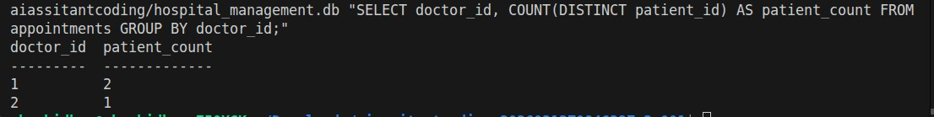
Justification:
Justification
● Copilot auto-generated FK constraints

● Ensured 3NF (no redundancy)

● Used joins implicitly via FK
Task 2 – Real-Time Application: Online Shopping Database Scenario:
Design a database for an E-commerce platform.
Prompt:
Create schema for e-commerce system
Tables: Users, Products, Orders, OrderDetails
Include relationships and normalization
Code
-- Task 2 - E-Commerce System (SQLite)
-- Normalized schema: users, products, orders, order_details
PRAGMAforeign_keys = ON;

BEGINTRANSACTION;

CREATETABLEusers( user_idINTEGERPRIMARYKEYAUTOINCREMENT, full_nameTEXTNOTNULL, emailTEXTNOTNULLUNIQUE, phoneTEXTUNIQUE, password_hashTEXTNOTNULL, is_activeINTEGERNOTNULLDEFAULT1CHECK (is_activeIN (0, 1)), created_atTEXTNOTNULLDEFAULT (datetime('now')), updated_atTEXTNOTNULLDEFAULT (datetime('now')),
CHECK (trim(full_name) <>''),
CHECK (trim(email) <>''),
CHECK (instr(email, '@') >1)
);

CREATETABLEproducts( product_idINTEGERPRIMARYKEYAUTOINCREMENT, product_nameTEXTNOTNULL, skuTEXTNOTNULLUNIQUE, descriptionTEXT, unit_priceNUMERICNOTNULL, stock_quantityINTEGERNOTNULLDEFAULT0,
is_activeINTEGERNOTNULLDEFAULT1CHECK (is_activeIN (0, 1)), created_atTEXTNOTNULLDEFAULT (datetime('now')), updated_atTEXTNOTNULLDEFAULT (datetime('now')),
CHECK (trim(product_name) <>''),
CHECK (trim(sku) <>''),
CHECK (unit_price>= 0),
CHECK (stock_quantity>= 0)
);

CREATETABLEorders( order_idINTEGERPRIMARYKEYAUTOINCREMENT, user_idINTEGERNOTNULL, order_dateTEXTNOTNULLDEFAULT (datetime('now')),

order_statusTEXTNOTNULLDEFAULT'Pending', payment_statusTEXTNOTNULLDEFAULT'Unpaid', shipping_addressTEXTNOTNULL, order_totalNUMERICNOTNULLDEFAULT0, created_atTEXTNOTNULLDEFAULT (datetime('now')), updated_atTEXTNOTNULLDEFAULT (datetime('now')),  FOREIGNKEY (user_id)  REFERENCESusers (user_id)  ONUPDATECASCADE  ONDELETERESTRICT,  CHECK (date(order_date) ISNOTNULL),  CHECK (order_statusIN ('Pending', 'Confirmed', 'Shipped', 'Cancelled')),  CHECK (payment_statusIN ('Unpaid', 'Paid', 'Refunded', 'Failed')),  CHECK (trim(shipping_address) <>''),  CHECK (order_total>= 0)  );  CREATETABLEorder_details( order_detail_idINTEGERPRIMARYKEYAUTOINCREMENT, order_idINTEGERNOTNULL, product_idINTEGERNOTNULL, quantityINTEGERNOTNULL, unit_priceNUMERICNOTNULL, line_totalNUMERICNOTNULL, created_atTEXTNOTNULLDEFAULT (datetime('now')), updated_atTEXTNOTNULLDEFAULT (datetime('now')),  FOREIGNKEY (order_id)  REFERENCESorders (order_id)  ONUPDATECASCADE  ONDELETECASCADE,  FOREIGNKEY (product_id)  REFERENCESproducts (product_id)  ONUPDATECASCADE  ONDELETERESTRICT,  CHECK (quantity>0),  CHECK (unit_price>= 0),  CHECK (line_total>= 0),  UNIQUE (order_id, product_id)  ); | 'Delivered',

CREATEINDEXidx_orders_user_id
ONorders (user_id);

CREATEINDEXidx_orders_order_date
ONorders (order_date);

CREATEINDEXidx_order_details_order_id
ONorder_details (order_id);

CREATEINDEXidx_order_details_product_id
ONorder_details (product_id);

COMMIT;
Queries and output

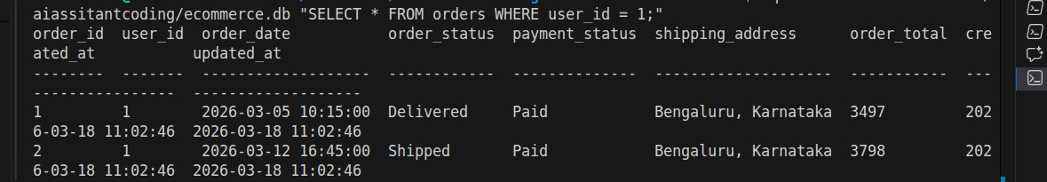
Task 3 – Library Database Task:
Design schema for a Library Management System.
Prompt:
Create library schema
Tables: Books, Members, Loans
Suggest indexes for performance
Code
- Task - Library Management System (SQLite)
-- Schema + sample data

PRAGMAforeign_keys = ON;

BEGINTRANSACTION;
CREATETABLEbooks( book_idINTEGERPRIMARYKEYAUTOINCREMENT, isbnTEXTNOTNULLUNIQUE, titleTEXTNOTNULL, author_nameTEXTNOTNULL, categoryTEXT, published_yearINTEGER, total_copiesINTEGERNOTNULLDEFAULT1, available_copiesINTEGERNOTNULLDEFAULT1, shelf_codeTEXT, created_atTEXTNOTNULLDEFAULT (datetime('now')), updated_atTEXTNOTNULLDEFAULT (datetime('now')),
CHECK (trim(isbn) <>''),
CHECK (trim(title) <>''),
CHECK (trim(author_name) <>''),
CHECK (published_yearISNULLORpublished_yearBETWEEN1450AND2100),
CHECK (total_copies>= 0),
CHECK (available_copies>= 0),
CHECK (available_copies<= total_copies)
);

CREATETABLEmembers( member_idINTEGERPRIMARYKEYAUTOINCREMENT, full_nameTEXTNOTNULL, emailTEXTNOTNULLUNIQUE, phoneTEXTUNIQUE,
membership_dateTEXTNOTNULLDEFAULT (date('now')), statusTEXTNOTNULLDEFAULT'Active', created_atTEXTNOTNULLDEFAULT (datetime('now')), updated_atTEXTNOTNULLDEFAULT (datetime('now')),
CHECK (trim(full_name) <>''),
CHECK (instr(email, '@') >1),
CHECK (statusIN ('Active', 'Suspended', 'Inactive')),
CHECK (date(membership_date) ISNOTNULL)
);

CREATETABLEloans( loan_idINTEGERPRIMARYKEYAUTOINCREMENT, book_idINTEGERNOTNULL,

member_idINTEGERNOTNULL, loan_dateTEXTNOTNULL, due_dateTEXTNOTNULL, return_dateTEXT, loan_statusTEXTNOTNULLDEFAULT'Borrowed', fine_amountNUMERICNOTNULLDEFAULT0, created_atTEXTNOTNULLDEFAULT (datetime('now')), updated_atTEXTNOTNULLDEFAULT (datetime('now')),
FOREIGNKEY (book_id)
REFERENCESbooks (book_id)
ONUPDATECASCADE
ONDELETERESTRICT,
FOREIGNKEY (member_id)
REFERENCESmembers (member_id)
ONUPDATECASCADE
ONDELETERESTRICT,
CHECK (date(loan_date) ISNOTNULL),
CHECK (date(due_date) ISNOTNULL),
CHECK (return_dateISNULLORdate(return_date) ISNOTNULL),
CHECK (date(due_date) >= date(loan_date)),
CHECK (return_dateISNULLORdate(return_date) >= date(loan_date)),
CHECK (loan_statusIN ('Borrowed', 'Returned', 'Overdue', 'Lost')),
CHECK (fine_amount>= 0)
);

-- Suggested performance indexes
CREATEINDEXidx_books_title
ONbooks (title);

CREATEINDEXidx_books_author
ONbooks (author_name);

CREATEINDEXidx_members_email
ONmembers (email);

CREATEINDEXidx_loans_member_status
ONloans (member_id, loan_status);

CREATEINDEXidx_loans_book_status
ONloans (book_id, loan_status);

CREATEINDEXidx_loans_due_date
ONloans (due_date);

-- Sample books
INSERTORIGNOREINTObooks
(isbn, title, author_name, category, published_year, total_copies, available_copies, shelf_code)
VALUES
('9780131103627', 'The C Programming Language', 'Brian W. Kernighan', 'Programming', 1988, 5, 3, 'CS-A1'),
('9780132350884', 'Clean Code', 'Robert C. Martin', 'Software Engineering', 2008, 4,
2, 'CS-B2'),
('9780262033848', 'Introduction to Algorithms', 'Thomas H. Cormen', 'Algorithms', 2009, 3, 1, 'CS-C3'),
('9780596009205', 'Head First Java', 'Kathy Sierra', 'Programming', 2005, 6, 4, 'CS-
D4');

-- Sample members
INSERTORIGNOREINTOmembers
(full_name, email, phone, membership_date, status)
VALUES
('Riya Verma', 'riya.verma@example.com', '9100000001', '2026-01-10', 'Active'),
('Arun Patel', 'arun.patel@example.com', '9100000002', '2026-02-04', 'Active'), ('Sneha Nair', 'sneha.nair@example.com', '9100000003', '2026-02-15', 'Active');

-- Sample loans
INSERTORIGNOREINTOloans (book_id, member_id, loan_date, due_date, return_date, loan_status, fine_amount) VALUES
(1, 1, '2026-03-10', '2026-03-20', NULL, 'Borrowed', 0),
(2, 1, '2026-03-01', '2026-03-10', '2026-03-09', 'Returned', 0),
(3, 2, '2026-03-05', '2026-03-15', NULL, 'Borrowed', 0),
(4, 3, '2026-02-20', '2026-03-01', '2026-03-03', 'Returned', 20);

COMMIT;

Queries and output:
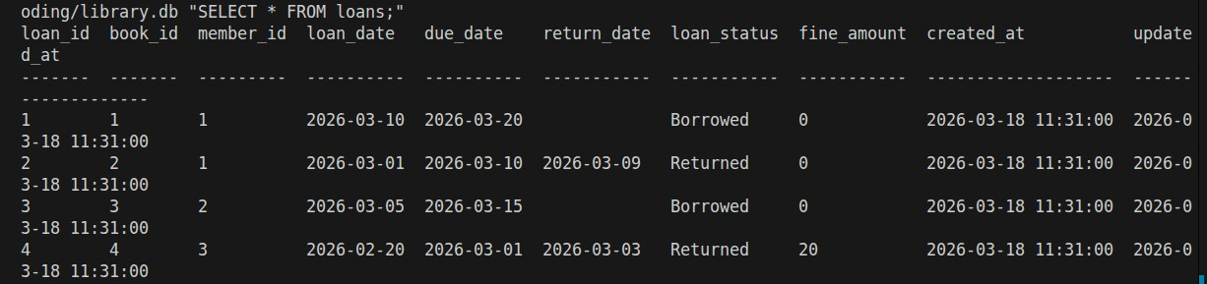

Justification
Index improves search speed
Copilot suggested indexing on date column Task 4: Optimize Queries Instructions:
- Use AI tools to analyze query efficiency.
- Optimize inefficient queries using joins, indexes, or reducing subqueries.
- Test optimized queries for correctness.
Starter Code Example:
-- Original query
SELECT * FROM Books WHERE author_id IN (SELECT author_id
FROM
Authors WHERE country='UK');
-- Optimized query
SELECT b.*
FROM Books b
JOIN Authors a ON b.author_id = a.author_id
WHERE a.country = 'UK';
Prompt :ptimize query using JOIN instead of subquery
Code
-- Original
SELECT * FROM Books WHERE author_id IN
(SELECT author_id FROM Authors WHERE country='UK');

-- Optimized
SELECT b.*
FROM Books b
JOIN Authors a ON b.author_id = a.author_id
-- Original
SELECT * FROMBooksWHEREauthor_idIN
(SELECTauthor_idFROMAuthorsWHEREcountry='UK');

-- Optimized SELECTb.*
FROMBooksb
JOINAuthorsaONb.author_id = a.author_id
WHEREa.country='UK';
WHERE a.country='UK';
Output:
book_id | author_id | title | category
------- | --------- | --------------------------------------- | ----------
- | 1 | 1984 | Fiction
- | 2 | Harry Potter and the Philosopher's Stone| Fantasy Justification

JOIN reduces nested query overhead

Faster on large datasets
Task 5: University Course Registration Scenario:
SR University needs a course registration system for students enrolling in different courses under faculty supervision.

- Use Copilot to design schema tables: Students, Courses, Faculty, andRegistrations.
- Define relationships:
- Each student can register for multiple courses.
- Each course is taught by a faculty member.
- Write SQL queries to:
- List all students enrolled in a specific course.
- Find faculty members teaching more than 2 courses.
- Retrieve courses with the highest number of registrations Prompt: ceate schema for Students, Courses, Faculty, Registrations
Define relationships and constraints Code
- Task 5 - University Course Registration (SQLite)
-- Schema + sample data + required queries

PRAGMAforeign_keys = ON;

BEGINTRANSACTION;

CREATETABLEfaculty( faculty_idINTEGERPRIMARYKEYAUTOINCREMENT, full_nameTEXTNOTNULL, emailTEXTNOTNULLUNIQUE, departmentTEXTNOTNULL, designationTEXT, hire_dateTEXT, is_activeINTEGERNOTNULLDEFAULT1CHECK (is_activeIN (0, 1)), created_atTEXTNOTNULLDEFAULT (datetime('now')), updated_atTEXTNOTNULLDEFAULT (datetime('now')),
CHECK (trim(full_name) <>''),
CHECK (instr(email, '@') >1),
CHECK (trim(department) <>''),
CHECK (hire_dateISNULLORdate(hire_date) ISNOTNULL)
);

CREATETABLEstudents( student_idINTEGERPRIMARYKEYAUTOINCREMENT, roll_noTEXTNOTNULLUNIQUE, full_nameTEXTNOTNULL,
emailTEXTNOTNULLUNIQUE, phoneTEXTUNIQUE, programTEXTNOTNULL, semesterINTEGERNOTNULL, enrollment_dateTEXTNOTNULLDEFAULT (date('now')), statusTEXTNOTNULLDEFAULT'Active', created_atTEXTNOTNULLDEFAULT (datetime('now')), updated_atTEXTNOTNULLDEFAULT (datetime('now')),
CHECK (trim(roll_no) <>''),
CHECK (trim(full_name) <>''),
CHECK (instr(email, '@') >1),
CHECK (trim(program) <>''),
CHECK (semesterBETWEEN1AND12),
CHECK (date(enrollment_date) ISNOTNULL),
CHECK (statusIN ('Active', 'Graduated', 'Dropped'))
);

CREATETABLEcourses( course_idINTEGERPRIMARYKEYAUTOINCREMENT, course_codeTEXTNOTNULLUNIQUE, course_titleTEXTNOTNULL, creditsINTEGERNOTNULL, departmentTEXTNOTNULL, faculty_idINTEGERNOTNULL, max_capacityINTEGERNOTNULLDEFAULT60, created_atTEXTNOTNULLDEFAULT (datetime('now')), updated_atTEXTNOTNULLDEFAULT (datetime('now')),
FOREIGNKEY (faculty_id)
REFERENCESfaculty (faculty_id)
ONUPDATECASCADE
ONDELETERESTRICT,
CHECK (trim(course_code) <>''),
CHECK (trim(course_title) <>''),
CHECK (trim(department) <>''),
CHECK (creditsBETWEEN1AND6),
CHECK (max_capacity>0)
);

CREATETABLEregistrations (
student_idINTEGERNOTNULL, course_idINTEGERNOTNULL, academic_yearTEXTNOTNULL, semester_termTEXTNOTNULL, registration_dateTEXTNOTNULLDEFAULT (date('now')), gradeTEXT, statusTEXTNOTNULLDEFAULT'Enrolled', created_atTEXTNOTNULLDEFAULT (datetime('now')), updated_atTEXTNOTNULLDEFAULT (datetime('now')),
FOREIGNKEY (student_id)
REFERENCESstudents (student_id)
ONUPDATECASCADE
ONDELETECASCADE,
FOREIGNKEY (course_id)
REFERENCEScourses (course_id)
ONUPDATECASCADE
ONDELETECASCADE,
CHECK (academic_yearGLOB'[0-9][0-9][0-9][0-9]-[0-9][0-9][0-9][0-9]'),
CHECK (semester_termIN ('Odd', 'Even', 'Summer')),
CHECK (date(registration_date) ISNOTNULL),
CHECK (gradeISNULLORgradeIN ('O', 'A+', 'A', 'B+', 'B', 'C', 'P', 'F')),
CHECK (statusIN ('Enrolled', 'Completed', 'Dropped', 'Withdrawn')),
UNIQUE (student_id, course_id, academic_year, semester_term)
);

-- Suggested performance indexes
CREATEINDEXidx_students_program_semester
ONstudents (program, semester);

CREATEINDEXidx_courses_faculty
ONcourses (faculty_id);

CREATEINDEXidx_registrations_course
ONregistrations (course_id);
registration_idINTEGERPRIMARYKEYAUTOINCREMENT, CREATEINDEXidx_registrations_student
ONregistrations (student_id);

CREATEINDEXidx_registrations_course_status
ONregistrations (course_id, status);

-- Sample faculty
INSERTORIGNOREINTOfaculty (full_name, email, department, designation, hire_date, is_active)
VALUES
('Dr. Anil Kumar', 'anil.kumar@sru.edu', 'Computer Science', 'Professor', '2015-06-10',
1),
('Dr. Priya Menon', 'priya.menon@sru.edu', 'Computer Science', 'Associate Professor',
'2018-01-12', 1),
('Dr. Rakesh Iyer', 'rakesh.iyer@sru.edu', 'Electronics', 'Assistant Professor', '2020-
08-01', 1);

-- Sample students
INSERTORIGNOREINTOstudents (roll_no, full_name, email, phone, program, semester, enrollment_date, status)
VALUES
('SRU23CSE001', 'Aman Verma', 'aman.verma@sru.edu', '9800000001', 'B.Tech CSE', 5,
'2023-08-01', 'Active'),
('SRU23CSE002', 'Nisha Rao', 'nisha.rao@sru.edu', '9800000002', 'B.Tech CSE', 5, '2023-
08-01', 'Active'),
('SRU22ECE010', 'Rahul Nair', 'rahul.nair@sru.edu', '9800000010', 'B.Tech ECE', 7,
'2022-08-01', 'Active'),
('SRU24CSE005', 'Megha Shah', 'megha.shah@sru.edu', '9800000005', 'B.Tech CSE', 3,
'2024-08-01', 'Active');

-- Sample courses
INSERTORIGNOREINTOcourses (course_code, course_title, credits, department, faculty_id, max_capacity)
VALUES
('CS301', 'Database Management Systems', 4, 'Computer Science', 1, 70),
('CS302', 'Operating Systems', 4, 'Computer Science', 1, 65),
('CS303', 'Design and Analysis of Algorithms', 4, 'Computer Science', 1, 60),
('CS304', 'Computer Networks', 3, 'Computer Science', 2, 60),
('EC401', 'Digital Signal Processing', 4, 'Electronics', 3, 55);

-- Sample registrations  INSERTORIGNOREINTOregistrations (student_id, course_id, semester_term, registration_date, grade, status)  VALUES  (1, 1, '2025-2026', 'Even', '2026-01-08', NULL, 'Enrolled'),  (1, 2, '2025-2026', 'Even', '2026-01-08', NULL, 'Enrolled'),  (1, 4, '2025-2026', 'Even', '2026-01-08', NULL, 'Enrolled'),  (2, 1, '2025-2026', 'Even', '2026-01-09', NULL, 'Enrolled'),  (2, 3, '2025-2026', 'Even', '2026-01-09', NULL, 'Enrolled'),  (3, 5, '2025-2026', 'Even', '2026-01-10', NULL, 'Enrolled'),  (4, 1, '2025-2026', 'Even', '2026-01-10', NULL, 'Enrolled'), (4, 4, '2025-2026', 'Even', '2026-01-10', NULL, 'Enrolled');  COMMIT; | academic_year,
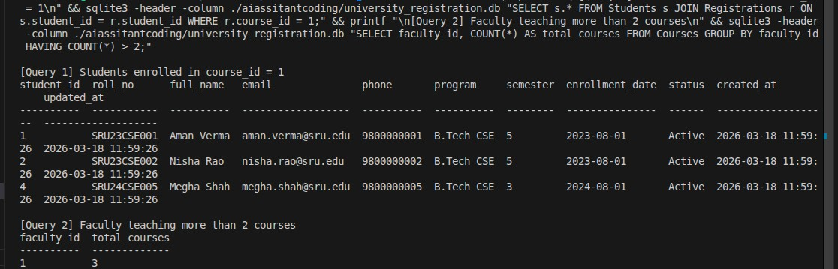
Query and output:
Justification

Copilot ensured many-to-many mapping
Queries optimized with JOIN + GROUP BY

