AI-ASSIGNMENT-6.4
Name :S.Rajkumar
Batch:42
Hall.no:2303A52478

Task 1: Student Performance Evaluation System:
Copilot: write a method to display student details
Copilot: write a method to check if marks are above class average
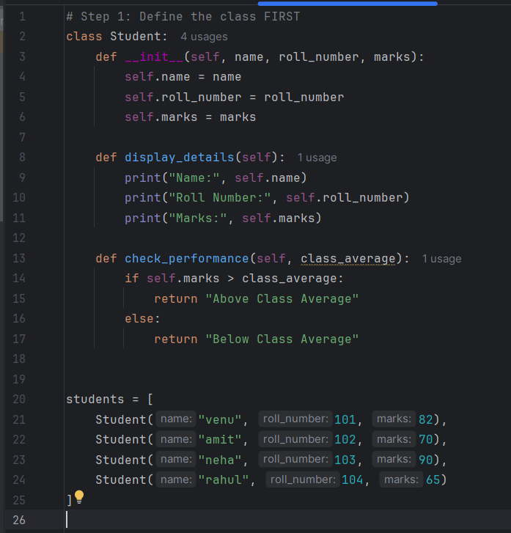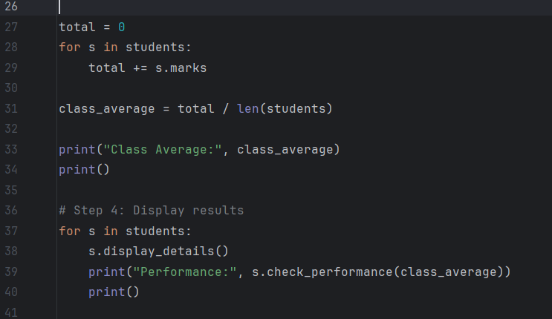
Output:
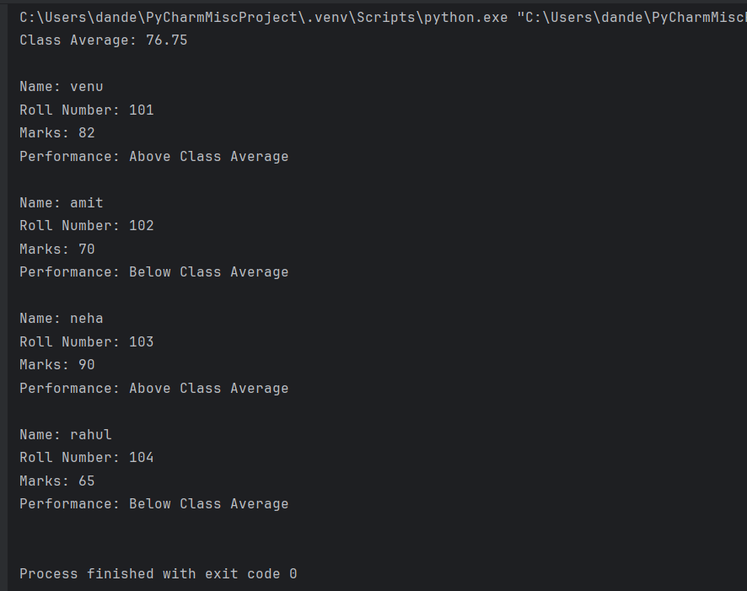
Task 2: Data Processing in a Monitoring System
Copilot: iterate through readings, check even numbers,
calculate their square and print the result

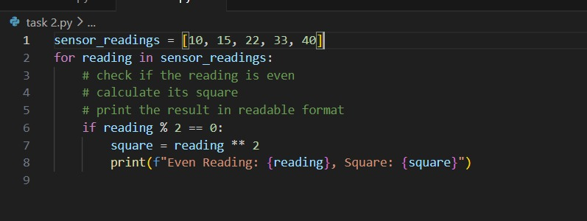
Output:
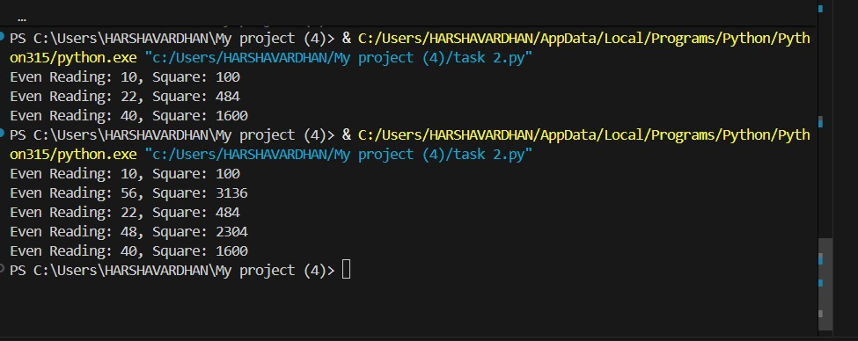

Task 3: Banking Transaction Simulation:
Copilot: method to deposit money
Copilot: method to withdraw money with balance check
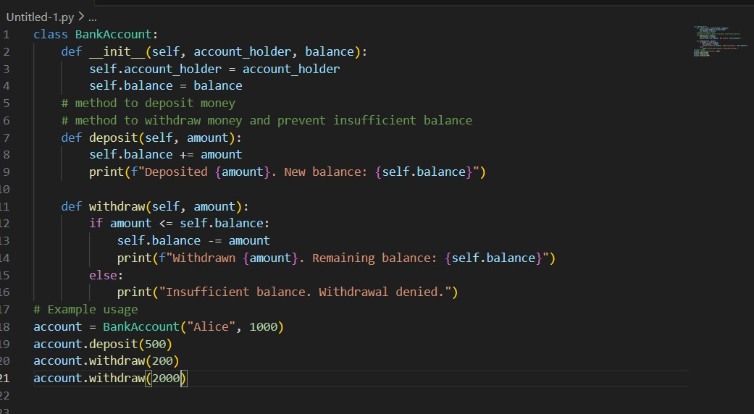
Output:
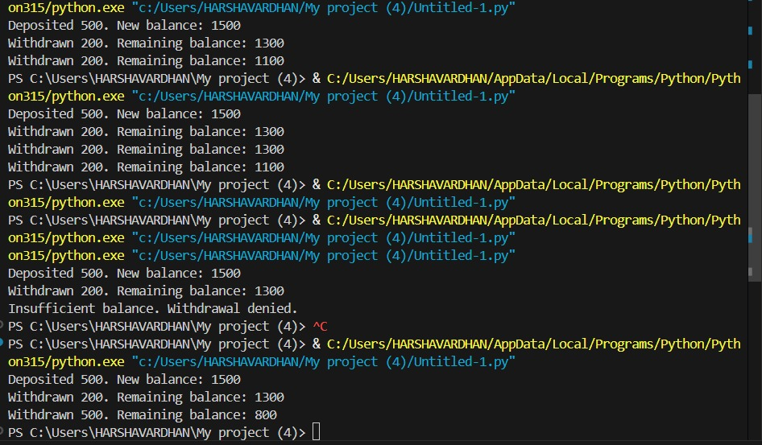
Task 4: Student Scholarship Eligibility Check:
Copilot: use while loop to print students scoring above 75
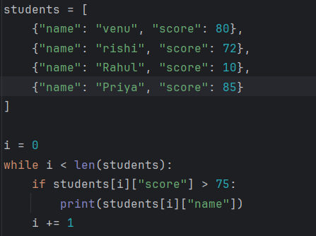
Output:
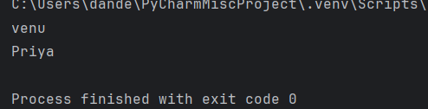
Task 5: Online Shopping Cart Module:

Copilot: add item method
Copilot: remove item method
Copilot: calculate total with discount
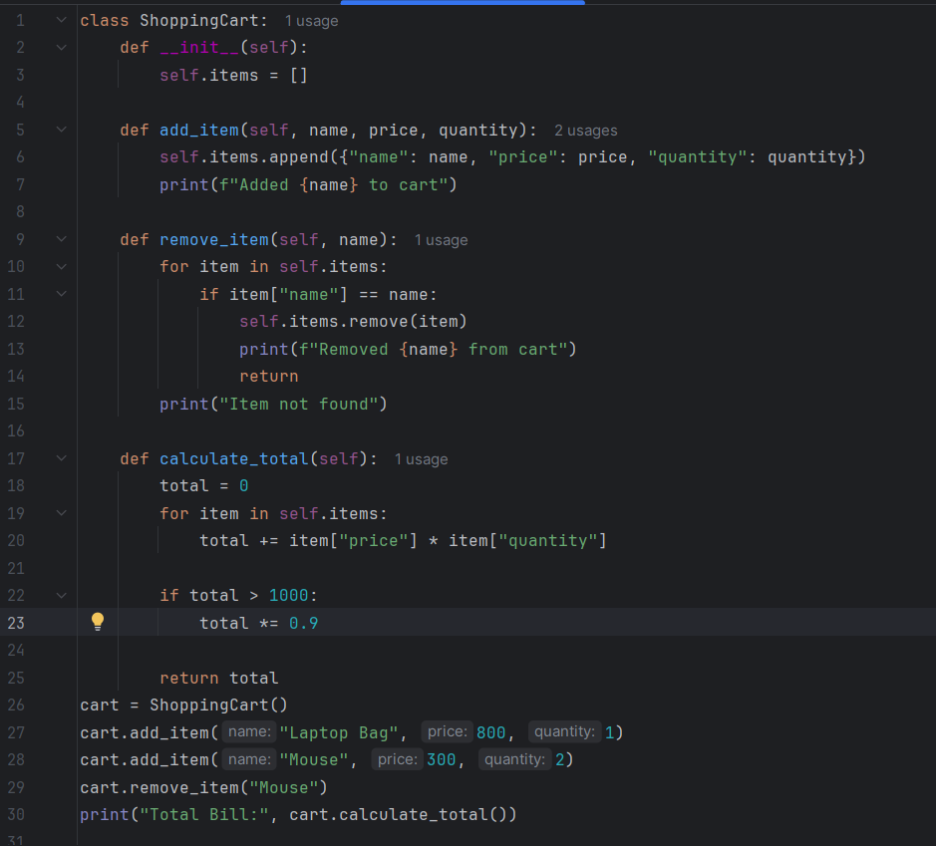
Output:
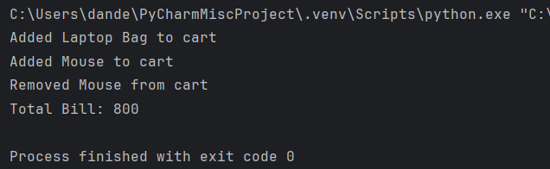
Justification:
This lab demonstrates how AI-based code completion assists in generating Python classes, loops, and conditional logic efficiently. It helps students understand, evaluate, and improve AI-generated code for correctness and real-world applications.

