AI Assistant Coding
Assignement-6.3
Name: T. Swetha
Roll No: 2303a51317
Batch:05
Task Description #1: Classes (Student Class)
Prompt:
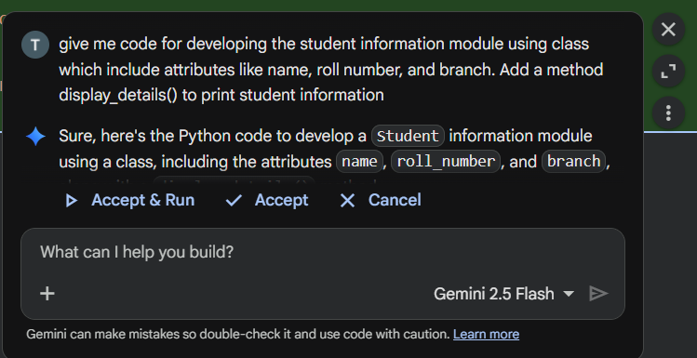
Code:
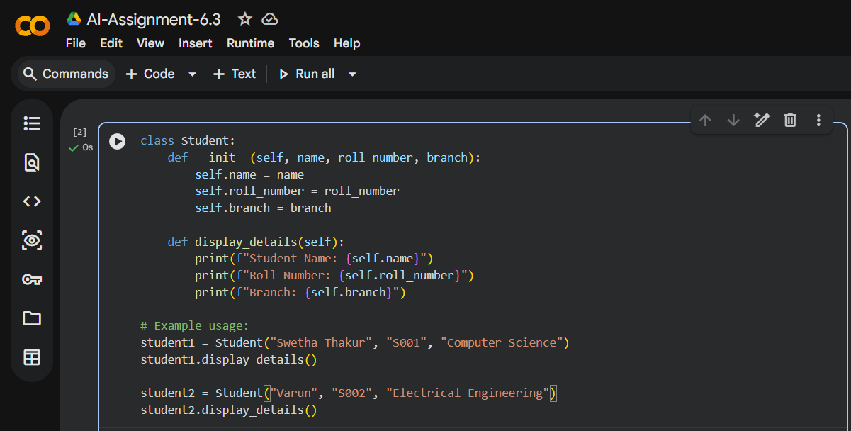
Output:
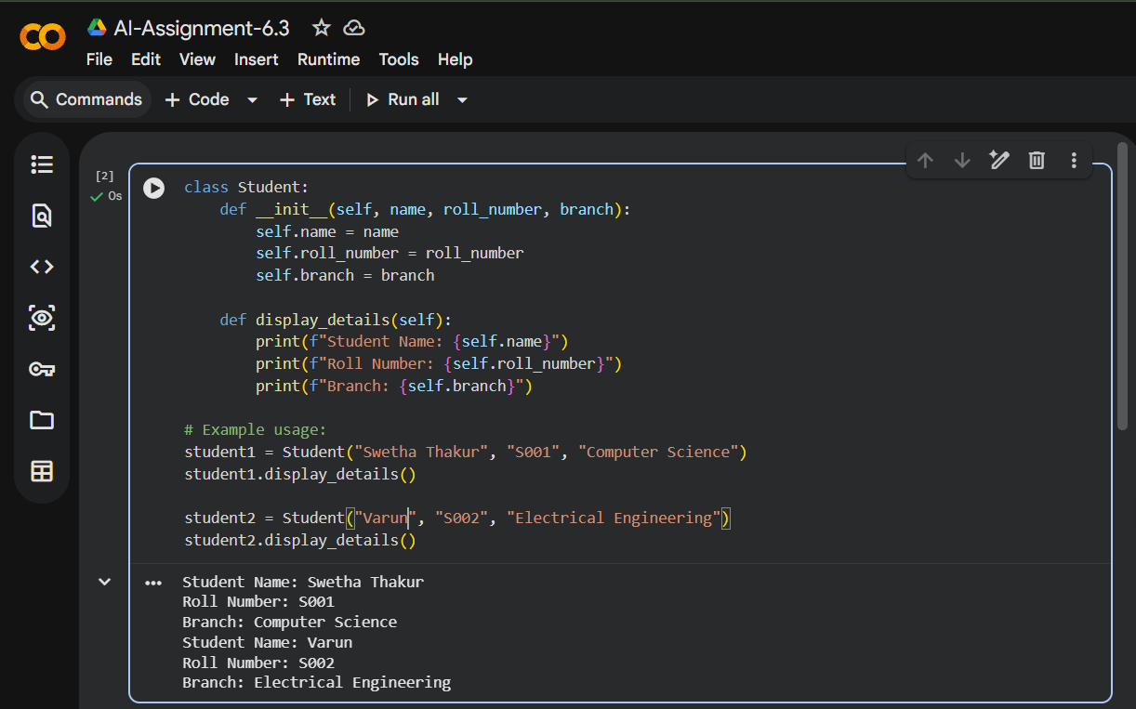
Code Explanation:
Class Definition
- class Student: → Defines a class named Student, which acts as a blueprint for creating student objects.
Constructor (__init__ method)
- def __init__(self, name, roll_number, branch): → Special method called automatically when a new object is created.
Parameters:
  - self → Refers to the current object (instance of the class).
  - name, roll_number, branch → Attributes passed during object creation.
- Inside the constructor:
- self.name = name → Assigns the given name to the object.
- self.roll_number = roll_number → Assigns the roll number.
- self.branch = branch → Assigns the branch.
Instance Method
- def display_details(self): → Defines a method to display student details.
- Uses f-strings for formatted output:
- print(f"Student Name: {self.name}")
- print(f"Roll Number: {self.roll_number}")
- print(f"Branch: {self.branch}")
Task Description #2: Loops (Multiples of a Number)
Prompt:
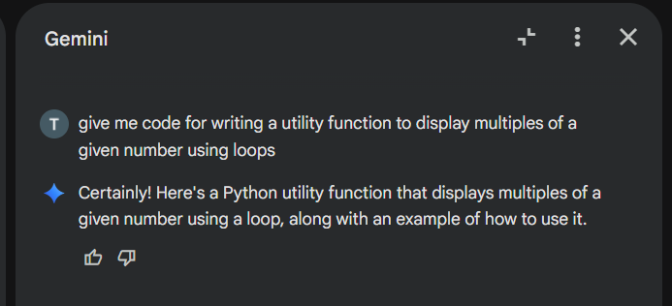
Code:
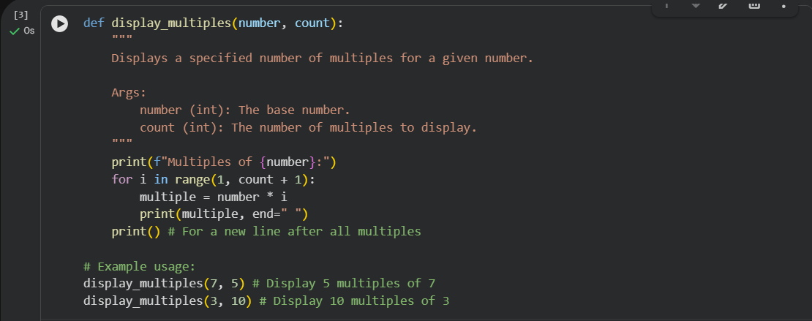
Output:
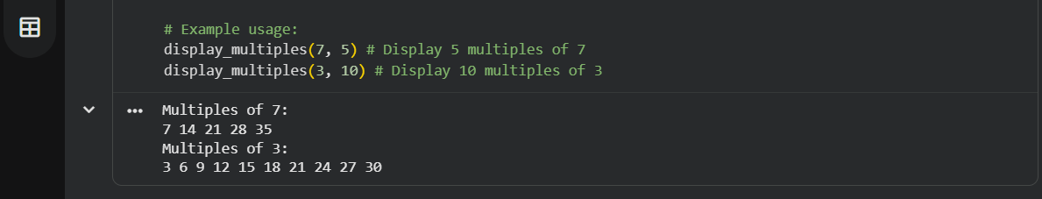
Code Explanation:
Function Definition
- def display_multiples(number, count):
- Defines a function named display_multiples.
Parameters:
- number → the base number whose multiples will be displayed.
- count → how many multiples to display.
Printing Header
- print(f"Multiples of {number}:")
- Prints a header showing which number’s multiples are being displayed.
- Uses an f-string for formatting.
Loop for Multiples
- for i in range(1, count + 1):
  - Loops from 1 up to count (inclusive).
  - Example: if count = 5, loop runs for i = 1, 2, 3, 4, 5.
- Inside the loop:
- multiple = number * i → calculates the multiple.
- print(multiple, end=" ") → prints the multiple on the same line separated by spaces (because of end=" ").
New Line After Loop
- print() → ensures the output moves to a new line after all multiples are printed.
Task Description #3: Conditional Statements (Age Classification)
Prompt:
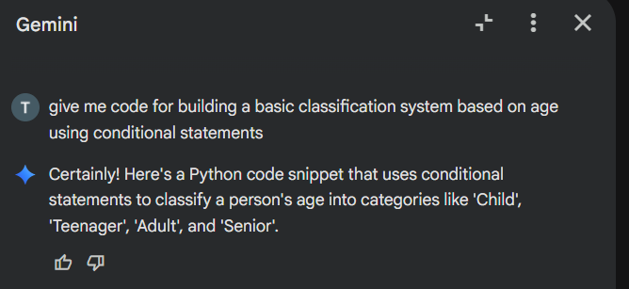
Code:
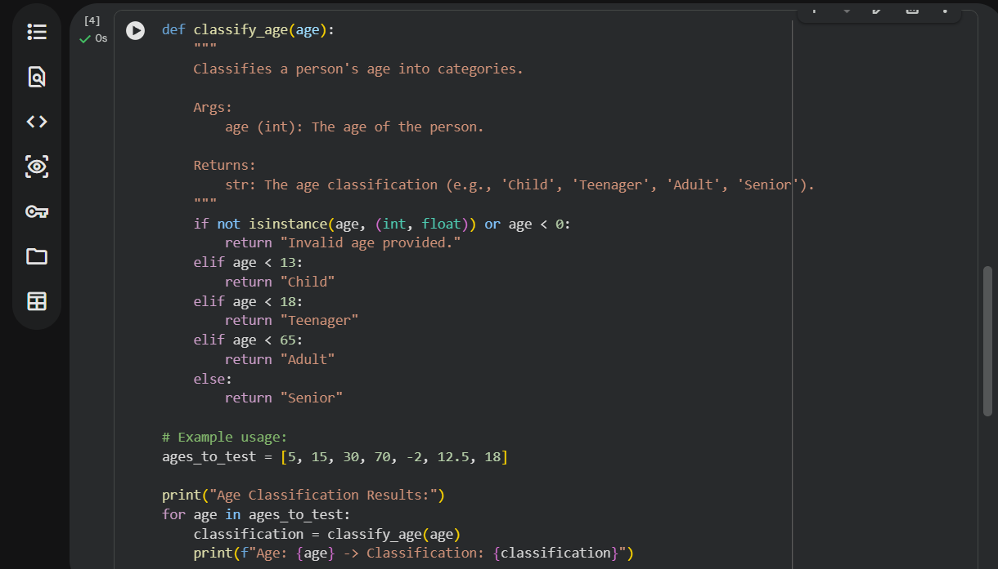
Output:
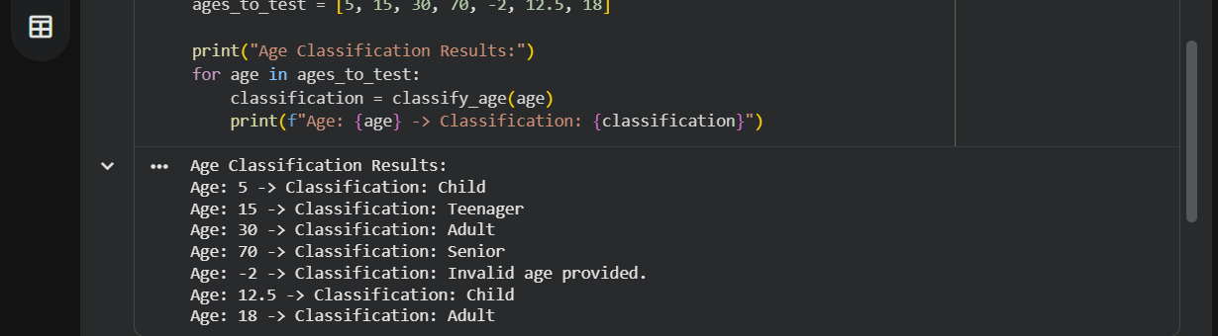
Code Explanation:
Function Definition
- def classify_age(age):
- Defines a function named classify_age.
- Takes one parameter: age (expected to be an integer or float).
Input Validation
- if not isinstance(age, (int, float)) or age < 0:
- Checks if age is not a number (int/float) OR is negative.
- If true → returns "Invalid age provided.".
Age Classification Logic
- elif age < 13: → Returns "Child" if age is less than 13.
- elif age < 18: → Returns "Teenager" if age is between 13 and 17.
- elif age < 65: → Returns "Adult" if age is between 18 and 64.
- else: → Returns "Senior" if age is 65 or above.
Task Description #4: For and While Loops (Sum of First n Numbers)
Prompt:
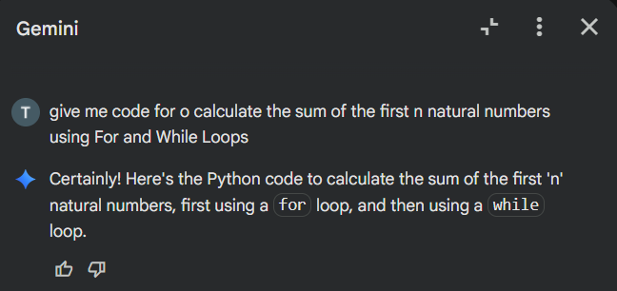
Code:(For loop)
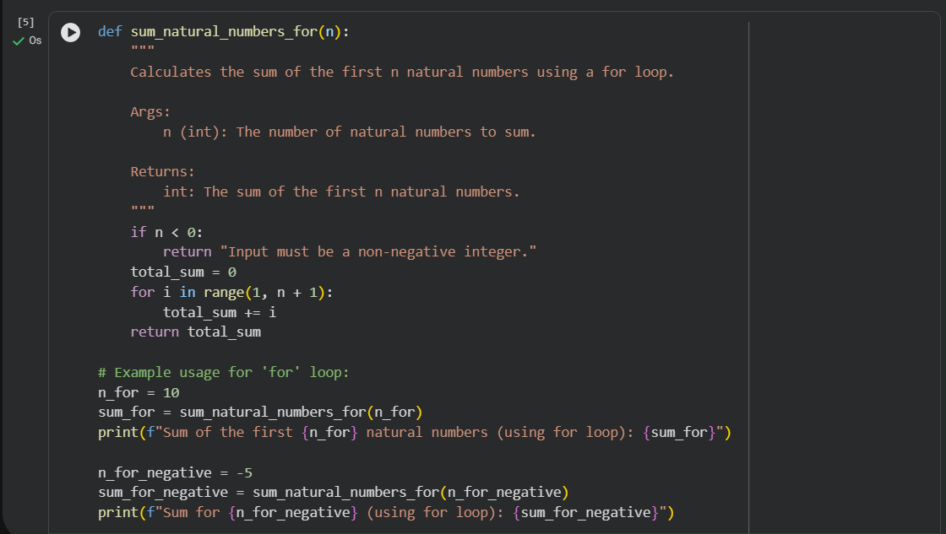
Output:
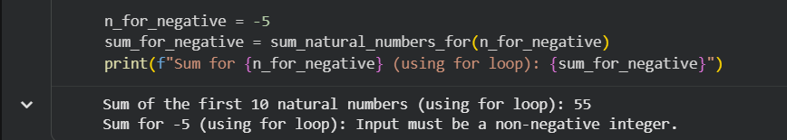
Code:(While loop)
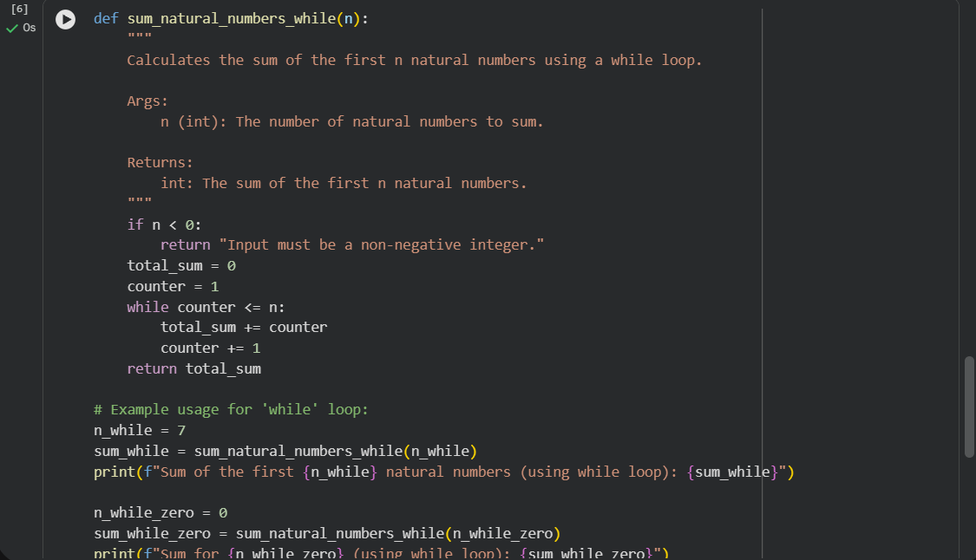
Output:
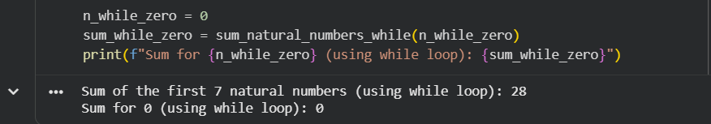
Code Explanation:
Function 1: sum_natural_numbers_for(n)
- Purpose: Calculates the sum of the first n natural numbers using a for loop.
- Steps:
  - Input validation:
    - If n < 0, returns "Input must be a non-negative integer.".
  - Initialize total_sum = 0.
  - Loop:
    - for i in range(1, n + 1): → iterates from 1 to n.
    - Adds each number to total_sum.
  - Returns the final sum.
Example usage:
- n_for = 10 → Sum = 55.
- n_for_negative = -5 → Returns "Input must be a non-negative integer.".
🔹Function 2: sum_natural_numbers_while(n)
- Purpose: Calculates the sum of the first n natural numbers using a while loop.
- Steps:
  - Input validation:
    - If n < 0, returns "Input must be a non-negative integer.".
  - Initialize total_sum = 0 and counter = 1.
  - Loop:
    - while counter <= n: → runs until counter exceeds n.
    - Adds counter to total_sum.
    - Increments counter by 1.
Task Description #5: Classes (Bank Account Class)
Prompt:
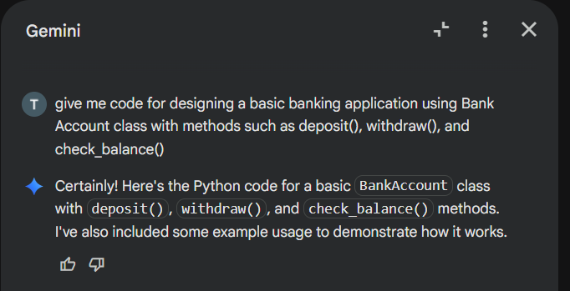
Code:
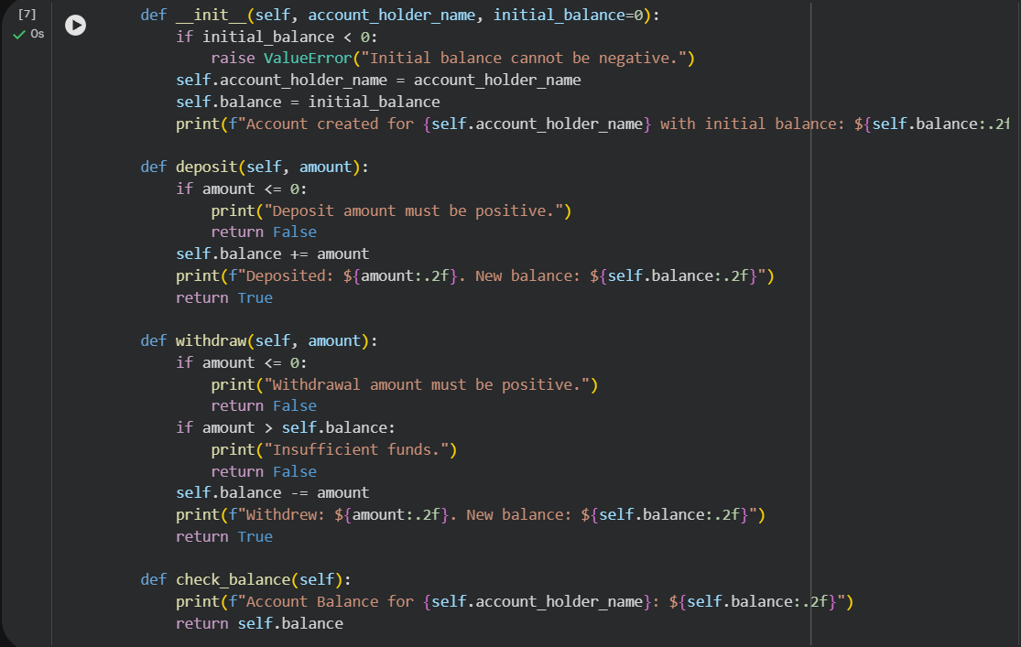
Output:
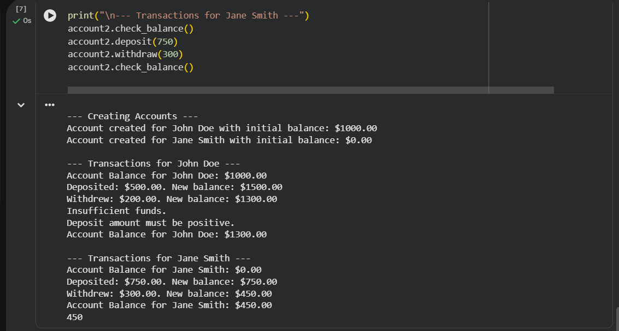
Code Explanation:
Class Definition
- class BankAccount: → Defines a BankAccount class to simulate basic banking operations.
Constructor (__init__)
- def __init__(self, account_holder_name, initial_balance=0):
- Initializes a new account with:
  - account_holder_name → Name of the account holder.
  - initial_balance → Starting balance (default = 0).
- Validation:
  - If initial_balance < 0, raises a ValueError.
- Sets attributes:
  - self.account_holder_name = account_holder_name
  - self.balance = initial_balance
- Prints confirmation message with formatted balance.
Deposit Method
- def deposit(self, amount):
- Validates deposit:
  - If amount <= 0, prints error and returns False.
- Otherwise:
- Adds amount to self.balance.
- Prints deposit confirmation and new balance.
- Returns True.
Withdraw Method
- def withdraw(self, amount):
- Validates withdrawal:
  - If amount <= 0, prints error and returns False.
  - If amount > self.balance, prints "Insufficient funds" and returns False.
- Otherwise:
- Deducts amount from self.balance.
- Prints withdrawal confirmation and new balance.
- Returns True.
Check Balance Method
- def check_balance(self): Prints current balance for the account holder.

