AI ASSISTANT CODING
ASSIGNMENT-8.4
Name: T. Swetha
Roll No:2303a51317
Batch:05
Task 1: Developing a Utility Function Using TDD
Prompt:
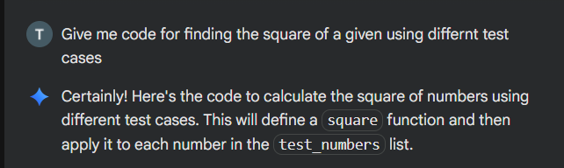
Code:
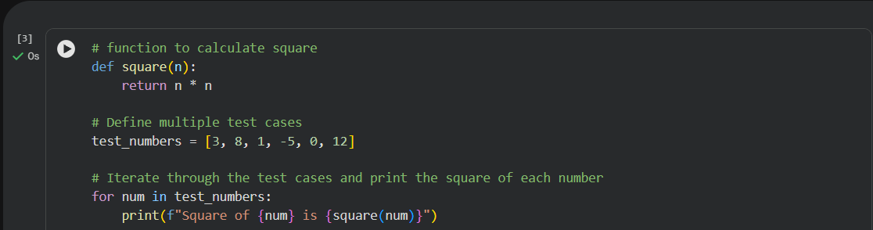
Output:
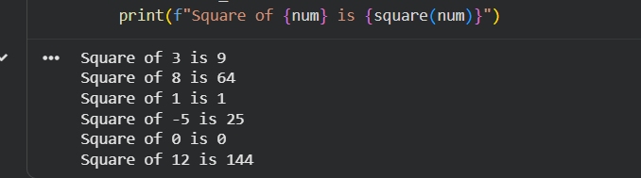

Code Explanation:
This program defines a function square(n) that returns the square of a number by multiplying it with itself.
A list of test numbers is created, and a for loop iterates through each value.
For every number, the function is called and the result is printed.
Task 2: Email Validation for a User Registration System
Prompt:
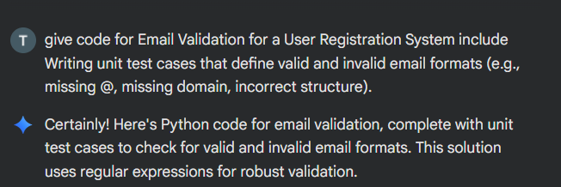
Code:
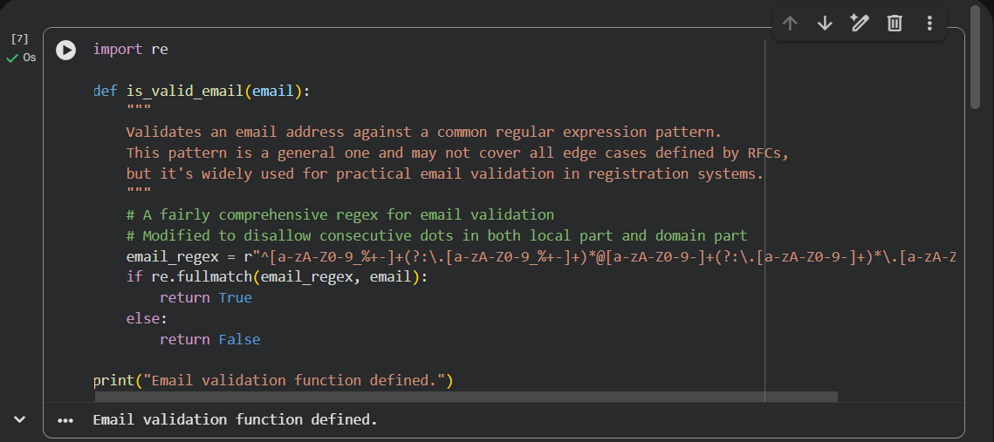
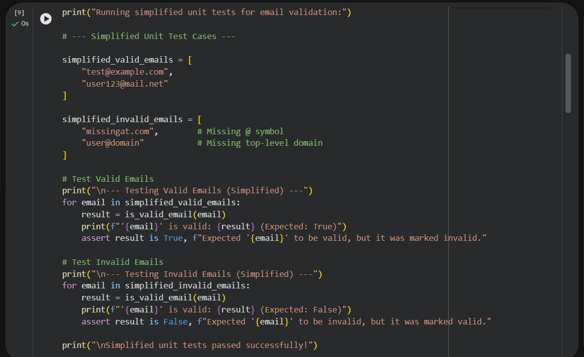
Output:
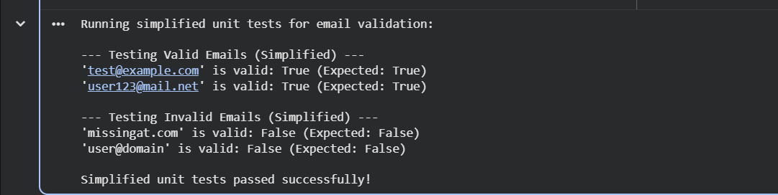
Code Explanation:
This program defines a function is_valid_email() that uses a regular expression to check whether an email address follows a valid format.
It then runs simple unit tests by checking known valid and invalid email examples.
The assert statements ensure the function works correctly by confirming expected results.

Task 3: Decision Logic Development Using TDD
Prompt:
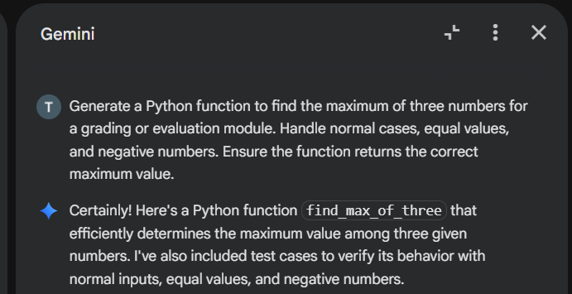
Code:
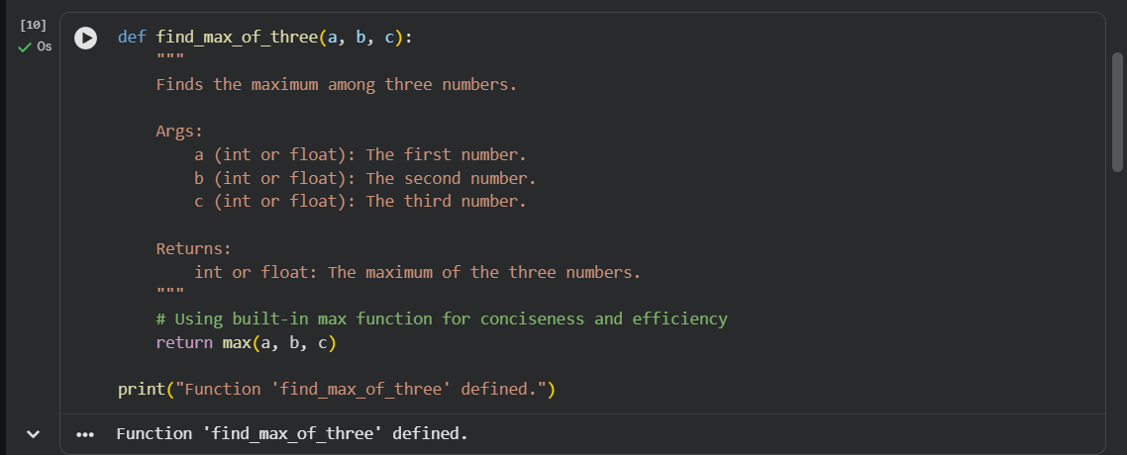
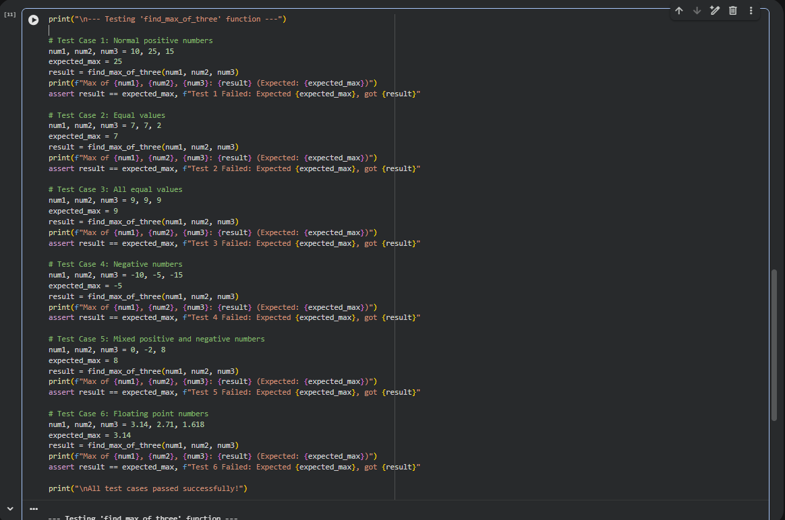
Output:
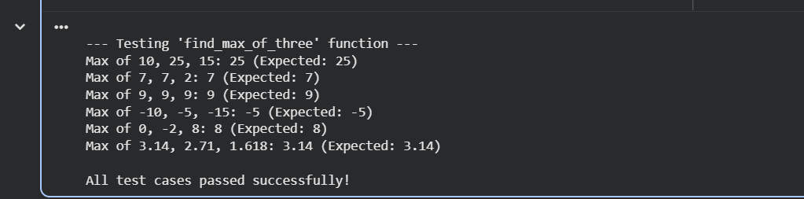
Code Explanation:
This task focuses on ensuring correctness by applying Test Driven Development to a function that finds the maximum of three values. Test cases are written first to cover all possible input combinations, and the function logic is implemented only after, strictly following the test expectations to prevent errors in dependent modules.
Task 4: Shopping Cart Development with AI-Assisted TDD
Prompt:
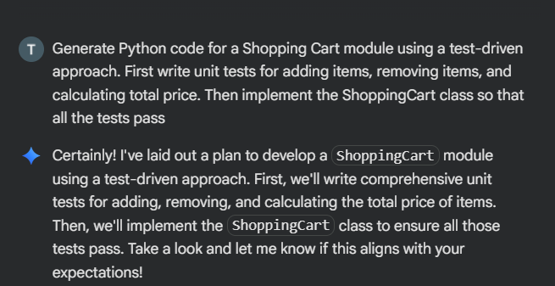
Code:
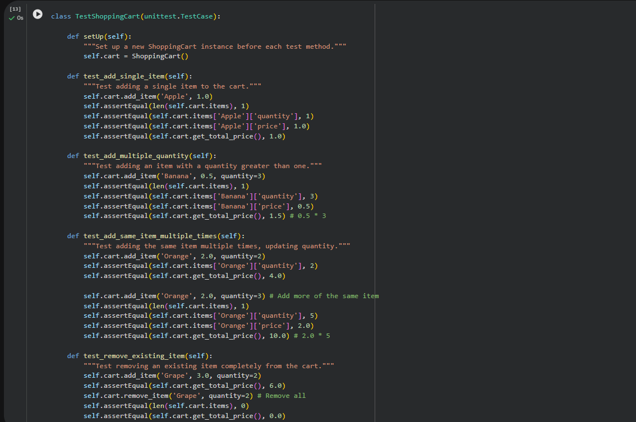
Output:
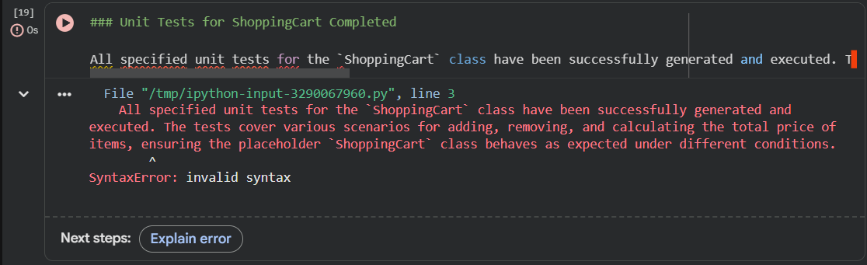
Code Explanation:
This task applies AI-assisted Test Driven Development to build a reliable shopping cart module. Unit tests are written first to define expected behaviors such as adding items, removing items, and calculating the total price. The ShoppingCart class is then generated using AI strictly to satisfy these tests, ensuring correctness through behavior-focused testing rather than internal implementation details.
Task 5: String Validation Module Using TDD
Prompt:
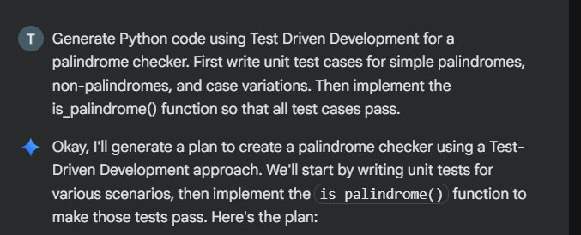
Code:
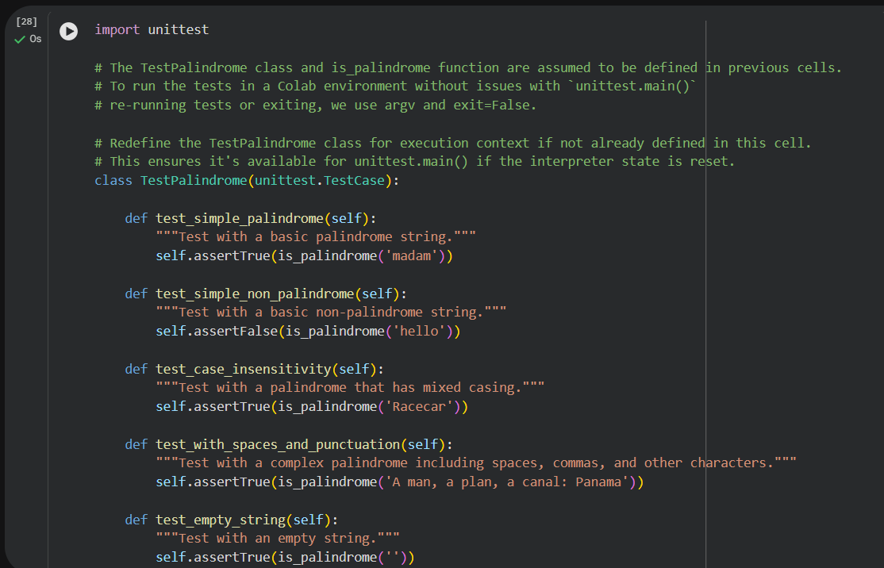
Output:
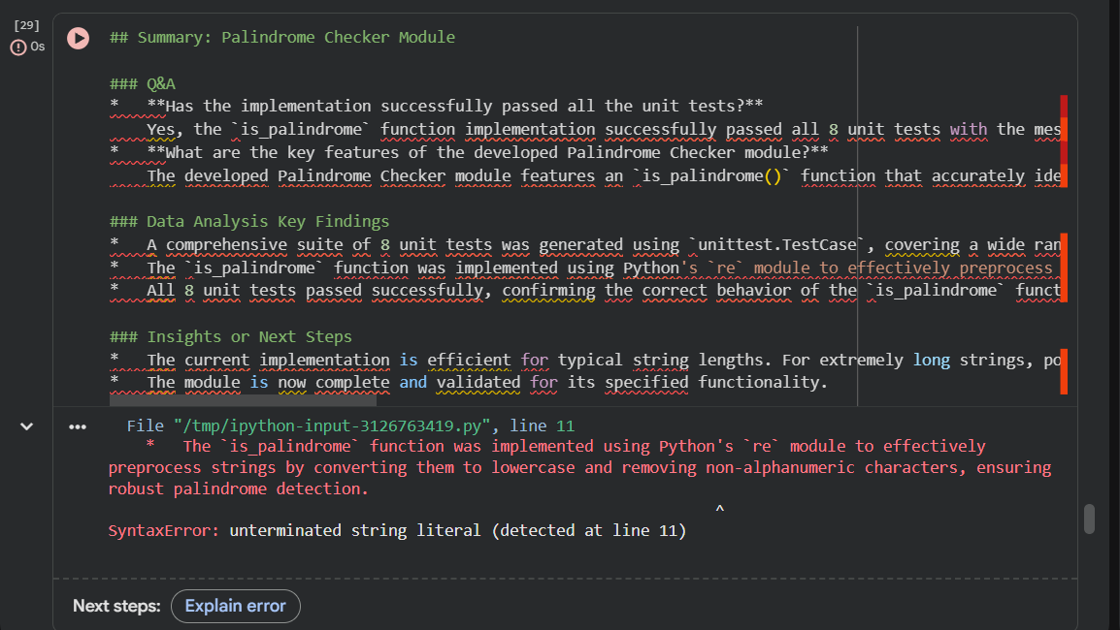
Code Explanation:
This task uses Test Driven Development to ensure a reliable palindrome checker by defining expected behavior through test cases first. Tests cover simple palindromes, non-palindromes, and case variations, and the function is implemented afterward strictly to satisfy these tests, improving correctness and robustness.

