ASSIGNMENT-2.3
Name: T. Swetha Ht.no:2303A51317
Batch:05

TASK:01
Word Frequency from Text File

PROMPT:
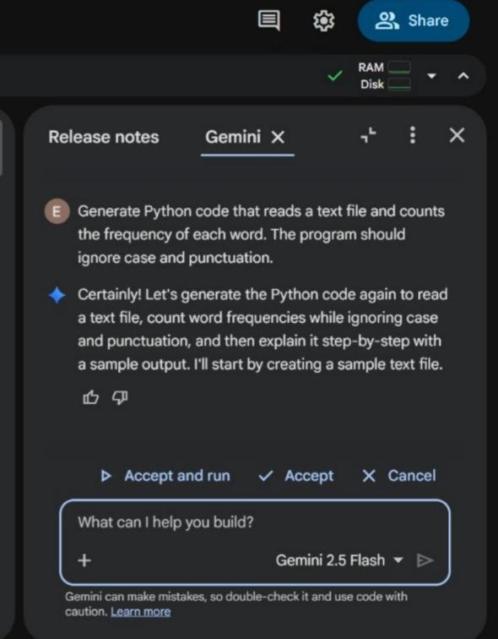

CODE:

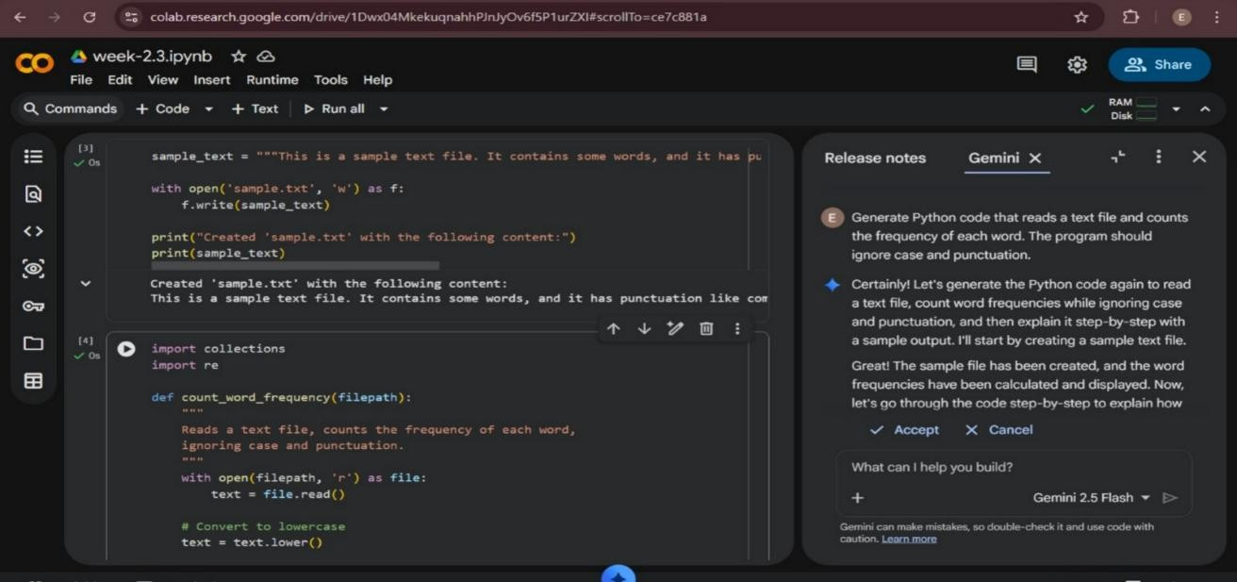
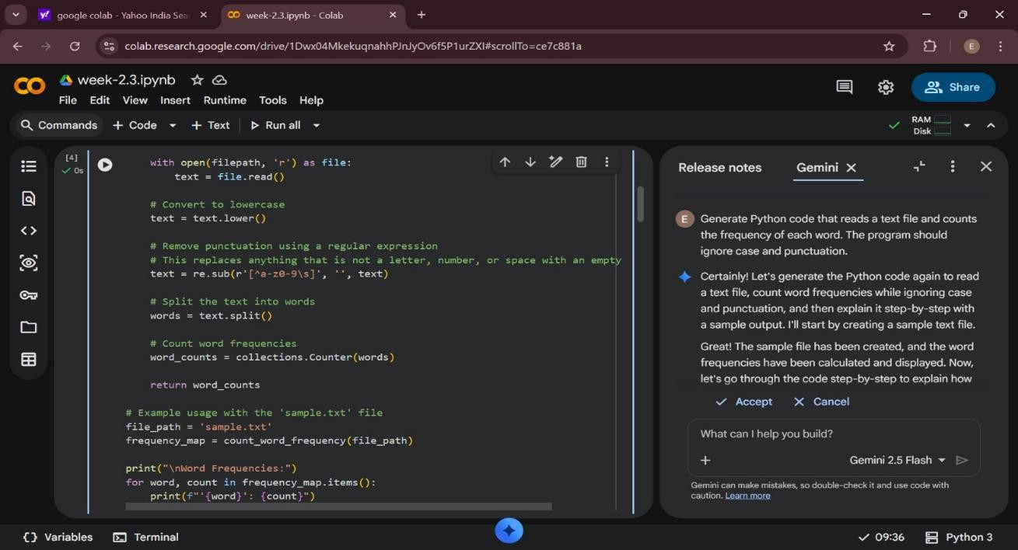

OUTPUT:
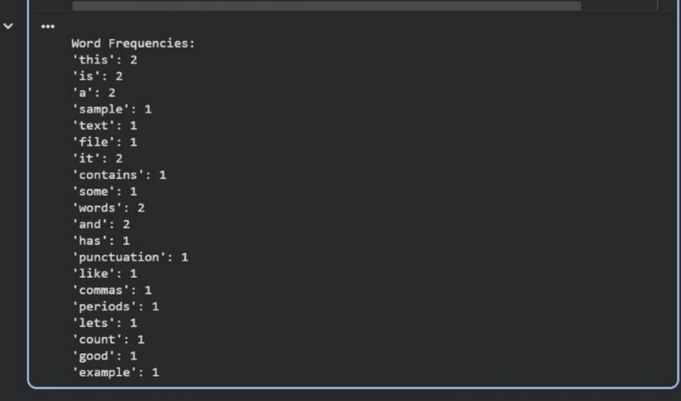

EXPLANATION:
- The program reads the contents of a text file.
- It converts all text to lowercase to avoid case mismatch.
- Punctuation marks are removed to ensure accurate word counting.
- Each word is counted using a dictionary.
- The final output displays each word along with its frequency.

TASK-02: PROMPT:
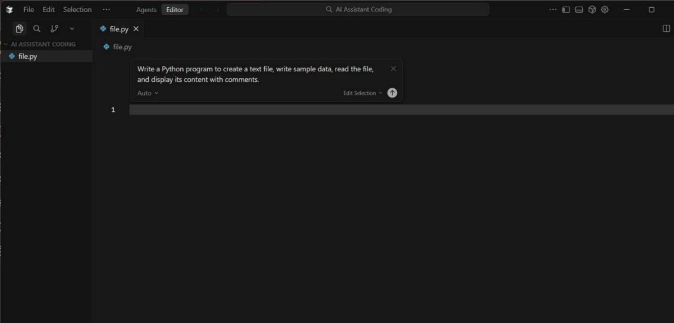
CODE:
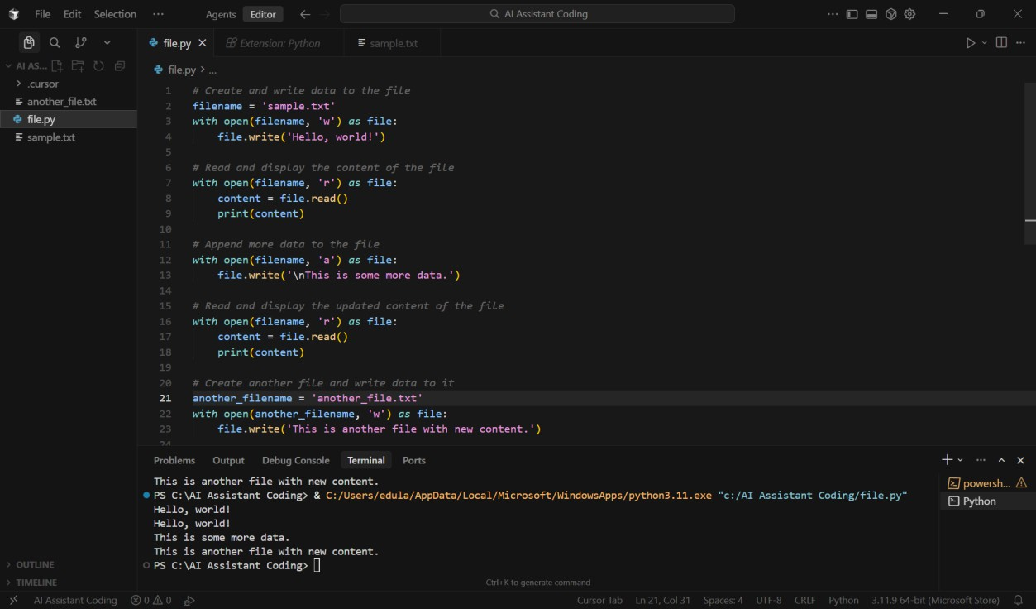

OUTPUT:
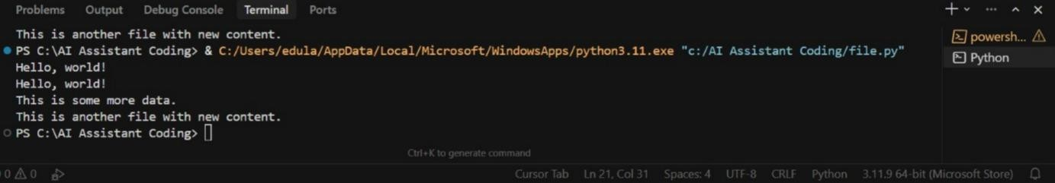
EXPLANATION:
- The program creates a new text file using write mode.
- Sample text is written into the file.
- The file is then opened in read mode.
- The program reads the content of the file.
- Finally, the file content is displayed on the screen.
TASK-03
CSV Data Analysis PROMPT:
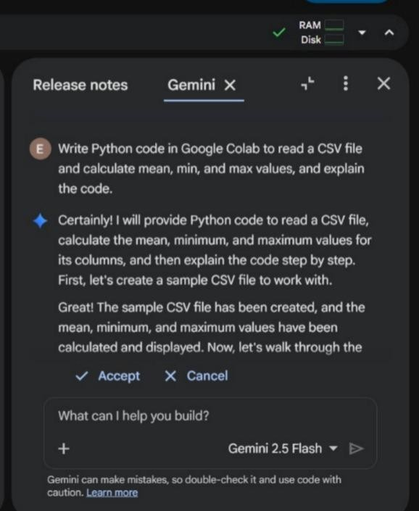

CODE:
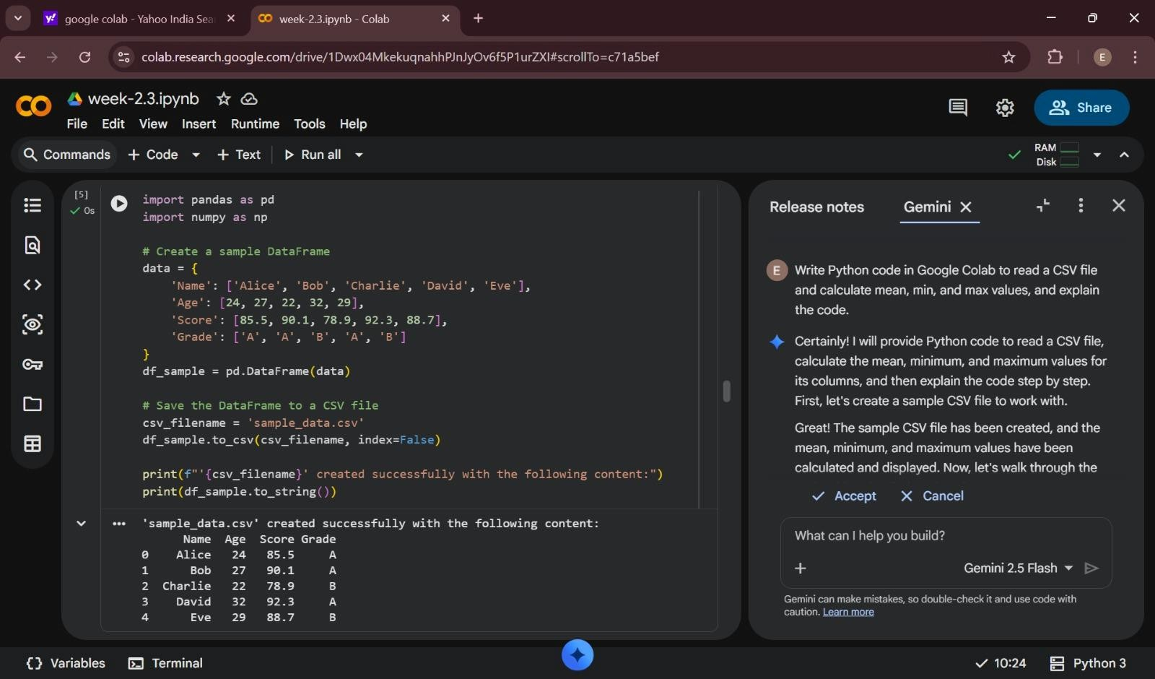
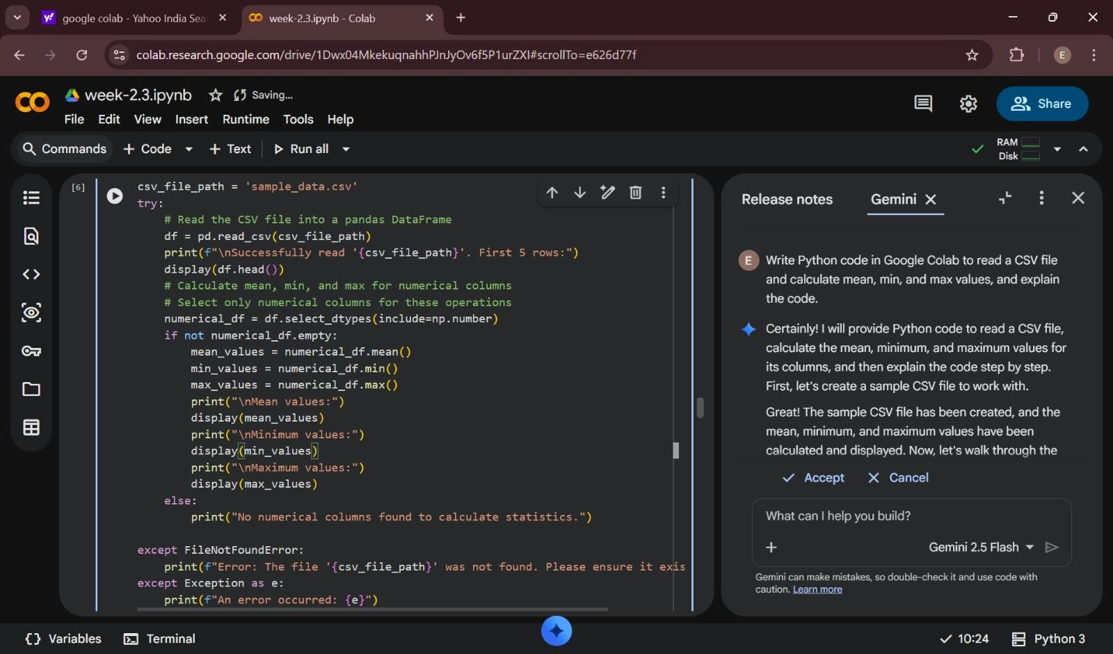

OUTPUT:
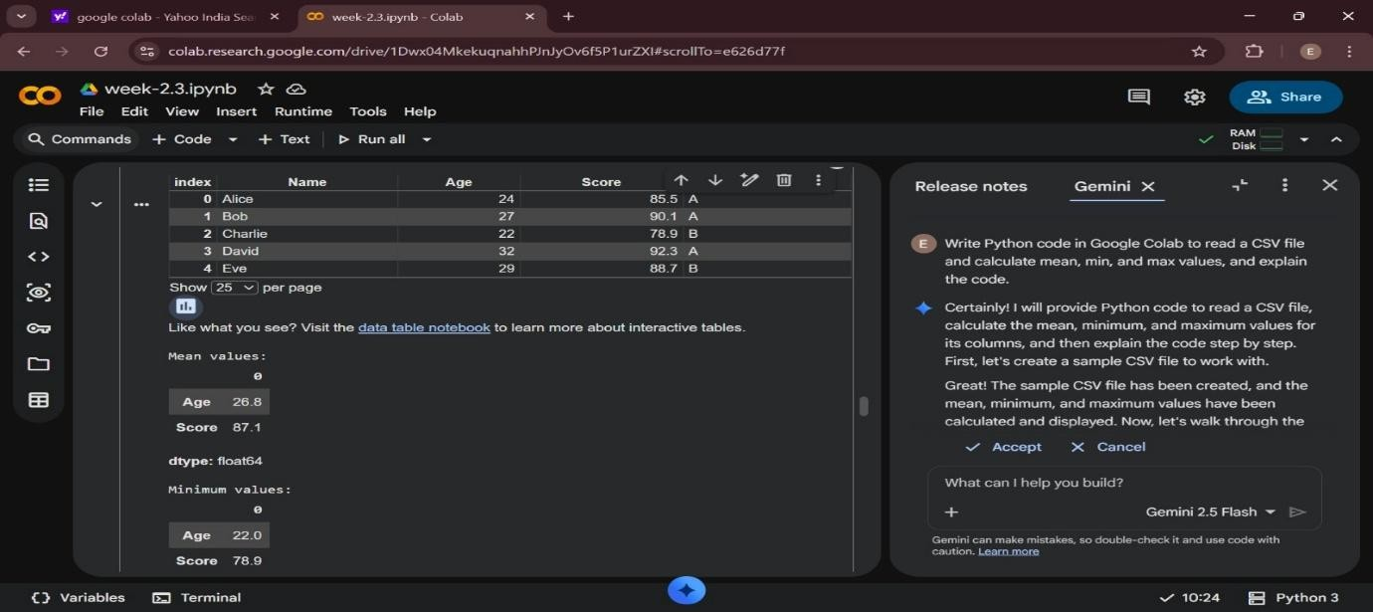
EXPLANATION:
- The program imports the pandas library to work with CSV data.
- The CSV file is uploaded and read into a DataFrame.
- The dataset is displayed to understand its structure.
- The program calculates the mean of numeric columns.
- It finds the minimum value in each numeric column.
- It finds the maximum value in each numeric column.
- The results are displayed as output.
TASK-04
Sorting Lists – Manual vs Built-in PROMPT:


CODE:
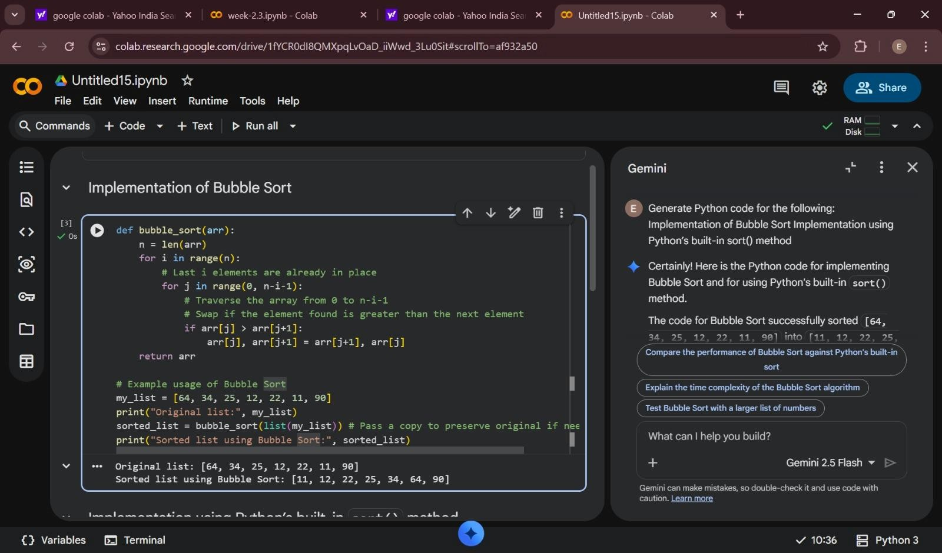
OUTPUT:
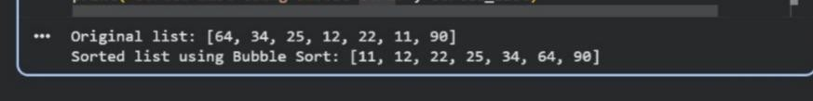
EXPLANATION:

Bubble Sort
- Bubble sort repeatedly compares adjacent elements.
- If the elements are in the wrong order, they are swapped.
- This process continues until the list is completely sorted.
- It is easy to understand but inefficient for large datasets.

Python Built-in sort()
- The sort() method sorts the list directly using an optimized algorithm.
- It is faster and more efficient than bubble sort.
- It requires less code and is suitable for large datasets.

Comparison
- Bubble sort has higher time complexity and is slower.
- Python’s sort() is optimized and much faster.
- Bubble sort is mainly used for learning, while sort() is used in real applications.

