AI Assistant Coding Assignment -1

Name: T. Swetha Roll no:2303a51317 Batch:05

1. Lab 1: Environment Setup – GitHub Copilot and VS Code Integration + Understanding AI-assisted Coding Workflow.
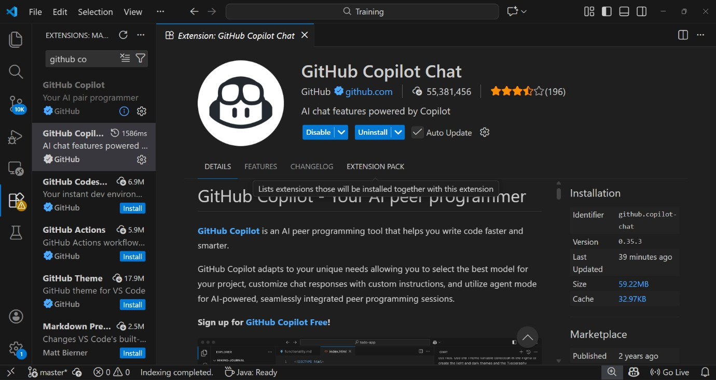

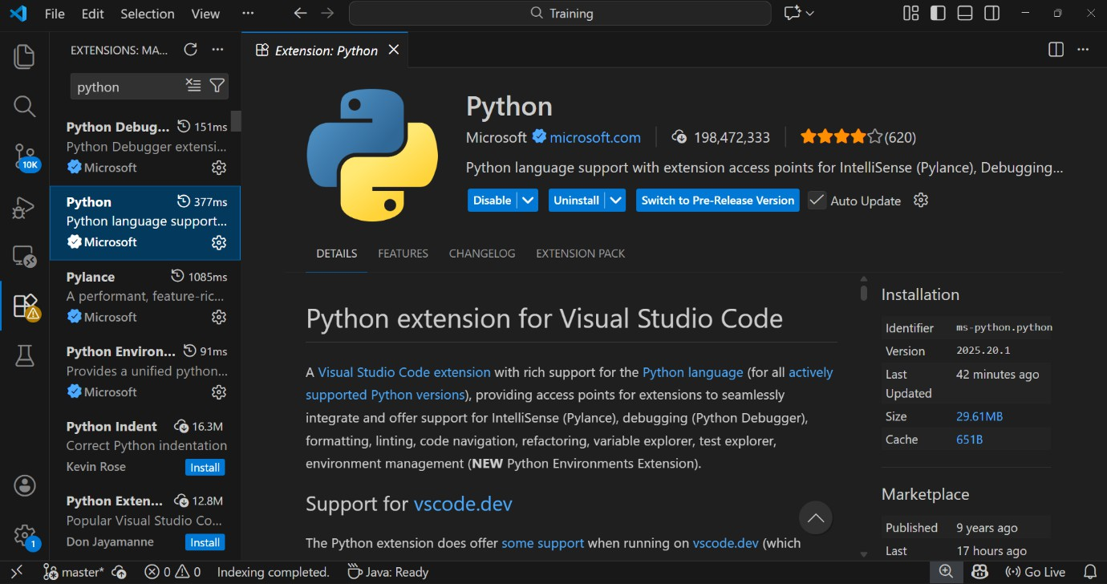
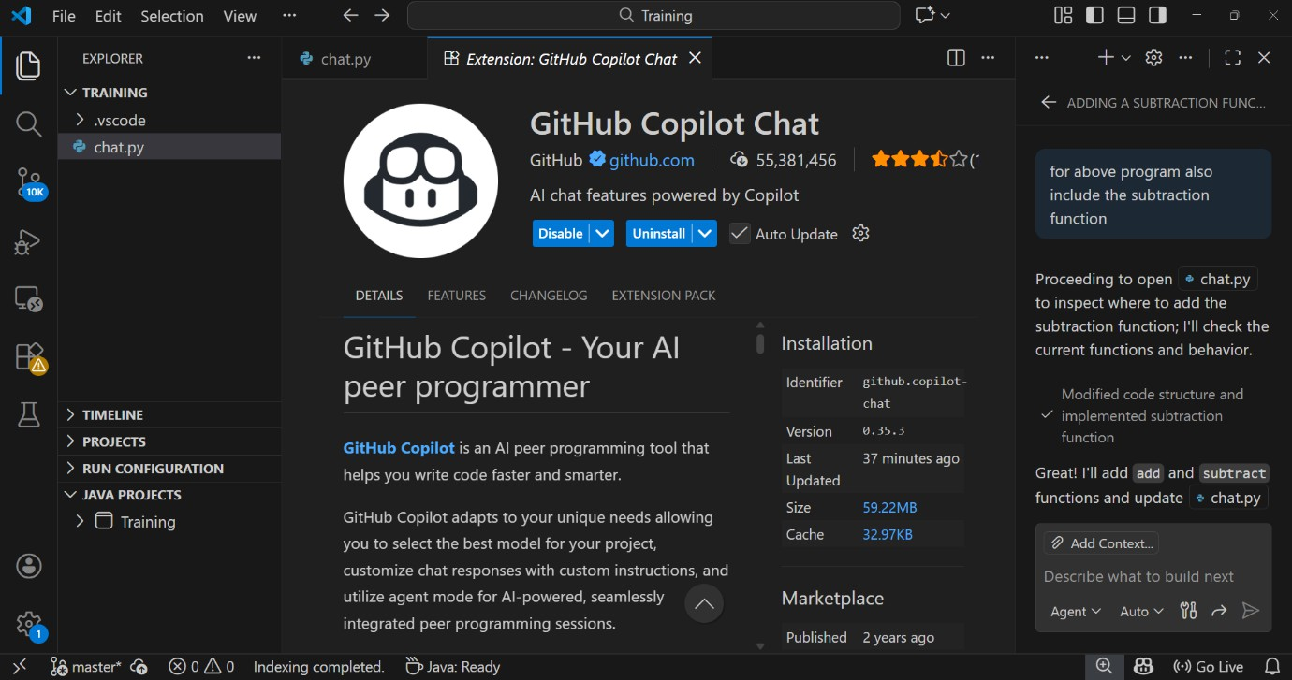

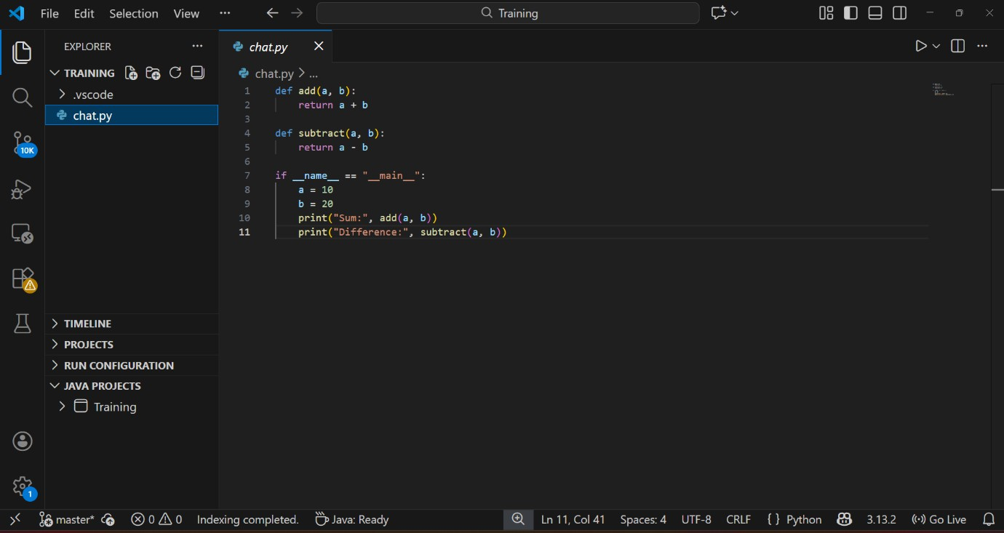
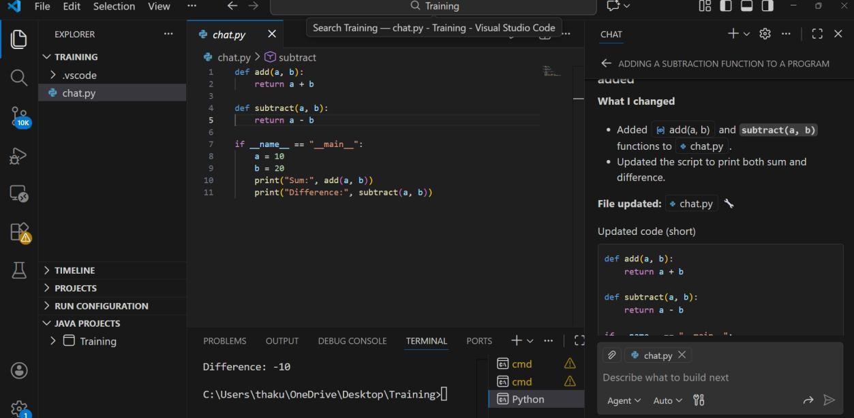

Task 1: AI-Generated Logic Without Modularization (Fibonacci Sequence Without Functions)
Step 1: Giving prompt: Give me code for fibonacci sequence up to n terms which accepts the user input without using functions

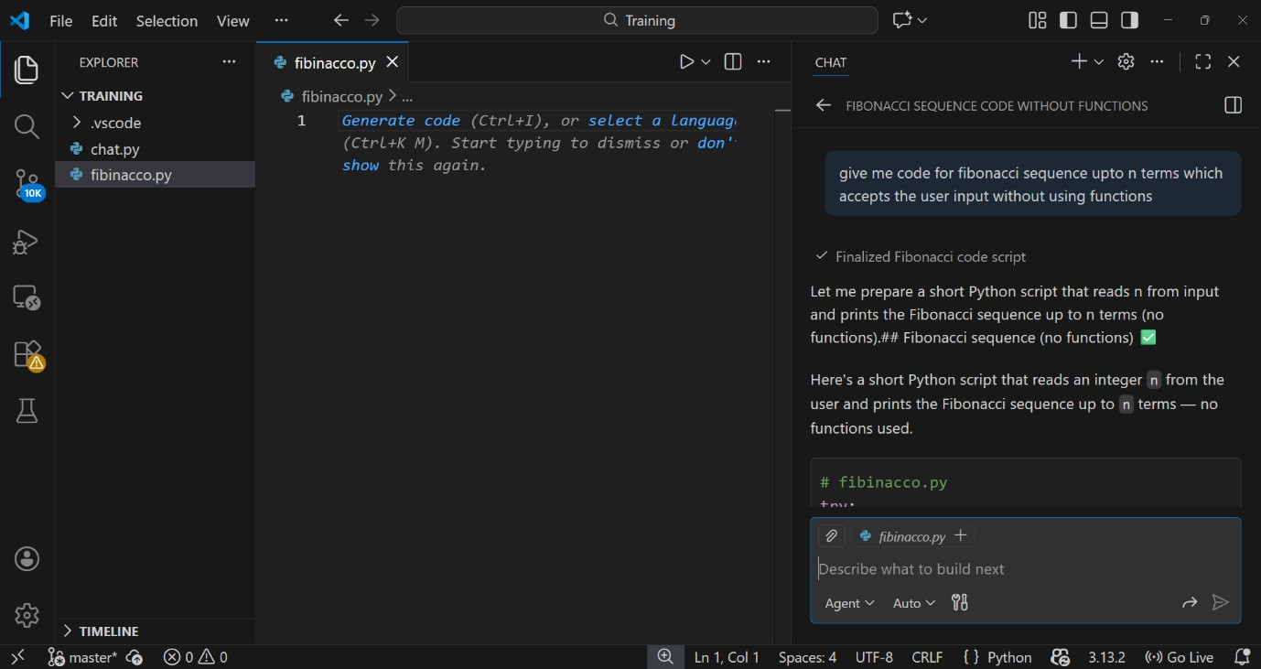
Step 2: Code
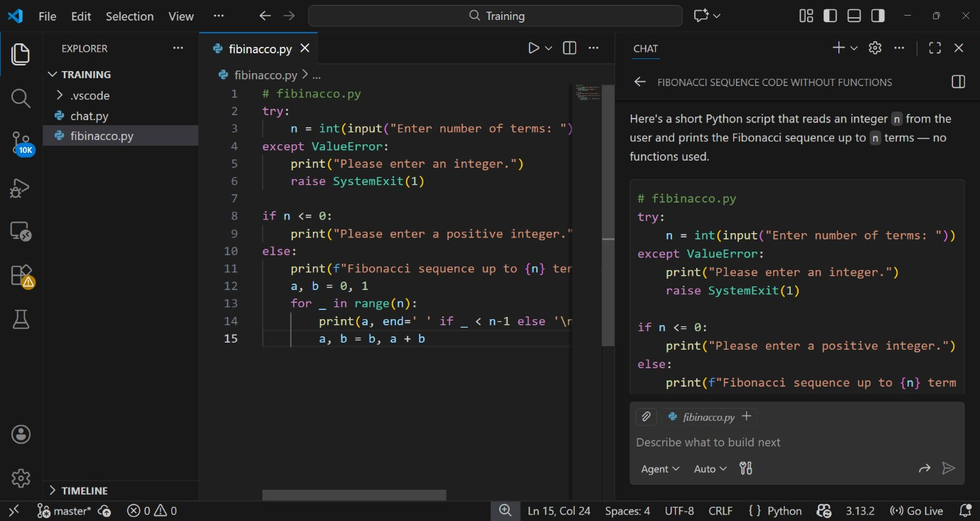

Step 3: Output

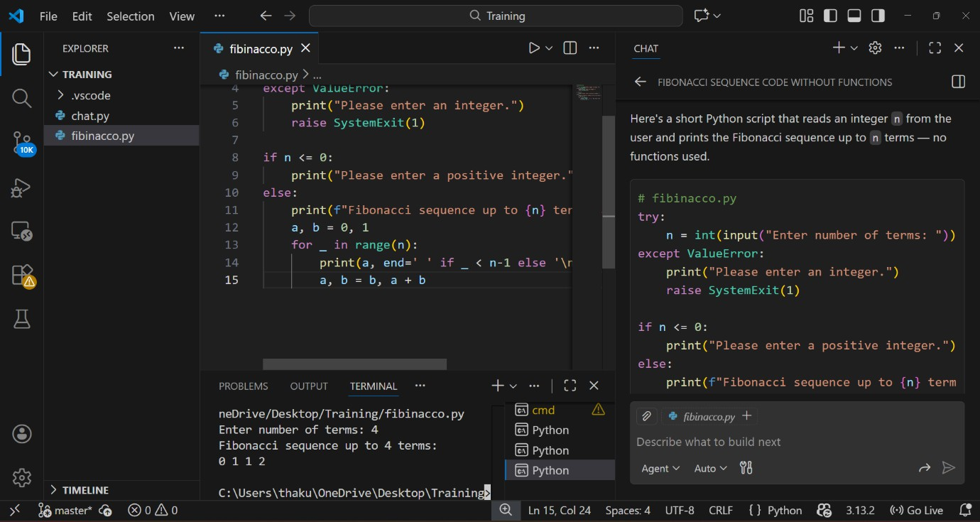
Step 4: Explanation of Code

Input Handling:
- Uses try-except to ensure the user enters an integer.
- Exits gracefully if input is invalid.

Validation:
- Checks if n <= 0.
- Prompts user to enter a positive integer if invalid.

Output Message:
- Prints a header with correct pluralization (term vs terms).

Initialization:
- Starts with a = 0, b = 1 (first two Fibonacci numbers).

Loop Logic:
- Runs for _ in range(n) to generate n terms.
- Prints current value of a.
- Updates values with a, b = b, a + b.

Printing Style:
- Numbers are printed on the same line separated by spaces.
- Last number ends with a newline.

Result:
- Produces the Fibonacci sequence up to n terms. Example:
Input: 4 → Output: 0 1 1 2

Task 2: AI Code Optimization & Cleanup (Improving Efficiency)

Step 1: Giving Prompt: Using the above code improve it by removing abundant variables and reduce to small loop logic and avoid unnecessary computations / optimize the code
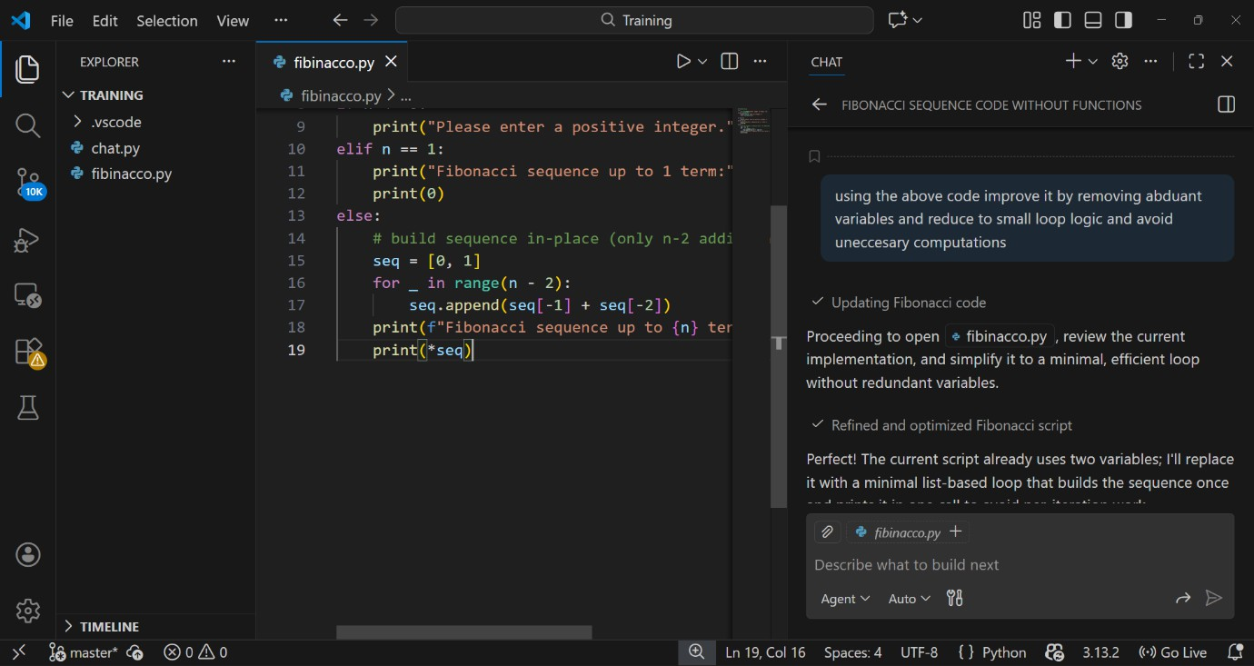

Step 2: Code

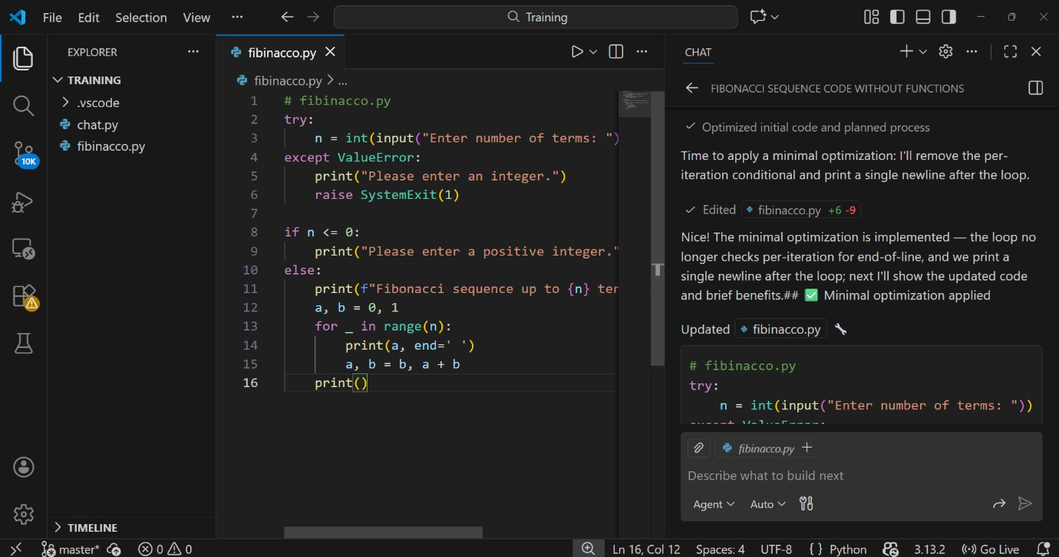
Step 3: Output

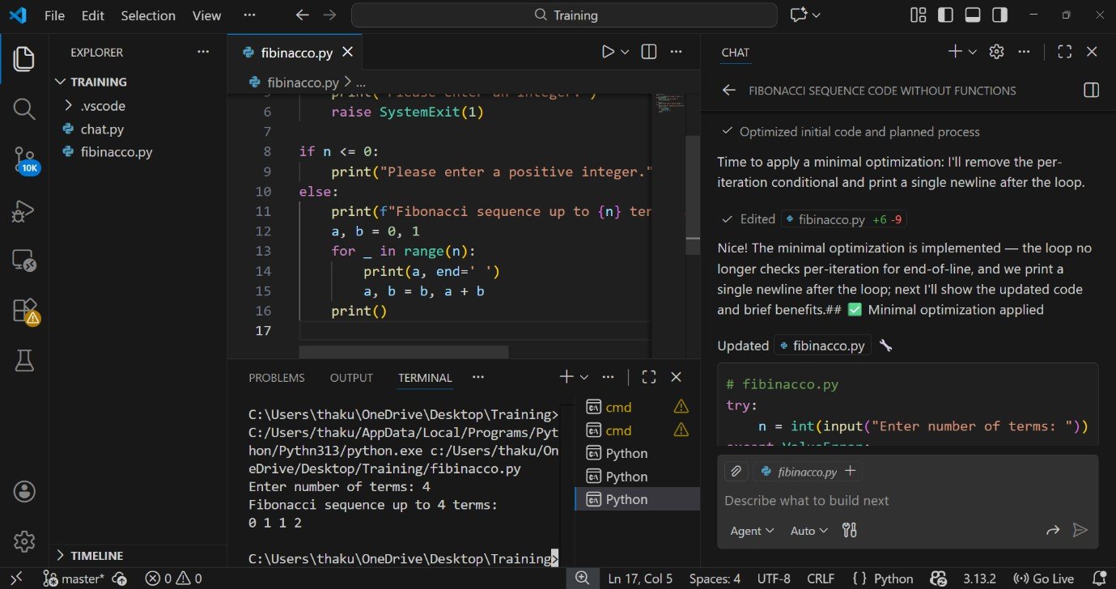
Step 4: Code Explanation

Input Handling
  - Uses try-except to ensure the user enters an integer.
  - Exits safely if input is invalid.

Validation
  - Checks if n <= 0.
  - Prompts user to enter a positive integer if invalid.

Output Message
  - Prints a header with correct pluralization (term vs terms).

Initialization
  - Starts with a = 0, b = 1 (first two Fibonacci numbers).

Loop Logic
  - Runs for _ in range(n) to generate n terms.
  - Prints current value of a.
  - Updates values with a, b = b, a + b.
What Was Inefficient in the Original Code
The original code had stuff that wasn't needed to generate the Fibonacci sequence.
A volatile memory variable was used to hold the sum and added extra length.
It's because you're putting the fibonacci sequence into a list as well a program like this will just output the result, but store it in memory somewhere.
The loop was constructed in more than one step, which made the code less readable
How the optimized/python version brings performance improvement and improved readability.
Unnecessary variables were discarded and the values were updated by tuple assignment in an efficient manner.
Your code also writes to disc, I assume you want to speed the codeup, so this is not good. Your optimized version that this saved memory.3) that it prints the number instead of storing a whole vector with all solutions.

Task 3: Modular Design Using AI Assistance (Fibonacci Using Functions)

Step 1: Prompt: Give code for Fibonacci sequence using functions.

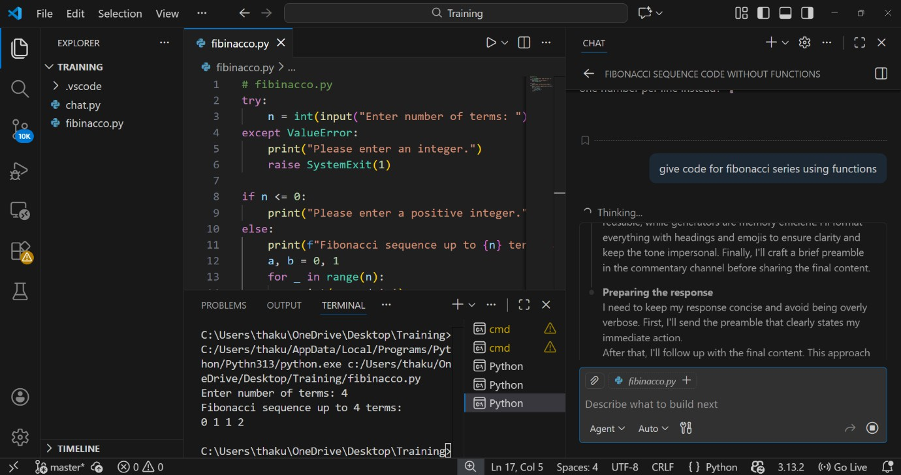

Step 2: Code:
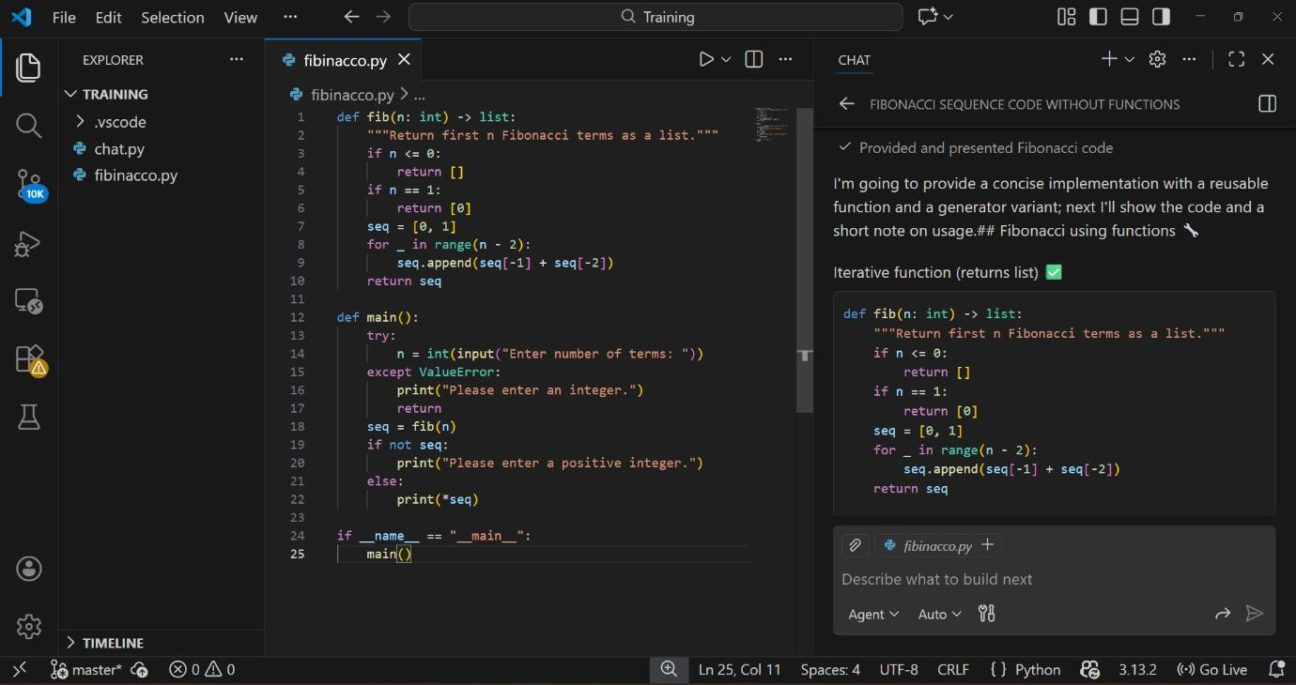

Step 3: Output

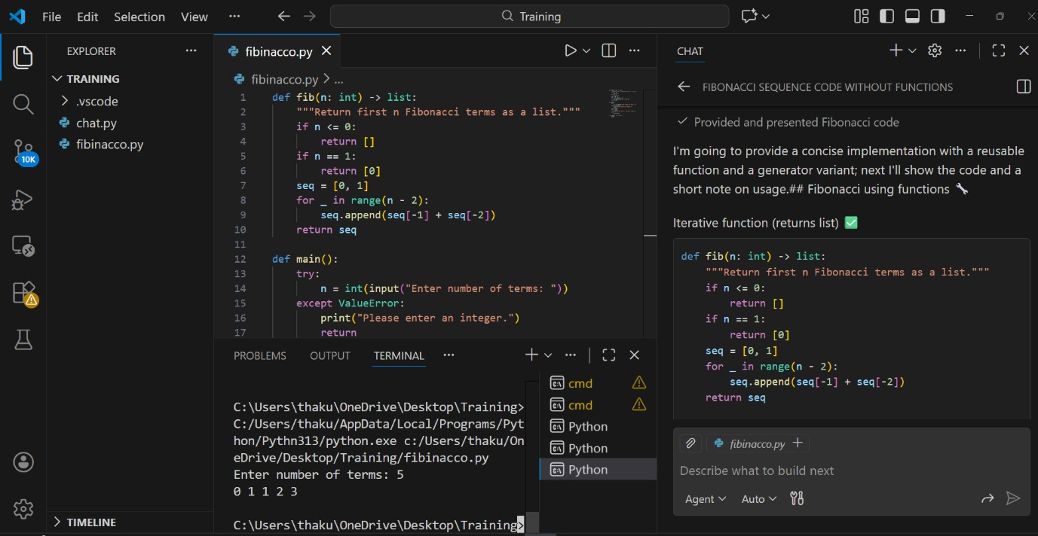
Step 4: Explanation of code
Function Design
  - fib(n) cleanly separates Fibonacci logic from input/output.
  - Returns a list of the first n Fibonacci terms.
Validation
  - If n <= 0: returns an empty list.
  - If n == 1: returns [0].
  - Handles edge cases gracefully.
Sequence Generation
  - Starts with [0, 1].
  - Uses a loop for _ in range(n - 2) to generate remaining terms.
  - Each new term = sum of last two (seq[-1] + seq[-2]).
Main Function
  - Prompts user for input.
  - Uses try-except to catch invalid input (ValueError).
  - Calls fib(n) to generate sequence.
  - Prints a warning if input is invalid or non-positive.

Output

Practices

- Prints the sequence neatly with print(*seq) (space-separated values).

  - Includes a docstring for clarity.
  - Uses name == " main " guard for modularity.
  - Keeps logic reusable and testable.

Task 4: Comparative Analysis – Procedural vs Modular Fibonacci Code

Feature | Without Functions | With Functions
Code Clarity | Logic is written in one block; harder to read when long | Logic is separated into a named function → easier to understand
Reusability | Cannot reuse Fibonacci logic without rewriting | Can call the function anywhere in program
Debugging Ease | Bugs must be traced in main logic, mixed with other code | Errors isolated in function  → easier to test & fix
Suitability for Larger Systems | Poor; not scalable, becomes messy with added features | Good; fits into bigger systems, easier to maintain
Testing | Hard to unit test a part of code independently | Function can be tested separately with multiple inputs
Maintainability | Low; changes affect entire code block | High; changes only in function, no impact on main flow
Performance Impact | No function call overhead (very small benefit) | Minimal overhead but worth it for structure & scaling

Task 5: AI-Generated Iterative vs Recursive Fibonacci
Approaches (Different Algorithmic Approaches for Fibonacci Series)
Step 1: Prompt: Give code for fibanocci series using iterative and recursive functions
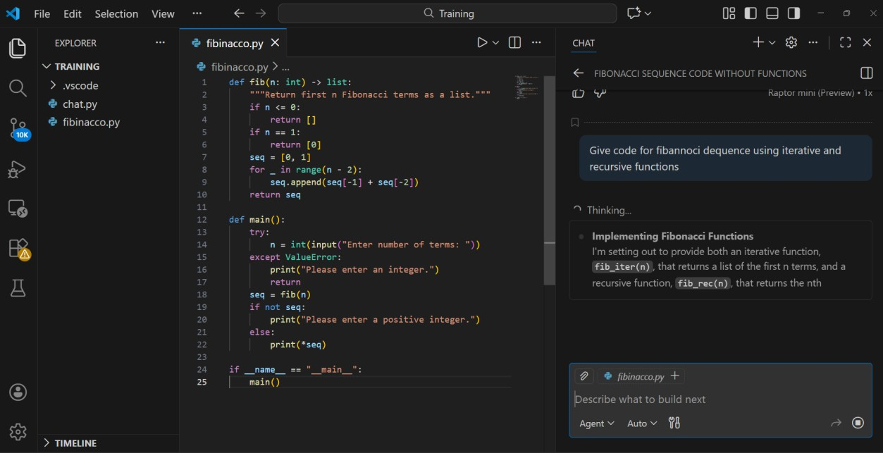
Step 2: Code Iterative:
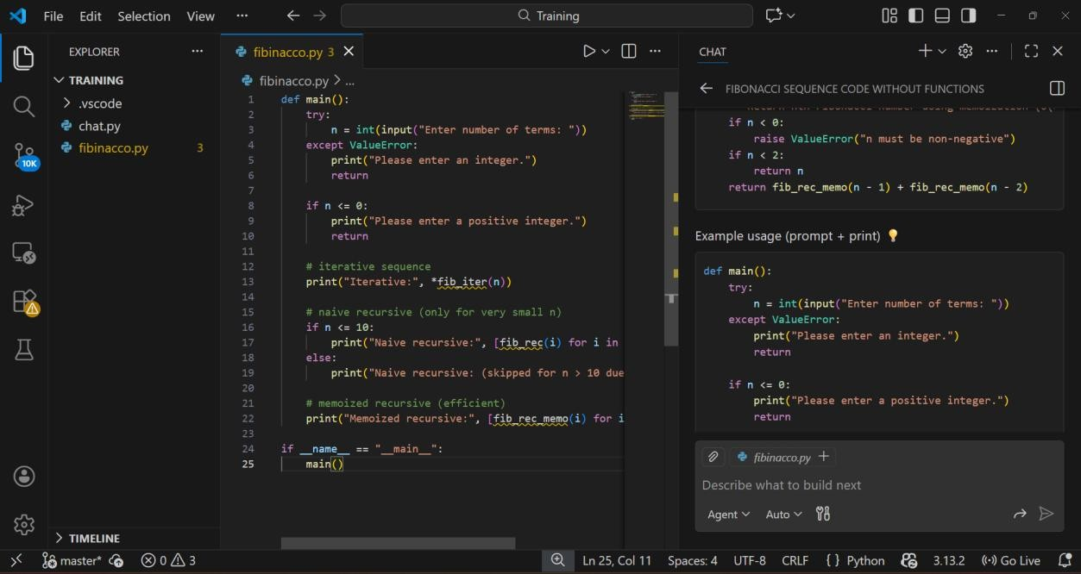

Step 3: Output
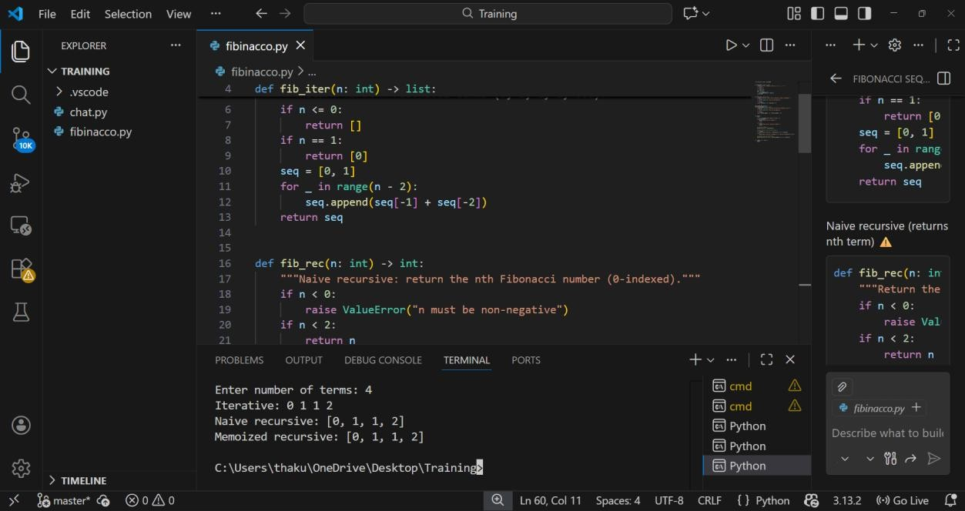
Step 4: Explanation of code
fib_iter(n) → Iterative list builder, efficient O(n).
  - fib_rec(n) → Naive recursion, exponential cost, only practical for very small n.
  - fib_rec_memo(n) → Recursive with @lru_cache, efficient O(n) via memoization.
  - Input Handling → Validates integer input, rejects negatives/zero.
  - Main Function →
    - Prints iterative sequence always.
    - Prints naive recursive only if n ≤ 10.
    - Prints memoized recursive for any n.
  - Good Practices → Clear separation of methods, input validation, modular design, efficient memoization.
Example (n=6):
Iterative: 0 1 1 2 3 5
Naive recursive: [0, 1, 1, 2, 3, 5]
Memoized recursive: [0, 1, 1, 2, 3, 5]

Comparison covering:
Aspect | Iterative | Recursive
Time Complexity | O(n) | O(2ⁿ) (very slow due to repeated calls)
Space Complexity | O(1) | O(n) (stack memory for calls)
Performance for Large n | Excellent (can handle 10⁷+ if needed) | Poor (fib(50) may take seconds/minutes)
Memory Usage | Very low | High because of recursion stack
Scalability | Best for real systems | Not scalable without optimization
Risk | No crash risk | Stack Overflow for large n

