Assignment - 19.5

N. Soukya
2303A51401
Batch-24
Task 1 – Python List Processing → C++ STL Conversion
Task:
Translate a Python program that filters even numbers from a list into
C++.
Instructions:
• Provide AI with Python list comprehension code.
• Convert it into C++ using vectors and loops/STL.
• Verify outputs for the same input list.
Expected Output:
• Equivalent working C++ program using STL.
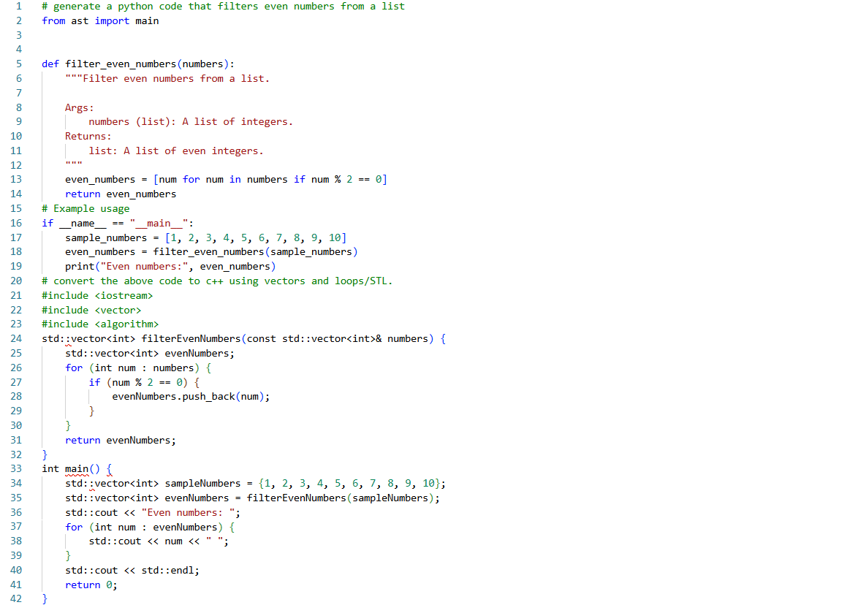

Task 2 – Java to Python OOP Translation
Task:
Convert a Java Student class into an equivalent Python class.
Instructions:
• Translate attributes, constructor, and methods properly.
• Ensure Python version uses __init__ and follows Python
conventions.
• Test both versions with sample objects.
Expected Output:
• Correct Python OOP class translated from Java
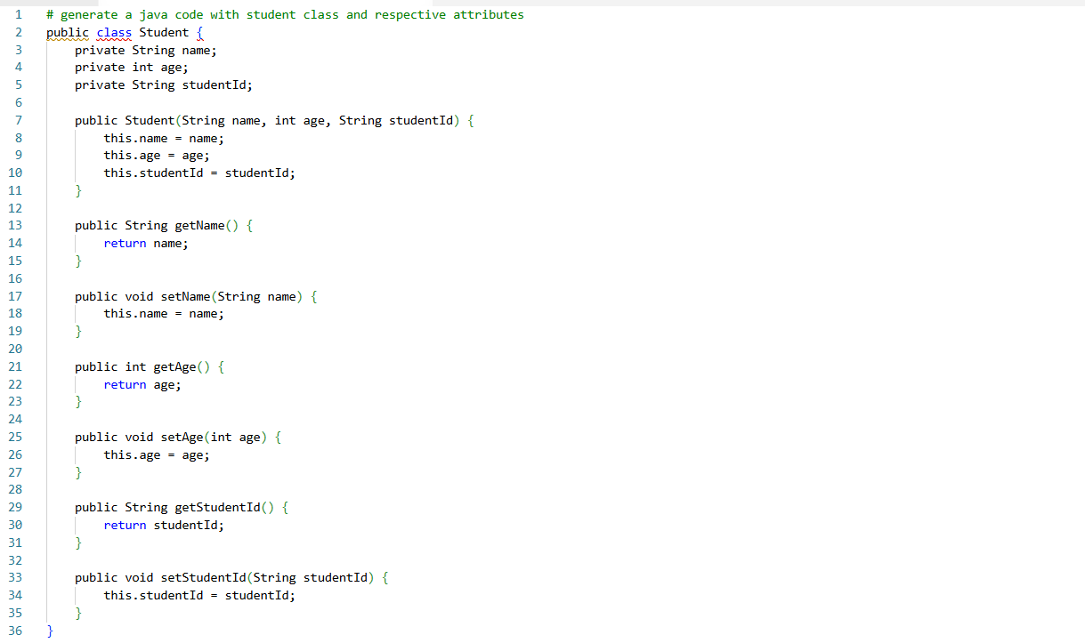
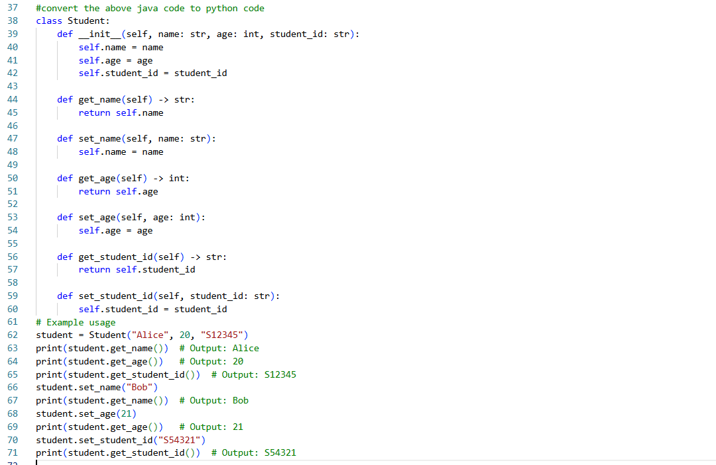
Task 3 – SQL Aggregation Query → Pandas GroupBy
Task:
Convert an SQL query with aggregation into Pandas.
Example SQL:
SELECT department, AVG(salary)
FROM employees
GROUP BY department;
Instructions:
• Translate into Pandas groupby() and mean().
• Validate using sample DataFrame.
Expected Output:
• Equivalent Pandas aggregation code.
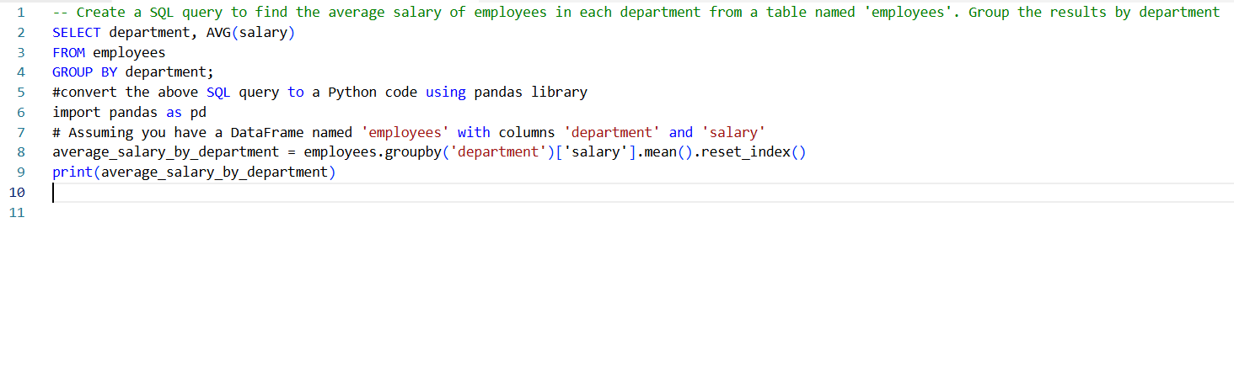

Task 4 – Python File Handling → C++ File Streams
Task:
Convert a Python program that reads a text file and counts words
into C++.
Instructions:
• Translate open() usage into ifstream.
• Handle file-not-found errors properly.
• Compare outputs for the same file.
Expected Output:
• Working C++ word counter program.
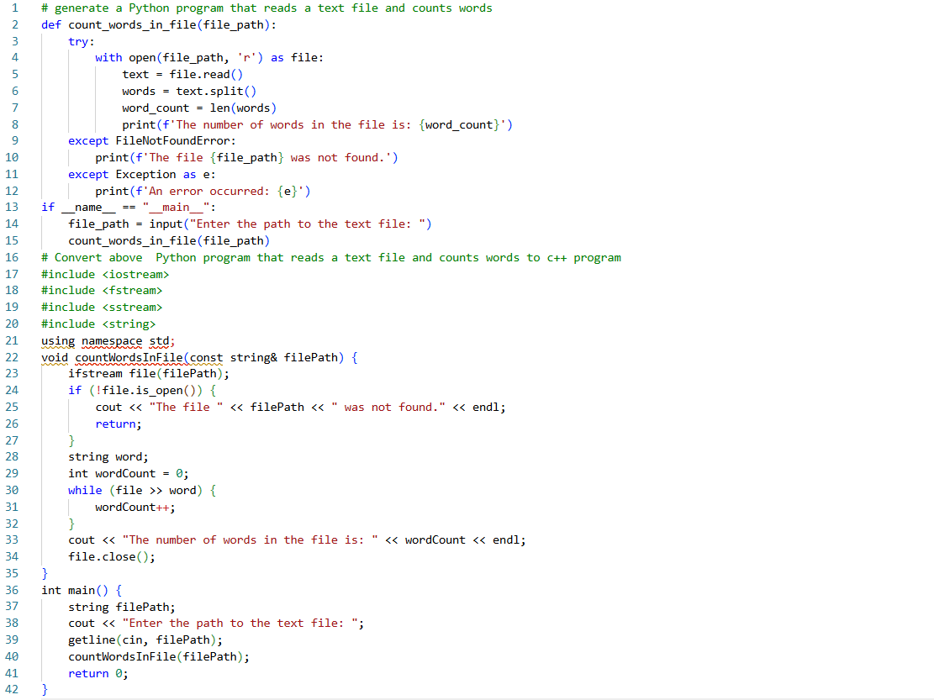
Task 5 – Java Exception Handling → Python Try/Except
Task:
Translate a Java program using try-catch for division into Python.
Instructions:
• Convert exception syntax properly.
• Handle divide-by-zero gracefully.
• Verify both programs behave the same.
Expected Output:
• Equivalent Python error-handling program.
