Name : K.Nikitha
H.T NO: 2303A51405

Lab 9: Documentation Generation – Automatic Documentation and Code Comments
Task 1: Basic Docstring Generation
Scenario
You are developing a utility function that processes numerical lists and must be properly
documented for future maintenance.
Requirements
• Write a Python function to return the sum of even numbers and sum of odd numbers in a
given list
• Manually add a Google Style docstring to the function
• Use an AI-assisted tool (Copilot / Cursor AI) to generate a function-level docstring
• Compare the AI-generated docstring with the manually written docstring
• Analyze clarity, correctness, and completeness
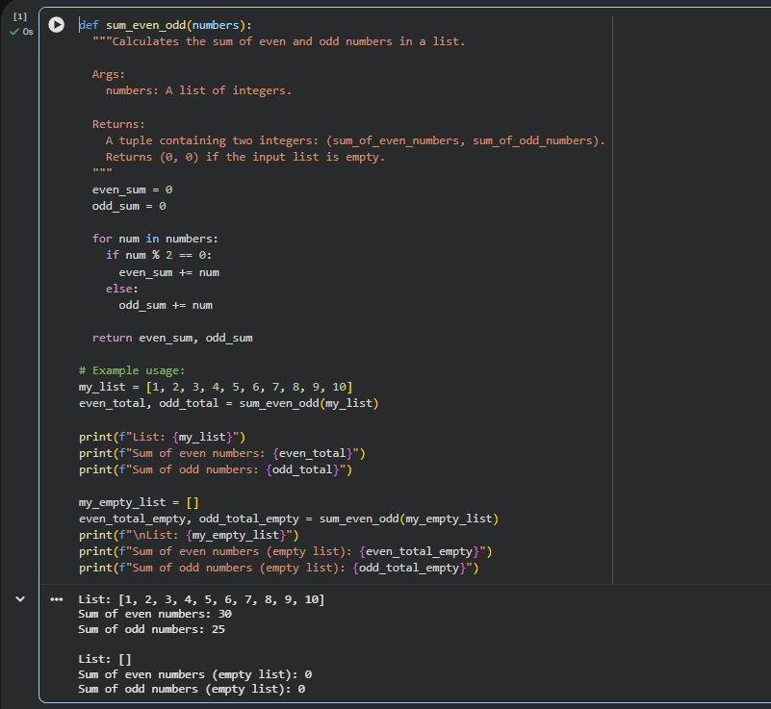

Task 2: Automatic Inline Comments
Scenario
You are developing a student management module that must be easy to understand for new
developers.
Requirements
• Write a Python program for an sru_student class with the following:
– Attributes: name, roll_no, hostel_status
– Methods: fee_update() and display_details()
• Manually write inline comments for each line or logical block
• Use an AI-assisted tool to automatically add inline comments
• Compare manual comments with AI-generated comments
• Identify missing, redundant, or incorrect AI comments
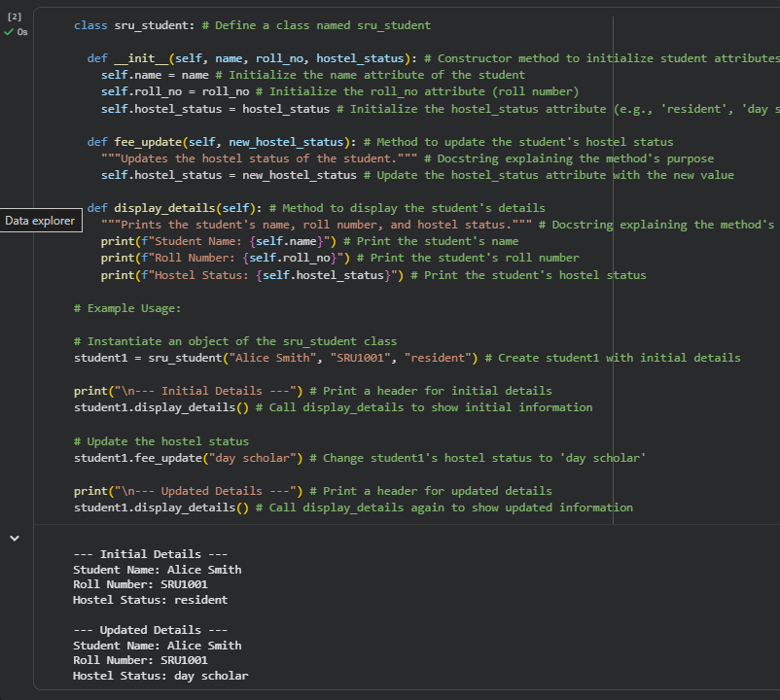
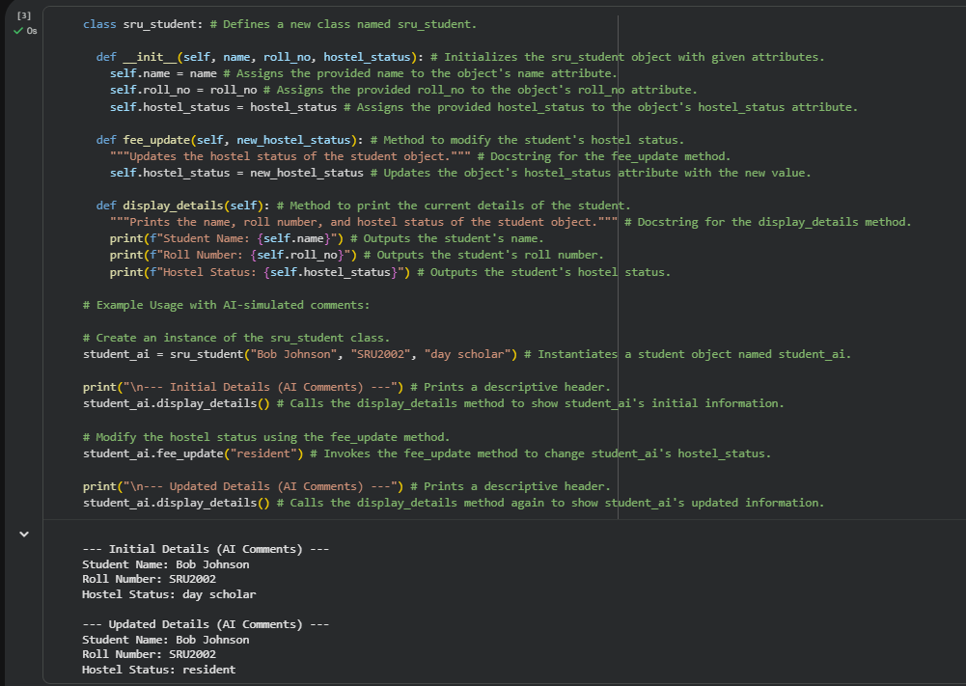

Task 3: Module-Level and Function-Level Documentation
Scenario
You are building a small calculator module that will be shared across multiple projects and
requires structured documentation.
Requirements
• Write a Python script containing 3–4 functions (e.g., add, subtract, multiply, divide)
• Manually write NumPy Style docstrings for each function
• Use AI assistance to generate:
– A module-level docstring
– Individual function-level docstrings
• Compare AI-generated docstrings with manually written ones
• Evaluate documentation structure, accuracy, and readability
