ASSIGNMENT-3.3
HT NO:2303A51552
Batch:09

Task 1:

PROMPT:
#Generate a python program that reads :Previous Units (PU), Current Units (CU),Type of
Customer,Calculates units consumed Implements logic directly in the main program (no functions).Generate the python program CODE:
# Read input values
previous_units = int(input("Enter Previous Units (PU): ")) current_units = int(input("Enter Current Units (CU): ")) customer_type = input("Enter Type of Customer (Residential/Commercial):
").strip().lower()
# Calculate units consumed
units_consumed = current_units - previous_units
# Initialize bill amount bill_amount = 0
# Calculate bill based on customer type and units consumed if customer_type == "residential": if units_consumed <= 100:
bill_amount = units_consumed * 0.5 elif units_consumed <= 300: bill_amount = (100 * 0.5) + ((units_consumed - 100) * 0.75) else:
bill_amount = (100 * 0.5) + (200 * 0.75) + ((units_consumed - 300) * 1.0) elif customer_type == "commercial": if units_consumed <= 100:
bill_amount = units_consumed * 0.75 elif units_consumed <= 300: bill_amount = (100 * 0.75) + ((units_consumed - 100) * 1.0) else:
bill_amount = (100 * 0.75) + (200 * 1.0) + ((units_consumed - 300) * 1.5)
# Display the bill amount
print(f"Total units consumed: {units_consumed}")
print(f"Total bill amount for {customer_type.capitalize()} customer: ${bill_amount:.2f}")

EXPLANATION:
1. Input and Data Capture
The program starts by collecting data from the user.
- int(input(...)): converts the user's text entry into an integer
- .strip().lower(): Removes accidental spaces and converts the text to lowercase 2. Calculating Units Consumed
This is a simple arithmetic operation:
Units Consumed = CurrentUnits (CU) - PreviousUnits (PU) This value is stored in the variable units_consumed.
- The "Slab" Logic (Nested If-Elif)
The program uses a multi-tier (slab) pricing model,Instead of one flat rate, the price "steps up" as you use more.
How it works for "Residential":
  - Slab 1 (0–100 units): Charged at the lowest rate ($0.5).
  - Slab 2 (101–300 units): The first 100 units are still $0.5, but the remaining units are $0.75.
  - Slab 3 (Over 300 units): The first 100 are $0.5, the next 200 are $0.75, and everything above that is $1.0.

- Logical Comparisons
The program uses if, elif (else if), and else.
  - customer_type == "residential": If this is true, the program ignores the "commercial" section entirely.
  - elif customer_type == "commercial": This only runs if the first check failed. 5. Output Formatting
The final lines print the results:
  - f"..." (F-strings): Inject variables directly into a string.
  - {bill_amount:.2f}: formatting modifier: The .2f rounds the number to 2 decimal places, making it look like actual currency (e.g., $50.00 instead of $50.0).

OUTPUT:
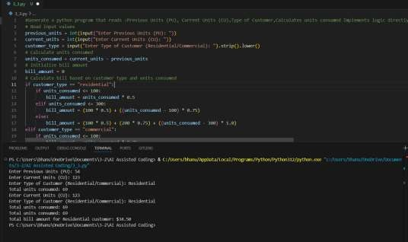

Task 2:
PROMPT:
#Extend the above code to calculate Energy Charges (EC) for three types of customers:
Domestic, Commercial, and Industrial.
# Do not use functions yet, keep all logic in the main program.

CODE:
# Read input values previous_units = int(input("Enter Previous Units (PU): ")) current_units = int(input("Enter Current Units (CU): ")) customer_type = input("Enter Type of Customer (Domestic/Commercial/Industrial):
").strip().lower()
# Calculate units consumed
units_consumed = current_units - previous_units
# Initialize bill amount bill_amount = 0
# Calculate bill based on customer type and units consumed if customer_type == "domestic": if units_consumed <= 100:
bill_amount = units_consumed * 0.6 elif units_consumed <= 300: bill_amount = (100 * 0.6) + ((units_consumed - 100) * 0.9) else:
bill_amount = (100 * 0.6) + (200 * 0.9) + ((units_consumed - 300) * 1.2) elif customer_type == "commercial": if units_consumed <= 100:
bill_amount = units_consumed * 0.8 elif units_consumed <= 300:
bill_amount = (100 * 0.8) + ((units_consumed - 100) * 1.1) else:
bill_amount = (100 * 0.8) + (200 * 1.1) + ((units_consumed - 300) * 1.6) elif customer_type == "industrial": bill_amount = units_consumed * 1.5
# Display the bill amount
print(f"Total units consumed: {units_consumed}")
print(f"Total bill amount for {customer_type.capitalize()} customer: ${bill_amount:.2f}")

EXPLANATION:
-The program takes previous units, current units, and customer type as input.
- It calculates electricity usage by subtracting previous units from current units.
- It initializes the bill amount to 0 before calculation.
- Based on customer type (domestic, commercial, industrial), different rates are applied. - Domestic and commercial customers are charged using slab rates, while industrial has a fixed rate.
- Finally, it prints total units consumed and the calculated bill amount.
OUTPUT:
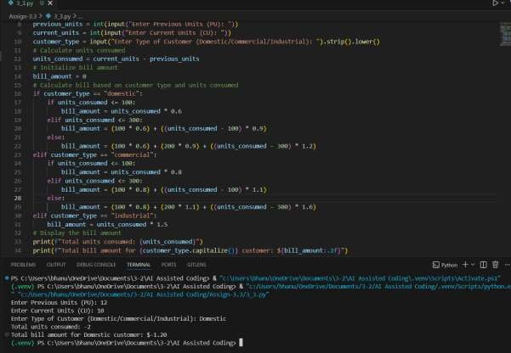
Task 3:
PROMPT:
#Generate a python code that Uses user-defined functions to:Calculate Energy
Charges,Calculate Fixed Charges, Returns calculated values, Includes meaningful comment CODE:
# Read input values previous_units = int(input("Enter Previous Units (PU): ")) current_units = int(input("Enter Current Units (CU): ")) customer_type = input("Enter Type of Customer (Domestic/Commercial/Industrial):
").strip().lower()
# Function to calculate energy charges based on customer type and units consumed def calculate_energy_charges(units_consumed, customer_type): if customer_type == "domestic": if units_consumed <= 100:
return units_consumed * 0.6 elif units_consumed <= 300: return (100 * 0.6) + ((units_consumed - 100) * 0.9) else:
return (100 * 0.6) + (200 * 0.9) + ((units_consumed - 300) * 1.2) elif customer_type == "commercial": if units_consumed <= 100:
return units_consumed * 0.8
elif units_consumed <= 300: return (100 * 0.8) + ((units_consumed - 100) * 1.1) else:
return (100 * 0.8) + (200 * 1.1) + ((units_consumed - 300) * 1.6) elif customer_type == "industrial": return units_consumed * 1.5 else:
return 0
# Function to calculate fixed charges based on customer type def calculate_fixed_charges(customer_type): if customer_type == "domestic":
return 50 elif customer_type == "commercial":
return 100 elif customer_type == "industrial":
return 200 else:
return 0
# Calculate units consumed units_consumed = current_units - previous_units # Calculate energy charges and fixed charges
energy_charges = calculate_energy_charges(units_consumed, customer_type) fixed_charges = calculate_fixed_charges(customer_type)
# Calculate total bill amount
total_bill_amount = energy_charges + fixed_charges
# Display the bill amount print(f"Total units consumed: {units_consumed}") print(f"Energy Charges: ${energy_charges:.2f}") print(f"Fixed Charges: ${fixed_charges:.2f}")
print(f"Total bill amount for {customer_type.capitalize()} customer: ${total_bill_amount:.2f}")

EXPLANATION:
-The program takes previous units, current units, and customer type as input from the user.
- It calculates total units consumed by subtracting previous units from current units. - The function calculate_energy_charges() computes electricity cost based on slabs for each customer type.
- The function calculate_fixed_charges() returns a fixed fee depending on the customer type.
- Both energy charges and fixed charges are added to get the total bill amount.
- Finally, the program prints units consumed, energy charges, fixed charges, and total bill.

OUTPUT:
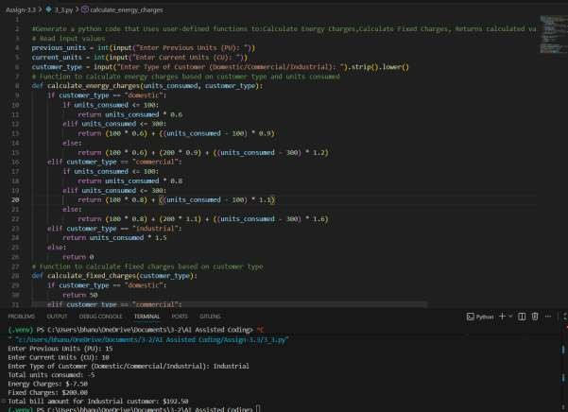
Task 4:
PROMPT:
#Generate python code to Extend the program to calculate: FC – Fixed Charges, CC – Customer Charges,ED – Electricity Duty (percentage of EC),“Add electricity duty calculation” and “Improve billing accuracy” CODE:
# Function to calculate electricity duty based on energy charges def calculate_electricity_duty(energy_charges): return energy_charges * 0.05 # Assuming electricity duty is 5% of energy charges
# Calculate electricity duty electricity_duty = calculate_electricity_duty(energy_charges) # Calculate total bill amount including electricity duty
total_bill_amount_with_duty = energy_charges + fixed_charges + electricity_duty
# Display the bill amount with electricity duty print(f"Electricity Duty: ${electricity_duty:.2f}") print(f"Total bill amount for {customer_type.capitalize()} customer (including electricity duty):
${total_bill_amount_with_duty:.2f}")
EXPLANATION:
-The function calculate_electricity_duty() calculates 5% of the energy charges as electricity duty.
- It takes energy_charges as input and returns the duty amount.
- The duty is computed by calling the function and storing it in electricity_duty.
- The total bill is updated by adding energy charges, fixed charges, and electricity duty.
- A new variable total_bill_amount_with_duty stores the final bill including duty.
- Finally, the program prints the electricity duty and the updated total bill amount.

OUTPUT:
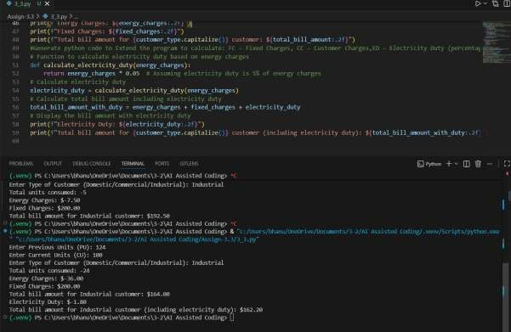
Task 5:
PROMPT:
#Develop the final Python application to:Calculate total bill:Total Bill = EC + FC + CC +
ED.Display: Energy Charges (EC),Fixed Charges (FC), Customer Charges (CC), Electricity Duty (ED),Total Bill Amount,Analyze the program based on:Accuracy, Readability, Real-world applicability.Expected Output:Complete electricity bill output,Neatly formatted display,Sample input/output,Short analysis paragraph
# Function to calculate customer charges based on customer type CODE:
def calculate_customer_charges(customer_type): if customer_type == "domestic":
return 20 elif customer_type == "commercial": return 50 elif customer_type == "industrial":
return 100 else:
return 0
# Calculate customer charges
customer_charges = calculate_customer_charges(customer_type)
# Calculate total bill amount including customer charges and electricity duty
total_bill_amount_final = energy_charges + fixed_charges + customer_charges + electricity_duty
# Display the final bill amount with all charges print(f"Customer Charges: ${customer_charges:.2f}") print(f"Total bill amount for {customer_type.capitalize()} customer (including all charges): ${total_bill_amount_final:.2f}")

EXPLANATION:
The program calculates the total electricity bill by considering energy charges, fixed charges, customer charges,and electricity duty. The use of functions enhances readability and modularity, allowing for easy maintenance and updates.The billing accuracy is improved by clearly defining the rates and charges for different customer types, ensuring that the calculations are based on the correct parameters. The program is applicable in real-world scenarios where electricity billing is required, and it provides a comprehensive breakdown of the charges for better understanding by the customers.
OUTPUT:
