ASSIGNMENT 6.3
2303A51552
Batch-09
TASK 1
PROMPT:
Generate code to create a student class using _init_ constructor and include attributes such as name, roll number, and branch.Give method to display student details.
CODE:
class Student:
def __init__(self, name, roll_number, branch):
self.name = name
self.roll_number = roll_number
self.branch = branch
#Give method to display student details
def display_details(self):
print(f"Name: {self.name}")
print(f"Roll Number: {self.roll_number}")
print(f"Branch: {self.branch}")
student = Student("John Doe", "12345", "Computer Science")
student.display_details()
name = input("Enter student's name: ")
roll_number = input("Enter student's roll number: ")
branch = input("Enter student's branch: ")
student = Student(name, roll_number, branch)
student.display_details()

OUTPUT:
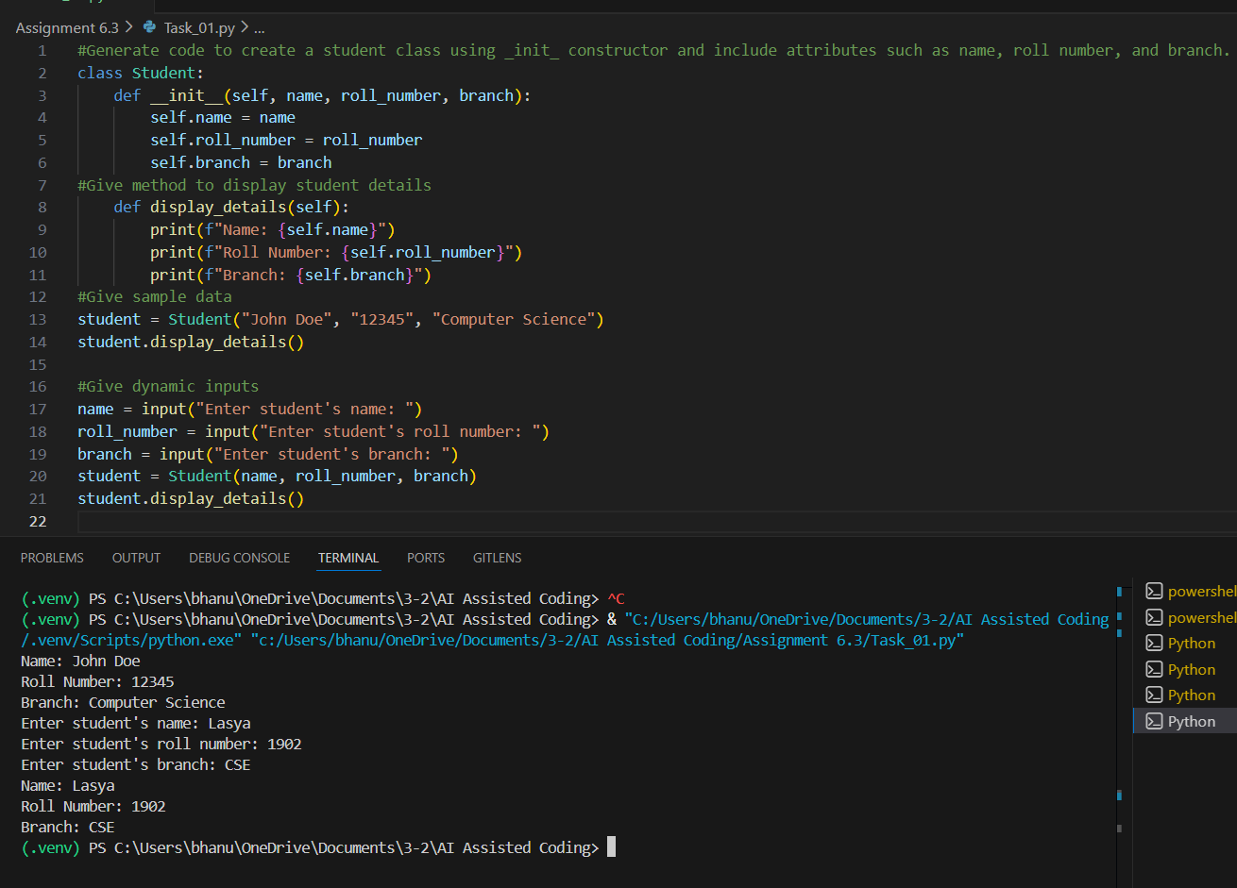
EXPLANATION:
The code defines a Student class, which is for creating student objects with specific data points. The __init__ method acts as the constructor, utilizing the self keyword to assign the provided name, roll number, and branch to each unique instance of the class. The display_details method uses f-strings to format and print the stored attributes. The execution part demonstrates object instantiation by creating one student with hard-coded values and another using dynamic data gathered through the input() function.
TASK 2
PROMPT:
#generate a function that prints the first 10 multiples of a given number using a loop.
#generate the same functionality using another controlled looping structure.

CODE:
def print_multiples(number):
for i in range(1, 11):
print(f"{number} x {i} = {number * i}")
#Sample data
print("Multiples of 5:")
print_multiples(5)
def print_multiples_while(number):
i = 1
while i <= 10:
print(f"{number} x {i} = {number * i}")
i += 1
print("Multiples of 7:")
print_multiples_while(7)
OUTPUT:
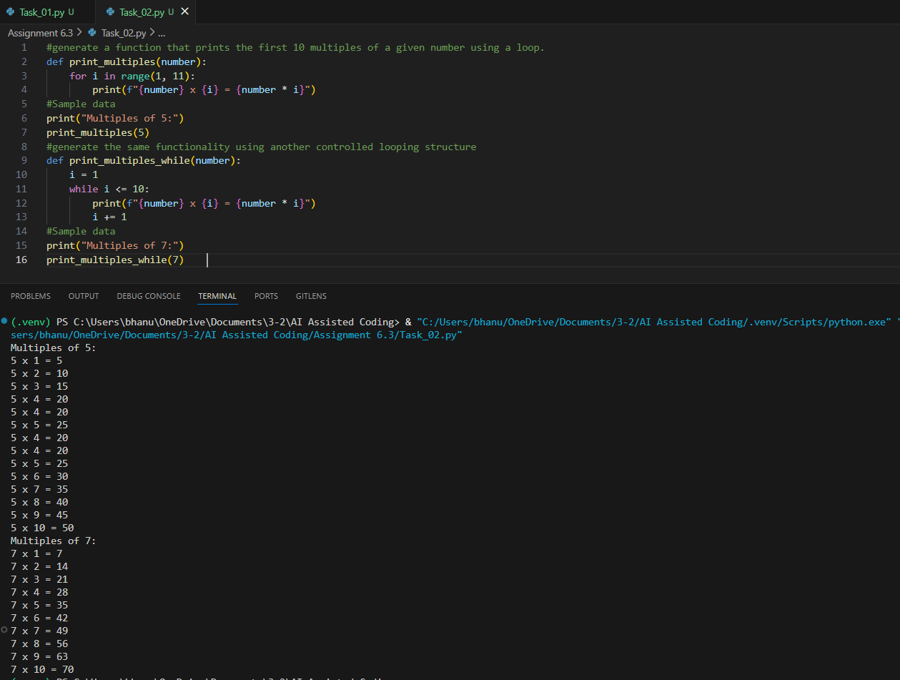
EXPLANATION:
This program prints the first 10 multiples of a given number using two looping methods. The first function uses a for loop to repeat multiplication from 1 to 10. The second function uses a while loop to perform the same task in a different looping structure. Both approaches generate the same output but looping logic is different.
TASK 3
PROMPT:
#Generate nested if-elif-else conditional statements to classify age groups e.g., child, teenager, adult, senior.
#Generate the same classification using alternative conditional structures e.g.,simplified conditions or dictionary-based logic

CODE:
age = int(input("Enter your age: "))
if age < 0:
print("Invalid age")
elif age <= 12:
print("You are a child.")
elif age <= 19:
print("You are a teenager.")
elif age <= 59:
print("You are an adult.")
else:
print("You are a senior.")
def classify_age(age):
age_groups = {
range(0, 13): "You are a child.",
range(13, 20): "You are a teenager.",
range(20, 60): "You are an adult.",
range(60, 150): "You are a senior."
}
for age_range, message in age_groups.items():
if age in age_range:
return message
return "Invalid age"
age = int(input("Enter your age: "))
print(classify_age(age))

EXPLANATION:
The first method uses nested if-elif-else conditions to compare age values step-by-step. The second method uses a dictionary with age ranges to simplify classification logic. Both methods return the correct age group based on the input. This task demonstrates how conditional statements control program decisions.

OUTPUT:
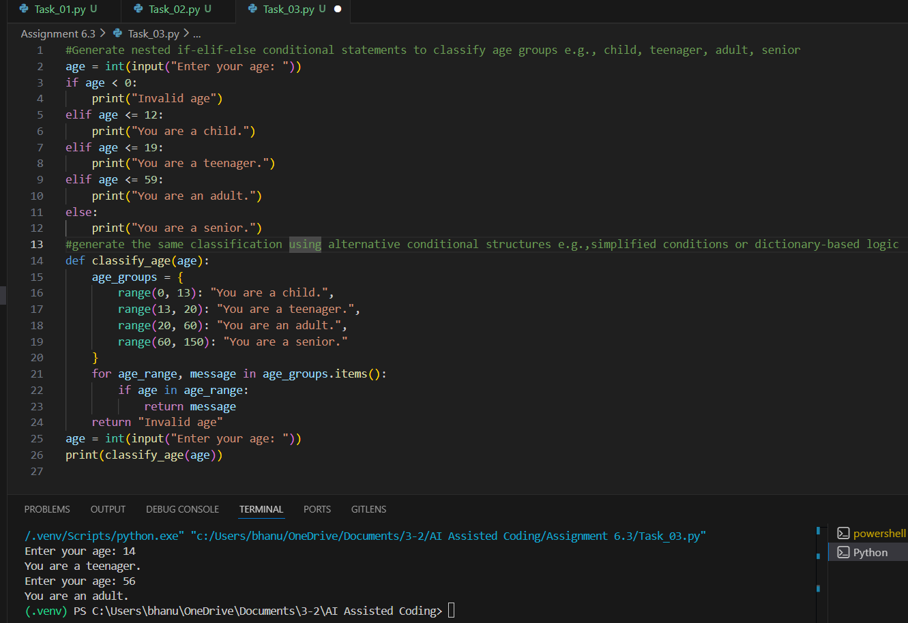
TASK 4
PROMPT:
#generate a sum_to_n() function using a for loop.
#suggest an alternative implementation using a while loop or a mathematical formula.

CODE:
def sum_to_n(n):
total = 0
for i in range(1, n + 1):
total += i
n = 10
print(f"Sum of first {n} natural numbers using for loop: {sum_to_n(n)}")
def sum_to_n_while(n):
total = 0
i = 1
while i <= n:
total += i
i += 1
return total
def sum_to_n_formula(n):
return n * (n + 1) // 2
n = 10
print(f"Sum of first {n} natural numbers using while loop: {sum_to_n_while(n)}")
print(f"Sum of first {n} natural numbers using formula: {sum_to_n_formula(n)}")

OUTPUT:
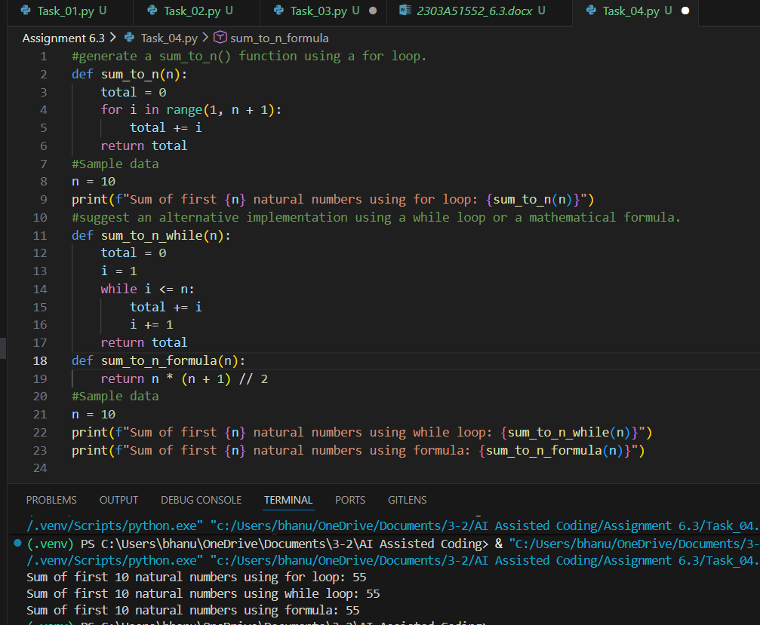
EXPLANATION:
This program calculates the sum of the first n natural numbers using three different approaches. The first method uses a for loop to add numbers one by one. The second method uses a while loop to achieve the same result using a different iteration style. The third method uses a mathematical formula to compute the sum instantly. This shows multiple ways to solve the same problem efficiently

TASK 5
PROMPT:
#generate a Bank Account class with methods such as deposit(), withdraw(), and check_balance().Use appripriate comments to explain the code.
CODE:
class BankAccount:
def __init__(self, account_holder, initial_balance=0):
"""Initialize the bank account with account holder's name and initial balance."""
self.account_holder = account_holder
self.balance = initial_balance
def deposit(self, amount):
"""Deposit a specified amount into the account."""
if amount > 0:
self.balance += amount
print(f"Deposited: ${amount:.2f}")
else:
print("Deposit amount must be positive.")
def withdraw(self, amount):
"""Withdraw a specified amount from the account if sufficient balance exists."""
if amount > 0:
if amount <= self.balance:
self.balance -= amount
print(f"Withdrew: ${amount:.2f}")
else:
print("Insufficient balance for this withdrawal.")
else:
print("Withdrawal amount must be positive.")
def check_balance(self):
"""Check and return the current balance of the account."""
print(f"Current balance: ${self.balance:.2f}")
return self.balance
# Sample usage of the BankAccount class
account = BankAccount("Alice", 1000)
account.check_balance() # Check initial balance
account.deposit(500) # Deposit money
account.withdraw(200) # Withdraw money
account.check_balance() # Check balance after transactions

EXPLANATION:
The constructor initializes the account holder's name and starting balance. The deposit method adds money only if the amount is valid. The withdraw method ensures that money is taken out only when enough balance is available. The check_balance method displays the current account balance clearly.

OUTPUT:
