Assignment -8.3
Hall ticket No:2303A51553
Name: M.Dakshinya

Task-01-Email Validation using TDD

Task Description
You are developing a user registration system that requires reliable email input validation.
Prompt:
# Generate Python function for email validation
Code:
import re
def is_valid_email(email):
# Regular expression for validating an Email
regex = r'^[a-zA-Z0-9._%+-]+@[a-zA-Z0-9.-]+\.[a-zA-Z]{2,}$'

# If the string matches the regular expression, it's a valid email
if re.match(regex, email):
return True
else:
return False
# example inputs
print(is_valid_email("kumardakshinya25@gmailcom"))
print(is_valid_email("2303a51553@sru.edu.in"))
Output:
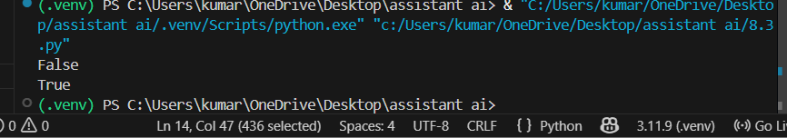
Explanation:

Task-02-Grade Assignment using Loops

Task Description
You are building an automated grading system for an online examination platform.
Prompt:
# write a python program to bulid an automated grading system for an online examination platform using loops and aslo include invalid input like -5,eighty
Code:
def calculate_grade(score):
if score < 0 or score > 100:
return "Invalid input"
elif score >= 90:
return "Grade: A"
elif score >= 80:
return "Grade: B"
elif score >= 70:
return "Grade: C"
elif score >= 60:
return "Grade: D"
else:
return "Grade: F"
# Test Cases
scores = [95, 85, 75, 65, 55, -5
, "eighty"]
for s in scores:
if isinstance(s, int):
print(f"Score: {s} - {calculate_grade(s)}")
else:
print(f"Score: {s} - Invalid input")
Output:
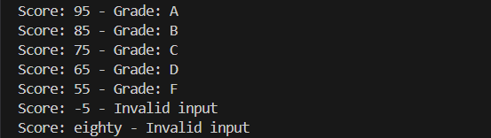
Explanation:

Task-03:-Sentence Palindrome Checker
• You are developing a text-processing utility to analyze sentences
Prompt:
#TASK-3:write a python program to check sentence palindrome checker to develop a text-processing utility to analyze sentences
Code:
def is_palindrome(sentence):
cleaned = ''.join(sentence.lower().split())
return cleaned == cleaned[::-1]
# Test Cases
sentences = ["Madam In Eden Im Adam",
"Hello World","A man a plan a canal Panama"]
for s in sentences:
if is_palindrome(s):
print(f'"{s}" is a palindrome.')
else:
print(f'"{s}" is not a palindrome.')
Output:
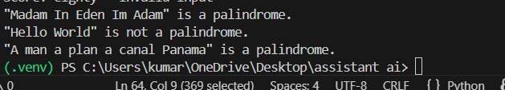
Explanation:

Task-04: -ShoppingCart Class

Task Description #4:
You are designing a basic shopping cart module for an e-commerce application.
Prompt:
#TASK-4:Write a python program to design a basic shopping cart module for an e-commerce application.add item and remove item and total cost
Code:
class ShoppingCart:
def __init__(self):
self.cart = {}
def add_item(self, item, price):
self.cart[item] = price
print(f"Added {item} to cart at ₹{price}")
def remove_item(self, item):
if item in self.cart:
del self.cart[item]
print(f"Removed {item} from cart")
else:
print(f"{item} not found in cart")
def total_cost(self):
return sum(self.cart.values())
# Test Cases
cart = ShoppingCart()
cart.add_item("Laptop", 50000)
cart.add_item("Headphones", 2000)
cart.add_item("Mouse", 500)
print("Total Cost: ₹", cart.total_cost())
cart.remove_item("Headphones")
print("Total Cost after removal: ₹", cart.total_cost())
o that number: "))
print(f"The sum of integers from 1 to {number} is {sum_to_n(number)}")
Output:
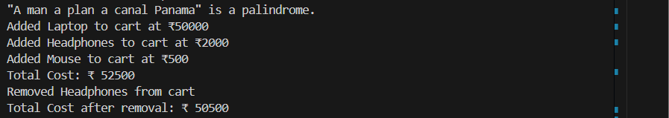
Explanation:

Task-05:

Task Description #5: Date Format Conversion
You are creating a utility function to convert date formats for reports
Prompt:
#TASK-5:write a python program to create a utility function to convert date formats for reports
Code:
from datetime import datetime
def convert_date_format(date_str, current_format, desired_format):
try:
date_obj = datetime.strptime(date_str, current_format)
return date_obj.strftime(desired_format)
except ValueError:
return "Invalid date format"
# Test Cases
dates = [("2024-06-15", "%Y-%m-%d", "%d/%m/%Y"),
("15/06/2024", "%d/%m/%Y", "%Y-%m-%d"),
("06-15-2024", "%m-%d-%Y", "%Y/%m/%d"),
("invalid-date", "%Y-%m-%d", "%d/%m/%Y")]
for date_str, current_fmt, desired_fmt in dates:
print(f"Original: {date_str} - Converted: {convert_date_format(date_str, current_fmt, desired_fmt)}")
Output:
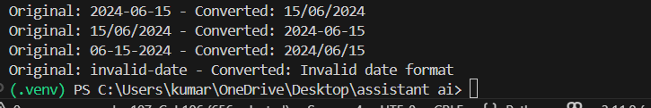
Explanation:

