Assignment -11.3
Hall ticket No:2303A51553
Name: M.Dakshinya
Task-01-Smart Contact Manager (Arrays & Linked Lists)
Prompt:
#Generate a Python Contact Manager using list array that supports add_contact, search_contact, and delete_contact operations with name and phone number.
Code:
class ContactManager:
def __init__(self):
self.contacts = []
def add_contact(self, name: str, phone_number: str) -> None:
"""Add a contact to the contact manager."""
self.contacts.append({'name': name, 'phone_number': phone_number})
def search_contact(self, name: str) -> list:
"""Search for contacts by name."""
return [contact for contact in self.contacts if contact['name'] == name]
def delete_contact(self, name: str) -> None:
"""Delete a contact by name."""
self.contacts = [contact for contact in self.contacts if contact['name'] != name]
# Example usage:
contact_manager = ContactManager()
contact_manager.add_contact("Alice", "123-456-7890")
contact_manager.add_contact("Bob", "987-654-3210")
print(contact_manager.search_contact("Alice")) # Output: [{'name': 'Alice', 'phone_number': '123-456-7890'}]
contact_manager.delete_contact("Alice")
print(contact_manager.search_contact("Alice")) # Output: []
Output: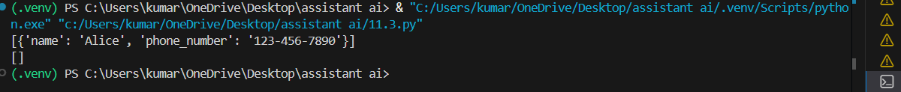
Code:
class ContactManagerLinkedList:
def __init__(self):
self.head = None
def add_contact(self, name: str, phone_number: str) -> None:
"""Add a contact to the contact manager."""
new_node = ContactNode(name, phone_number)
new_node.next = self.head
self.head = new_node
def search_contact(self, name: str) -> list:
"""Search for contacts by name."""
current = self.head
results = []
while current:
if current.name == name:
results.append({'name': current.name, 'phone_number': current.phone_number})
current = current.next
return results
def delete_contact(self, name: str) -> None:
"""Delete a contact by name."""
current = self.head
prev = None
while current:
if current.name == name:
if prev:
prev.next = current.next
else:
self.head = current.next
return
prev = current
current = current.next
class ContactNode:
def __init__(self, name: str, phone_number: str):
self.name = name
self.phone_number = phone_number
self.next = None
# Example usage:
contact_manager = ContactManagerLinkedList()
contact_manager.add_contact("Alice", "123-456-7890")
contact_manager.add_contact("Bob", "987-654-3210")
print(contact_manager.search_contact("Alice")) # Output: [{'name': 'Alice', 'phone_number': '123-456-7890'}]
contact_manager.delete_contact("Alice")
print(contact_manager.search_contact("Alice")) # Output: []
Output: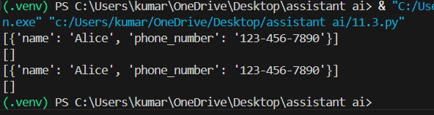
Explanation:
Efficiency Comparison:
- Array-based Contact Manager:
- Adding a contact: O(1) (amortized)
- Searching for a contact: O(n) (linear search)
- Deleting a contact: O(n) (linear search)
- Linked List-based Contact Manager:
- Adding a contact: O(1) (inserting at the head)
- Searching for a contact: O(n) (linear search)
- Deleting a contact: O(n) (linear search)
In summary, both implementations have similar time complexities for searching and deleting contacts, but the linked list allows for more efficient additions without needing to resize an array. However, the array-based implementation may have better cache performance due to contiguous memory allocation.
Task-02-Library Book Search System (Queues & Priority Queues)
Prompt:
# Generate a Python program implementing a FIFO queue for managing library book requests with enqueue() and dequeue() operations.
#Extend the program to implement a priority queue where faculty requests are served before student requests.
Code:
def calculate(a, b, operation):
class BookRequestQueue:
def __init__(self):
self.queue = []
def enqueue(self, book_request: str) -> None:
"""Add a book request to the queue."""
self.queue.append(book_request)
def dequeue(self) -> str:
"""Remove and return the oldest book request from the queue."""
if not self.is_empty():
return self.queue.pop(0)
else:
raise IndexError("Queue is empty")

def is_empty(self) -> bool:
"""Check if the queue is empty."""
return len(self.queue) == 0
# Example usage:
book_request_queue = BookRequestQueue()
book_request_queue.enqueue("Request 1: 'The Great Gatsby'")
book_request_queue.enqueue("Request 2: 'To Kill a Mockingbird'")
print(book_request_queue.dequeue()) # Output: "Request 1: 'The Great Gatsby'"
print(book_request_queue.dequeue()) # Output: "Request 2: 'To Kill a Mockingbird'"
#Extend the program to implement a priority queue where faculty requests are served before student requests.
class PriorityBookRequestQueue:
def __init__(self):
self.faculty_queue = []
self.student_queue = []
def enqueue(self, book_request: str, is_faculty: bool) -> None:
"""Add a book request to the appropriate queue based on priority."""
if is_faculty:
self.faculty_queue.append(book_request)
else:
self.student_queue.append(book_request)
def dequeue(self) -> str:
"""Remove and return the oldest book request from the queues, prioritizing faculty requests."""
if not self.is_empty():
if self.faculty_queue:
return self.faculty_queue.pop(0)
else:
return self.student_queue.pop(0)
else:
raise IndexError("Both queues are empty")
def is_empty(self) -> bool:
"""Check if both queues are empty."""
return len(self.faculty_queue) == 0 and len(self.student_queue) == 0
# Example usage:
priority_queue = PriorityBookRequestQueue()
priority_queue.enqueue("Request 1 (Faculty)", is_faculty=True)
priority_queue.enqueue("Request 2 (Student)", is_faculty=False)
print(priority_queue.dequeue()) # Output: "Request 1 (Faculty)"
print(priority_queue.dequeue()) # Output: "Request 2 (Student)"

Output:
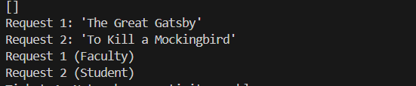
Explanation:
First, a Queue (FIFO) is implemented where requests are processed in the order they arrive. The enqueue() operation adds a request, and dequeue() removes the first request.
Next, a Priority Queue is implemented where faculty requests are given higher priority than student requests.
This ensures that important requests are handled first while still maintaining queue behavior.
Task-03-Emergency Help Desk(StackImplementation)
Prompt:
#Generate a Python stack implementation for managing IT support tickets with push, pop, peek, is_empty, and is_full operations.Simulate at least five support tickets being pushed and popped to demonstrate LIFO behavior.
Code:
class SupportTicketStack:
def __init__(self, capacity: int):
self.stack = []
self.capacity = capacity
def push(self, ticket: str) -> None:
"""Add a support ticket to the stack."""
if not self.is_full():
self.stack.append(ticket)
else:
raise OverflowError("Stack is full")
def pop(self) -> str:
"""Remove and return the most recent support ticket from the stack."""
if not self.is_empty():
return self.stack.pop()
else:
raise IndexError("Stack is empty")
def peek(self) -> str:
"""Return the most recent support ticket without removing it."""
if not self.is_empty():
return self.stack[-1]
else:
raise IndexError("Stack is empty")
def is_empty(self) -> bool:
"""Check if the stack is empty."""
return len(self.stack) == 0
def is_full(self) -> bool:
"""Check if the stack is full."""
return len(self.stack) >= self.capacity
# Example usage:
ticket_stack = SupportTicketStack(capacity=5)
ticket_stack.push("Ticket 1: Printer not working")
ticket_stack.push("Ticket 2: Computer won't start")
ticket_stack.push("Ticket 3: Software installation issue")
ticket_stack.push("Ticket 4: Network connectivity problem")
print(ticket_stack.peek()) # Output: "Ticket 4: Network connectivity problem"
ticket_stack.push("Ticket 5: Email not syncing")
print(ticket_stack.is_full()) # Output: True
print(ticket_stack.pop()) # Output: "Ticket 5: Email not syncing"
print(ticket_stack.pop()) # Output: "Ticket 4: Network connectivity problem"
print(ticket_stack.pop()) # Output: "Ticket 3: Software installation issue"
print(ticket_stack.pop()) # Output: "Ticket 2: Computer won't start"
print(ticket_stack.pop()) # Output: "Ticket 1: Printer not working"
Output:
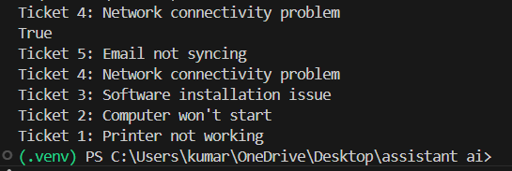
Explanation:
In this task models an IT help desk ticket system using a Stack (LIFO).In a stack, the last ticket raised is resolved first.
Operations used:
push(ticket) → add a new support ticket
pop() → remove the most recent ticket
peek() → view the top ticket without removing it
Additional functions such as is_empty() and is_full() check the stack status.
A simulation with five tickets shows how the stack works.
Task-04-Hash Table
Prompt :
# Generate a Python HashTable class with insert, search, and delete methods using collision handling with chaining and proper comments.
class HashTable:
def __init__(self, size: int):
self.size = size
self.table = [[] for _ in range(size)]

def _hash(self, key: str) -> int:
"""Compute the hash value for a given key."""
return hash(key) % self.size

def insert(self, key: str, value: str) -> None:
"""Insert a key-value pair into the hash table."""
index = self._hash(key)
bucket = self.table[index]
for i, (k, v) in enumerate(bucket):
if k == key:
bucket[i] = (key, value)
return
bucket.append((key, value))

def search(self, key: str) -> str:
"""Search for a value associated with a given key."""
index = self._hash(key)
bucket = self.table[index]
for k, v in bucket:
if k == key:
return v
raise KeyError("Key not found")

def delete(self, key: str) -> None:
"""Delete a key-value pair from the hash table."""
index = self._hash(key)
bucket = self.table[index]
for i, (k, v) in enumerate(bucket):
if k == key:
del bucket[i]
return
raise KeyError("Key not found")
# Example usage:
hash_table = HashTable(size=10)
hash_table.insert("name", "Alice")
hash_table.insert("age", "30")
print(hash_table.search("name")) # Output: "Alice"
print(hash_table.search("age")) # Output: "30"
hash_table.delete("name")
try: print(hash_table.search("name")) # This will raise a KeyError
except KeyError as e: print(e) # Output: "Key not found"
Output:
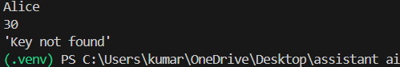
Explanation:
This task implements a Hash Table, a data structure used for fast data storage and retrieval.A hash function converts a key into an index in the table.
If two keys map to the same index, it causes a collision.To solve this, chaining is used, where each table index stores a linked list of elements.
Operations implemented:
Insert → add key-value pair
Search → find value using key
Delete → remove key-value pair
Task-05-Real-Time Application Challenge
Prompt :
#Suggest appropriate data structures for student attendance tracking, event registration, library borrowing, bus scheduling, and cafeteria order queue with short justification.Generate a Python program implementing a cafeteria order queue system using a queue data structure.
Code:
# 5. Cafeteria Order Queue: A queue data structure is ideal for managing cafeteria orders, as it follows the First-In-First-Out (FIFO) principle, ensuring that orders are processed in the order they were received.
class CafeteriaOrderQueue:
def __init__(self):
self.queue = []
def enqueue(self, order: str) -> None:
"""Add a cafeteria order to the queue."""
self.queue.append(order)
def dequeue(self) -> str:
"""Remove and return the oldest cafeteria order from the queue."""
if not self.is_empty():
return self.queue.pop(0)
else:
raise IndexError("Queue is empty")
def is_empty(self) -> bool:
"""Check if the queue is empty."""
return len(self.queue) == 0
# Example usage:
order_queue = CafeteriaOrderQueue()
order_queue.enqueue("Order 1: Sandwich")
order_queue.enqueue("Order 2: Salad")
print(order_queue.dequeue()) # Output: "Order 1: Sandwich"
print(order_queue.dequeue()) # Output: "Order 2: Salad"
Output:
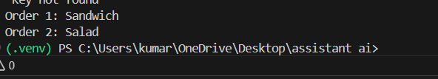
Explanation:
A Queue follows FIFO (First In First Out) rule.
In a cafeteria, the first student who places the order should receive the food first.
So queue is the best data structure to manage order processing in sequence.

