Assignment -3.4
Hall ticket No:2303A51553
Name: M.Dakshinya

Task-01
Task Description
Without giving an example, write a single comment prompt asking GitHub Copilot to generate a Python function to print the first N Fibonacci numbers
Prompt:
# Generate a Python function to print the first N Fibonacci numbers.

Code:
def fibonacci_sequence(n):
fib_sequence = [] a, b = 0, 1 for _ in range(n): fib_sequence.append(a) a, b = b, a + b return fib_sequence
N = int(input("Enter the number of Fibonacci numbers to generate: ")) fib_numbers = fibonacci_sequence(N) print("The first", N, "Fibonacci numbers are:") for num in fib_numbers: print(num, end=' ')
print() # for a new line after the Fibonacci numbers

Output:
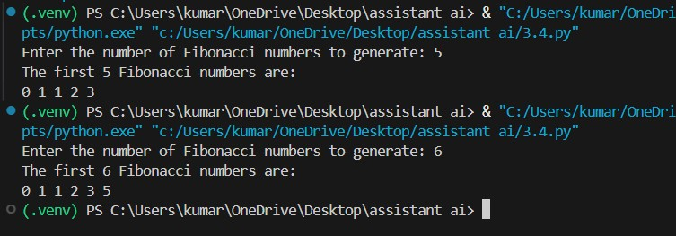
Explanation:

Task-02
Task Description
• Write a comment prompt to reverse a list and provide one example below the comment to guide Copilot.
Prompt:
# Generate a comment prompt to reverse a list and provide one example below the comment to guide Copilot.
# Example: If the list is [1, 2, 3, 4], the reversed list should be [4, 3, 2, 1].
# Write a Python function to reverse a given list user input
Code:
def reverse_list(lst): return lst[::-1]
user_input = input("Enter a list of elements separated by spaces: ") input_list = user_input.split() reversed_list = reverse_list(input_list) print("The reversed list is:", reversed_list)

Output:
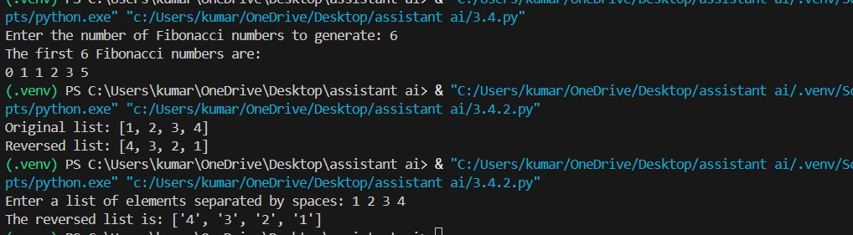
Explanation:

Task-03: Few-shot Prompt – String Pattern Matching
• Write a comment with 2–3 examples to help Copilot understand how to check if a string starts with a capital letter and ends with a period.
Prompt:
# Generate how to check if a string starts with a capital letter and ends with a period output true or false with example like below
# Example: If the string is "Hello world.", the output should be True.
# Example 2: If the string is "hello world", the output should be False.
Code:
def check_string(s):
return s[0].isupper() and s.endswith('.') user_input = input("Enter a string: ") result = check_string(user_input) print("The string starts with a capital letter and ends with a period:", result)

Output:
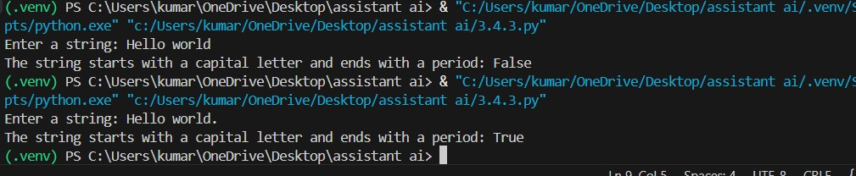
Explanation:

Task-04: Zero-shot vs Few-shot – Email Validator
Task Description
Prompt for Zero-short:
# write an email validation function using python
Code:
import re def is_valid_email(email):
pattern = r'^[a-zA-Z0-9._%+-]+@[a-zA-Z0-9.-]+\.[a-zA-Z]{2,}$' return re.match(pattern, email) is not None user_email = input("Enter an email address: ") if is_valid_email(user_email):
print("The email address is valid.") else:
print("The email address is invalid.")

Output:
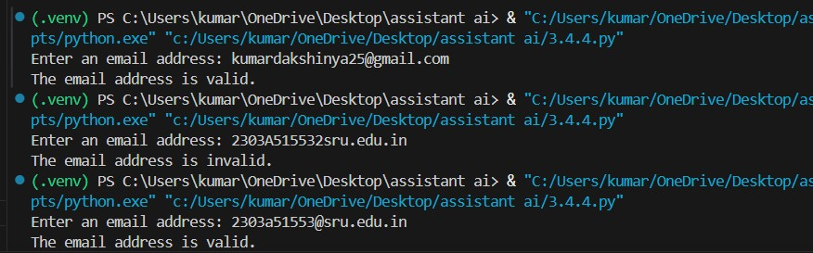
Prompt for few-short:
# Generate an email validation function using python like example :@ and domain checking etc.
Code:
def is_valid_email(email):
import re pattern = r'^[a-zA-Z0-9._%+-]+@[a-zA-Z0-9.-]+\.[a-zA-Z]{2,}$' return re.match(pattern, email) is not None user_email = input("Enter an email address: ") if is_valid_email(user_email):
print(f"{user_email} is a valid email address.") else:
print(f"{user_email} is not a valid email address.")
Output:
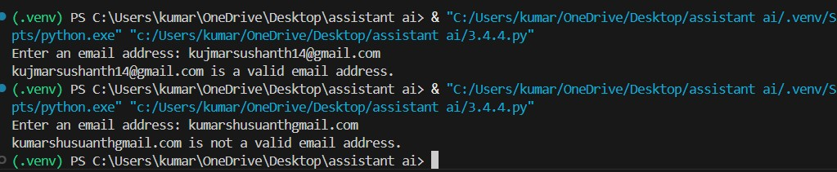
Explanation:

Task-05: Prompt Tuning – Summing Digits of a Number
Task Description
• Experiment with 2 different prompt styles to generate a function that returns the sum of digits of a number.
Style 1: Generic task prompt Style 2: Task + Input/Output example
Prompt:
# Generate a python code for sum of the numbers user input
Code:
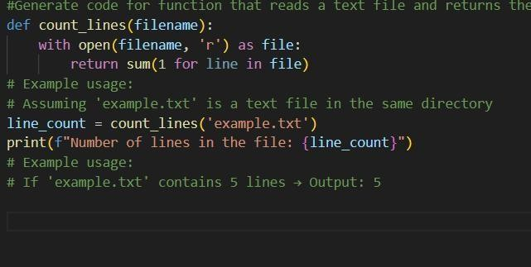

Output:
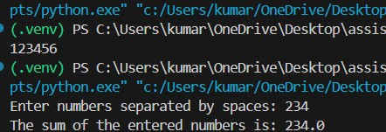
Style-2
Prompt:
# Generate a python code for sum of the numbers user input example # Example:123=output:6 Code:
def sum_of_digits(number):
return sum(int(digit) for digit in str(number) if digit.isdigit()) user_input = input("Enter a number: ") result = sum_of_digits(user_input) print(f"The sum of the digits in {user_input} is {result}.")

Output:
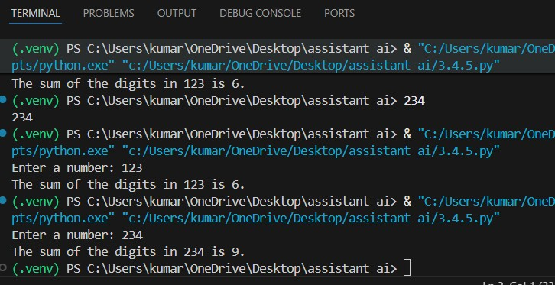

Explanation:

