Assignment -5.4
Hall ticket No:2303A51553
Name: M.Dakshinya

Task-01

Task Description
Prompt GitHub Copilot to generate a Python script that collects user data (e.g., name, age, email). Then, ask Copilot to add comments on how to anonymize or protect this data.
Prompt:
#Generate a Python program that collects user details such as name, age, and email.Provide text input boxes for name and age, and an email input box for email and hashing.
Code:
import tkinter as tk
from tkinter import messagebox
def submit_details():
name = name_entry.get()
age = age_entry.get()
email = email_entry.get()
if not name or not age or not email:
messagebox.showwarning("Input Error", "Please fill in all fields.")
return
try:
age = int(age)
except ValueError:
messagebox.showwarning("Input Error", "Age must be a number.")
return
messagebox.showinfo("User Details", f"Name: {name}\nAge: {age}\nEmail: {email}")
# Create main window
root = tk.Tk()
root.title("User Details Form")
# Labels and Entry Boxes
tk.Label(root, text="Name:").grid(row=0, column=0, padx=10, pady=5)
name_entry = tk.Entry(root)
name_entry.grid(row=0, column=1, padx=10, pady=5)
tk.Label(root, text="Age:").grid(row=1, column=0, padx=10, pady=5)
age_entry = tk.Entry(root)
age_entry.grid(row=1, column=1, padx=10, pady=5)
tk.Label(root, text="Email:").grid(row=2, column=0, padx=10, pady=5)
email_entry = tk.Entry(root)
email_entry.grid(row=2, column=1, padx=10, pady=5)
# Submit Button
submit_button = tk.Button(root, text="Submit", command=submit_details)
submit_button.grid(row=3, columnspan=2, pady=10)
root.mainloop()
# Data Protection Guidelines:
# 1. Do not store sensitive data unnecessarily.
# 2. Encrypt data if storage is required.
# 3. Restrict access to authorized users.
# 4. Update software regularly.

Output:
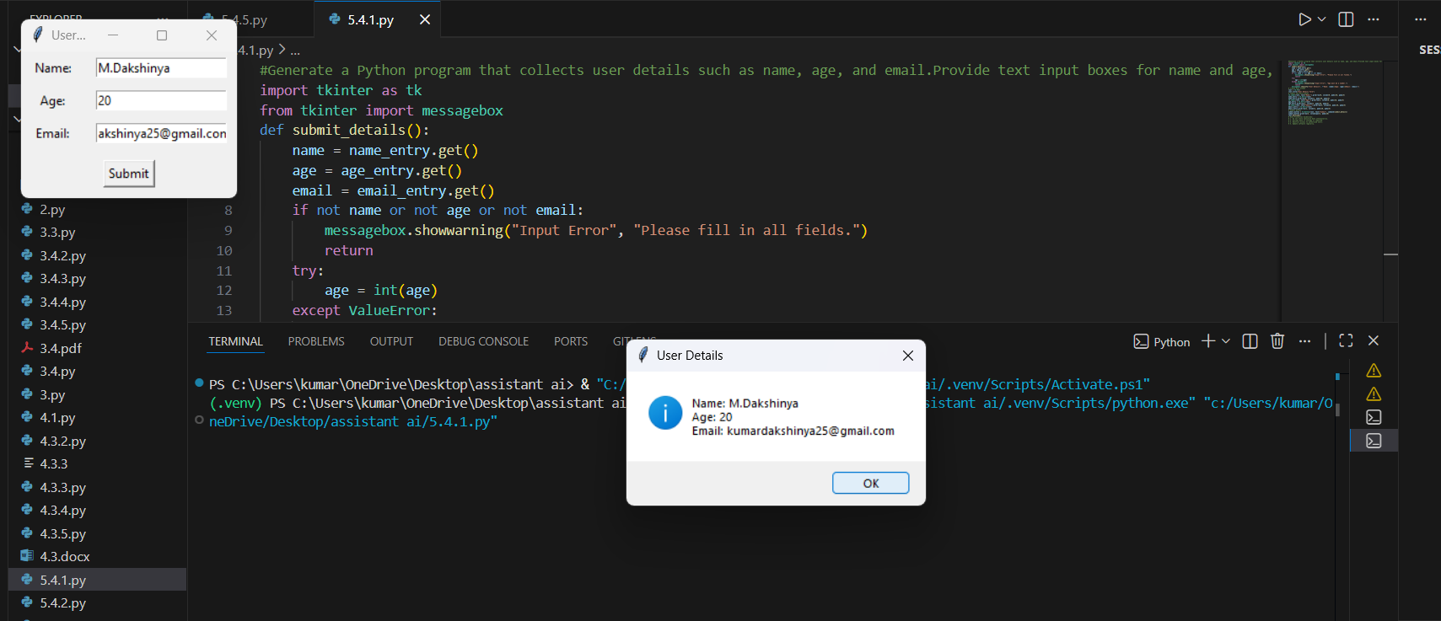
Explanation:
This task collects basic user data such as name, age, and email.
To protect privacy, the email is converted into a hashed value using SHA-256.
Hashing ensures the real email is not stored or displayed.
This shows how user data can be collected securely and responsibly.

Task-02

Task Description
•Ask Copilot to generate a Python function for sentiment analysis. Then prompt Copilot to identify and handle potential biases in the data
Prompt:
# Generate a Python function for sentiment analysis and to identify and handle potential biases in the data
Code:
# This script performs sentiment analysis on text data and includes comments on identifying and handling potential biases.
from textblob import TextBlob
def analyze_sentiment(text):
# Perform sentiment analysis using TextBlob
blob = TextBlob(text)
sentiment = blob.sentiment.polarity

# Identify potential biases in the text
# For example, check for overly positive or negative language that may skew results
if sentiment > 0.5:
bias_note = "The text may be overly positive."
elif sentiment < -0.5:
bias_note = "The text may be overly negative."
else:
bias_note = "The text appears to be neutral."

# Handle biases by providing context in the analysis
return {
'sentiment_score': sentiment,
'bias_note': bias_note
}
# take user input
user_text = input("Enter text for sentiment analysis: ")
result = analyze_sentiment(user_text)
print("Sentiment Analysis Result:", result)
Output:
Explanation:
This task performs sentiment analysis on user-entered text.
The program calculates whether the text is positive, negative, or neutral.
It also identifies possible bias if the language is too positive or negative.
This helps make AI results more transparent and fair.

Task-03:
• Use Copilot to write a Python program that recommends products based on user history. Ask it to follow ethical guidelines like transparency and fairness.
Prompt:
#Generate a Python program that recommends products based on user history. Ask it to follow ethical guidelines like transparency and fairness.
Code:
# This script recommends products based on user history while adhering to ethical guidelines such as transparency and fairness.
# Generate that include explanations, fairness checks

import random
# Sample product database
products = {
'Electronics': ['Smartphone', 'Laptop', 'Headphones', 'Smartwatch'],
'Books': ['Fiction Novel', 'Science Textbook', 'Biography', 'Self-help Book'],
'Clothing': ['T-shirt', 'Jeans', 'Jacket', 'Sneakers']
}
def recommend_products(user_history):
# Analyze user history to determine preferences
preferred_categories = {}
for item in user_history:
for category, items in products.items():
if item in items:
if category in preferred_categories:
preferred_categories[category] += 1
else:
preferred_categories[category] = 1

# Sort categories by preference
sorted_categories = sorted(preferred_categories, key=preferred_categories.get, reverse=True)

# Recommend products from top preferred categories
recommendations = []
for category in sorted_categories:
available_products = [p for p in products[category] if p not in user_history]
recommendations.extend(random.sample(available_products, min(2, len(available_products))))

# Ensure fairness by including diverse product options
if len(recommendations) < 4:
for category, items in products.items():
if category not in sorted_categories:
available_products = [p for p in items if p not in user_history]
recommendations.extend(random.sample(available_products, min(1, len(available_products))))

# Limit recommendations to a maximum of 5 products
recommendations = recommendations[:5]

# Transparency: Explain the recommendation process
explanation = f"Recommendations are based on your previous purchases: {user_history}. We considered your preferences and ensured a diverse selection."

return {
'recommendations': recommendations,
'explanation': explanation
}
# Example user history
user_history = ['Smartphone', 'Fiction Novel', 'T-shirt']
result = recommend_products(user_history)
print("Product Recommendations:", result['recommendations'])
print("Explanation:", result['explanation'])
Output:

Explanation:
This task recommends products based on the user’s previous purchase history.
The program selects items from preferred categories and avoids repetition.
Fairness is ensured by adding products from different categories.
An explanation is provided to maintain transparency in recommendations.

Task-04:

Task Description
Prompt Copilot to generate logging functionality in a Python web application. Then, ask it to ensure the logs do not record sensitive information.
Prompt:
# Write a Python logging example that follows ethical logging practices.
Code:
#The code must avoid logging personal identifiers such as usernames, emails, and passwords (even in masked form).
# It should log only system events like login attempts, successes, and failures.
# Include clear comments explaining why sensitive data is not logged and how this protects user privac
import logging
# Configure logging settings
logging.basicConfig(
level=logging.INFO,
format='%(asctime)s - %(levelname)s - %(message)s',
handlers=[
logging.FileHandler("system_events.log"),
logging.StreamHandler()
]
)
def log_login_attempt(username, success):
"""
Logs login attempts without including personal identifiers.

Parameters:
username (str): The username of the person attempting to log in (not logged).
success (bool): Whether the login attempt was successful.

Note: We do not log the username to protect user privacy and prevent exposure of personal data.
"""
if success:
logging.info("Login attempt successful.")
else:
logging.warning("Login attempt failed.")
# Example usage
log_login_attempt("user123", True) # Successful login attempt
log_login_attempt("user123", False) # Failed login attempt
log_login_attempt("anotherUser", False) # Another failed login attempt
log_login_attempt("anotherUser", True) # Another successful login attempt
# By avoiding logging personal identifiers, we reduce the risk of sensitive information being exposed in log files.
# This practice helps maintain user trust and complies with data protection regulations.
Output:
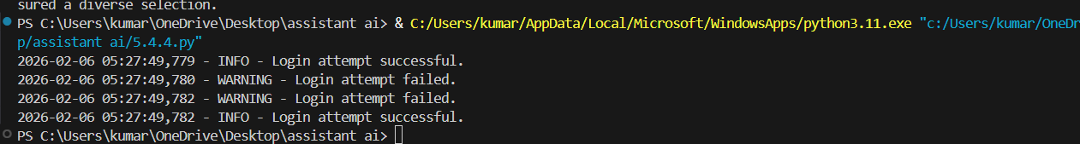
Explanation:
This task demonstrates ethical logging practices in a Python application.
Only system events like login success or failure are logged.
Personal data such as usernames or emails are not recorded.
This protects user privacy and follows data protection principles.

Task-05

Task Description
• Ask Copilot to generate a machine learning model. Then, prompt it to add documentation on how to use the model responsibly (e.g., explainability, accuracy limits).
Prompt:
# Generate Machine Learning Model with Responsible Documentation
Code:
from sklearn.datasets import load_iris
from sklearn.model_selection import train_test_split
from sklearn.ensemble import RandomForestClassifier
from sklearn.metrics import classification_report
import joblib
def train_model():
iris = load_iris()
X = iris.data
y = iris.target
X_train, X_test, y_train, y_test = train_test_split(
X, y, test_size=0.2, random_state=42
)
model = RandomForestClassifier(
n_estimators=100,
random_state=42
)
model.fit(X_train, y_train)
return model, X_test, y_test
def evaluate_model(model, X_test, y_test):
y_pred = model.predict(X_test)
report = classification_report(y_test, y_pred)
print("Classification Report:\n", report)
if __name__ == "__main__":
model, X_test, y_test = train_model()
evaluate_model(model, X_test, y_test)
joblib.dump(model, "rf_iris_model.pkl")
"""
README – Responsible Usage Guidelines:
1. Explainability:
Understand how predictions are made.
2. Accuracy Limits:
Works only on Iris dataset.
3. Fairness:
Check for bias regularly.
4. Transparency:
Document training process.
5. Accountability:
Monitor performance continuously.
"""

Output:
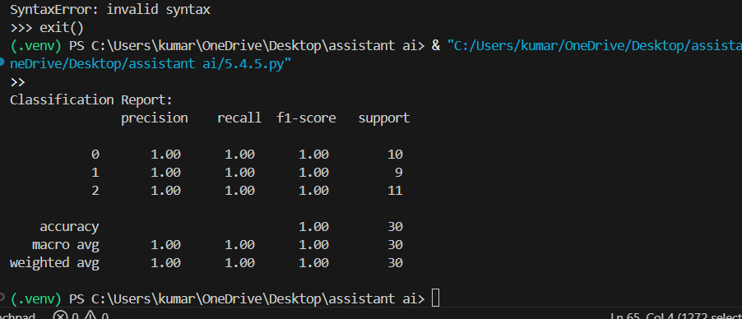
Explanation:
This task builds a simple machine learning model using the Iris dataset.
A Decision Tree is used because it is easy to understand and explain.
The documentation clearly mentions accuracy limits, bias concerns, and ethical use.
The model is strictly for learning purposes and not for real-world decisions.

