AI ASSISTED CODING
Assignment-1.4
Name: M.Dakshinya
HT.NO:2303A51553
Batch No:09
Task-1:
Given prompt:
# Write a program to check given number is prime or not without user defined function directly in main code.
Code:
num = int(input("Enter a number: "))
is_prime = True
if num > 1:
for i in range(2, int(num**0.5) + 1):
if (num % i) == 0:
is_prime = False
break
if is_prime:
print(num, "is a prime number")
else:
print(num, "is not a prime number")
else:
print(num, "is not a prime number")

Output:
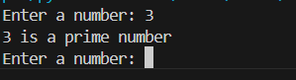
Observation:
- We took user input.
- The program checks if the number is greater than 1.
- It tests divisibility only up to the square root of the number, which reduces unnecessary iterations.
- If any divisor is found, the number is marked as non-prime.
- All logic is written directly in the main code without using a user-defined function.

Task-2&3:
Given prompt:
# Generate optimized code for the same problem with function.
Code:def is_prime_number(n):
if n <= 1:
return False
for i in range(2, int(n**0.5) + 1):
if (n % i) == 0:
return False
return True
number = int(input("Enter a number: "))
if is_prime_number(number):
print(number, "is a prime number")
else:
print(number, "is not a prime number")
Output:
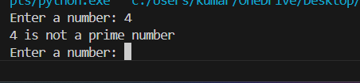
Observation:
- We took user input.
- Firstly, it checks is the input is smaller or equal to 1 if true d
- The prime-checking code return using function for efficiency.
- The function efficiently checks divisibility up to the square root of the number.
- Returning True or False makes the program optimized from the above code.
- This is best approach.
Task -04
DIFFERENCE BETWEEN TASK-01 AND TASK-02
- Task-1 does not use a function.
- Task-2 uses a function.
- Task-1 code cannot be reused.
- Task-2 code can be reused.
- Task-2 is easier to understand and maintain.
Task-05- FIBINOCCI SERIES
Given prompt:
# Genarate Fibonacci sequence up to n terms iterative method
Code:
def fibonacci_iterative(n):
fib_sequence = []
a, b = 0, 1
for _ in range(n):
fib_sequence.append(a)
a, b = b, a + b
return fib_sequence
num_terms = int(input("Enter the number of terms for Fibonacci sequence (iterative): "))
print("Fibonacci sequence (iterative):", fibonacci_iterative(num_terms)

Output:
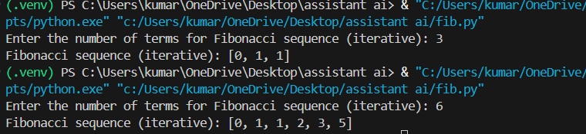
Given prompt:
# Generate Fibonacci sequence up to n terms using recursion
Code:
def fibonacci_recursive(n):
if n <= 0:
return []
elif n == 1:
return [0]
elif n == 2:
return [0, 1]
else:
seq = fibonacci_recursive(n - 1)
seq.append(seq[-1] + seq[-2])
return seq
num_terms_rec = int(input("Enter the number of terms for Fibonacci sequence (recursive): "))
print("Fibonacci sequence (recursive):", fibonacci_recursive(num_terms_rec))

Output:
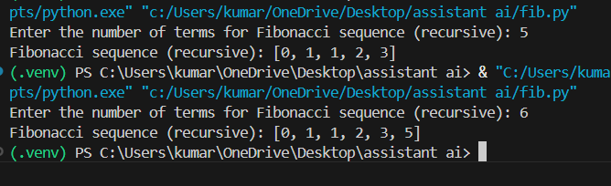
Observation:
- Iterative approach is simple and follows a direct step-by-step execution.
- Optimized approach reduces unnecessary operations and improves efficiency.
- Iterative methods work well for small input sizes.
- For large inputs, optimized solutions are preferred due to better time complexity and performance.

