Assignment -4.3
Hall ticket No:2303A51553
Name: M.Dakshinya
Task-01
-Zero-Shot Prompting – Leap Year Check
Scenario
Zero-shot prompting involves giving instructions without providing examples.
Task Description
Use zero-shot prompting to instruct an AI tool to generate a Python function that:
• Accepts a year as input
• Checks whether the given year is a leap year
• Returns an appropriate result
Note: No input-output examples should be provided in the prompt.
Prompt:
#Generate code for take user input and check whether it is leap year are not
Code:
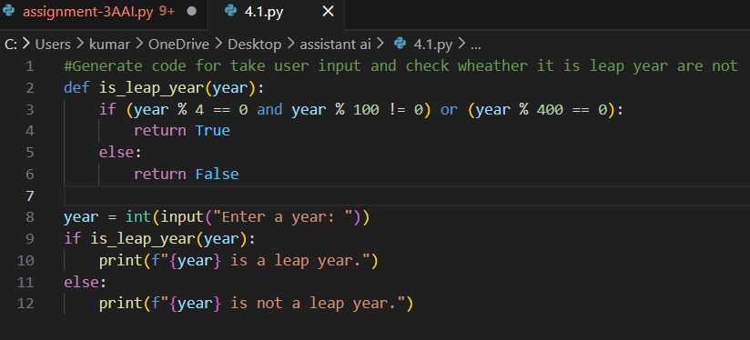
Output:
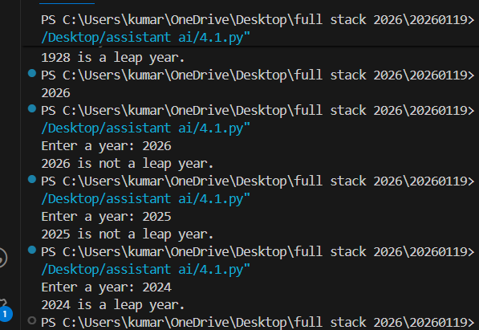
Explanation:
In this task, zero-shot prompting is used where no examples are given.
The AI generates a function that takes a year as input and checks leap-year conditions.
If the year satisfies the leap-year rules, it is identified correctly.
Thus, the program determines whether a year is a leap year or not.
Task-02
- One-Shot Prompting – Centimetres to Inches Conversion
Scenario
One-shot prompting guides AI using a single example.
Task Description
Use one-shot prompting by providing one input-output example to generate a Python function that:
• Converts centimetres to inches
• Uses the correct mathematical formula
Prompt:
#Generate code for taking user input and converting centimeters to inches use correct mathematical formula like example:10 cm = 3.93701 inches

Code:
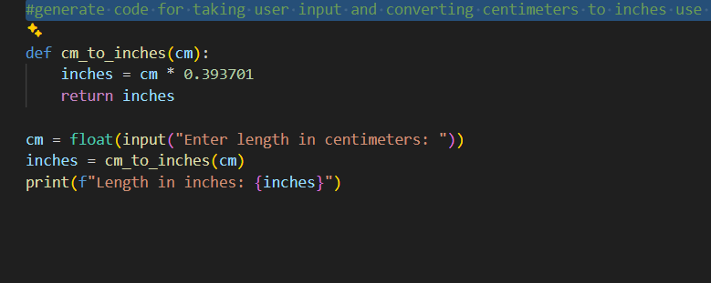
Output:
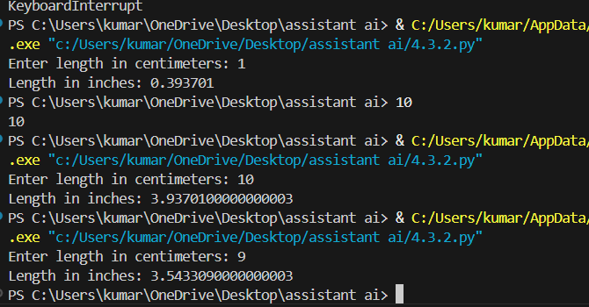
Explanation:
In this task, one-shot prompting is used by giving one example.
The program takes centimetres as input and converts it into inches using the correct formula.
The example helps the AI understand the conversion logic.
The result is printed accurately.
Task-03
- Few-Shot Prompting – Name Formatting
Scenario
Few-shot prompting improves accuracy by providing multiple examples.
Task Description
Use few-shot prompting with 2–3 examples to generate a Python function that:
• Accepts a full name as input
• Formats it as “Last, First”
Prompt:
# Generate code for taking user input full name and print format first,last examples like "John Smith" → "Smith, John" and "Anita Rao" → "Rao, Anita"

Code:
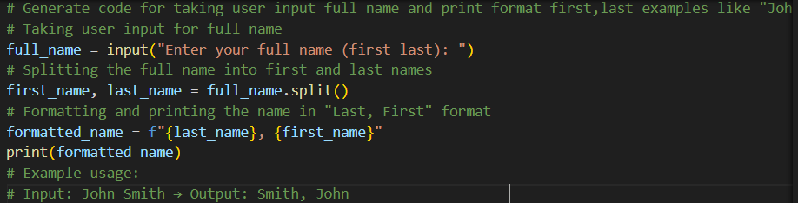
Output:
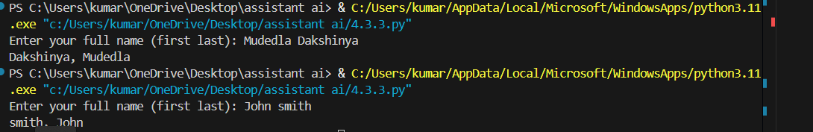
Explanation:
In this task, few-shot prompting is used by providing multiple examples.
The program takes a full name as input and separates the first and last names.
It then prints the name in the format “Last, First”.
Using examples improves accuracy and formatting.
Task-04
-Few-Shot Prompting – Name Formatting
Scenario
Different prompt strategies may produce different code quality.
Task Description
• Use zero-shot prompting to generate a function that counts vowels in a string
• Use few-shot prompting for the same problem
• Compare both outputs based on:
o Accuracy
o Readability
o Logical clarity
Prompt for Zero-short:
# Generate code for user input string and count the number of vowels in it
Code:
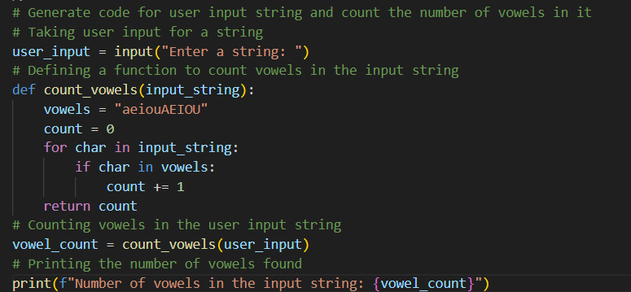
Output:
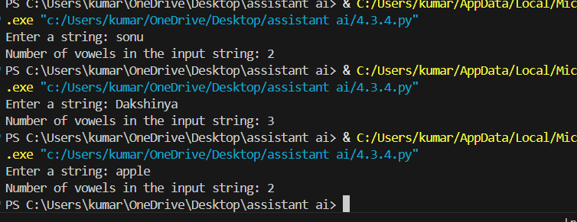
Prompt for few-short:
# Generate code for user input string and count the number of vowels in it Example apple _→ 2, Orange → 3

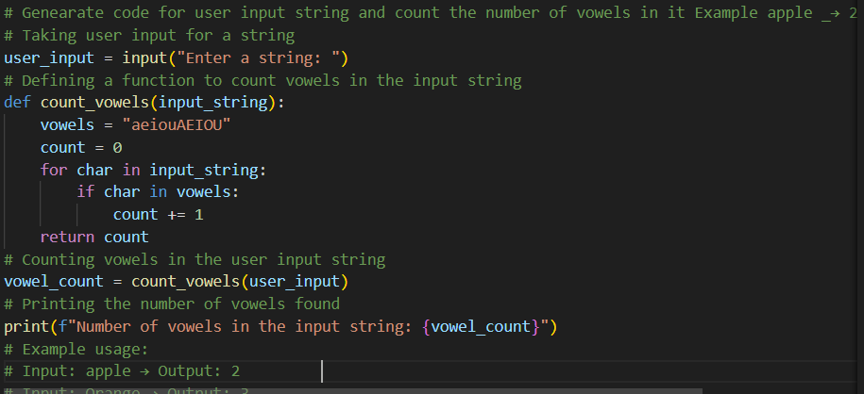
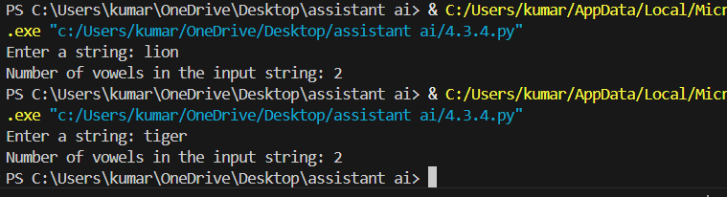

Explanation:
In zero-shot prompting, the AI generates vowel-counting code without examples.
In few-shot prompting, examples are provided to guide the logic.
The few-shot solution is more readable and logically clear.
Thus, few-shot prompting produces better quality code.
Task-05
- Few-Shot Prompting – File Handling
Scenario
File processing requires clear logical understanding.
Task Description
Use few-shot prompting to generate a Python function that:
• Reads a .txt file
• Counts the number of lines in the file
• Returns the line count
Prompt:
#Generate code for function that reads a text file and returns the number of lines in the file

Code:
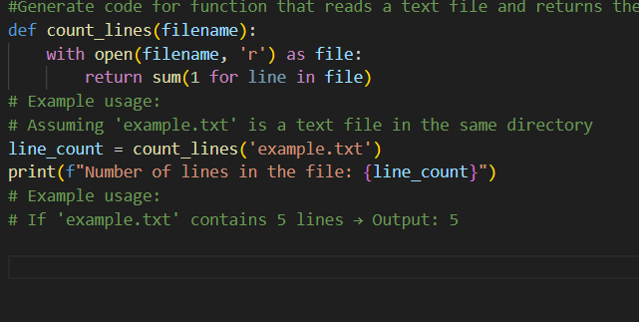
Output:
Explanation:
In this task, a text file is opened in read mode.
The program reads the file line by line and counts the total number of lines.
Few-shot prompting helps the AI understand file-processing logic clearly.
The correct line count is returned as output.

