Assignment -6.3
Hall ticket No:2303A51553
Name: M.Dakshinya

Task-01

Task Description
A Python class with a constructor (__init__) and a display_details() method.
• Sample object creation and output displayed on the console.
• Brief analysis of AI-generated code.
Prompt:
# Generate a Python program for a simple student information management module.

Code:
class Student:
def __init__(self, name, roll_number, branch):
"""Initialize the student attributes."""
self.name = name
self.roll_number = roll_number
self.branch = branch

def display_details(self):
"""Print the student information."""
print("Student Details:")
print(f"Name: {self.name}")
print(f"Roll Number: {self.roll_number}")
print(f"Branch: {self.branch}")
# Create a Student object
student1 = Student("Alice Smith", "101", "Computer Science")
# Call the display_details() method to show output on the console
student1.display_details()

Output:
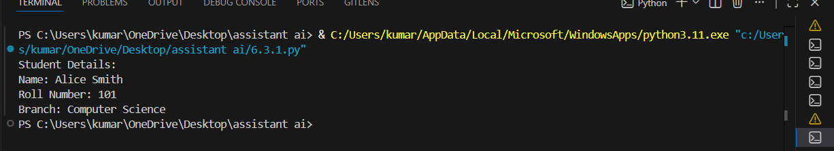
Explanation:
- While doing this task, I used AI to generate a Student class with basic details like name, roll number, and branch.
- I understood how the __init__() method stores values when an object is created.
- By calling the display_details() method, I clearly saw how class data is accessed and printed.
- Executing the program helped me understand object-oriented programming in a simple way.
- The AI-generated code was clear and easy to follow.

Task-02

Task Description
• Write a comment prompt to reverse a list and provide one
example below the comment to guide Copilot.
Prompt:
# Generate a python utility function that prints the first 10 multiples of a given number by user input
Code:
# Function to display multiples of a number
def display_multiples(number):
"""Print the first 10 multiples of the given number."""
print(f"The first 10 multiples of {number} are:")
for i in range(1, 11):
print(number * i)
# Get user input
user_input = int(input("Enter a number to see its first 10 multiples: "))
# Call the function with user input
display_multiples(user_input)
Output:
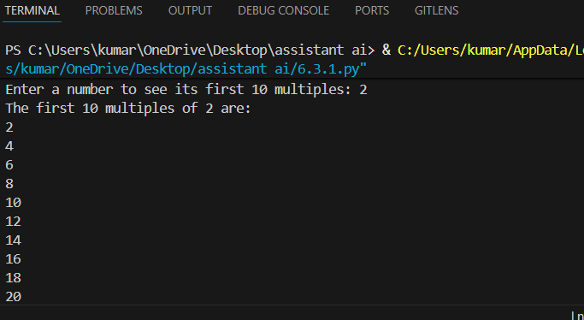
Prompt:
# Generate the same functionality using another controlled looping structure (e.g.,while instead of for).

Code:
def display_multiples_while(number):
"""Print the first 10 multiples of the given number using a while loop."""
print(f"The first 10 multiples of {number} are:")
i = 1
while i <= 10:
print(number * i)
i += 1
user_input = int(input("Enter a number to see its first 10 multiples: "))
# Call the function with user input
display_multiples_while(user_input)

Output:

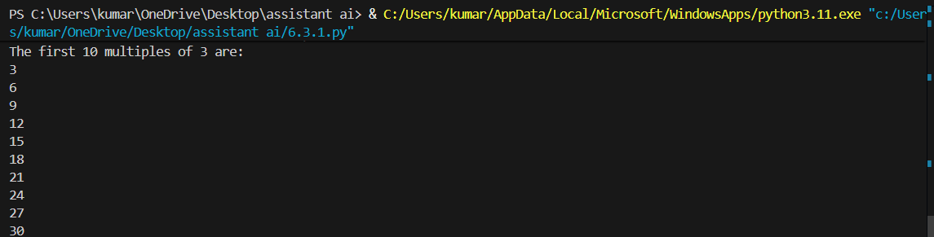
Explanation:
- In this task, AI generated a function to print the first 10 multiples of a number.
- First, I observed the solution using a for loop and understood how iteration works.
- Then, the same logic was shown using a while loop, which helped me compare both loops.
- Running both programs showed that different loops can give the same output.
- This task improved my understanding of looping structures.

Task-03:
• You are building a basic classification system based on age.
Prompt:
# Generate nested if-elif-else conditional statements to classify age groups(e.g., child, teenager, adult, senior).
Code:
age = int(input("Enter your age: "))
if age < 0:
print("Invalid age.")
elif age < 13:
print("You are a child.")
elif age < 20:
print("You are a teenager.")
elif age < 65:
print("You are an adult.")
else:
print("You are a senior citizen.")
Output:
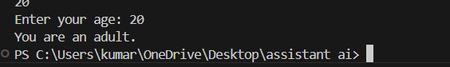
Prompt:
# Generate the same classification using alternative conditional structures (e.g.,simplified conditions or dictionary-based logic).
Code:
age = int(input("Enter your age: "))
age_groups = {
"child": lambda x: x < 13,
"teenager": lambda x: 13 <= x < 20,
"adult": lambda x: 20 <= x < 65,
"senior": lambda x: x >= 65
}
for group, condition in age_groups.items():
if condition(age):
print(f"You are a {group}.")
break
else:
print("Invalid age.")

Output:
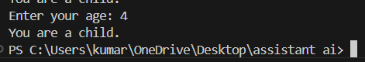
Explanation:
- While doing this task, I learned how decision-making works using if-elif-else statements.
- The AI-generated conditions correctly classified age into child, teenager, adult, and senior.
- I also learned an alternative method using dictionary-based logic.
- This helped me understand that conditions can be written in more than one way.
- The output was correct and easy to verify.

Task-04:

Task Description #4: For and While Loops (Sum of First n Numbers)
Prompt:
# Generate a sum_to_n() function using a for loop.
Code:
def sum_to_n(n):
"""Calculate the sum of integers from 1 to n."""
total = 0
for i in range(1, n + 1):
total += i
return total
# Example usage:
number = int(input("Enter a number to calculate the sum of integers from 1 to that number: "))
print(f"The sum of integers from 1 to {number} is {sum_to_n(number)}")
Output:
Prompt for alternative:
# Generate an alternative implementation using a while loop or a mathematical formula.
Code:
def sum_to_n_while(n):
"""Calculate the sum of integers from 1 to n using a while loop."""
total = 0
i = 1
while i <= n:
total += i
i += 1
return total
# Example usage:
number = int(input("Enter a number to calculate the sum of integers from 1 to that number (using while loop): "))
print(f"The sum of integers from 1 to {number} is {sum_to_n_while(number)}")

Output: 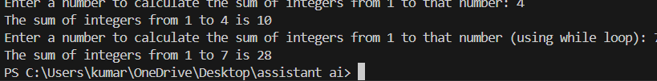
Explanation:
- In this task, AI generated a function to calculate the sum of first n natural numbers.
- The for loop version helped me understand step-by-step addition.
- The while loop version showed how condition-based looping works.
- Executing both versions gave the same result, which increased my confidence.
- I learned when to use for and while loops properly.

Task-05:

Task Description #5: Classes (Bank Account Class)
Prompt:
# Generate a Bank Account class with methods such as deposit(), withdraw(),and check_balance().
Code:
class BankAccount:
def __init__(self, account_holder, initial_balance=0):
"""Initialize the bank account with account holder's name and initial balance."""
self.account_holder = account_holder
self.balance = initial_balance

def deposit(self, amount):
"""Deposit money into the account."""
if amount > 0:
self.balance += amount
print(f"Deposited: ${amount:.2f}")
else:
print("Deposit amount must be positive.")

def withdraw(self, amount):
"""Withdraw money from the account."""
if 0 < amount <= self.balance:
self.balance -= amount
print(f"Withdrew: ${amount:.2f}")
else:
print("Insufficient balance or invalid withdrawal amount.")

def check_balance(self):
"""Check the current balance of the account."""
print(f"Current balance: ${self.balance:.2f}")
# Example usage:
account = BankAccount("John Doe", 1000)
account.check_balance()
account.deposit(500)
account.withdraw(200)
account.check_balance()
account.withdraw(2000) # Attempt to withdraw more than the balance
Output:
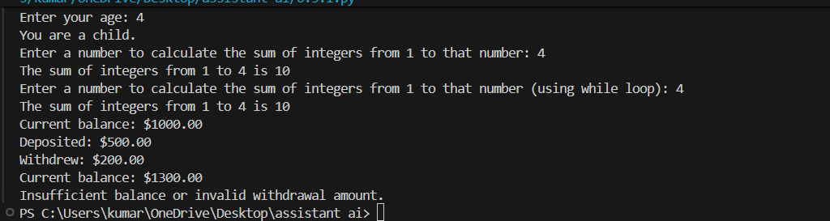
Explanation:
- While working on this task, I learned how real-life examples can be converted into classes.
- The AI-generated Bank Account class had methods for deposit, withdrawal, and balance checking.
- I understood the importance of validating data before updating the balance.
- Running the program showed how methods change the account state.
- This task helped me understand practical use of classes in Python.

