Assignment -3.3
Hall ticket No:2303A51553
Name: M.Dakshinya
Task-01-AI-Generated Logic for Reading Consumer Details
Prompt:
#Generate Python code to read previous units, current units, and customer type, then calculate units consumed and the total bill based on the given rates.
Code:
def calculate_bill(previous_units, current_units, customer_type):
units_consumed = current_units - previous_units
if customer_type == 'residential':
if units_consumed <= 100:
rate = 0.5
elif units_consumed <= 300:
rate = 0.75
else:
rate = 1.0
elif customer_type == 'commercial':
if units_consumed <= 100:
rate = 0.75
elif units_consumed <= 300:
rate = 1.0
else:
rate = 1.5
else:
raise ValueError("Invalid customer type. Must be 'residential' or 'commercial'.")

total_bill = units_consumed * rate
return units_consumed, total_bill
# Example usage:
previous_units = 500
current_units = 850
customer_type = 'residential'
units_consumed, total_bill = calculate_bill(previous_units, current_units, customer_type)
print(f"Units Consumed: {units_consumed}")
print(f"Total Bill: ${total_bill:.2f}")
Output:
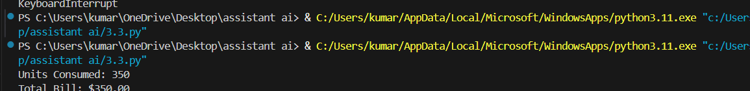
Explanation:
This task calculates electricity usage by subtracting previous units from current units.
Based on customer type (residential or commercial), different rates are applied.
If the customer type is invalid, an error is shown.
Finally, the total bill is calculated and displayed.
Task-02-Energy Charges Calculation Based on Units Consumed
Prompt:
# Add if-else logic to calculate energy charges for domestic, commercial, and industrial users
Code:
def calculate_energy_charges(units_consumed, user_type):
if user_type == 'domestic':
if units_consumed <= 100:
rate = 0.5
elif units_consumed <= 300:
rate = 0.75
else:
rate = 1.0
elif user_type == 'commercial':
if units_consumed <= 100:
rate = 0.75
elif units_consumed <= 300:
rate = 1.0
else:
rate = 1.5
elif user_type == 'industrial':
if units_consumed <= 100:
rate = 1.0
elif units_consumed <= 300:
rate = 1.5
else:
rate = 2.0
else:
raise ValueError("Invalid user type. Must be 'domestic', 'commercial', or 'industrial'.")

total_charges = units_consumed * rate
return total_charges
# Example usage:
units_consumed = 250
user_type = 'commercial'
total_charges = calculate_energy_charges(units_consumed, user_type)
print(f"Total Energy Charges for {user_type} user: ${total_charges:.2f}")
Output:
Explanation:
This program calculates energy charges using if-else conditions.
Different rates are applied for domestic, commercial, and industrial users.
The charges depend on the number of units consumed.
The final energy charge is returned correctly.
Task-03-Modular Design Using AI Assistance
Prompt:
# Create Python functions to calculate energy charges and fixed charges
Code:
def calculate_fixed_charges(user_type):
if user_type == 'domestic':
return 50
elif user_type == 'commercial':
return 100
elif user_type == 'industrial':
return 200
else:
raise ValueError("Invalid user type. Must be 'domestic', 'commercial', or 'industrial'.")
def calculate_total_bill(units_consumed, user_type):
energy_charges = calculate_energy_charges(units_consumed, user_type)
fixed_charges = calculate_fixed_charges(user_type)
total_bill = energy_charges + fixed_charges
return total_bill
# Example usage:
units_consumed = 250
user_type = 'commercial'
total_bill = calculate_total_bill(units_consumed, user_type)
print(f"Total Bill for {user_type} user: ${total_bill:.2f}")
Output:
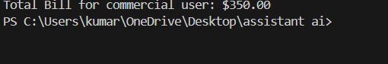
Explanation:
This task uses separate functions for fixed charges and total bill calculation.
Modular design makes the code easy to understand and reuse.
Energy charges and fixed charges are added together.
The total bill is calculated clearly
Task-04-Calculation of Additional Charges
Prompt :
# Add fixed charges, customer charges, and electricity duty calculation
Code:
def calculate_electricity_duty(total_bill):
return total_bill * 0.05 # Assuming a 5% electricity duty
def calculate_total_bill_with_duty(units_consumed, user_type):
energy_charges = calculate_energy_charges(units_consumed, user_type)
fixed_charges = calculate_fixed_charges(user_type)
total_bill = energy_charges + fixed_charges
electricity_duty = calculate_electricity_duty(total_bill)
total_bill_with_duty = total_bill + electricity_duty
return total_bill_with_duty
# Example usage:
units_consumed = 250
user_type = 'commercial'
total_bill_with_duty = calculate_total_bill_with_duty(units_consumed, user_type)
print(f"Total Bill with Electricity Duty for {user_type} user: ${total_bill_with_duty:.2f}")
Output:
Explanation:
This task adds electricity duty to the total bill.
Electricity duty is calculated as 5% of the total bill.
The program combines energy charges, fixed charges, and duty.
The final amount including duty is returned.
Task-05-Final Bill Generation and Output Analysis
Prompt:
# Generate formatted electricity bill output with total amount
Code:
def generate_electricity_bill(previous_units, current_units, user_type):
units_consumed = current_units - previous_units
energy_charges = calculate_energy_charges(units_consumed, user_type)
fixed_charges = calculate_fixed_charges(user_type)
total_bill = energy_charges + fixed_charges
electricity_duty = calculate_electricity_duty(total_bill)
total_bill_with_duty = total_bill + electricity_duty

bill_output = f"""
Electricity Bill
----------------
Previous Units: {previous_units}
Current Units: {current_units}
Units Consumed: {units_consumed}
User Type: {user_type.capitalize()}

Energy Charges: ${energy_charges:.2f}
Fixed Charges: ${fixed_charges:.2f}
Electricity Duty: ${electricity_duty:.2f}

Total Bill (including duty): ${total_bill_with_duty:.2f}
"""
return bill_output
# Example usage:
previous_units = 500
current_units = 850
user_type = 'commercial'
bill = generate_electricity_bill(previous_units, current_units, user_type)
print(bill)
Output:
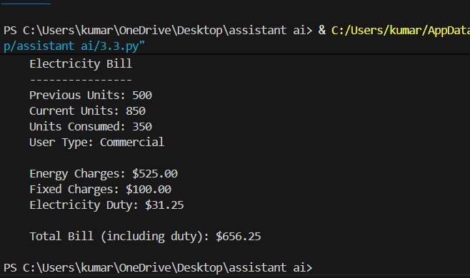
Explanation:
This task generates a complete and formatted electricity bill.
It displays unit details, charges, and total amount clearly.
All calculations are combined in one function.
The final bill output is easy to read and user-friendly

