Assignment -6.4
Hall ticket No:2303A51553
Name: M.Dakshinya
Task-01-Student Performance Evaluation System
Prompt:
#Generate a completed Student class methods proper use of conditonal statements and attributes
Code:
class Student:
def __init__(self, name, age, grade):
self.name = name
self.age = age
self.grade = grade

def is_passing(self):
if self.grade >= 60:
return True
else:
return False

def get_grade_letter(self):
if self.grade >= 90:
return 'A'
elif self.grade >= 80:
return 'B'
elif self.grade >= 70:
return 'C'
elif self.grade >= 60:
return 'D'
else:
return 'F'

def display_info(self):
print(f"Name: {self.name}")
print(f"Age: {self.age}")
print(f"Grade: {self.grade} ({self.get_grade_letter()})")
# Example usage
student1 = Student("Alice", 20, 85)
student1.display_info()
print("Is passing:", student1.is_passing())
student2 = Student("Bob", 22, 55)
student2.display_info()
print("Is passing:", student2.is_passing())
Output: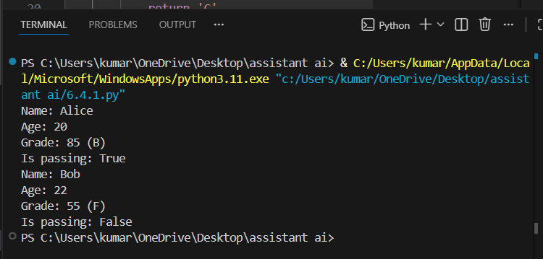
Explanation:
In Task 1, while creating the Student class, I clearly understood the use of self attributes and conditional statements. I learned how marks can be checked using if-else conditions to evaluate student performance
Task-02-Data Processing in a Monitoring System
Prompt:
#Generate the for loop to identify even numbers, calculate their square using conditions, and print the results user input
Code:
numbers = []
input_numbers = input("Enter a list of numbers separated by spaces: ")
numbers = list(map(int, input_numbers.split()))
even_squares = []
for num in numbers:
if num % 2 == 0:
even_squares.append(num ** 2)
print("Even numbers and their squares:")
for num in even_squares:
print(num)

Output:
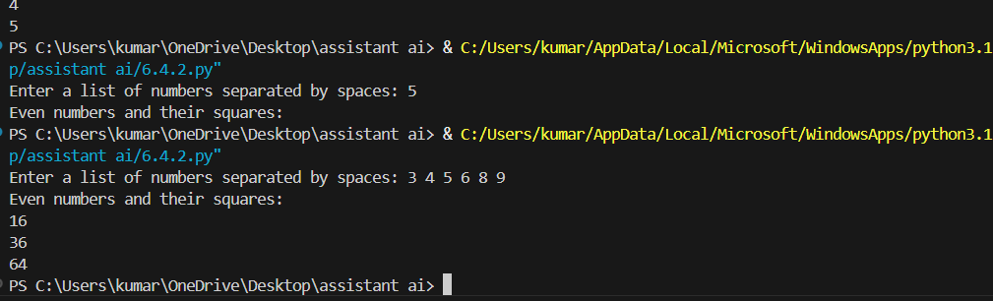
Explanation:
In Task 2, working with sensor data helped me understand loops and conditions together. I learned how even numbers are identified using the modulus operator (%) and how AI completes logic inside loops correctly.
Task-03-Banking Transaction Simulation
Prompt:
# Generate a completed BankAccount class with deposit and withdraw methods using if-else conditions
Code:
# Generate a completed BankAccount class with deposit and withdraw methods using if-else conditions
class BankAccount:
def __init__(self, account_holder, balance=0):
self.account_holder = account_holder
self.balance = balance

def deposit(self, amount):
if amount > 0:
self.balance += amount
print(f"Deposited ${amount}. New balance: ${self.balance}.")
else:
print("Deposit amount must be positive.")

def withdraw(self, amount):
if amount > 0:
if amount <= self.balance:
self.balance -= amount
print(f"Withdrew ${amount}. New balance: ${self.balance}.")
else:
print("Insufficient funds for withdrawal.")
else:
print("Withdrawal amount must be positive.")
# Example usage:
account = BankAccount("John Doe", 1000)
account.deposit(500) # Deposited $500. New balance: $1500.
account.withdraw(200) # Withdrew $200. New balance: $1300.
account.withdraw(1500) # Insufficient funds for withdrawal.
account.deposit(-100) # Deposit amount must be positive.
account.withdraw(-50) # Withdrawal amount must be positive.
Output:
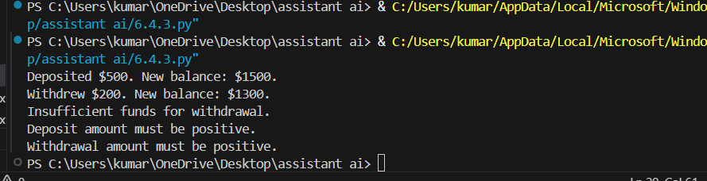
Explanation:
In Task 3, the banking module taught me how real-world problems like deposits and withdrawals are handled using classes and conditions. I clearly understood how to prevent invalid operations using if-else.
Task-04-Student Scholarship Eligibility Check
Prompt :
# Generate the while loop to print names of students scoring more than 75 using conditional statements
Code:
students = [
{"name": "Alice", "score": 85},
{"name": "Bob", "score": 70},
{"name": "Charlie", "score": 90},
{"name": "Diana", "score": 65}
]
i = 0
while i < len(students):
if students[i]["score"] > 75:
print(students[i]["name"])
i += 1
Output:
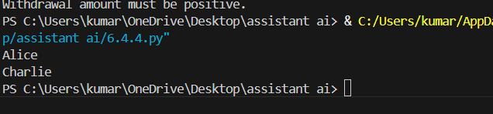
Explanation:
In Task 4, using a while loop improved my understanding of index-based iteration. I learned how conditions are used to filter data from a list.
Task-05-Online Shopping Cart Module
Prompt:
# Generate a completed ShoppingCart class with methods to add items, remove items, calculate total, and apply discount using conditions
Code:
class ShoppingCart:
def __init__(self):
self.items = []

def add_item(self, item_name, price):
self.items.append({"name": item_name, "price": price})

def remove_item(self, item_name):
for i in range(len(self.items)):
if self.items[i]["name"] == item_name:
del self.items[i]
return
print(f"Item '{item_name}' not found in the cart.")

def calculate_total(self):
total = 0
for item in self.items:
total += item["price"]
return total

def apply_discount(self, discount_percentage):
if 0 < discount_percentage < 100:
total = self.calculate_total()
discount_amount = total * (discount_percentage / 100)
return total - discount_amount
else:
print("Invalid discount percentage. It must be between 0 and 100.")
return self.calculate_total()
# Example usage:
cart = ShoppingCart()
cart.add_item("Laptop", 1000)
cart.add_item("Mouse", 50)
cart.add_item("Keyboard", 80)
print("Total before discount:", cart.calculate_total())
discounted_total = cart.apply_discount(10)
print("Total after discount:", discounted_total)
# Example usage:
cart.remove_item("Mouse")
print("Total after removing Mouse:", cart.calculate_total())
# Example usage:
cart.remove_item("Tablet") # Trying to remove an item not in the cart
Output:
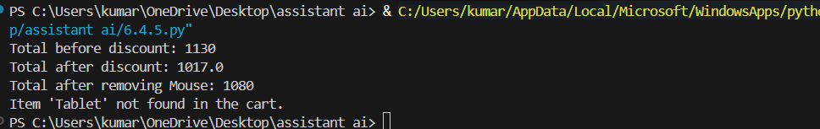
Explanation:
In Task 5, the shopping cart system helped me understand how loops, lists, and conditions work together. I learned how totals are calculated and how discounts are applied based on conditions.

