2303A51556
Batch: 25

Task 1: Refactoring – Removing Code Duplication
Objective
To eliminate repeated logic by extracting reusable functions.
Task Description
Use AI assistance to refactor a legacy Python script that contains repeated
blocks of code calculating the area and perimeter of rectangles.
Starter (Legacy) Code
# Legacy script with repeated logic
print("Area of Rectangle:", 5 * 10)
print("Perimeter of Rectangle:", 2 * (5 + 10))
print("Area of Rectangle:", 7 * 12)
print("Perimeter of Rectangle:", 2 * (7 + 12))
print("Area of Rectangle:", 10 * 15)
print("Perimeter of Rectangle:", 2 * (10 + 15))
Expected Outcome
• A reusable function to calculate area and perimeter
• No duplicated code blocks
• Proper docstrings for all functions
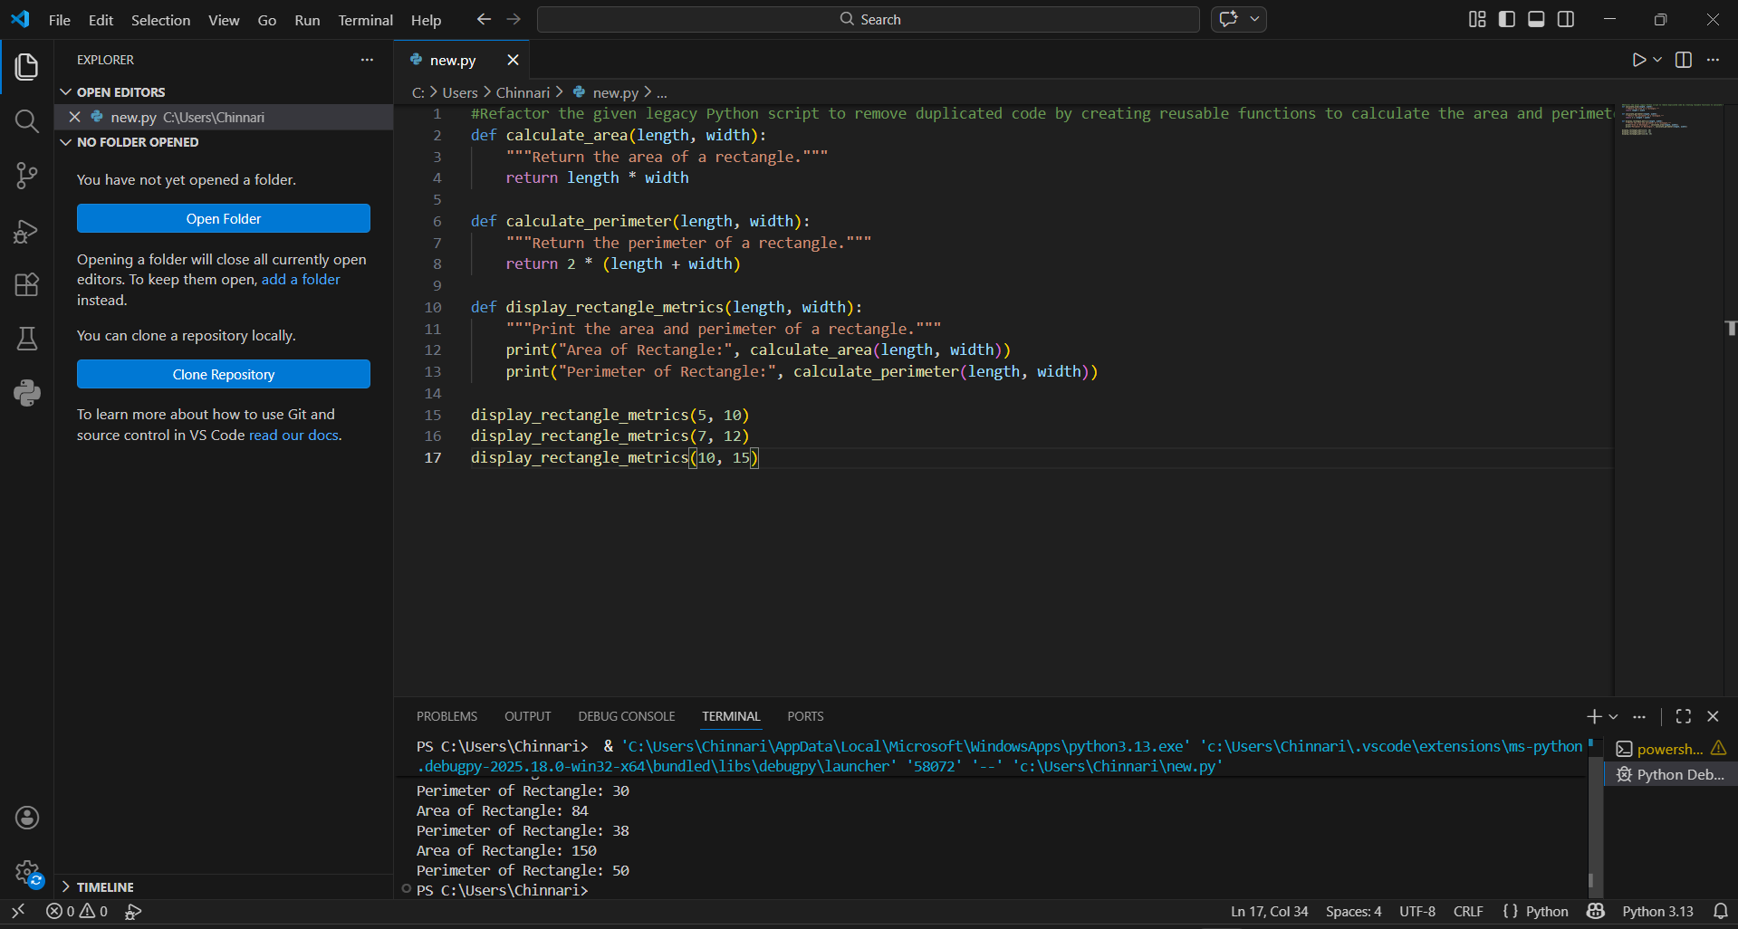

Task 2: Refactoring – Optimizing Loops and Conditionals
Objective
To improve performance by replacing inefficient nested loops with optimized
structures.
Task Description
Use AI to analyze and refactor a script that checks the presence of elements
using nested loops.
Starter (Legacy) Code
names = ["Alice", "Bob", "Charlie", "David"]
search_names = ["Charlie", "Eve", "Bob"]
for s in search_names:
found = False
for n in names:
if s == n:
found = True
if found:
print(f"{s} is in the list")
else:
print(f"{s} is not in the list")
Expected Outcome
• Optimized solution using set lookups or comprehensions
• Performance comparison before and after refactoring

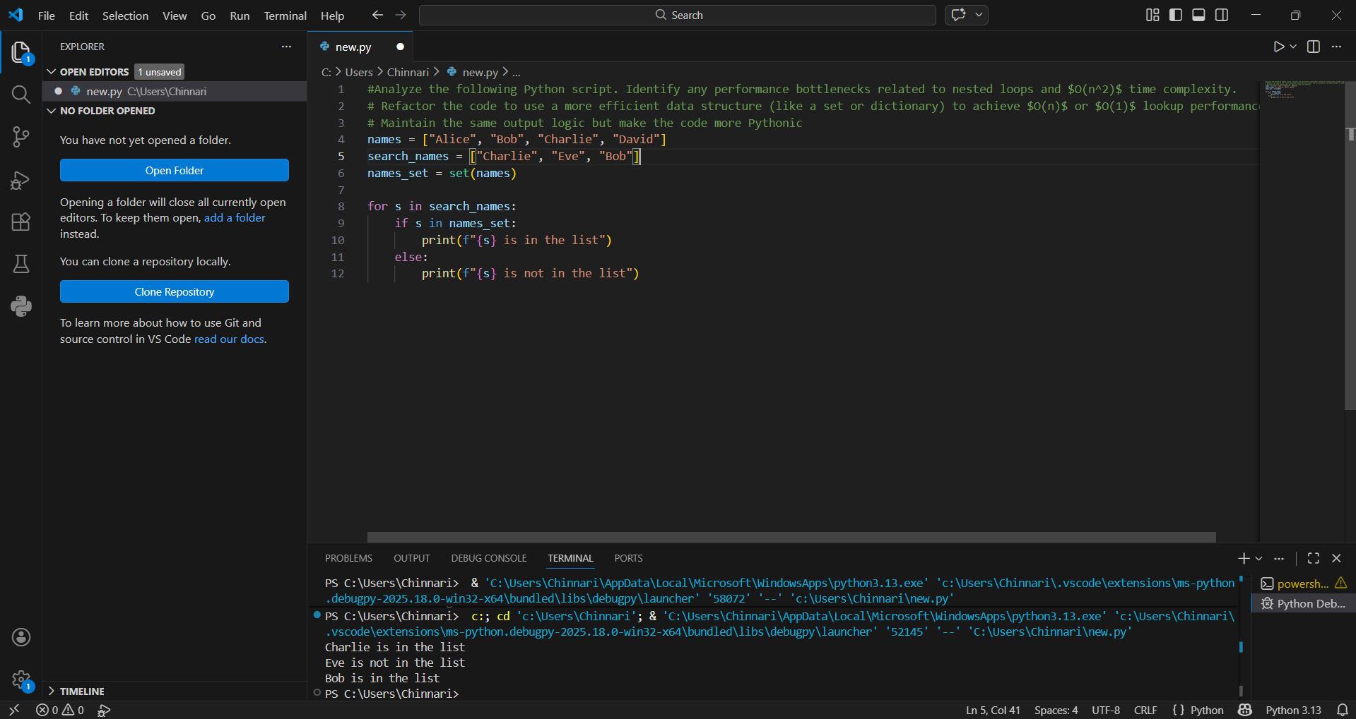
Task 3: Refactoring – Extracting Reusable Functions
Objective
To modularize code by extracting calculations into reusable functions.
Task Description
Refactor a legacy script where price and tax calculations are written inline.
Starter (Legacy) Code
price = 250
tax = price * 0.18
total = price + tax
print("Total Price:", total)
price = 500
tax = price * 0.18
total = price + tax
print("Total Price:", total)
Expected Outcome
• A function calculate_total(price)
• Cleaner and reusable code structure
• Proper documentation
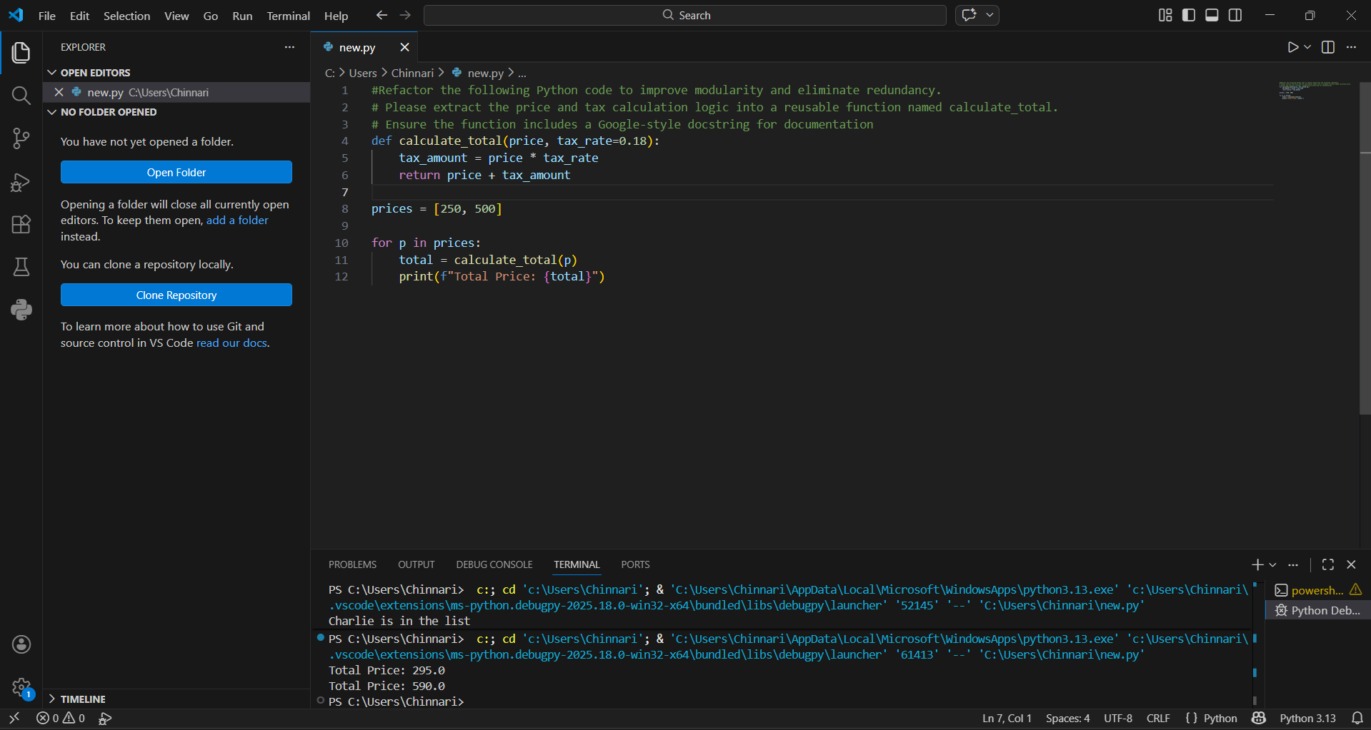
Task 4: Refactoring – Replacing Hardcoded Values with Constants
Objective
To improve maintainability by replacing magic numbers with named constants.
Task Description
Use AI to identify hardcoded values and replace them with constants.
Starter (Legacy) Code
print("Area of Circle:", 3.14159 * (7 ** 2))
print("Circumference of Circle:", 2 * 3.14159 * 7)
Expected Outcome
• Constants such as PI and RADIUS
• Cleaner, maintainable code
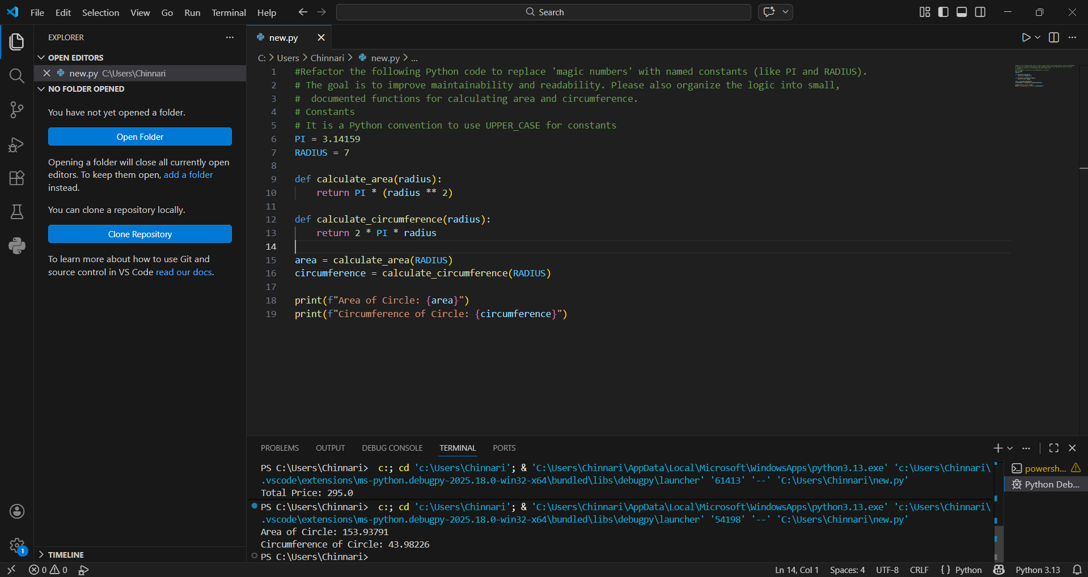
Task 5: Refactoring – Improving Variable Naming and Readability
Objective
To enhance readability using descriptive variable names and comments.
Task Description
Refactor a script with unclear variable names.
Starter (Legacy) Code
a = 10
b = 20
c = a * b / 2
print(c)
Expected Outcome
• Descriptive variable names
• Inline comments explaining logic
• Identical output
Note: Report should be submitted as a word document for all tasks in a single
document with prompts, comments & code explanation, and output and if
required, screenshots.
