Assignment- 13.5
2303A51574
Batch-29

Task Description 1 Refactoring – Removing Global Variables) • Task: Use AI to eliminate unnecessary global variables from the code.
• Instructions:
- Identify global variables used across functions. o Refactor the code to pass values using function parameters.
- Improve modularity and testability.
- Sample Legacy Code:
rate = 0.1 def calculate_interest(amount): return amount * rate print(calculate_interest(1000))
- Expected Output:
o Refactored version passing rate as a parameter or using a configuration structure.
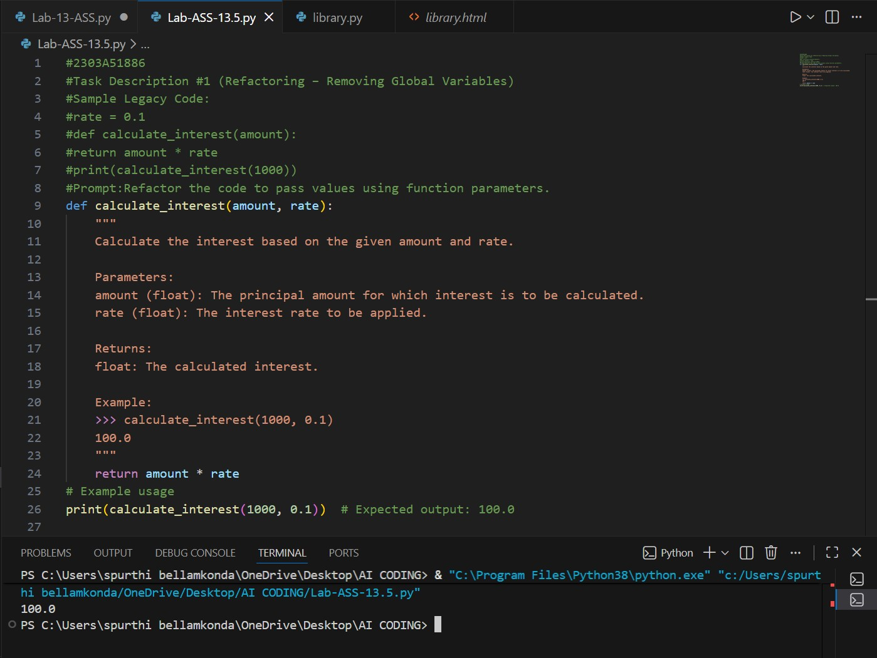
Task Description 2 : Refactoring Deeply Nested Conditionals) • Task: Use AI to refactor deeply nested if–elif–else logic into a cleaner structure.
• Focus Areas: o Readability o Logical simplification o Maintainability Legacy Code: score = 78 if score >= 90 print("Excellent") else:
if score >= 75 print("Very Good") else:
if score >= 60 print("Good") else:
print("Needs Improvement") Expected Outcome:
o Flattened logic using guard clauses or a mapping-based approach.
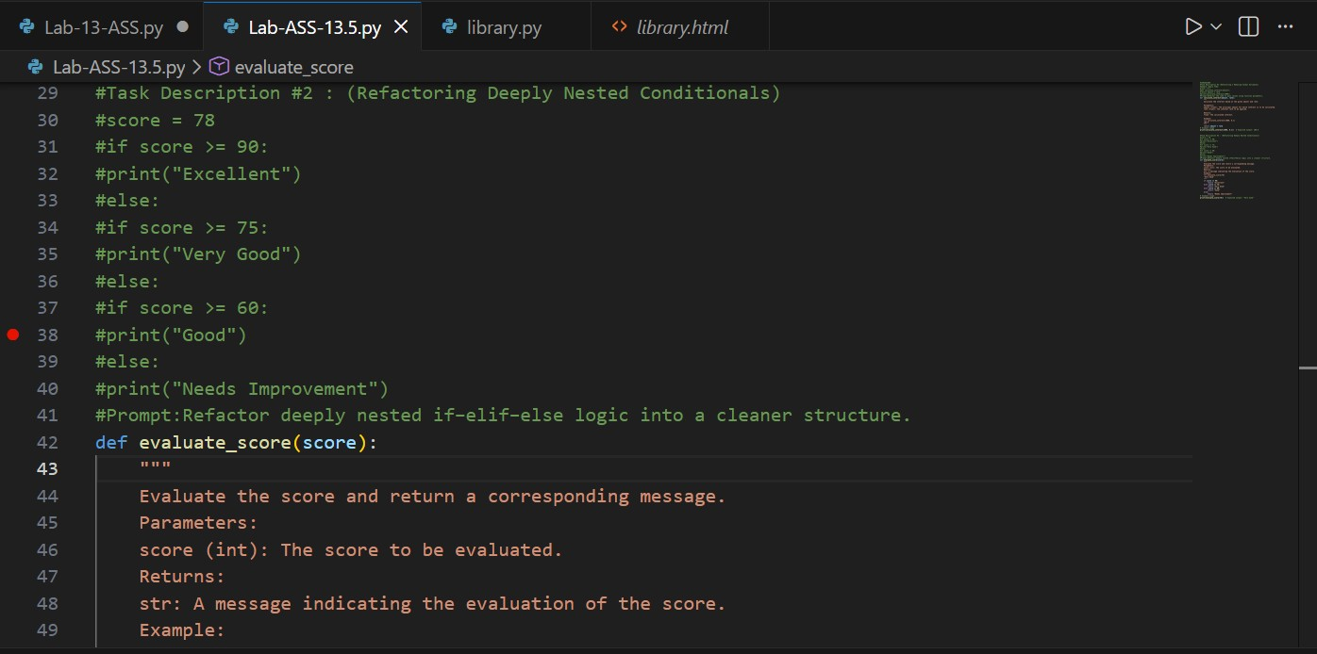
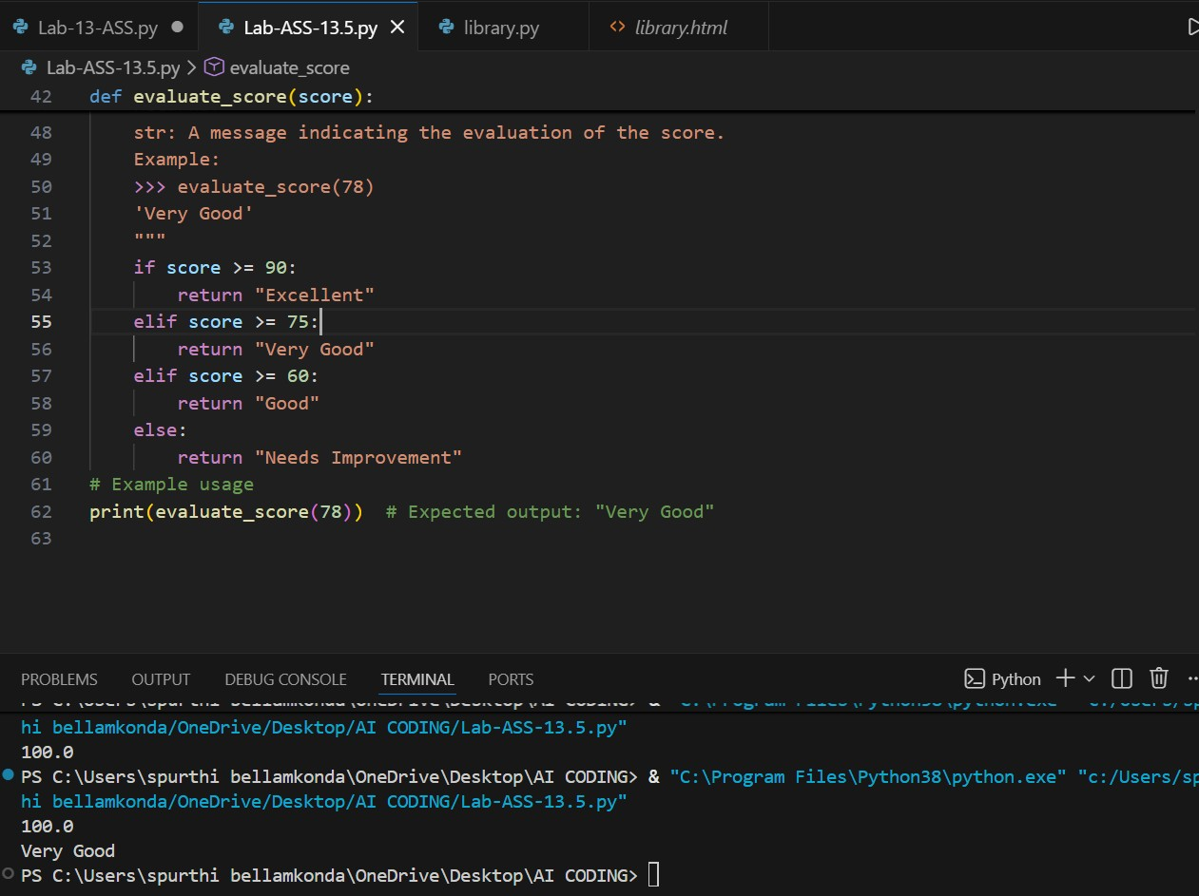
Task 3 Refactoring Repeated File Handling Code) • Task: Use AI to refactor repeated file open/read/close logic.
• Focus Areas: o DRY principle o Context managers o Function reuse Legacy Code: f = open("data1.txt") print(f.read()) f.close() f = open("data2.txt") print(f.read()) f.close()
Expected Outcome:
o Reusable function using with open() and parameters.
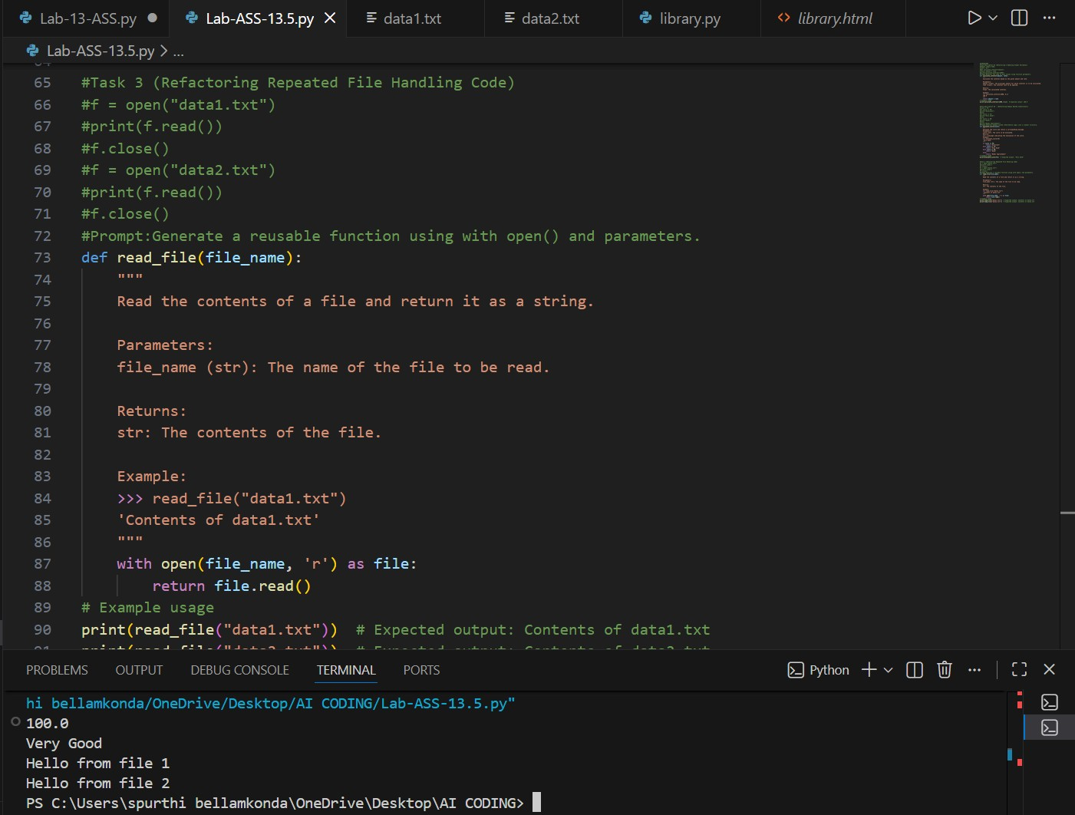
Task 4 Optimizing Search Logic)
- Task: Refactor inefficient linear searches using appropriate data structures.
- Focus Areas: o Time complexity o Data structure choice Legacy Code:
users = ["admin", "guest", "editor", "viewer"] name = input("Enter username: ") found = False for u in users: if u == name: found = True print("Access Granted" if found else "Access Denied") Expected Outcome: o Use of sets or dictionaries with complexity justification.
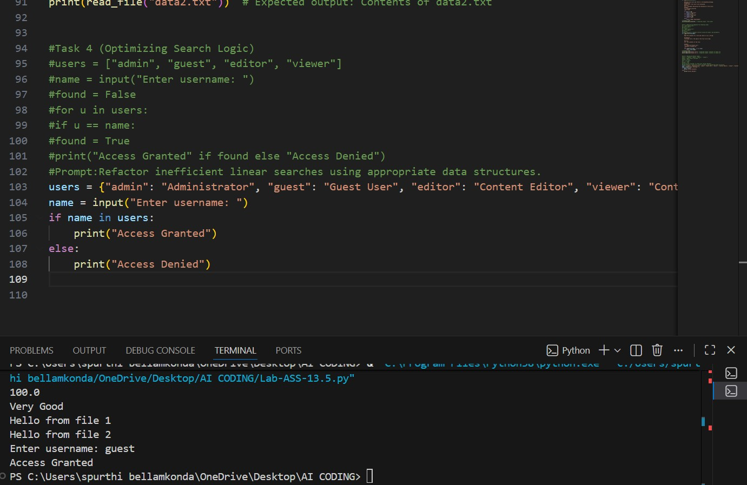
Task 5 Refactoring Procedural Code into OOP Design) • Task: Use AI to refactor procedural code into a class-based design.
- Focus Areas: o Object-Oriented principles o Encapsulation Legacy Code: salary = 50000 tax = salary * 0.2 net = salary - tax print(net)
Expected Outcome:
o A class like EmployeeSalaryCalculator with methods and attributes.
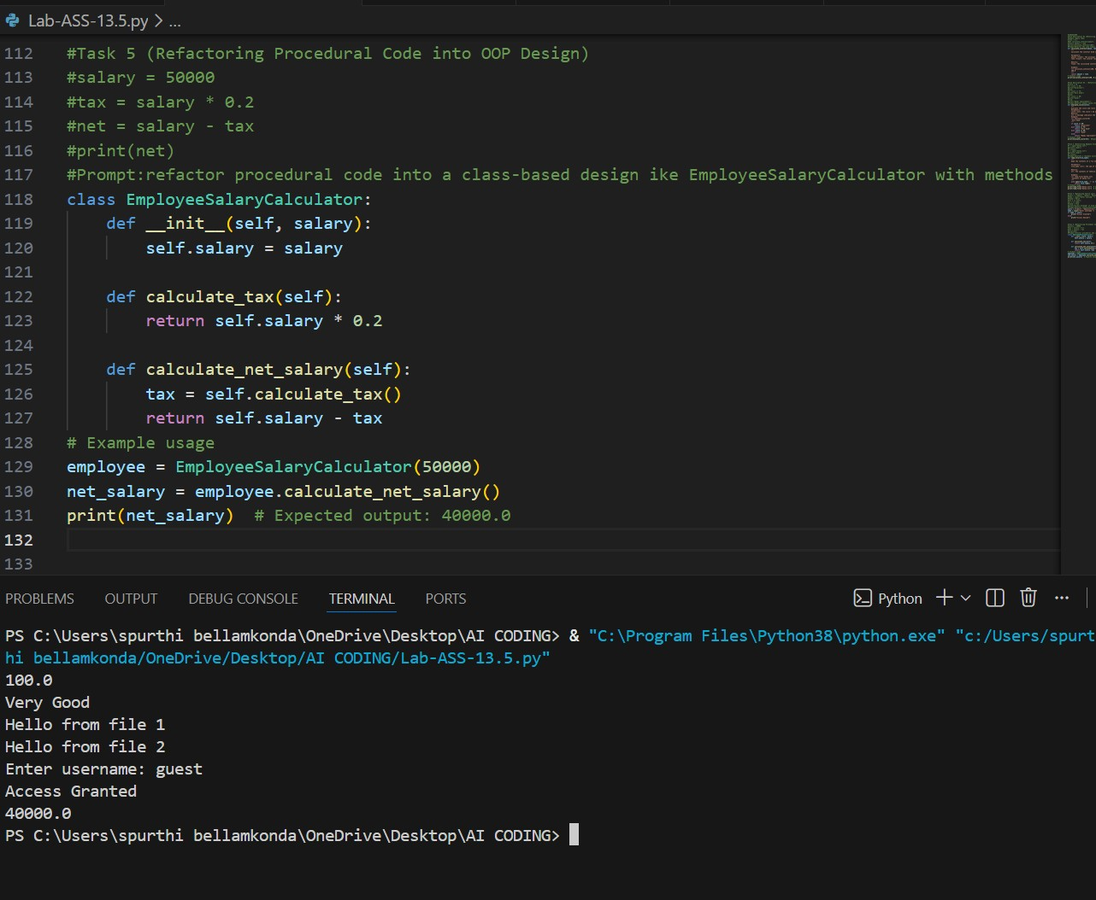
Task 6 Refactoring for Performance Optimization)
- Task: Use AI to refactor a performance-heavy loop handling large data.
- Focus Areas:
- Algorithmic optimization o Use of built-in functions Legacy Code: total = 0 for i in range(1, 1000000 if i % 2 == 0 total += i print(total)
Expected Outcome:
- Optimized logic using mathematical formulas or comprehensions, with time comparison.
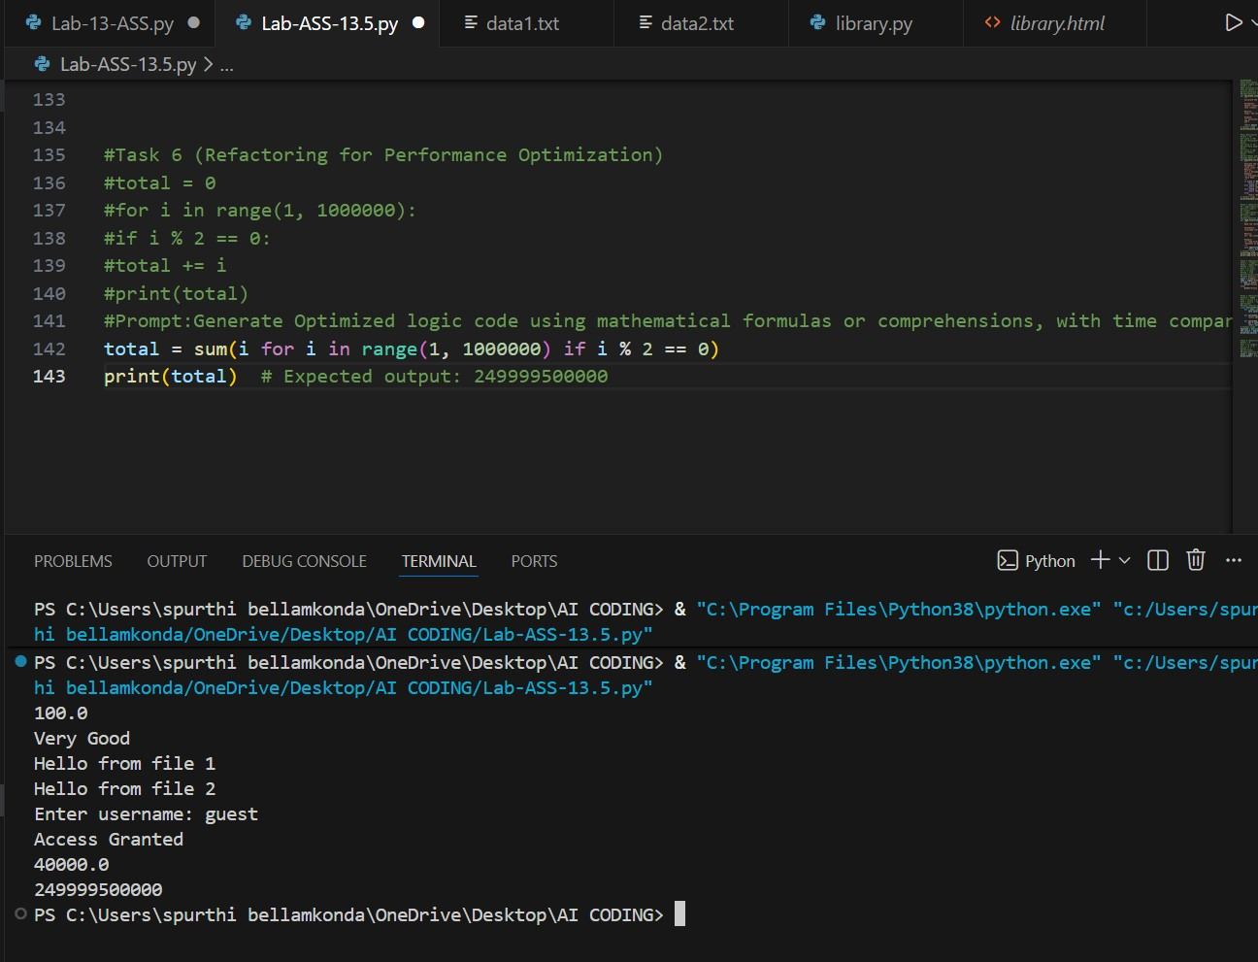
Task 7 Removing Hidden Side Effects)
- Task: Refactor code that modifies shared mutable state.
- Focus Areas: o Functional-style refactoring o Predictability Legacy Code: data = [] def add_item(x): data.append(x) add_item(10) add_item(20) print(data)
Expected Outcome:
o Refactored function returning values instead of mutating globals.
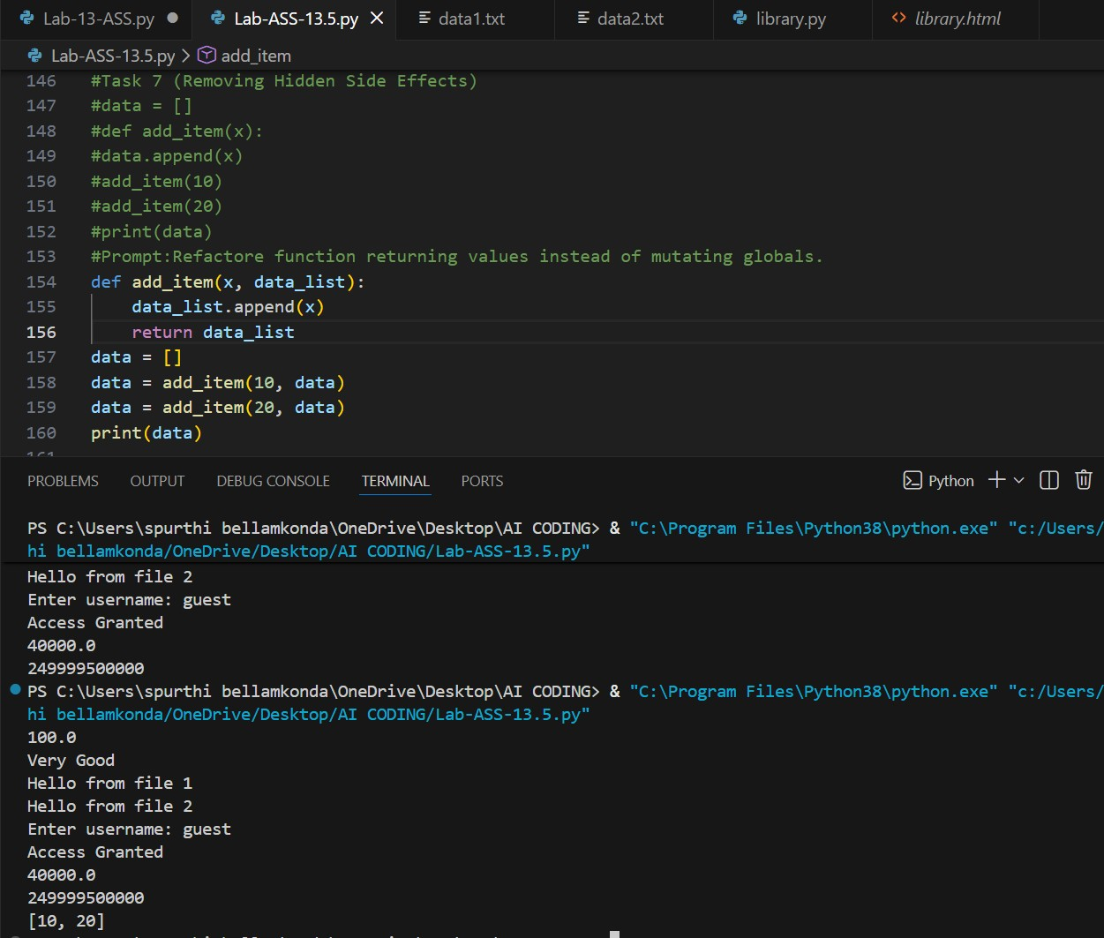
Task 8 Refactoring Complex Input Validation Logic) • Task: Use AI to simplify and modularize complex validation rules. • Focus Areas: o Readability o Testability Legacy Code:
password = input("Enter password: ") if len(password) >= 8 if any(c.isdigit() for c in password): if any(c.isupper() for c in password):
print("Valid Password") else:
print("Must contain uppercase") else:
print("Must contain digit") else:
print("Password too short")
Expected Outcome:
o Separate validation functions with clear responsibility
