Name: B.Priyanka
Hall Ticket: 2303A52468 Batch: 42
Task 1: Refactoring Data Transformation Logic Prompt:
Refactor this loop into a more Python-style solution using list comprehension or a helper function, and make sure the output stays the same.
Code:
values = [2, 4, 6, 8, 10] doubled = []
for v in values: doubled.append(v * 2)
print(doubled)
#Refactor this loop into a more Python-style solution using list comprehension or a helper function.
doubled = [v * 2 for v in values] print(doubled)
#Refactor this loop into a more Python-style solution using a helper function. def double(v):
return v * 2
doubled = list(map(double, values)) print(doubled)
#Refactor this loop into a more Python-style solution using a helper function. def double(v):
return v * 2
doubled = list(map(double, values)) print(doubled)

Output:
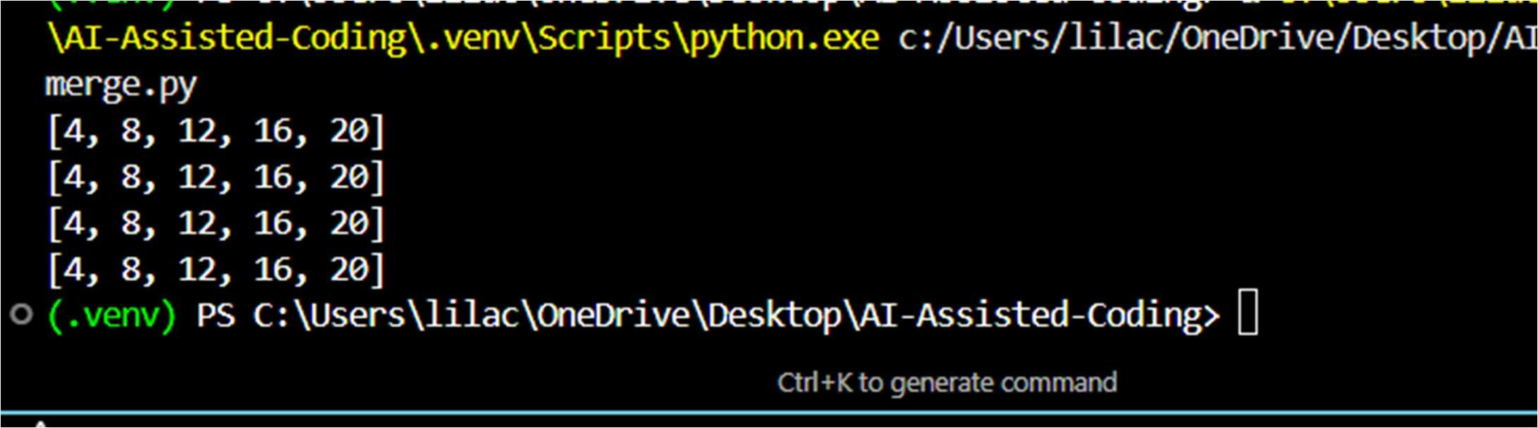
Explanation:
AI analyzes the loop pattern and replaces it with a shorter, more Pythonic structure like a list comprehension while keeping the output unchanged.

Prompt:
Rewrite this string-building loop in a more readable and efficient Python way, keeping the final output unchanged.
Code:
words = ["Refactoring", "with", "AI", "improves","quality"] message = ""
for w in words: message += w + " "
print(message.strip())
#Rewrite this string-building loop in a more readable and efficient Python way, keeping the final output unchanged
message = " ".join(words)
print(message)

Output:
Explanation:
AI recognizes that repeated string concatenation inside a loop is inefficient and suggests using a cleaner method like " ".join(words) to improve readability and performance while keeping the output the same.

Task 3: Safer Access to Configuration Data Prompt:
Refactor this manual dictionary key check into a safer and cleaner Python approach (such as using get), while keeping the same behavior for missing keys.
Code:
config = {"host": "localhost", "port": 8080} if "timeout" in config:
print(config["timeout"]) else:
print("Default timeout used")
#Refactor this manual dictionary key check into a safer and cleaner Python approach, while keeping the same behavior for missing keys.
if config.get("timeout") is not None: print(config["timeout"])
else:
print("Default timeout used")
Output:


AI notices the manual key check pattern and suggests using a safer method like config.get() to avoid errors and make the code cleaner. It keeps the same behavior when the key is missing by allowing a default value.

Task 4: Refactoring Conditional Logic for Scalability Prompt:
Refactor this multiple if–elif conditional logic into a cleaner and more scalable approach using a mapping technique, while keeping the same functionality.
Code:
action = "divide" x, y = 10, 2
if action == "add": result = x + y
elif action == "subtract": result = x - y
elif action == "multiply": result = x * y
elif action == "divide": result = x / y
else:
result = None print(result)
#Refactor this multiple if–elif conditional logic into a cleaner and more scalable approach using a mapping technique, while keeping the same functionality. operations = {
"add": lambda x, y: x + y, "subtract": lambda x, y: x - y, "multiply": lambda x, y: x * y, "divide": lambda x, y: x / y
}
result = operations.get(action, lambda x, y: None)(x, y) print(result)

Output:
Explanation:
AI sees that many if–elif conditions make the code longer and harder to maintain, so it suggests using a dictionary mapping to make the logic cleaner and easier to extend in the future.

Task 5: Simplifying Search Logic in Collections Prompt:
Refactor this manual loop-based search into a more concise and readable Python approach, while preserving the same output behavior.

inventory = ["pen", "notebook", "eraser", "marker"] found = False
for item in inventory: if item == "eraser":
found = True break
print("Item Available" if found else "Item Not Available")
#Refactor this manual loop-based search into a more concise and readable Python approach, while preserving the same output behavior.
if "eraser" in inventory: print("Item Available")
else:
print("Item Not Available")

Output:
Explanation:
AI recognizes that manually looping to search an item is unnecessary and suggests using Python’s built-in in operator to make the code shorter and easier to read while keeping the same result.

