Name: B.Priyanka
Hall Ticket: 2303A52468 Batch: 42
Task 1: Fixing Syntax Errors
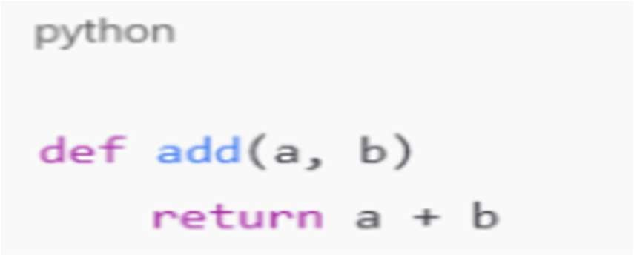
Prompt:
def add(a,b) return a+b
detect the syntax error in the above code, correct the function definition and explain the syntax issue and give correct output

Code:
def add(a, b): return a + b
print(add(2, 3))

Output:

Explanation:
Python requires a colon (:) after the function parameter list.
The function body must be on the next line and indented (typically 4 spaces).

Task 2: Debugging Logic Errors in Loops
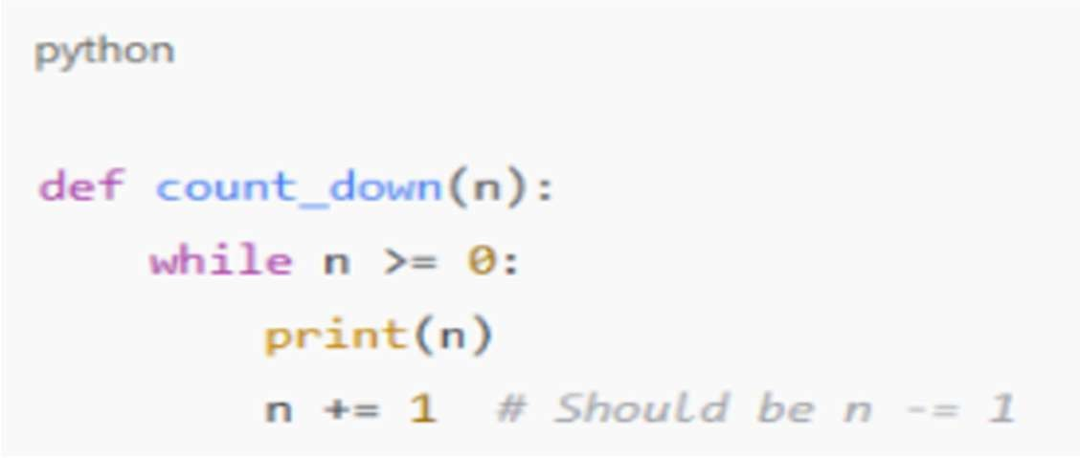
Prompt:
fix the error in the code by Providing a loop with an increment or decrement error, identify the cause of infinite iteration and fix the loop logic
- Analyze the corrected loop behavior and explain the logic error

Code:
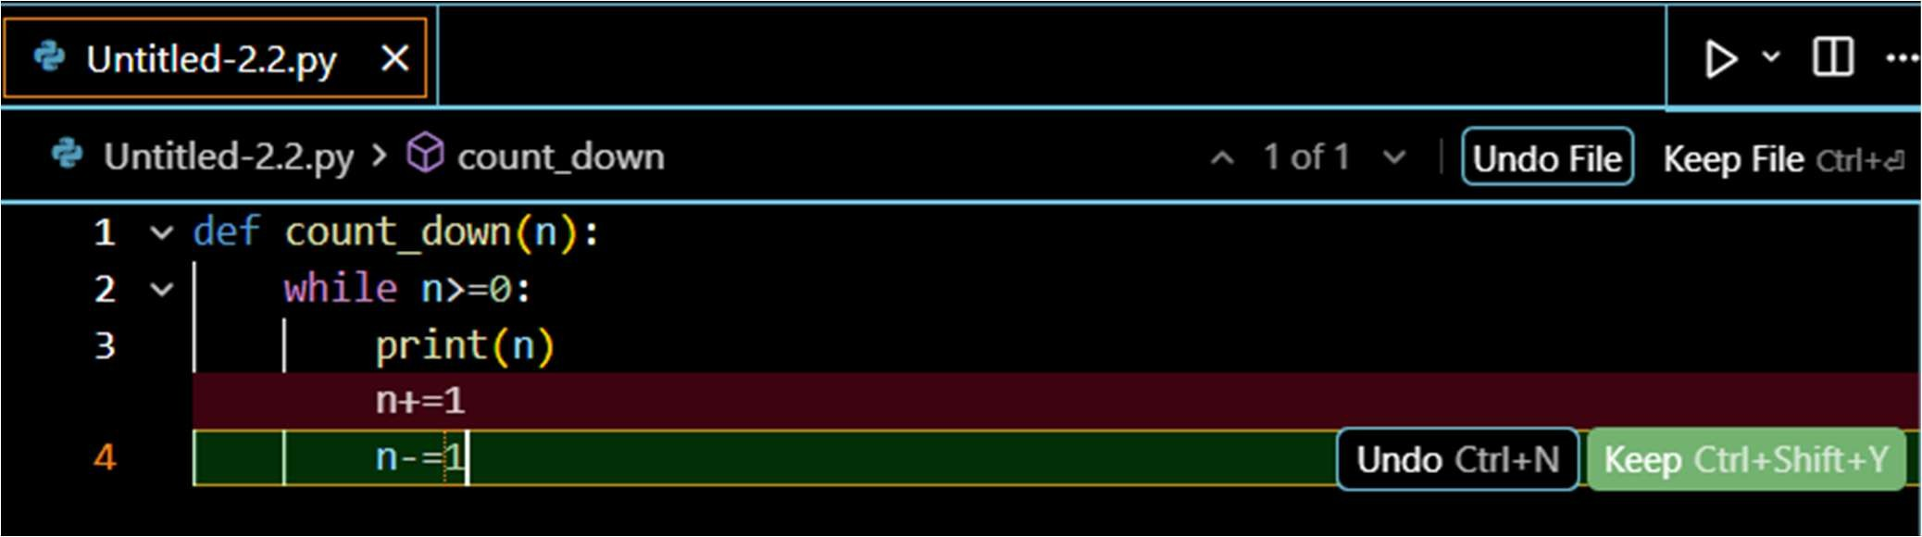
def count_down(n): n = 5
while n>=0:
print(n) n-=1

# Call the function to see the output count_down(5)

Output:
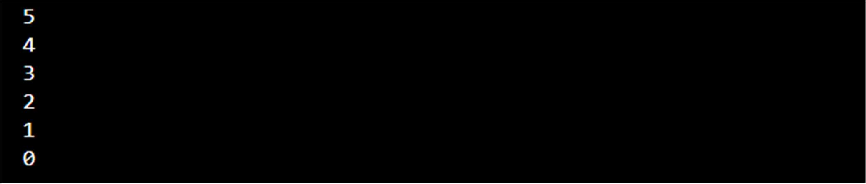

Explanation:
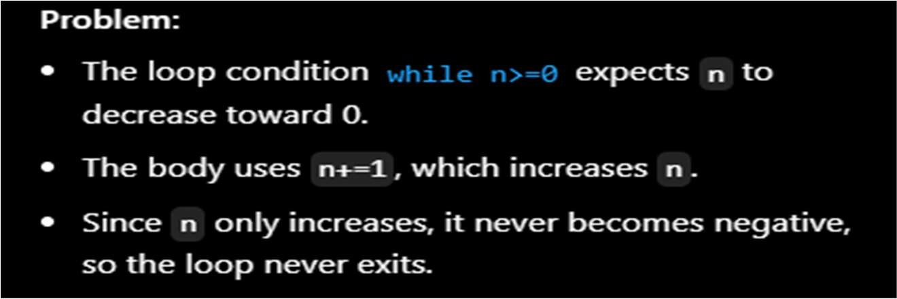

Task 3: Handling Runtime Errors (Division by Zero)
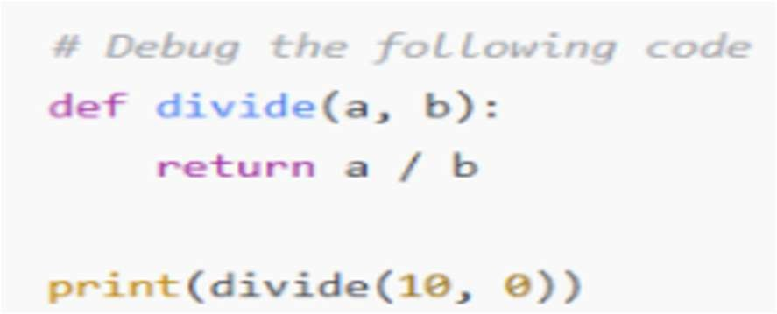

Prompt:
Debug the following code.add try-except blocks to handle division by zero error.Provide a function that performs division without validation.give error handlin approach and identify the runtime error

Code:
# Function WITHOUT validation (original - will raise ZeroDivisionError) def divide_no_validation(a, b):
"""Performs division without any error checking.""" return a / b

# Function WITH error handling using try-except def divide(a, b):
"""
Performs division with error handling for division by zero. Returns None if division by zero occurs.
"""
try:
result = a / b return result
except ZeroDivisionError:
print(f"Error: Cannot divide {a} by zero!") return None

# Function WITH validation (proactive approach) def divide_with_validation(a, b):
"""
Performs division with validation before attempting division. Checks if divisor is zero before dividing.
"""
if b == 0:
print(f"Error: Cannot divide {a} by zero!") return None
return a / b

# Test the functions
print("=== Testing divide() with try-except ===") result1 = divide(10, 2)
print(f"divide(10, 2) = {result1}")

result2 = divide(10, 0) print(f"divide(10, 0) = {result2}")

print("\n=== Testing divide_with_validation() ===") result3 = divide_with_validation(10, 2) print(f"divide_with_validation(10, 2) = {result3}")

result4 = divide_with_validation(10, 0) print(f"divide_with_validation(10, 0) = {result4}")

print("\n=== Testing divide_no_validation() (will raise error) ===")

try:
result5 = divide_no_validation(10, 2) print(f"divide_no_validation(10, 2) = {result5}")

# This will raise ZeroDivisionError result6 = divide_no_validation(10, 0)
print(f"divide_no_validation(10, 0) = {result6}") except ZeroDivisionError as e:
print(f"Runtime Error Caught: {type(e). name }: {e}")

Output:
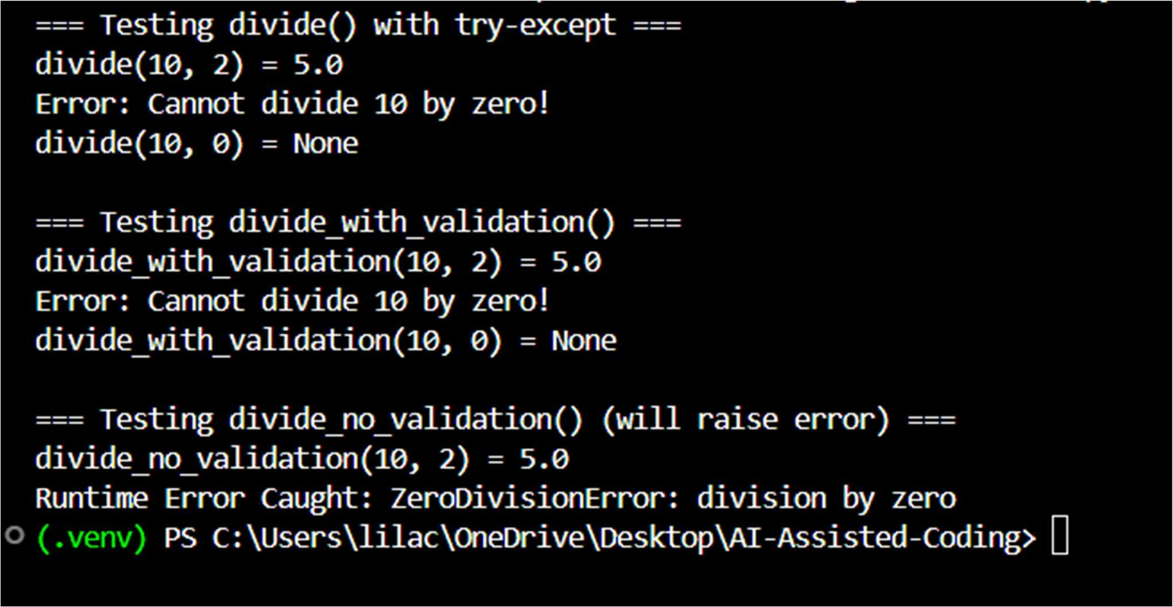

Explanation:

The runtime error occurs because dividing any number by zero is not allowed in Python.This causes a ZeroDivisionError when divide(10, 0) is executed.The try block runs the division code that may cause an error.The except ZeroDivisionError block catches the error instead of crashing the program.This approach handles the error gracefully by displaying a clear error message.

Task 4: Debugging Class Definition Errors
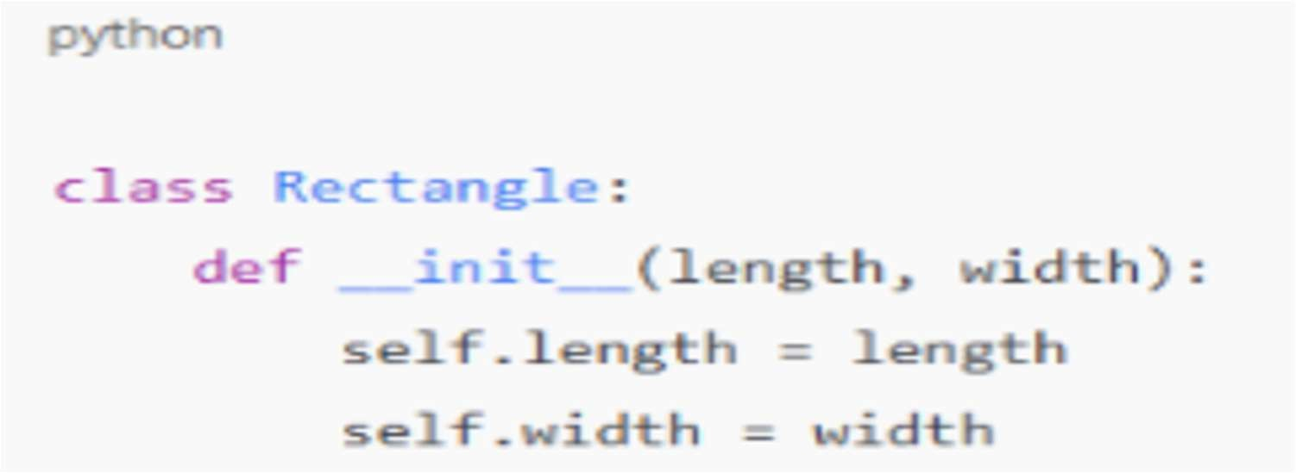
Prompt:
Provide a class definition with missing self-parameter. identify the issue in the init () method.correct the class definition.Understand why self is required and explain it

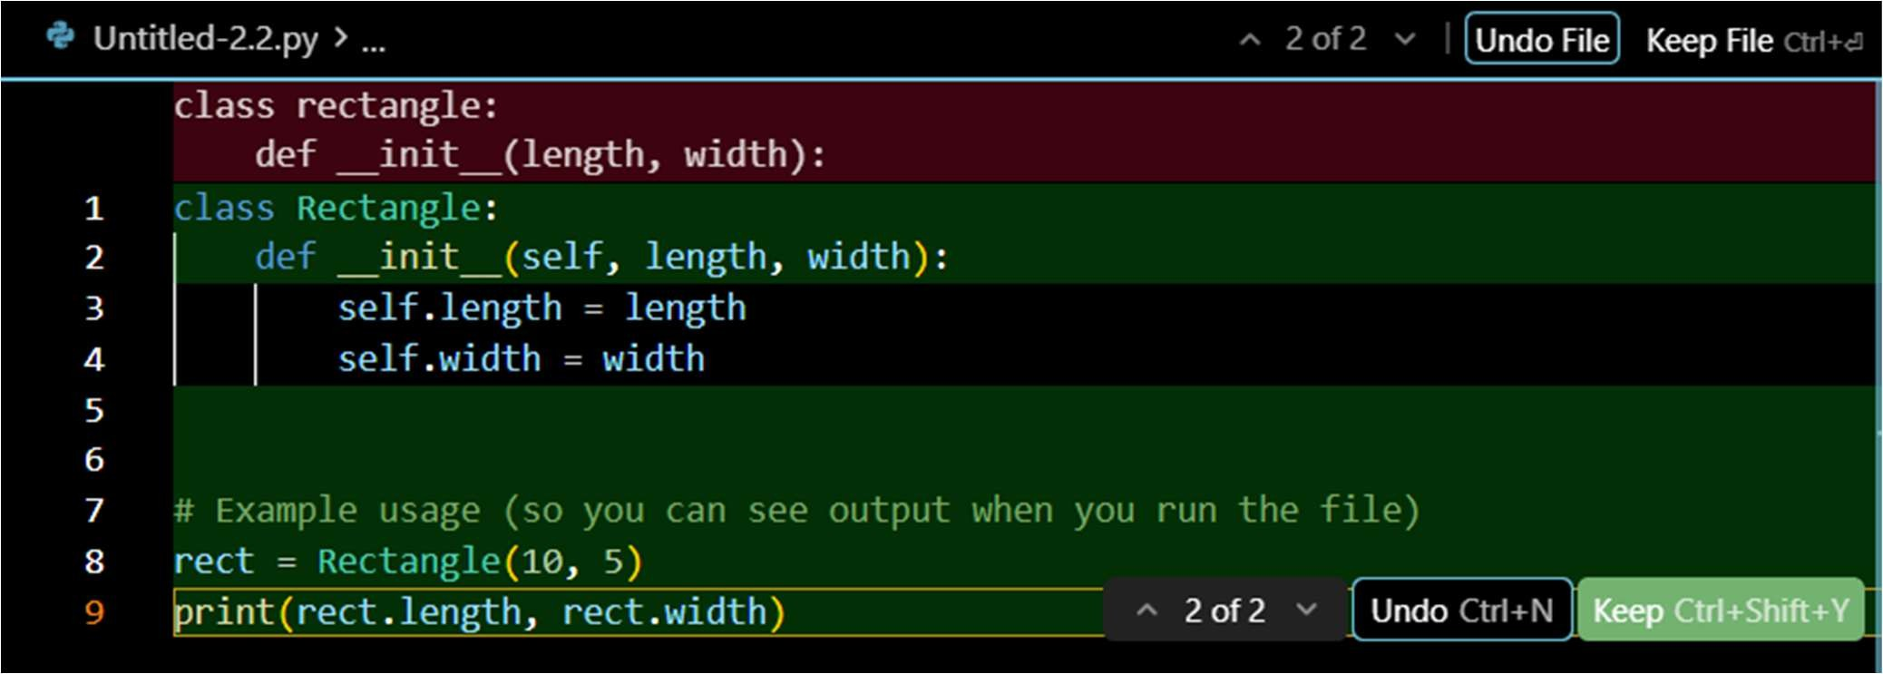
Code:
class Rectangle:
def init (self, length, width): self.length = length self.width = width

# Example usage (so you can see output when you run the file) rect = Rectangle(10, 5)
print(rect.length, rect.width)

Output:
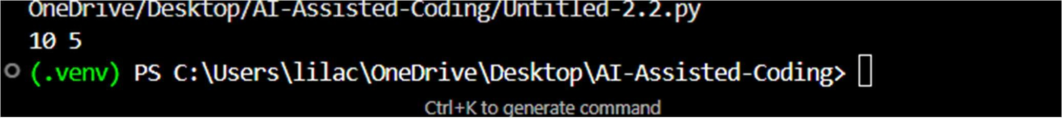
Explanation:

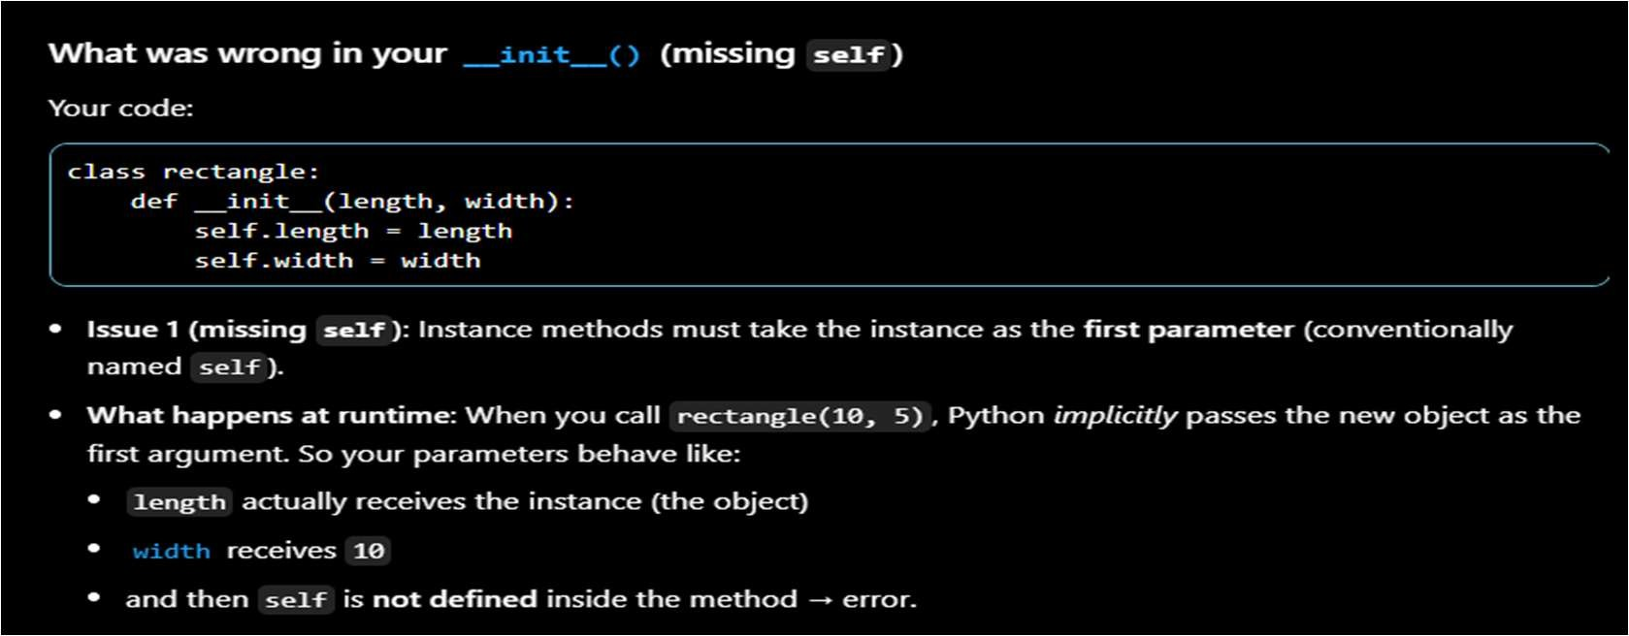
The issue was that the init () method was missing the self parameter.Without self, the class cannot store values in instance variables.Adding self allows length and width to be saved as object attributes.The corrected class properly initializes each Rectangle object.self is required because it refers to the current object and lets methods access its data.

Task 5: Resolving Index Errors in Lists
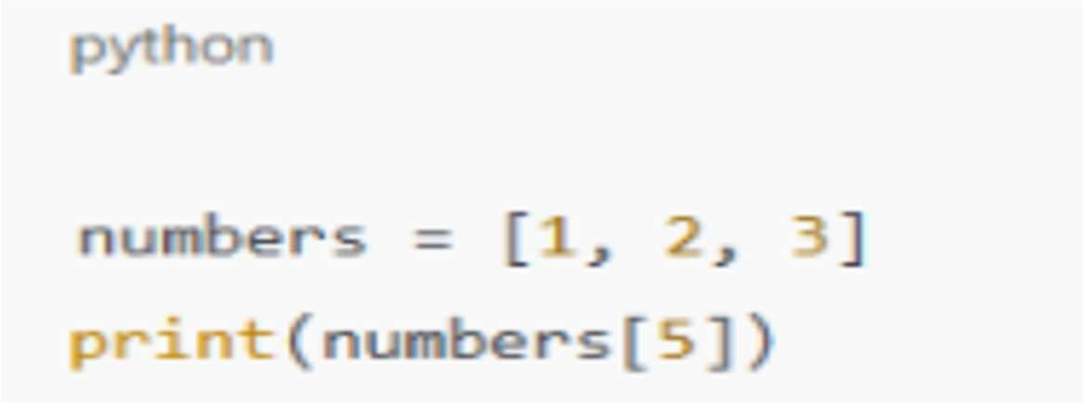
Prompt:
Provide code that accesses an out-of-range list index.identify the Index Error.suggest safe access methods.Apply bounds checking or exception handling.explain the changes made

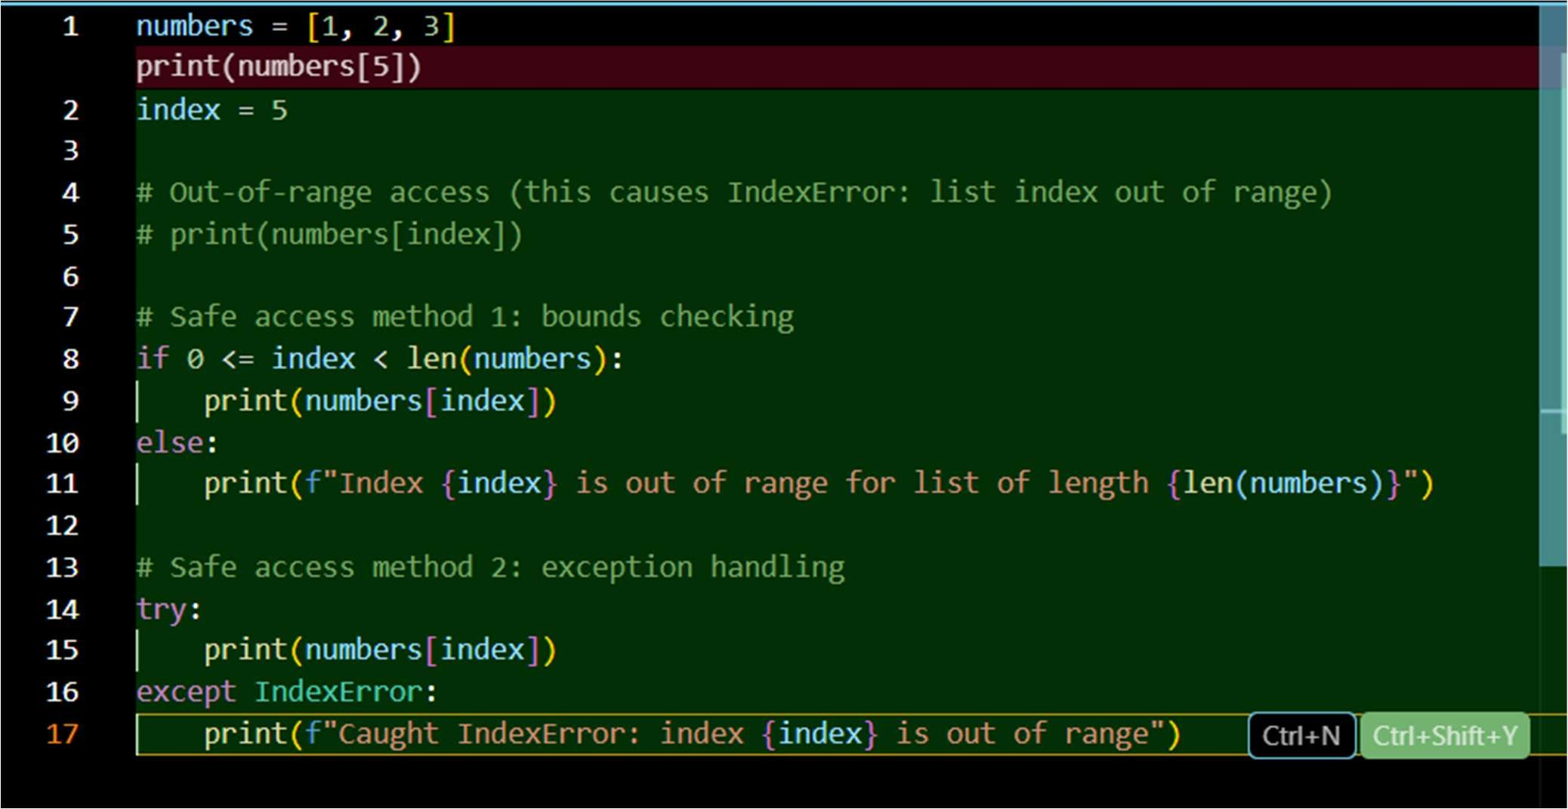
Code:

Output:
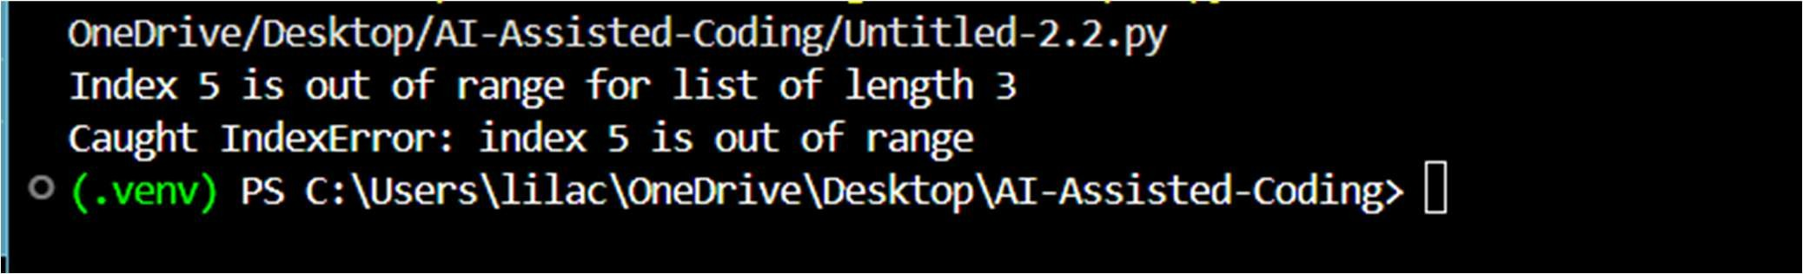
Explanation:
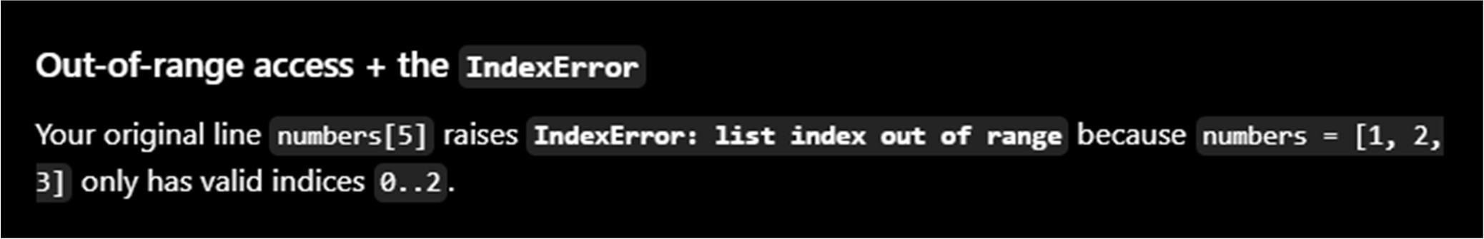
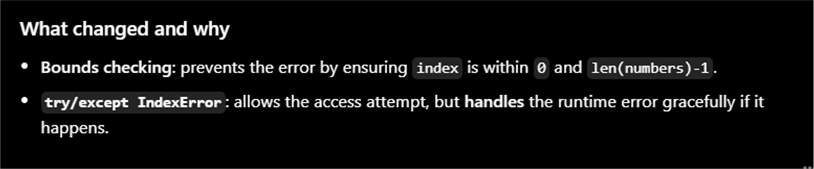
The list only has three items, but the code tries to access a sixth one.Python gets confused because that position doesn’t exist and raises an IndexError.The try block is used to attempt the risky operation.When the error happens, the except block steps in instead of crashing the program.This way, the program stays safe and shows a helpful message instead of stopping.

